Product Line Profitability & Margin Performance Analysis
For Nassau Candy Distributor

Submitted By: Deepanshu Bisht

Domain: Data Analytics & Business Intelligence
Tools: Python | Pandas | Plotly | Streamlit | GitHub

Platform: Unified Mentor Internship Program
Year: 2026

Abstract

In today's highly competitive distribution and retail environment, organizations require accurate data-driven insights to improve profitability, optimize product portfolios, and make effective strategic decisions. Traditional business analysis often focuses mainly on sales revenue; however, high sales volume does not always indicate strong financial performance. Products generating large revenue may still contribute less profit due to high manufacturing costs, inefficient pricing strategies, or poor margin performance.
This project, Product Line Profitability & Margin Performance Analysis for Nassau Candy Distributor, focuses on analyzing product-level financial performance by evaluating revenue, cost, gross profit, and profitability metrics. The primary objective of this project is to identify the products and divisions that contribute the most to overall profitability while detecting low-margin products that may create financial risks for the organization.
The project follows a complete data analytics workflow including data cleaning, validation, feature engineering, exploratory data analysis (EDA), KPI development, and interactive dashboard creation. Important business metrics such as Gross Margin Percentage, Profit per Unit, Revenue Contribution, Profit Contribution, and Margin Risk Classification were developed to evaluate product performance.
Using Python-based analytical tools including Pandas for data processing, Plotly for interactive visualization, and Streamlit for dashboard development, a business intelligence solution was created. The dashboard provides interactive insights through multiple analytical modules such as product profitability ranking, division-level revenue and profit comparison, monthly revenue trends, cost versus margin diagnostics, margin health distribution, and Pareto 80/20 profit contribution analysis.
The developed solution enables stakeholders to identify high-performing products, evaluate pricing strategies, understand profitability patterns, and optimize business decisions. This analysis supports product rationalization, cost optimization, and improved decision-making by transforming raw transactional data into meaningful business intelligence insights.

Introduction

In the modern business environment, organizations generate large amounts of transactional and operational data through daily activities such as sales, manufacturing, inventory management, and customer interactions. However, raw data alone does not provide meaningful value unless it is properly processed, analyzed, and converted into actionable business insights. Data analytics plays an important role in helping organizations understand performance patterns, improve decision-making, and increase operational efficiency.
For product-based companies and distributors, measuring success only through sales revenue can often lead to inaccurate conclusions. A product generating high sales volume may appear successful, but it may not contribute significantly to overall profitability if production costs, operational expenses, or resource utilization are high. Therefore, analyzing profitability along with revenue is essential for understanding the true financial contribution of each product.
Product Line Profitability Analysis is a business intelligence approach that evaluates products based on important financial indicators such as sales revenue, manufacturing cost, gross profit, and profit margin. It helps organizations identify which products generate maximum profit, which products require pricing adjustments, and which products may negatively affect overall business performance.
Nassau Candy Distributor manages multiple product categories across different divisions, making it important to continuously monitor product performance. Different products contribute differently to business growth. Some products may generate large revenue but operate at lower margins, while others may have lower sales volume but provide higher profitability. Without proper analysis, companies may continue investing resources into products that do not provide sufficient financial returns.
This project, Product Line Profitability & Margin Performance Analysis for Nassau Candy Distributor, focuses on applying data analytics techniques to evaluate product-level and division-level profitability. The project analyzes historical sales data, calculates key performance indicators, performs exploratory data analysis, and develops an interactive business intelligence dashboard.
Using tools such as Python, Pandas, Plotly, and Streamlit, raw transactional data is transformed into meaningful visual insights. The dashboard enables users to analyze revenue trends, product rankings, division performance, cost efficiency, margin risks, and profit concentration patterns.
The main purpose of this project is to support data-driven decision-making by providing clear visibility into profitability performance. The insights generated from this analysis can help businesses improve pricing strategies, optimize product portfolios, reduce unnecessary costs, and focus on products that create maximum financial value.

Problem Statement

In today’s competitive business environment, distributors and product-based organizations handle a large number of products across multiple categories and divisions. While traditional business evaluation methods mainly focus on total sales revenue, sales performance alone does not provide a complete understanding of product success. A product with high sales volume may not always contribute positively to overall profitability because of high manufacturing costs, lower margins, or inefficient pricing strategies.
Nassau Candy Distributor manages different product lines across multiple divisions, where each product has different revenue generation capacity, production cost, and profit contribution. Without proper analytical visibility into product-level financial performance, it becomes difficult for decision-makers to identify which products truly increase profitability and which products create financial inefficiencies.
The organization faces challenges in understanding whether high-selling products are actually profitable or if they consume excessive operational and manufacturing resources. Products that appear successful based on revenue may reduce overall business margins if their costs are not effectively managed. Similarly, products with moderate sales may provide higher profit margins and stronger financial value.
The major challenge is the lack of a centralized analytical system that can provide insights into:
- Which product lines generate the highest gross margin.
- Which products contribute the most to total profitability.
- Whether high-revenue products are financially efficient.
- How profitability varies among different product divisions.
- Which products represent potential margin risks.
Without these insights, business decisions related to pricing, promotions, inventory planning, cost control, and product portfolio management remain dependent on assumptions rather than data-driven analysis. This can result in inefficient resource allocation, reduced profitability, and missed opportunities for business optimization.
This project aims to solve these challenges by developing a data analytics solution that evaluates product profitability using historical sales and cost data. Through data preprocessing, KPI calculation, exploratory data analysis, and interactive dashboard visualization, the project provides a clear understanding of product performance.
The developed dashboard helps stakeholders monitor important profitability indicators such as Gross Margin Percentage, Profit per Unit, Revenue Contribution, and Profit Contribution. It enables the identification of high-performing products, low-margin products, cost-heavy items, and areas where pricing or operational improvements are required.
By transforming raw transactional data into meaningful business intelligence insights, this project supports Nassau Candy Distributor in making informed decisions to improve profitability, optimize product strategy, and enhance overall financial performance.

Dataset Description

The dataset used for this project contains detailed transactional and product-related information of Nassau Candy Distributor. The data represents customer orders, product categories, sales performance, manufacturing costs, and profitability information. This dataset acts as the foundation for performing product profitability analysis and developing business intelligence insights.
The primary objective of analyzing this dataset is to understand how different products and divisions contribute to overall business performance. Instead of evaluating products only based on sales revenue, the dataset allows a deeper analysis by considering important financial factors such as cost, gross profit, number of units sold, and profit margins.
The dataset consists of approximately 10,194 records and 18 attributes, where each record represents an individual order transaction. These attributes provide information related to orders, customers, geographical regions, products, and financial performance. The combination of these fields enables product-level, division-level, and profitability-based analysis.
The major categories of information available in the dataset are:
1. Order Information
Order-related attributes provide details about customer purchases and delivery information. These fields help in understanding transaction timelines and shipment methods.
Important attributes include:
RowID:
A unique identifier assigned to each row in the dataset. It helps in maintaining record uniqueness.
OrderID:
A unique identification number assigned to every customer order.
OrderDate:
Represents the date on which the customer placed the order. This field is used for time-based analysis such as monthly revenue and profit trends.
ShipDate:
Represents the date when the product was shipped to the customer.
ShipMode:
Defines the shipping method used for delivering products.

Customer and Location Information
Customer and geographical attributes help analyze business distribution across different locations.
The important fields include:
CustomerID:
A unique identifier assigned to each customer.
Country/Region:
Represents the country or region where the customer belongs.
City:
Shows the city location of the customer.
State/Province:
Represents the customer's state or province.
PostalCode:
Provides postal information related to customer location.
Region:
Defines the geographical region associated with the order.

Product Information
Product-related attributes provide details about the products sold by Nassau Candy Distributor. These fields are essential for product-level profitability analysis.
Important attributes include:
ProductID:
A unique identification code assigned to every product.
ProductName:
Contains the name of the product purchased by customers.
Division:
Represents the product category or business division. The major divisions include categories such as Chocolate, Sugar, and Other products.
The Division field helps compare revenue generation, profitability, and margin performance across different product groups.

Financial Information
Financial attributes are the most important part of this analysis because they help measure the actual profitability of products.
Important fields include:
Sales:
Represents the total revenue generated from product sales. It indicates how much money a product brings into the business.
Units:
Shows the total quantity of products sold in each transaction. It helps calculate unit-level profitability.
Cost:
Represents the manufacturing or operational cost required to produce the product.
GrossProfit:
Represents the profit generated after subtracting cost from sales.
It is calculated as:
Gross Profit = Sales − Cost

Derived Analytical Fields
Additional metrics were created during the analysis process to better evaluate business performance.
The major calculated fields include:
GrossMarginPercentage:
Measures the profitability efficiency of each product.
Formula:
Gross Margin (%) = (Gross Profit ÷ Sales) × 100
A higher margin percentage indicates better profitability.

Profit Per Unit:
Measures the average profit generated from each unit sold.
Formula:

Profit Per Unit = Gross Profit ÷ Units

Revenue Contribution:
Measures how much each product contributes to total company revenue.

Profit Contribution:
Identifies products responsible for generating the majority of business profit.

Margin Status:
Products were classified based on profitability performance to identify healthy and risky products.

This dataset provides a complete foundation for performing product profitability analysis. By combining sales, cost, product, and division-level information, meaningful insights were generated regarding high-performing products, margin risks, revenue dependency, and business optimization opportunities.
The processed dataset was finally used to develop an interactive Streamlit dashboard that enables stakeholders to explore profitability patterns and make informed business decisions.

Methodology

The methodology followed in this project represents a complete Data Analytics and Business Intelligence workflow designed to transform raw transactional data into meaningful business insights. The process includes multiple stages starting from data collection and preprocessing to KPI development, exploratory analysis, visualization, and dashboard deployment.
The main objective of the methodology is to systematically analyze Nassau Candy Distributor’s product performance by identifying profitability patterns, evaluating margin efficiency, and providing actionable recommendations for business improvement.

Data Collection
The first step of the project involved collecting the transactional dataset of Nassau Candy Distributor. The dataset contained information related to customer orders, product categories, sales performance, manufacturing cost, and profitability.
The dataset included various business attributes such as:
- Order details
- Product information
- Product divisions
- Sales revenue
- Units sold
- Manufacturing cost
- Gross profit
The collected dataset served as the primary source for performing product profitability and margin performance analysis.

Data Understanding and Initial Exploration
After collecting the dataset, the next step was understanding the structure and characteristics of the available data.
Initial exploration was performed to analyze:
- Number of records and columns
- Data types of different attributes
- Missing values
- Duplicate records
- Numerical and categorical variables
- Overall dataset quality
Python libraries such as Pandas were used to inspect and understand the dataset.
The following information was analyzed:
Dataset Shape
The dataset consisted of:
- Total Records: 10,194 rows
- Total Features: 18 columns
These records provided enough information to analyze product-level and division-level performance.

Data Cleaning and Validation
Data cleaning is an important stage in any analytics project because inaccurate or inconsistent data can result in incorrect business conclusions.
The dataset was processed and validated before performing analysis.
The major cleaning steps included:
Handling Missing Values
The dataset was checked for missing or incomplete values.
Missing data can affect:
- Profit calculations
- Product ranking
- Dashboard accuracy
Necessary validation was performed to ensure data consistency.

Date Format Conversion
Date columns such as:
- Order Date
- Ship Date
were converted into proper datetime format.
This conversion enabled time-based analysis such as:
- Monthly revenue trends
- Profit changes over time
- Business performance monitoring

Validation of Financial Values
Important numerical fields were validated:
- Sales
- Cost
- Gross Profit
- Units
Records with invalid values could create incorrect profitability calculations.

Financial validation ensured that:
Gross Profit = Sales – Cost
relationship was maintained.
Standardization of Product Information
Product-related fields such as:
- Product Name
- Division
were checked to maintain consistency.
This helped in accurate grouping and comparison during product analysis.

KPI Development

After cleaning the dataset, additional analytical features were created to gain deeper business insights.
Feature engineering helps convert basic data into meaningful performance indicators.
Several Key Performance Indicators (KPIs) were developed.

Gross Margin Percentage
Gross Margin Percentage measures how efficiently a product converts revenue into profit.
Formula:
Gross Margin (%) = (Gross Profit / Sales) × 100
This KPI helps identify:
- High-margin products
- Low-margin products
- Pricing problems
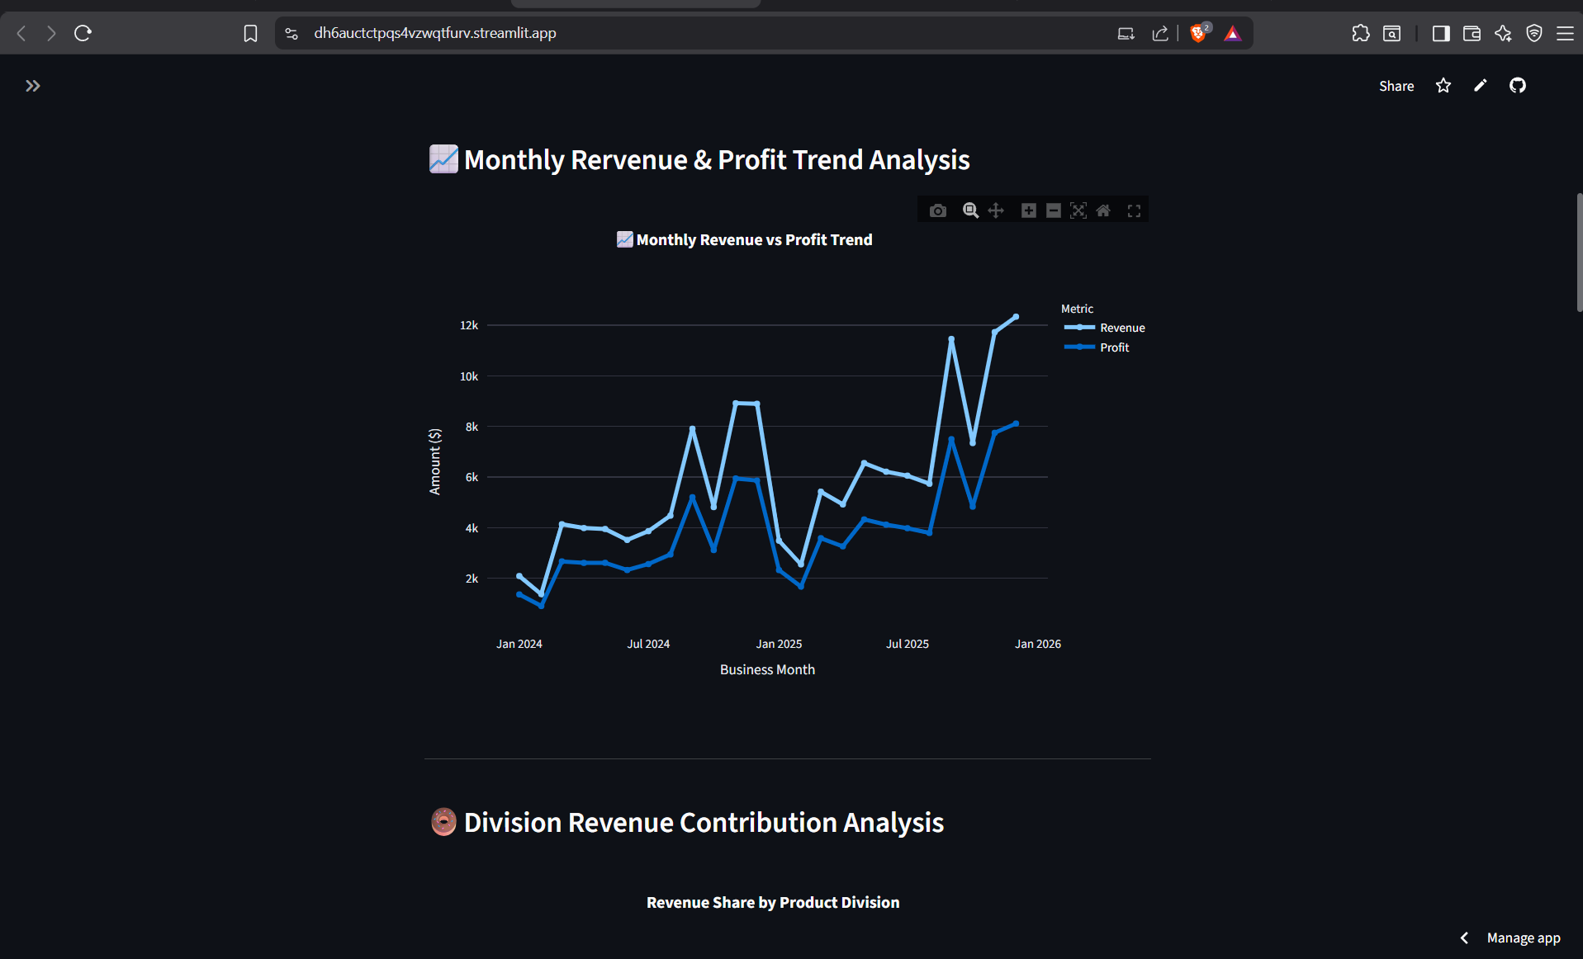

Profit Per Unit
Profit per unit calculates the average profit generated from every unit sold.
Formula:
Profit Per Unit = Gross Profit / Units
This helps compare products regardless of sales volume.

Revenue Contribution
Revenue contribution identifies how much each product contributes to total company revenue.
It helps find:
- Main revenue drivers
- Product dependency

Profit Contribution
Profit contribution measures how much each product contributes to total business profit.
This helps identify products that provide maximum financial value.

Margin Risk Classification
Products were classified based on their profitability performance.
This helped identify:
- Healthy margin products
- Medium-performing products
- Low-margin risk products

Exploratory Data Analysis (EDA)
Exploratory Data Analysis was performed to discover hidden patterns and relationships within the dataset.
EDA helped answer important business questions such as:
- Which products generate the highest profit?
- Which divisions perform better financially?
- Are high-sales products always profitable?
- Which products create margin risk?
Different analyses performed included:
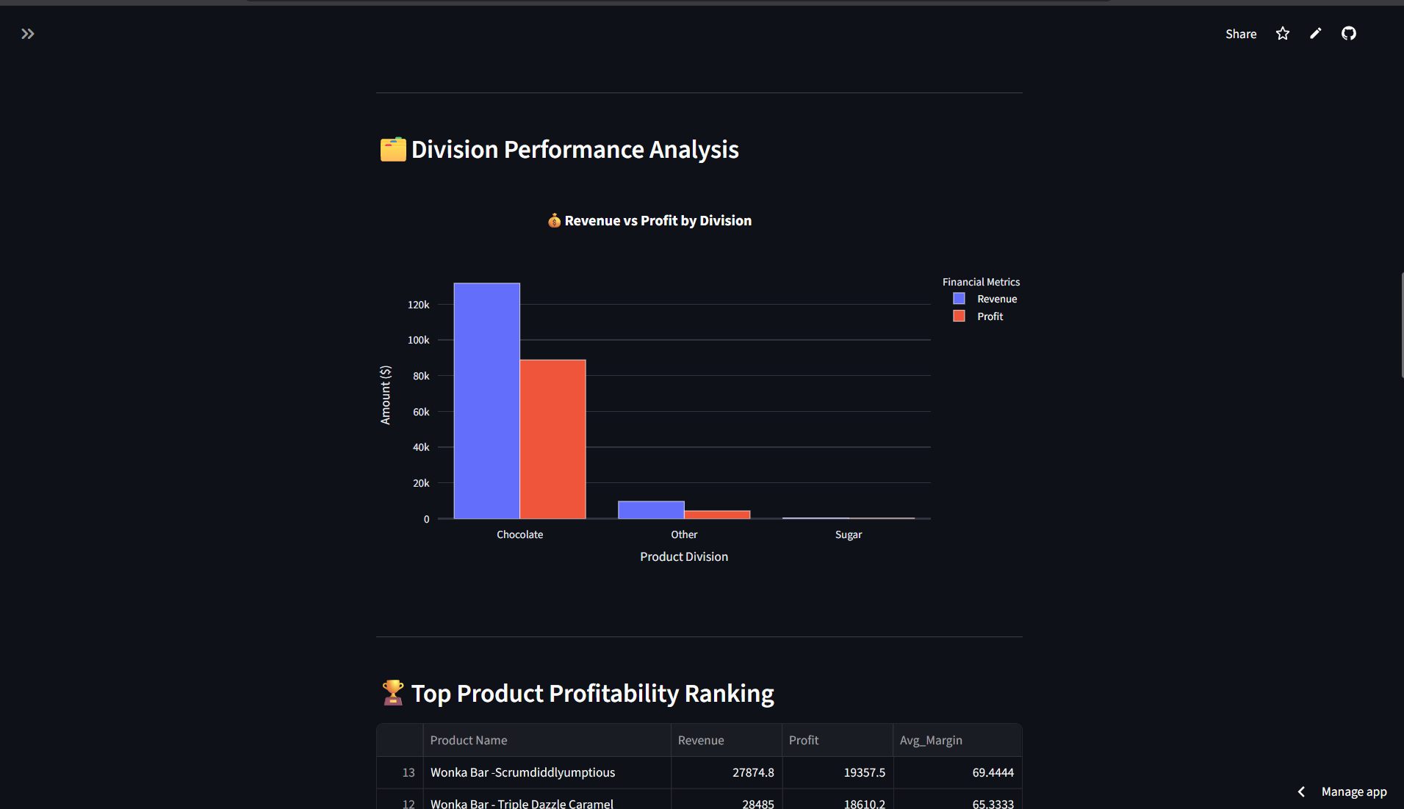

Product-Level Profitability Analysis

Products were analyzed based on:
- Total revenue
- Gross profit
- Profit margin
This helped identify:
- High-profit products
- Low-performing products

Division-Level Analysis
Product divisions were compared using:
- Total revenue
- Gross profit
- Average margin
This helped understand the financial efficiency of each division.

Cost Structure Analysis
Cost versus sales relationship was analyzed to identify:
- Expensive products
- Cost-heavy products
- Products requiring pricing improvement

Pareto 80/20 Analysis
Pareto analysis was performed to understand profit concentration.
The purpose was to identify whether:
A small percentage of products generate the majority of company profit.
This helps businesses focus on their most valuable products.

Data Visualization
Interactive visualizations were created using Plotly to represent analytical findings.
The major visualization modules included:
- Monthly Revenue and Profit Trend
- Division Revenue Contribution Chart
- Revenue vs Profit Comparison
- Product Profit Leaderboard
- Cost vs Margin Diagnostics
- Margin Health Distribution
- Pareto Profit Analysis
These visualizations converted complex data into easy-to-understand business insights.

Dashboard Development
After completing analysis and visualization, an interactive web dashboard was developed using Streamlit.
The dashboard provides:
- Real-time filtering
- Dynamic charts
- KPI monitoring
- Product search capability
User controls included:
- Date range selector
- Division filter
- Margin threshold filter
- Product search option
This allowed users to explore profitability insights interactively.
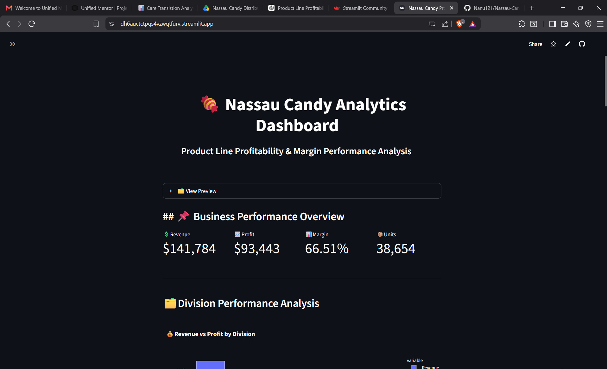
Business Insight Generation
The final stage involved converting analytical results into meaningful recommendations.
The analysis helped identify:
- Products generating maximum profit
- Products requiring pricing review
- Product divisions with strong performance
- Cost optimization opportunities
These insights support better decision-making related to:
- Product strategy
- Pricing decisions
- Inventory planning
- Cost management
This methodology ensured a structured and reliable analytical process, transforming Nassau Candy Distributor’s raw business data into a complete decision-support system through data analytics and interactive visualization.

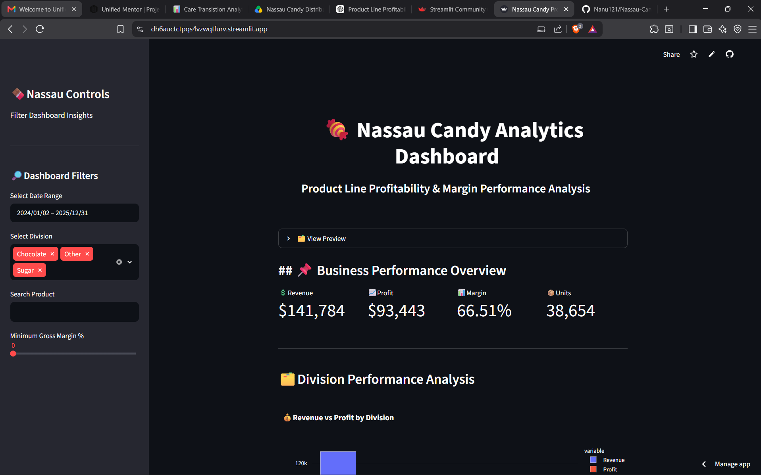

Business Insights

Business insights represent the meaningful conclusions obtained after analyzing Nassau Candy Distributor’s product sales, cost, and profitability data. The purpose of generating business insights is to convert raw transactional information into valuable knowledge that can support strategic decision-making.
Through detailed Exploratory Data Analysis (EDA), KPI evaluation, and dashboard visualization, several important patterns were identified related to product profitability, division performance, cost efficiency, and revenue contribution.
The following insights were obtained from the analysis:
Revenue Alone Does Not Represent Product Success
One of the major insights discovered during the analysis is that a product’s success cannot be measured only through its total sales revenue. High revenue does not always indicate that a product is financially efficient.
Some products may generate a large amount of sales but have lower profitability due to higher manufacturing or operational costs. These products may appear successful from a sales perspective but contribute less value to overall business growth.
The analysis compared:
- Sales Revenue
- Manufacturing Cost
- Gross Profit
- Gross Margin Percentage
This helped identify whether products with high sales were actually creating strong financial returns.
By analyzing profitability metrics, the business can shift focus from only increasing sales volume to improving actual profit generation.

Identification of High-Profit Products
Product profitability ranking helped identify the products that contribute the highest amount of gross profit to Nassau Candy Distributor.
The analysis ranked products based on:
- Total Revenue Generated
- Gross Profit Contribution
- Profit Margin Performance
High-profit products are extremely valuable because they directly improve the company’s financial performance.
These products should receive greater business attention through:
- Better inventory availability
- Focused marketing campaigns
- Sales promotion strategies
- Customer demand analysis
By prioritizing profitable products, the company can increase overall business efficiency and maximize financial returns.

Detection of Low-Margin Products
The Margin Health Distribution and Cost vs Margin Diagnostics helped detect products that generate lower profit margins.
Low-margin products represent a potential business risk because they consume resources but provide limited financial returns.
Possible reasons for lower margins include:
- Higher manufacturing costs
- Inefficient pricing strategies
- Increased operational expenses
- Lower selling price compared to production cost
Identifying these products allows management to take corrective actions such as:
- Adjusting product pricing
- Reducing production costs
- Improving supplier negotiations
- Reviewing product continuation decisions

Division-Level Performance Insights
The division-level profitability analysis provided a comparison of different product categories within Nassau Candy Distributor.
Each division was evaluated using:
- Total Revenue
- Gross Profit
- Average Margin Performance
This analysis helped identify which divisions operate with better financial efficiency.
A division generating higher revenue may not always be the most profitable division. Therefore, comparing both revenue and profit provides a clearer understanding of actual business performance.
Division analysis helps management:
- Allocate resources effectively
- Focus on stronger performing categories
- Improve weaker product divisions

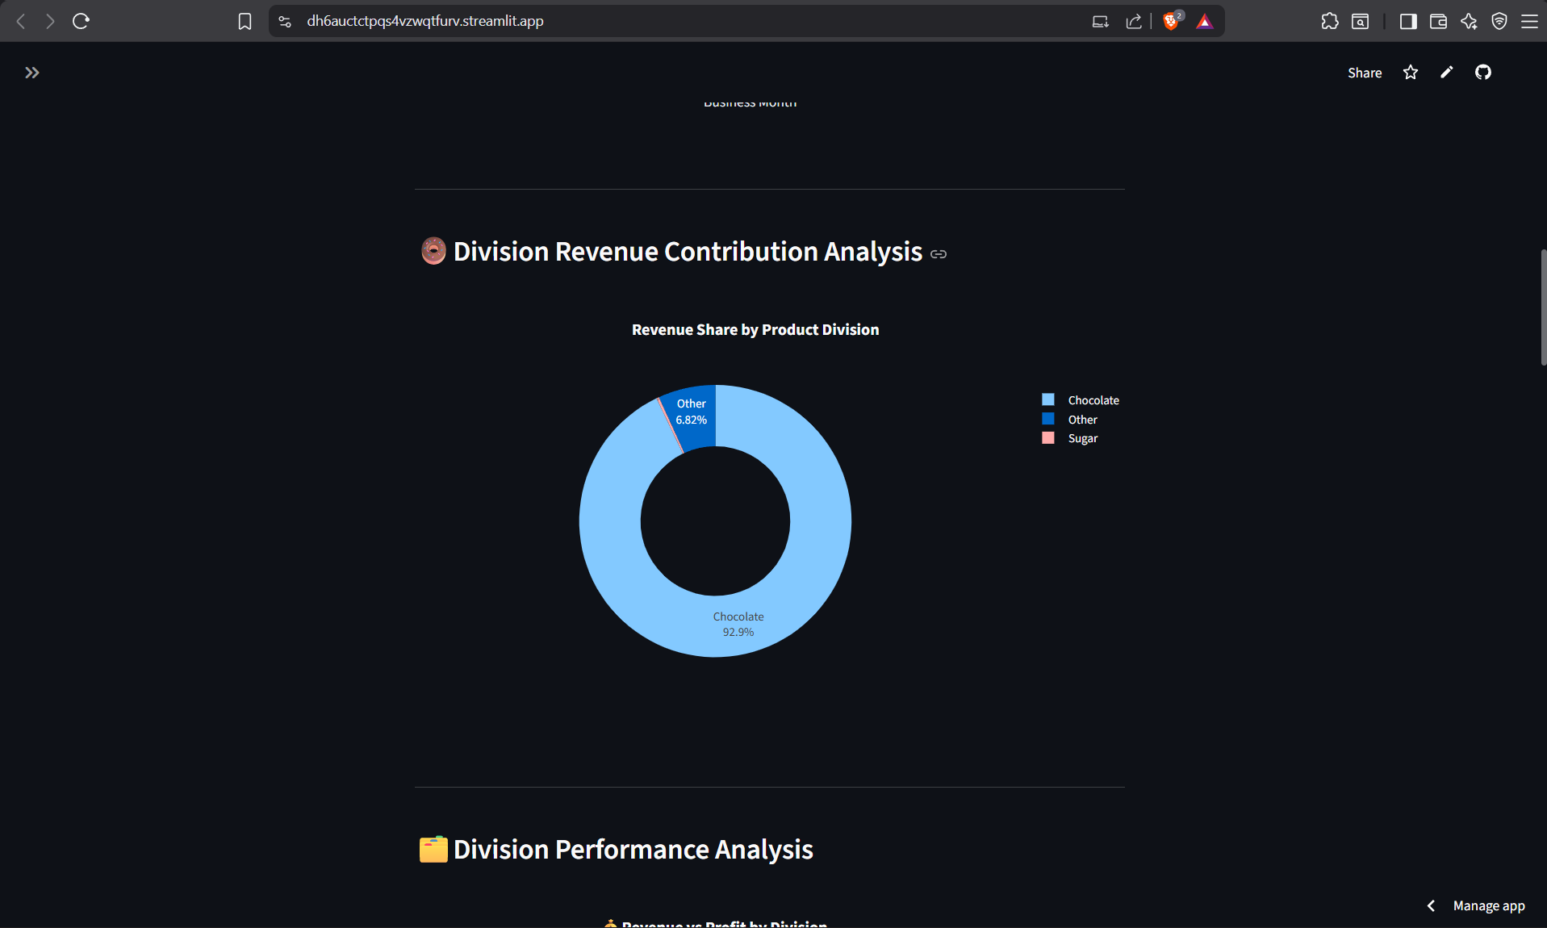

Revenue Dependency and Pareto 80/20 Analysis
Pareto analysis was performed to understand profit concentration among products.
The analysis follows the business principle that:
A smaller percentage of products often contributes to a larger percentage of total profit.
The Pareto 80/20 analysis helped identify whether the company depends heavily on a limited number of products for profitability.
Understanding profit concentration helps reduce business risk.
If a company depends too much on only a few products, problems such as:
- Product demand reduction
- Supply chain issues
- Market changes
can significantly affect profitability.
Using this insight, Nassau Candy Distributor can maintain a balanced and sustainable product portfolio.

Cost Efficiency Insights
Cost analysis was performed by comparing product manufacturing cost with sales and profitability.
The Cost vs Margin Diagnostic analysis helped identify:
- High-cost products
- Low-margin products
- Products requiring cost optimization
Products with increasing costs but limited profit contribution can negatively impact overall financial performance.
Cost efficiency analysis supports:
- Supplier negotiation
- Production optimization
- Better pricing decisions
- Cost reduction strategies
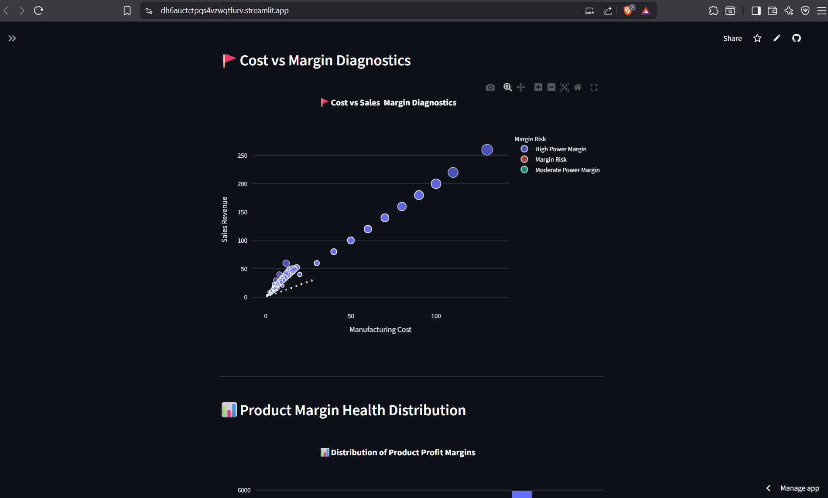

Product Portfolio Optimization Insights
The combined analysis of revenue, cost, profit, and margin performance provides a complete understanding of the company’s product portfolio.
Products can be categorized into:
High Revenue + High Margin Products
These products are strong performers and should receive maximum business focus.
High Revenue + Low Margin Products
These products require pricing or cost optimization because they generate sales but provide limited profit.
Low Revenue + Low Profit Products
These products should be reviewed because they may not provide enough business value.
This classification helps management make informed decisions about:
- Product promotions
- Pricing strategy
- Product continuation
- Resource allocation
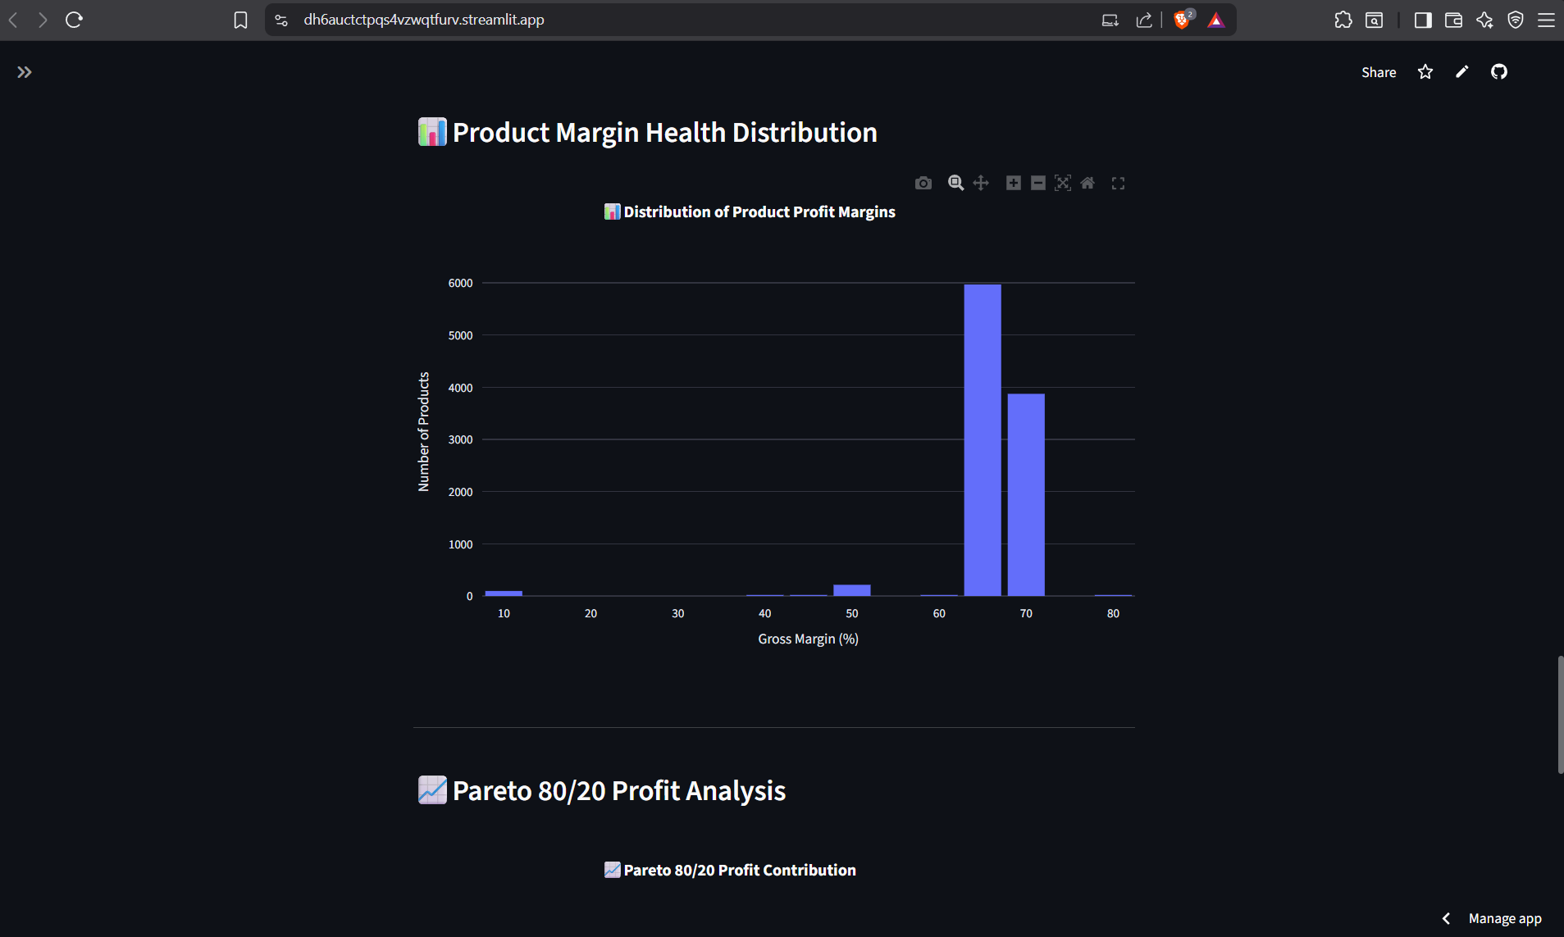

Overall Business Impact
The developed analytics solution provides Nassau Candy Distributor with a data-driven approach to profitability management.
The dashboard allows stakeholders to:
- Monitor important KPIs
- Identify profitable products
- Detect financial risks
- Understand division performance
- Improve strategic planning
Instead of relying on assumptions, business teams can use real-time analytical insights to make better decisions.
The project demonstrates how Business Intelligence and Data Analytics can improve profitability, reduce risks, and support long-term business growth.

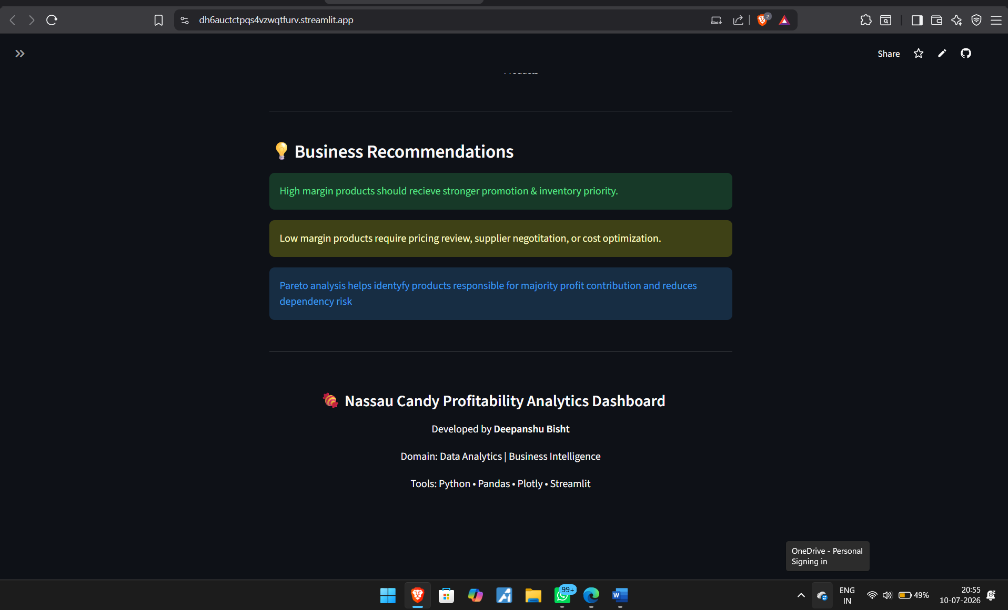

Recommendations

Business recommendations are developed based on the insights obtained from product profitability analysis, margin evaluation, cost diagnostics, and dashboard visualization. The objective of these recommendations is to help Nassau Candy Distributor improve profitability, optimize product strategies, reduce financial risks, and make better data-driven decisions.
The recommendations focus on improving product portfolio management, pricing strategies, cost efficiency, and long-term business performance.

Prioritize High-Profit and High-Margin Products
The profitability analysis identified that not all products contribute equally to overall business growth. Some products generate stronger financial returns because they maintain a better balance between revenue generation and manufacturing costs.
Nassau Candy Distributor should focus more on products that provide:
- High Gross Profit
- Strong Gross Margin Percentage
- Consistent Revenue Contribution
These products represent the strongest performers in the portfolio and should receive higher business priority.
The company can improve profitability by:
- Increasing marketing focus on profitable products
- Maintaining better inventory availability
- Expanding sales opportunities for high-margin products
- Understanding customer demand patterns for top-performing items
Prioritizing financially efficient products allows the company to increase overall profitability without depending only on sales volume.

Review and Optimize Low-Margin Products
The Margin Health Distribution and Cost vs Margin Analysis identified products with weaker profitability performance. These products may generate revenue but contribute limited profit due to high costs or inefficient pricing.
Low-margin products should be reviewed carefully because they can reduce overall business efficiency.
Recommended actions include:
- Analyze manufacturing and operational costs
- Review supplier and sourcing expenses
- Adjust product pricing where required
- Improve production efficiency
If a product continues to generate low margins after optimization efforts, the company can consider reducing focus on that product or redesigning its strategy.
This approach ensures that resources are allocated toward products that generate better financial returns.
Improve Pricing Strategy Using Profitability Insights
Pricing decisions should not be based only on market demand or sales volume. A product’s cost structure and profit margin should also be considered before deciding its pricing strategy.
The analysis shows the importance of monitoring:
- Product Cost
- Selling Price
- Gross Profit
- Margin Percentage
Products with high sales but low margins may require price adjustments to improve profitability.
A data-driven pricing strategy can help the organization:
- Increase profit margins
- Maintain competitive pricing
- Reduce losses from inefficient products
- Improve long-term financial stability
Using profitability analytics allows management to make pricing decisions based on measurable financial performance.
Overall Recommendation Summary
Based on the complete analysis, Nassau Candy Distributor should:
- Focus on products generating maximum profit contribution.
- Improve pricing strategies for low-margin products.
- Reduce unnecessary manufacturing costs.
- Monitor product profitability regularly.
- Maintain a balanced product portfolio.
- Use business intelligence dashboards for decision-making.
By applying these recommendations, the organization can improve profitability, reduce operational inefficiencies, and make more effective strategic decisions.

Future Scope

The Product Line Profitability & Margin Performance Analysis for Nassau Candy Distributor project successfully provides valuable insights into product performance, profitability patterns, cost efficiency, and business decision-making. However, as business environments continuously evolve, the analytics solution can be further enhanced by integrating advanced technologies and additional analytical capabilities.
Future improvements can expand this project from a descriptive analytics solution into a more advanced predictive and automated business intelligence system.
Implementation of Predictive Analytics
The current system analyzes historical sales and profitability data to identify patterns and business insights. In the future, predictive analytics techniques can be implemented to forecast upcoming business performance.
Machine Learning models can be developed to predict:
- Future sales trends
- Expected revenue growth
- Product profitability changes
- Customer demand patterns
Predictive models can help management prepare strategies in advance rather than responding after changes occur.
For example, forecasting future demand for specific products can help the organization improve inventory planning, production decisions, and resource allocation.
Machine Learning-Based Profit Forecasting
Future versions of the project can integrate Machine Learning algorithms to estimate future profitability based on historical data patterns.
Machine Learning models can analyze relationships between:
- Product sales
- Manufacturing cost
- Customer demand
- Market trends
- Profit margins
Algorithms such as Linear Regression, Random Forest, and Time-Series Forecasting models can be used to predict future profit performance.
This would help Nassau Candy Distributor identify potential growth opportunities and financial risks before they occur.
Real-Time Data Integration
Currently, the dashboard analyzes existing historical data. In the future, real-time database connectivity can be implemented to provide continuously updated business insights.
The dashboard can be connected with:
- Company databases
- ERP systems
- Cloud storage platforms
- Live sales systems
This would allow decision-makers to monitor current business performance without manually updating datasets.
Real-time analytics can improve response time and support faster business decisions.
Advanced Dashboard Features
The Streamlit dashboard can be further improved by adding advanced features such as:
- User authentication
- Database connectivity
- Downloadable reports
- Advanced filtering options
- Forecasting visualizations
- Automated alerts for low-margin products
Overall Future Enhancement
- The future scope of this project focuses on transforming the current analytical dashboard into a complete business intelligence and decision-support platform.
- By integrating machine learning, automation, and real-time analytics, Nassau Candy Distributor can improve profitability management, reduce business risks, and create a more efficient data-driven business environment.

These improvements would make the dashboard more suitable for enterprise-level business usage.

Conclusion

The Product Line Profitability & Margin Performance Analysis for Nassau Candy Distributor project demonstrates the effective use of data analytics and business intelligence techniques to solve real-world business challenges.
In modern organizations, analyzing only sales revenue is not sufficient to understand actual business performance. Products with high sales may not always generate high profits due to increased manufacturing costs or lower margins. Therefore, profitability-based analysis is essential for making accurate business decisions.
This project successfully analyzed product-level and division-level performance by considering important financial factors such as:
- Sales Revenue
- Manufacturing Cost
- Gross Profit
- Gross Margin Percentage
- Profit Contribution
A complete data analytics workflow was followed, including data cleaning, preprocessing, feature engineering, exploratory data analysis, KPI development, and dashboard creation.
The developed Streamlit dashboard provides interactive business intelligence capabilities through multiple analytical modules, including:
- Business KPI Overview
- Monthly Revenue and Profit Trend Analysis
- Division Performance Analysis
- Product Profitability Ranking
- Cost vs Margin Diagnostics
- Product Margin Health Distribution
- Pareto 80/20 Profit Analysis
The analysis provided important insights into product profitability patterns, margin risks, cost efficiency issues, and revenue dependency. These insights allow stakeholders to identify high-value products, improve pricing decisions, optimize costs, and manage product portfolios more effectively.
The project highlights how raw business data can be transformed into meaningful insights using modern data analytics tools such as Python, Pandas, Plotly, and Streamlit.
Overall, this project provides a practical demonstration of how data-driven decision-making can help organizations improve profitability, increase operational efficiency, and achieve better long-term business performance.

References
- Python Documentation
- Pandas Documentation
- Streamlit Documentation
- Plotly Documentation

