Spatio-Temporal Analysis and Prediction of Urban Crime in Chicago
2026-03-16
# Load Packages
library(tidyverse)
library(lubridate)
library(sf)
library(tmap)
library(spdep)
library(forecast)
library(tseries)
library(randomForest)
library(Metrics)
library(viridis)
library(gridExtra)
library(zoo)
library(rsample)
# Load files
crime_raw <- read.csv("/Users/lu_nanxi/CASA/STDM/crime_data.csv", stringsAsFactors = FALSE)
# Inspect columns
str(crime_raw)
head(crime_raw)
# Data Cleaning
crime <- crime_raw %>%
filter(!is.na(Latitude), !is.na(Longitude), !is.na(Date)) %>%
mutate(
Date = parse_date_time(Date, orders = c("mdy HMS", "mdy HM", "ymd HMS", "ymd HM"))
) %>%
filter(!is.na(Date)) %>%
mutate(
year = year(Date),
month = month(Date),
month_name = month(Date, label = TRUE, abbr = TRUE),
day = day(Date),
wday = wday(Date, label = TRUE, abbr = FALSE),
hour = hour(Date),
year_month = floor_date(Date, unit = "month")
) %>%
filter(year >= 2022, year <= 2024)
# Convert to sf object
crime_sf <- st_as_sf(
crime,
coords = c("Longitude", "Latitude"),
crs = 4326,
remove = FALSE
)
# Reproject to a projected CRS suitable for Chicago
# UTM zone 16N
crime_sf_proj <- st_transform(crime_sf, 26916)
# ASPATIAL ESTDA
# Summary statistics
total_crimes <- nrow(crime)
total_crimes
## [1] 753676
# Monthly counts
monthly_counts <- crime %>%
count(year_month, name = "crime_count") %>%
complete(
year_month = seq(min(year_month), max(year_month), by = "month"),
fill = list(crime_count = 0)
) %>%
arrange(year_month)
mean_monthly <- mean(monthly_counts$crime_count)
sd_monthly <- sd(monthly_counts$crime_count)
# Temporal Analysis
# Monthly time series plot
ggplot(monthly_counts, aes(x = year_month, y = crime_count)) +
geom_line() + geom_point(size = 1) +
labs(
title = "Monthly crime counts",
x = "Month",
y = "Crime count"
) +
theme_minimal()
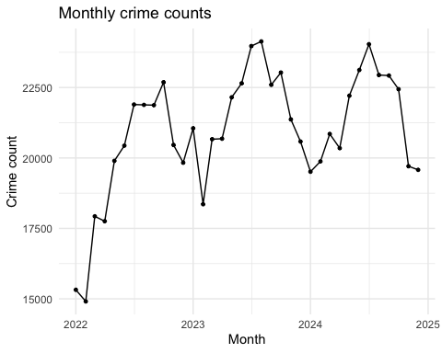
# Hour by weekday heatmap
heat_data <- crime %>%
count(wday, hour) %>%
mutate(
wday = factor(
wday,
levels = c(
"Monday", "Tuesday", "Wednesday",
"Thursday", "Friday", "Saturday", "Sunday"
)
)
)
ggplot(heat_data, aes(x = hour, y = wday, fill = n)) +
geom_tile(color = "white") +
scale_fill_viridis_c(option = "viridis") +
scale_x_continuous(breaks = seq(0, 23, by = 3)) +
labs(
title = "Crime intensity by hour and weekday",
x = "Hour of day",
y = "Day of week",
fill = "Count"
) +
theme_minimal()
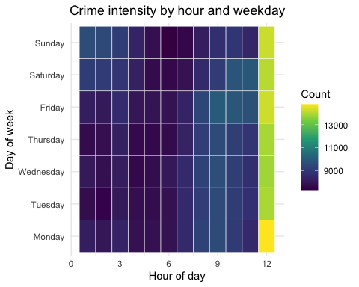
# Spatial join crime points to grid (crime area only)
# Remove coordinate outliers first
crime_clean <- crime %>%
filter(
!is.na(Latitude),
!is.na(Longitude),
!is.na(Date),
Longitude > -88,
Longitude < -87.5,
Latitude > 41.6,
Latitude < 42.05
)
# Rebuild sf object from cleaned data
crime_sf <- st_as_sf(
crime_clean,
coords = c("Longitude", "Latitude"),
crs = 4326,
remove = FALSE
)
crime_sf_proj <- st_transform(crime_sf, 26916)
# Count crimes per grid cell
grid_2km <- st_make_grid(
crime_sf_proj,
cellsize = 2000,
square = TRUE
) %>%
st_as_sf() %>%
mutate(grid_id = row_number())
# Join counts back to grid
crime_grid_join <- st_join(crime_sf_proj, grid_2km, join = st_within)
grid_counts <- crime_grid_join %>%
st_drop_geometry() %>%
count(grid_id, name = "crime_count")
grid_sf <- grid_2km %>%
left_join(grid_counts, by = "grid_id") %>%
mutate(crime_count = replace_na(crime_count, 0))
# Choropleth map of counts
tm_shape(grid_sf %>% filter(crime_count > 0)) +
tm_polygons(
col = "crime_count",
style = "quantile",
palette = "Reds",
title = "Crime count"
) +
tm_borders(col = "white", lwd = 0.2) +
tm_layout(frame = FALSE)
##
## ── tmap v3 code detected ───────────────────────────────────────────────────────
## [v3->v4] `tm_polygons()`: instead of `style = "quantile"`, use fill.scale =
## `tm_scale_intervals()`.
## ℹ Migrate the argument(s) 'style', 'palette' (rename to 'values') to
## 'tm_scale_intervals(<HERE>)'
## [v3->v4] `tm_polygons()`: use 'fill' for the fill color of polygons/symbols
## (instead of 'col'), and 'col' for the outlines (instead of 'border.col').
## [v3->v4] `tm_polygons()`: migrate the argument(s) related to the legend of the
## visual variable `fill` namely 'title' to 'fill.legend = tm_legend(<HERE>)'
## [cols4all] color palettes: use palettes from the R package cols4all. Run
## `cols4all::c4a_gui()` to explore them. The old palette name "Reds" is named
## "brewer.reds"
## Multiple palettes called "reds" found: "brewer.reds", "matplotlib.reds". The first one, "brewer.reds", is returned.
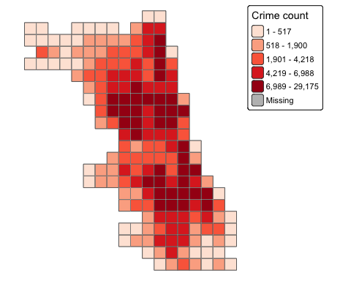
# grid-based hotspot map
grid_1km <- st_make_grid(crime_sf_proj, cellsize = 1000, square = TRUE) %>%
st_as_sf() %>%
mutate(cell_id = row_number())
crime_grid_join_fine <- st_join(crime_sf_proj, grid_1km, join = st_within)
fine_counts <- crime_grid_join_fine %>%
st_drop_geometry() %>%
count(cell_id, name = "crime_count")
fine_grid_sf <- grid_1km %>%
left_join(fine_counts, by = "cell_id") %>%
mutate(crime_count = ifelse(is.na(crime_count), 0, crime_count))
tm_shape(fine_grid_sf) +
tm_polygons(
col = "crime_count",
style = "fixed",
breaks = c(0, 100, 500, 1000, 3000, 12000),
palette = "Reds",
title = "Crime count"
) +
tm_layout(frame = FALSE)
##
## ── tmap v3 code detected ───────────────────────────────────────────────────────
## [v3->v4] `tm_polygons()`: instead of `style = "fixed"`, use fill.scale =
## `tm_scale_intervals()`.
## ℹ Migrate the argument(s) 'style', 'breaks', 'palette' (rename to 'values') to
## 'tm_scale_intervals(<HERE>)'
## [v3->v4] `tm_polygons()`: migrate the argument(s) related to the legend of the
## visual variable `fill` namely 'title' to 'fill.legend = tm_legend(<HERE>)'
## [cols4all] color palettes: use palettes from the R package cols4all. Run
## `cols4all::c4a_gui()` to explore them. The old palette name "Reds" is named
## "brewer.reds"
## Multiple palettes called "reds" found: "brewer.reds", "matplotlib.reds". The first one, "brewer.reds", is returned.
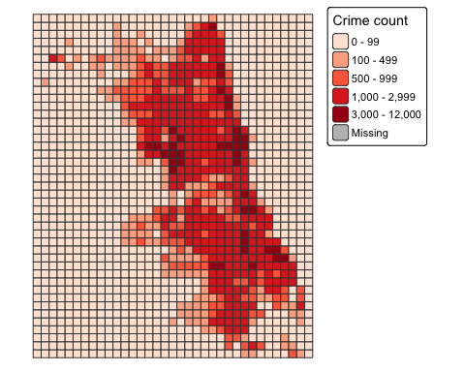
# Spatial Autocorrelation
# Neighbours and weights
nb <- poly2nb(grid_sf)
lw <- nb2listw(nb, style = "W", zero.policy = TRUE)
# Neighbourhood structure
summary(card(nb))
## Min. 1st Qu. Median Mean 3rd Qu. Max.
## 3.000 8.000 8.000 7.404 8.000 8.000
table(card(nb))
##
## 3 5 8
## 4 72 320
# Global Moran's I
moran_result <- moran.test(grid_sf$crime_count, lw, zero.policy = TRUE)
moran_result
##
## Moran I test under randomisation
##
## data: grid_sf$crime_count
## weights: lw
##
## Moran I statistic standard deviate = 25.265, p-value < 2.2e-16
## alternative hypothesis: greater
## sample estimates:
## Moran I statistic Expectation Variance
## 0.6503021145 -0.0025316456 0.0006676996
# Local Moran's I
local_moran <- localmoran(grid_sf$crime_count, lw, zero.policy = TRUE)
grid_sf$Ii <- local_moran[, 1]
grid_sf$Z_Ii <- local_moran[, 4]
grid_sf$P_Ii <- local_moran[, 5]
# LISA cluster map
lag_crime <- lag.listw(lw, grid_sf$crime_count, zero.policy = TRUE)
crime_mean <- mean(grid_sf$crime_count, na.rm = TRUE)
lag_mean <- mean(lag_crime, na.rm = TRUE)
grid_sf <- grid_sf %>%
mutate(
crime_std = crime_count - crime_mean,
lag_std = lag_crime - lag_mean,
lisa_cluster = case_when(
crime_std > 0 & lag_std > 0 & P_Ii <= 0.05 ~ "High-High",
crime_std < 0 & lag_std < 0 & P_Ii <= 0.05 ~ "Low-Low",
crime_std > 0 & lag_std < 0 & P_Ii <= 0.05 ~ "High-Low",
crime_std < 0 & lag_std > 0 & P_Ii <= 0.05 ~ "Low-High",
TRUE ~ "Not significant"
)
)
tm_shape(grid_sf) +
tm_polygons(
col = "lisa_cluster",
palette = c(
"High-High" = "red",
"Low-Low" = "blue",
"High-Low" = "orange",
"Low-High" = "lightblue",
"Not significant" = "grey85"
),
title = "LISA cluster"
) +
tm_borders(col = "white", lwd = 0.2) +
tm_layout(frame = FALSE)
##
## ── tmap v3 code detected ───────────────────────────────────────────────────────
## [v3->v4] `tm_tm_polygons()`: migrate the argument(s) related to the scale of
## the visual variable `fill` namely 'palette' (rename to 'values') to fill.scale
## = tm_scale(<HERE>).
## [v3->v4] `tm_polygons()`: migrate the argument(s) related to the legend of the
## visual variable `fill` namely 'title' to 'fill.legend = tm_legend(<HERE>)'
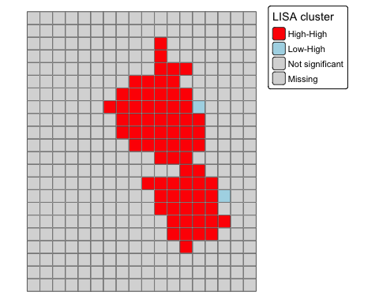
# Spatial-temporal map 2022, 2023, 2024
years <- c(2022, 2023, 2024)
for (y in years) {
crime_year <- crime_sf_proj %>%
filter(year == y)
crime_grid_year <- st_join(crime_year, grid_2km, join = st_within)
grid_counts_year <- crime_grid_year %>%
st_drop_geometry() %>%
count(grid_id, name = "crime_count")
grid_year <- grid_2km %>%
left_join(grid_counts_year, by = "grid_id") %>%
mutate(crime_count = replace_na(crime_count, 0))
print(
tm_shape(grid_year) +
tm_polygons(
col = "crime_count",
style = "fixed",
breaks = c(0, 100, 500, 1000, 3000, max(grid_year$crime_count)),
palette = "Reds"
) +
tm_layout(
title = paste("Crime hotspots in Chicago,", y),
frame = FALSE
)
)
}
##
## ── tmap v3 code detected ───────────────────────────────────────────────────────
## [v3->v4] `tm_polygons()`: instead of `style = "fixed"`, use fill.scale =
## `tm_scale_intervals()`.
## ℹ Migrate the argument(s) 'style', 'breaks', 'palette' (rename to 'values') to
## 'tm_scale_intervals(<HERE>)'
## [v3->v4] `tm_layout()`: use `tm_title()` instead of `tm_layout(title = )`
## [cols4all] color palettes: use palettes from the R package cols4all. Run
## `cols4all::c4a_gui()` to explore them. The old palette name "Reds" is named
## "brewer.reds"
## Multiple palettes called "reds" found: "brewer.reds", "matplotlib.reds". The first one, "brewer.reds", is returned.
##
## [plot mode] fit legend/component: Some legend items or map compoments do not
## fit well, and are therefore rescaled.
## ℹ Set the tmap option `component.autoscale = FALSE` to disable rescaling.
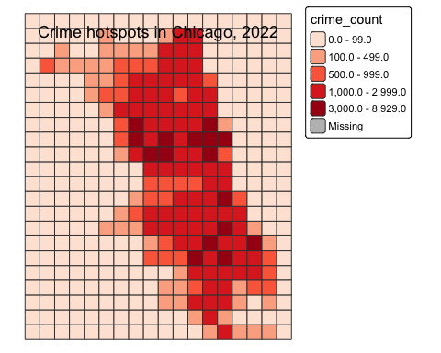
##
## ── tmap v3 code detected ───────────────────────────────────────────────────────
## [v3->v4] `tm_polygons()`: instead of `style = "fixed"`, use fill.scale =
## `tm_scale_intervals()`.
## ℹ Migrate the argument(s) 'style', 'breaks', 'palette' (rename to 'values') to
## 'tm_scale_intervals(<HERE>)'[v3->v4] `tm_layout()`: use `tm_title()` instead of `tm_layout(title = )`[cols4all] color palettes: use palettes from the R package cols4all. Run
## `cols4all::c4a_gui()` to explore them. The old palette name "Reds" is named
## "brewer.reds"Multiple palettes called "reds" found: "brewer.reds", "matplotlib.reds". The first one, "brewer.reds", is returned.
## [plot mode] fit legend/component: Some legend items or map compoments do not
## fit well, and are therefore rescaled.
## ℹ Set the tmap option `component.autoscale = FALSE` to disable rescaling.
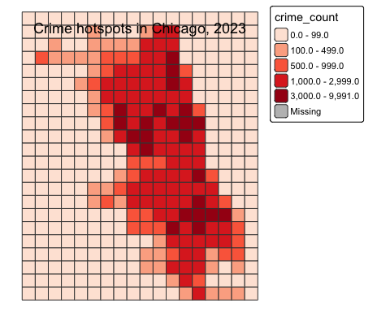
##
## ── tmap v3 code detected ───────────────────────────────────────────────────────
## [v3->v4] `tm_polygons()`: instead of `style = "fixed"`, use fill.scale =
## `tm_scale_intervals()`.
## ℹ Migrate the argument(s) 'style', 'breaks', 'palette' (rename to 'values') to
## 'tm_scale_intervals(<HERE>)'[v3->v4] `tm_layout()`: use `tm_title()` instead of `tm_layout(title = )`[cols4all] color palettes: use palettes from the R package cols4all. Run
## `cols4all::c4a_gui()` to explore them. The old palette name "Reds" is named
## "brewer.reds"Multiple palettes called "reds" found: "brewer.reds", "matplotlib.reds". The first one, "brewer.reds", is returned.
## [plot mode] fit legend/component: Some legend items or map compoments do not
## fit well, and are therefore rescaled.
## ℹ Set the tmap option `component.autoscale = FALSE` to disable rescaling.
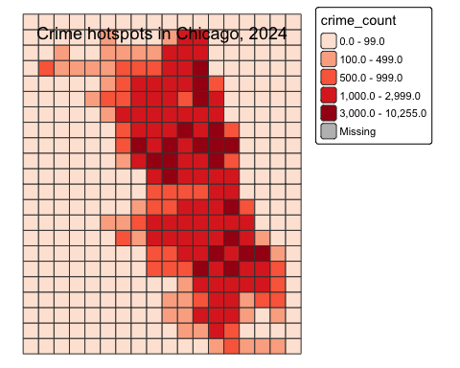
# Temporal autocorrelation
monthly_counts <- crime %>%
count(year_month, name = "crime_count") %>%
complete(
year_month = seq(min(year_month), max(year_month), by = "month"),
fill = list(crime_count = 0)
) %>%
arrange(year_month)
crime_ts <- ts(monthly_counts$crime_count, frequency = 12)
# Plot series
autoplot(crime_ts) +
labs(
title = "Monthly crime counts in Chicago",
x = "Time",
y = "Crime count"
) +
theme_minimal()
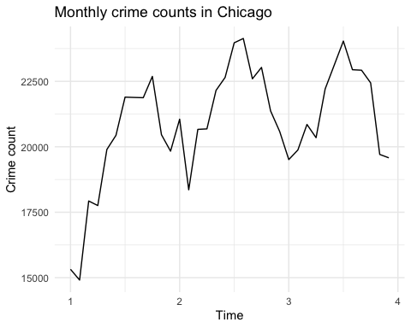
# Seasonal Decomposition
crime_decomp <- stl(crime_ts, s.window = "periodic")
autoplot(crime_decomp) +
labs(title = "STL decomposition of monthly crime counts") +
theme_minimal()
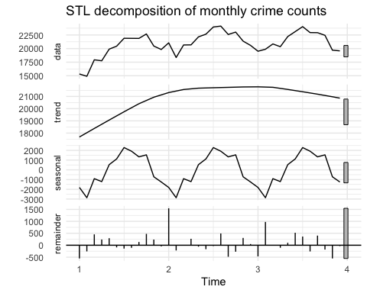
# STL decomposition was used to examine whether the monthly crime series contained trend and seasonal components. Given the short time span of three years, the decomposition was interpreted cautiously.
# ACF and PACF
acf(crime_ts, main = "ACF of monthly crime counts")
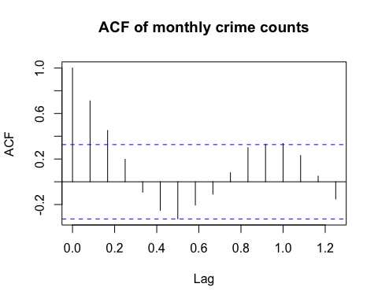
pacf(crime_ts, main = "PACF of monthly crime counts")
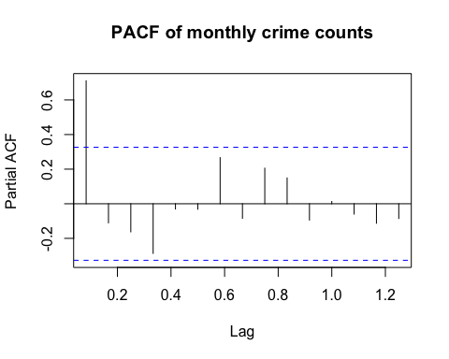
adf_result <- adf.test(crime_ts)
adf_result
##
## Augmented Dickey-Fuller Test
##
## data: crime_ts
## Dickey-Fuller = -4.2058, Lag order = 3, p-value = 0.0131
## alternative hypothesis: stationary
if (adf_result$p.value >= 0.05) {
crime_ts_diff <- diff(crime_ts)
autoplot(crime_ts_diff) +
labs(
title = "Differenced monthly crime counts",
x = "Time",
y = "Differenced crime count"
) +
theme_minimal()
acf(crime_ts_diff, main = "ACF of differenced series")
pacf(crime_ts_diff, main = "PACF of differenced series")
adf_diff_result <- adf.test(crime_ts_diff)
adf_diff_result
}
# Weekly crime series
weekly_counts <- crime %>%
mutate(year_week = floor_date(Date, unit = "week", week_start = 1)) %>%
count(year_week, name = "crime_count") %>%
complete(
year_week = seq(min(year_week), max(year_week), by = "week"),
fill = list(crime_count = 0)
) %>%
arrange(year_week)
weekly_counts <- weekly_counts %>%
filter(year_week < max(year_week))
ggplot(weekly_counts, aes(x = year_week, y = crime_count)) +
geom_line() +
labs(
title = "Weekly crime counts in Chicago",
x = "Week",
y = "Crime count"
) +
theme_minimal()
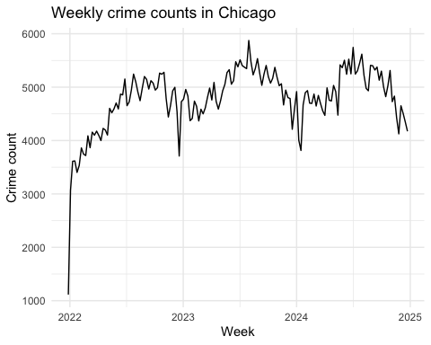
crime_ts_weekly <- ts(weekly_counts$crime_count, frequency = 52)
# Shared train/test split for all weekly time-series models
n_ts_weekly <- length(crime_ts_weekly)
train_size_weekly <- floor(0.8 * n_ts_weekly)
train_ts_weekly <- ts(
weekly_counts$crime_count[1:train_size_weekly],
frequency = 52
)
test_ts_weekly <- ts(
weekly_counts$crime_count[(train_size_weekly + 1):n_ts_weekly],
frequency = 52
)
test_dates_weekly <- weekly_counts$year_week[(train_size_weekly + 1):n_ts_weekly]
# STL decomposition
crime_decomp_weekly <- stl(crime_ts_weekly, s.window = "periodic")
autoplot(crime_decomp_weekly) +
labs(title = "STL decomposition of weekly crime counts") +
theme_minimal()
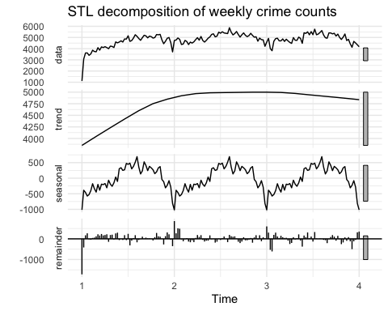
# ACF and PACF
acf(crime_ts_weekly, main = "ACF of weekly crime counts")
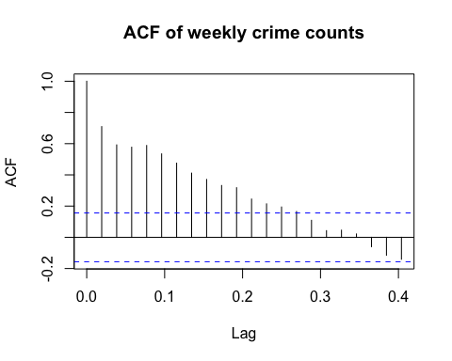
pacf(crime_ts_weekly, main = "PACF of weekly crime counts")
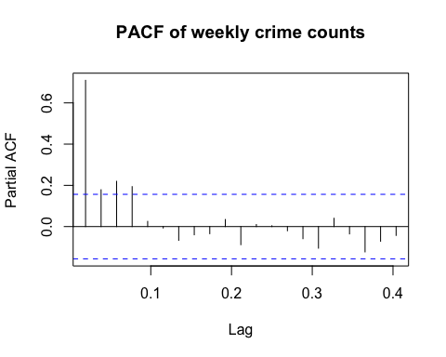
# ADF test
adf_result_weekly <- adf.test(crime_ts_weekly)
adf_result_weekly
##
## Augmented Dickey-Fuller Test
##
## data: crime_ts_weekly
## Dickey-Fuller = -2.1095, Lag order = 5, p-value = 0.5307
## alternative hypothesis: stationary
if (adf_result_weekly$p.value >= 0.05) {
crime_ts_weekly_diff <- diff(crime_ts_weekly)
autoplot(crime_ts_weekly_diff) +
labs(
title = "Differenced weekly crime counts",
x = "Time",
y = "Differenced crime count"
) +
theme_minimal()
acf(crime_ts_weekly_diff, main = "ACF of differenced weekly series")
pacf(crime_ts_weekly_diff, main = "PACF of differenced weekly series")
adf_diff_result_weekly <- adf.test(crime_ts_weekly_diff)
adf_diff_result_weekly
}
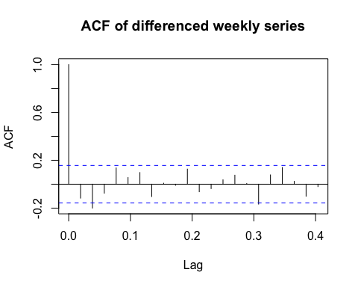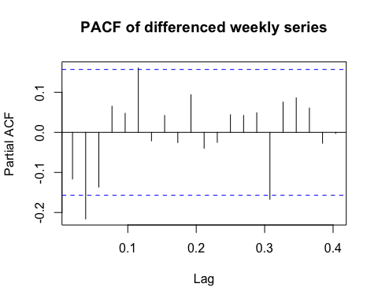
## Warning in adf.test(crime_ts_weekly_diff): p-value smaller than printed p-value
##
## Augmented Dickey-Fuller Test
##
## data: crime_ts_weekly_diff
## Dickey-Fuller = -6.2001, Lag order = 5, p-value = 0.01
## alternative hypothesis: stationary
# Naive baseline model
naive_fc_weekly <- naive(train_ts_weekly, h = length(test_ts_weekly))
naive_rmse <- rmse(as.numeric(test_ts_weekly), as.numeric(naive_fc_weekly$mean))
naive_mae <- mae(as.numeric(test_ts_weekly), as.numeric(naive_fc_weekly$mean))
naive_plot_data <- tibble(
year_week = test_dates_weekly,
actual = as.numeric(test_ts_weekly),
predicted = as.numeric(naive_fc_weekly$mean)
)
ggplot(naive_plot_data, aes(x = year_week)) +
geom_line(aes(y = actual, linetype = "Actual")) +
geom_line(aes(y = predicted, linetype = "Predicted")) +
labs(
title = "Naive baseline versus actual weekly crime counts",
x = "Week",
y = "Crime count",
linetype = ""
) +
theme_minimal()
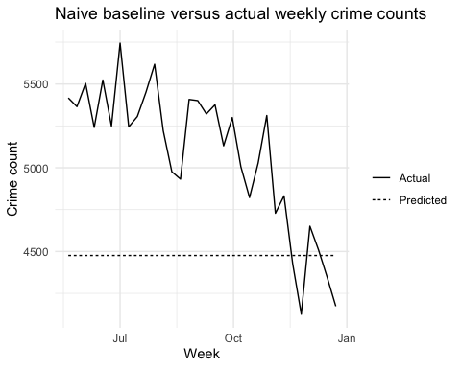
# Non-seasonal ARIMA
arima_model_ns <- auto.arima(train_ts_weekly, seasonal = FALSE)
summary(arima_model_ns)
## Series: train_ts_weekly
## ARIMA(3,1,2)
##
## Coefficients:
## ar1 ar2 ar3 ma1 ma2
## 0.8005 -0.7665 0.1247 -1.0451 0.5972
## s.e. 0.2333 0.1674 0.1861 0.2063 0.2375
##
## sigma^2 = 97439: log likelihood = -885.99
## AIC=1783.98 AICc=1784.7 BIC=1800.9
##
## Training set error measures:
## ME RMSE MAE MPE MAPE MASE ACF1
## Training set 40.40901 304.5691 211.6822 0.9714623 4.793276 0.4263666 0.08046626
checkresiduals(arima_model_ns)
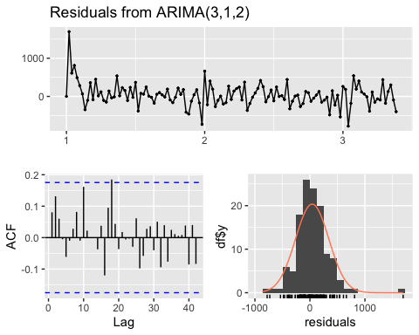
##
## Ljung-Box test
##
## data: Residuals from ARIMA(3,1,2)
## Q* = 18.915, df = 20, p-value = 0.5273
##
## Model df: 5. Total lags used: 25
arima_fc_ns <- forecast(arima_model_ns, h = length(test_ts_weekly))
arima_ns_rmse <- rmse(as.numeric(test_ts_weekly), as.numeric(arima_fc_ns$mean))
arima_ns_mae <- mae(as.numeric(test_ts_weekly), as.numeric(arima_fc_ns$mean))
arima_ns_plot_data <- tibble(
year_week = test_dates_weekly,
actual = as.numeric(test_ts_weekly),
predicted = as.numeric(arima_fc_ns$mean)
)
ggplot(arima_ns_plot_data, aes(x = year_week)) +
geom_line(aes(y = actual, linetype = "Actual")) +
geom_line(aes(y = predicted, linetype = "Predicted")) +
labs(
title = "Non-seasonal ARIMA versus actual weekly crime counts",
x = "Week",
y = "Crime count",
linetype = ""
) +
theme_minimal()
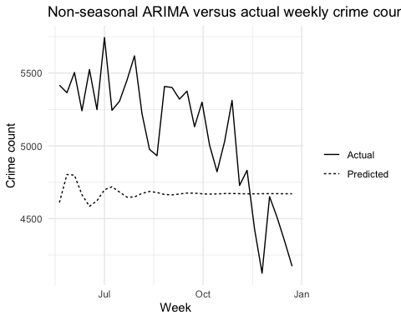
# Seasonal SARIMA
sarima_model <- auto.arima(train_ts_weekly, seasonal = TRUE)
summary(sarima_model)
## Series: train_ts_weekly
## ARIMA(1,1,1)(0,1,0)[52]
##
## Coefficients:
## ar1 ma1
## 0.4764 -0.7057
## s.e. 0.2932 0.2479
##
## sigma^2 = 163791: log likelihood = -533.44
## AIC=1072.88 AICc=1073.24 BIC=1079.71
##
## Training set error measures:
## ME RMSE MAE MPE MAPE MASE
## Training set -51.83038 302.8576 164.1304 -1.170445 3.422251 0.3305885
## ACF1
## Training set 0.09431031
checkresiduals(sarima_model)
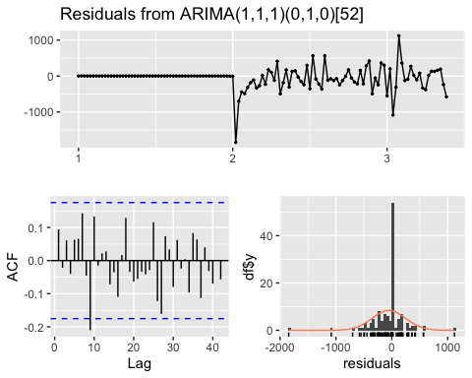
##
## Ljung-Box test
##
## data: Residuals from ARIMA(1,1,1)(0,1,0)[52]
## Q* = 23.889, df = 23, p-value = 0.41
##
## Model df: 2. Total lags used: 25
sarima_fc <- forecast(sarima_model, h = length(test_ts_weekly))
sarima_rmse <- rmse(as.numeric(test_ts_weekly), as.numeric(sarima_fc$mean))
sarima_mae <- mae(as.numeric(test_ts_weekly), as.numeric(sarima_fc$mean))
sarima_plot_data <- tibble(
year_week = test_dates_weekly,
actual = as.numeric(test_ts_weekly),
predicted = as.numeric(sarima_fc$mean)
)
ggplot(sarima_plot_data, aes(x = year_week)) +
geom_line(aes(y = actual, linetype = "Actual")) +
geom_line(aes(y = predicted, linetype = "Predicted")) +
labs(
title = "Seasonal SARIMA versus actual weekly crime counts",
x = "Week",
y = "Crime count",
linetype = ""
) +
theme_minimal()
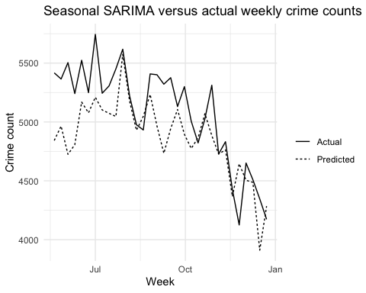
# Random Forest model weekly
rf_data <- weekly_counts %>%
mutate(
week_num = isoweek(year_week),
year_num = year(year_week),
month_num = month(year_week),
lag1 = lag(crime_count, 1),
lag2 = lag(crime_count, 2),
lag3 = lag(crime_count, 3),
lag4 = lag(crime_count, 4),
lag12 = lag(crime_count, 12),
lag52 = lag(crime_count, 52),
roll_mean_4 = lag(rollmean(crime_count, k = 4, fill = NA, align = "right"), 1),
roll_mean_12 = lag(rollmean(crime_count, k = 12, fill = NA, align = "right"), 1),
sin_week = sin(2 * pi * week_num / 52),
cos_week = cos(2 * pi * week_num / 52)
) %>%
filter(
!is.na(lag52),
!is.na(roll_mean_4),
!is.na(roll_mean_12)
)
ggplot(rf_data, aes(x = year_week, y = crime_count)) +
geom_line() +
labs(
title = "Weekly crime counts used for Random Forest",
x = "Week",
y = "Crime count"
) +
theme_minimal()
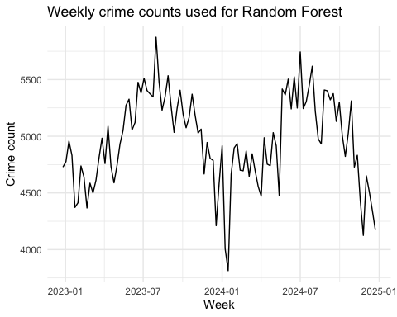
# Train/test split for RF
train_size_rf <- floor(0.8 * nrow(rf_data))
rf_train <- rf_data[1:train_size_rf, ]
rf_test <- rf_data[(train_size_rf + 1):nrow(rf_data), ]
XTrain <- rf_train %>%
select(
week_num, year_num, month_num,
lag1, lag2, lag3, lag4, lag12, lag52,
roll_mean_4, roll_mean_12,
sin_week, cos_week
)
yTrain <- rf_train$crime_count
XTest <- rf_test %>%
select(
week_num, year_num, month_num,
lag1, lag2, lag3, lag4, lag12, lag52,
roll_mean_4, roll_mean_12,
sin_week, cos_week
)
yTest <- rf_test$crime_count
set.seed(101)
rf_model <- randomForest(
x = XTrain,
y = yTrain,
ntree = 500,
mtry = 4,
importance = TRUE
)
print(rf_model)
##
## Call:
## randomForest(x = XTrain, y = yTrain, ntree = 500, mtry = 4, importance = TRUE)
## Type of random forest: regression
## Number of trees: 500
## No. of variables tried at each split: 4
##
## Mean of squared residuals: 62245.5
## % Var explained: 59.12
rf_pred <- predict(rf_model, XTest)
rf_rmse <- rmse(yTest, rf_pred)
rf_mae <- mae(yTest, rf_pred)
rf_plot_data <- rf_test %>%
select(year_week, crime_count) %>%
mutate(predicted = rf_pred)
ggplot(rf_plot_data, aes(x = year_week)) +
geom_line(aes(y = crime_count, linetype = "Actual")) +
geom_line(aes(y = predicted, linetype = "Predicted")) +
labs(
title = "Random Forest versus actual weekly crime counts",
x = "Week",
y = "Crime count",
linetype = ""
) +
theme_minimal()
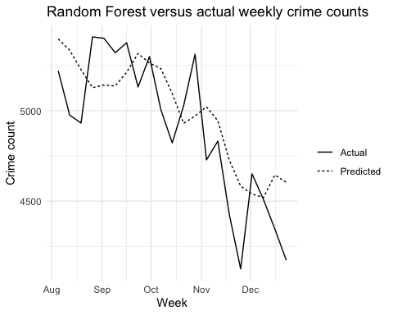
varImpPlot(rf_model)
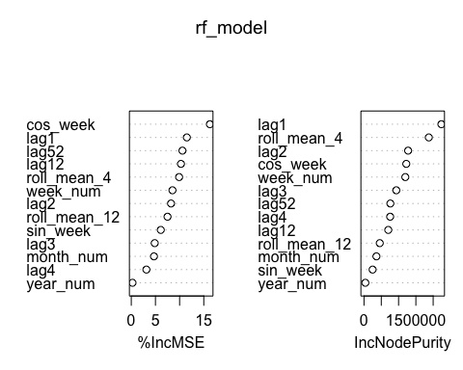
# Model comparison
model_compare <- tibble(
Model = c("Naive", "ARIMA_nonseasonal", "SARIMA", "Random_Forest"),
RMSE = c(naive_rmse, arima_ns_rmse, sarima_rmse, rf_rmse),
MAE = c(naive_mae, arima_ns_mae, sarima_mae, rf_mae)
)
model_compare
## # A tibble: 4 × 3
## Model RMSE MAE
## <chr> <dbl> <dbl>
## 1 Naive 737. 660.
## 2 ARIMA_nonseasonal 584. 521.
## 3 SARIMA 337. 264.
## 4 Random_Forest 261. 233.
model_compare_long <- model_compare %>%
pivot_longer(cols = c(RMSE, MAE), names_to = "Metric", values_to = "Value")
ggplot(model_compare_long, aes(x = Model, y = Value, fill = Metric)) +
geom_col(position = "dodge") +
labs(
title = "Model comparison of weekly crime forecasting methods",
x = "Model",
y = "Error"
) +
theme_minimal()
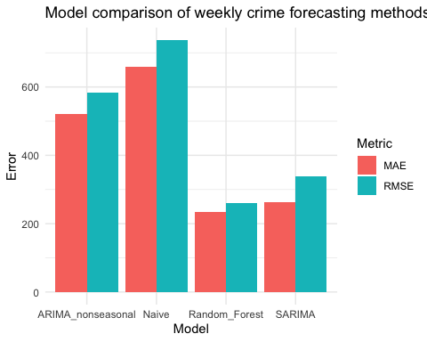
# Combined prediction plot for time-series models
combined_plot_data <- tibble(
year_week = test_dates_weekly,
actual = as.numeric(test_ts_weekly),
Naive = as.numeric(naive_fc_weekly$mean),
ARIMA_nonseasonal = as.numeric(arima_fc_ns$mean),
SARIMA = as.numeric(sarima_fc$mean)
) %>%
pivot_longer(
cols = c(Naive, ARIMA_nonseasonal, SARIMA),
names_to = "Model",
values_to = "predicted"
)
ggplot() +
geom_line(
data = combined_plot_data %>% distinct(year_week, actual),
aes(x = year_week, y = actual, linetype = "Actual")
) +
geom_line(
data = combined_plot_data,
aes(x = year_week, y = predicted, colour = Model)
) +
labs(
title = "Actual versus predicted weekly crime counts for time-series models",
x = "Week",
y = "Crime count",
linetype = ""
) +
theme_minimal()
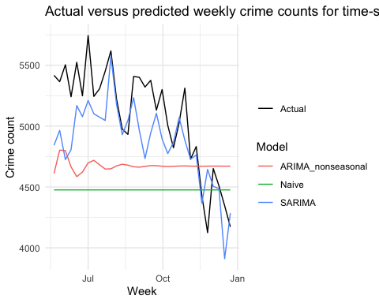
library(sf)
library(dplyr)
# force projection to Chicago UTM
crime_sf_proj <- st_transform(crime_sf, 26916)
# confirm
st_crs(crime_sf_proj)
## Coordinate Reference System:
## User input: EPSG:26916
## wkt:
## PROJCRS["NAD83 / UTM zone 16N",
## BASEGEOGCRS["NAD83",
## DATUM["North American Datum 1983",
## ELLIPSOID["GRS 1980",6378137,298.257222101,
## LENGTHUNIT["metre",1]]],
## PRIMEM["Greenwich",0,
## ANGLEUNIT["degree",0.0174532925199433]],
## ID["EPSG",4269]],
## CONVERSION["UTM zone 16N",
## METHOD["Transverse Mercator",
## ID["EPSG",9807]],
## PARAMETER["Latitude of natural origin",0,
## ANGLEUNIT["degree",0.0174532925199433],
## ID["EPSG",8801]],
## PARAMETER["Longitude of natural origin",-87,
## ANGLEUNIT["degree",0.0174532925199433],
## ID["EPSG",8802]],
## PARAMETER["Scale factor at natural origin",0.9996,
## SCALEUNIT["unity",1],
## ID["EPSG",8805]],
## PARAMETER["False easting",500000,
## LENGTHUNIT["metre",1],
## ID["EPSG",8806]],
## PARAMETER["False northing",0,
## LENGTHUNIT["metre",1],
## ID["EPSG",8807]]],
## CS[Cartesian,2],
## AXIS["(E)",east,
## ORDER[1],
## LENGTHUNIT["metre",1]],
## AXIS["(N)",north,
## ORDER[2],
## LENGTHUNIT["metre",1]],
## USAGE[
## SCOPE["Engineering survey, topographic mapping."],
## AREA["North America - between 90°W and 84°W - onshore and offshore. Canada - Manitoba; Nunavut; Ontario. United States (USA) - Alabama; Arkansas; Florida; Georgia; Indiana; Illinois; Kentucky; Louisiana; Michigan; Minnesota; Mississippi; Missouri; North Carolina; Ohio; Tennessee; Wisconsin."],
## BBOX[23.97,-90,84,-84]],
## ID["EPSG",26916]]
st_bbox(crime_sf_proj)
## xmin ymin xmax ymax
## 422168.6 4610489.3 456357.4 4652500.8
grid_5km <- st_make_grid(
st_as_sfc(st_bbox(crime_sf_proj)),
cellsize = 5000,
square = TRUE
) %>%
st_as_sf() %>%
mutate(grid_id = row_number()) %>%
arrange(grid_id)
crime_sf_proj <- crime_sf_proj %>%
mutate(year_week = floor_date(Date, unit = "week", week_start = 1))
# join once
crime_grid_week <- st_join(crime_sf_proj, grid_5km, join = st_within) %>%
filter(!is.na(grid_id))
# keep only used cells
used_ids <- crime_grid_week %>%
st_drop_geometry() %>%
distinct(grid_id) %>%
pull(grid_id)
grid_5km <- grid_5km %>%
filter(grid_id %in% used_ids) %>%
arrange(grid_id)
# Rejoin after filtering
crime_grid_week <- st_join(crime_sf_proj, grid_5km, join = st_within) %>%
filter(!is.na(grid_id))
# Count crimes by grid and week
grid_week_counts <- crime_grid_week %>%
st_drop_geometry() %>%
count(grid_id, year_week, name = "crime_count")
# Spatial neighbours and weights
nb <- poly2nb(grid_5km)
lw <- nb2listw(nb, style = "W", zero.policy = TRUE)
# Complete grid-week table
grid_week_full <- grid_week_counts %>%
complete(
grid_id = grid_5km$grid_id,
year_week = seq(min(year_week), max(year_week), by = "week"),
fill = list(crime_count = 0)
) %>%
arrange(year_week, grid_id)
# Spatial lag
n_cells <- nrow(grid_5km)
calc_spatial_lag <- function(df_week, lw_obj, n_cells) {
df_week <- df_week %>%
arrange(grid_id)
if (nrow(df_week) != n_cells) {
stop("Row mismatch")
}
df_week$spatial_lag <- lag.listw(
lw_obj,
df_week$crime_count,
zero.policy = TRUE
)
df_week
}
grid_week_lagged <- grid_week_full %>%
group_by(year_week) %>%
group_modify(~ calc_spatial_lag(.x, lw, n_cells)) %>%
ungroup()
# Temporal lags
grid_week_model <- grid_week_lagged %>%
arrange(grid_id, year_week) %>%
group_by(grid_id) %>%
mutate(
lag1 = lag(crime_count, 1),
lag2 = lag(crime_count, 2),
lag4 = lag(crime_count, 4)
) %>%
ungroup()
# Prepare model data
model_data <- grid_week_model %>%
filter(
!is.na(lag1),
!is.na(lag2),
!is.na(lag4),
!is.na(spatial_lag)
) %>%
mutate(
week_num = isoweek(year_week),
year_num = year(year_week)
)
# Train-test split
train_size <- floor(0.8 * nrow(model_data))
train_data <- model_data[1:train_size, ]
test_data <- model_data[(train_size + 1):nrow(model_data), ]
x_train <- train_data %>%
select(lag1, lag2, lag4, spatial_lag, week_num, year_num)
y_train <- train_data$crime_count
x_test <- test_data %>%
select(lag1, lag2, lag4, spatial_lag, week_num, year_num)
y_test <- test_data$crime_count
# Random Forest
set.seed(101)
rf_spacetime <- randomForest(
x = x_train,
y = y_train,
ntree = 300,
importance = TRUE
)
# Predictions
pred <- predict(rf_spacetime, x_test)
# Evaluation
rmse(y_test, pred)
## [1] 16.42055
mae(y_test, pred)
## [1] 8.175028

