Causal Diagnostics Report: Vivacity Active Travel Models
Pre-trend tests, event-study diagnostics, and control credibility decision
Purpose
This report tests whether the current matched-control Vivacity modelling design is credible enough to support stronger causal claims. It should be read as a diagnostic companion to the exploratory treated-control models.
Overall Decision
The current design should remain exploratory. The diagnostics strengthen transparency, but they do not justify describing the model as a final strong causal impact estimate. The most defensible label is: exploratory matched-control interrupted time-series analysis with pre-trend and event-study diagnostics.
Scheme | Pre-trend | Event study | Final credibility decision
12d | 2 warnings | 0 pre warnings; 2 post flags | Not credible for strong causal wording. Use as exploratory only because active travel and pedestrian pre-trends are already divergent.
12f | 0 warnings | 1 pre warnings; 4 post flags | Partly credible but still exploratory. Linear pre-trends pass, but event-study active-travel pre-period warning and small sample prevent definitive causal claims.
13 | 0 warnings | 1 pre warnings; 0 post flags | Partly credible but still exploratory. Linear pre-trends pass, but cyclist pre-event warning and control-verification uncertainty remain.
Pre-Trend Tests
The pre-trend test uses only pre-intervention observations. The key term is the treated-control difference in pre-intervention slope. A statistically flagged term indicates that treated and control countlines were already moving differently before the scheme month.
Scheme | Outcome | Pre-period | p | Slope diff. | Decision
12d | Active travel | 2022-11-14 to 2023-02-27 | 0.037 | -1.69% per week | warning
12d | Pedestrian | 2022-11-14 to 2023-02-27 | 0.028 | -2.92% per week | warning
12d | Cyclist | 2022-11-14 to 2023-02-27 | 0.385 | -1.51% per week | no warning
12f | Active travel | 2022-11-14 to 2023-05-29 | 0.394 | +0.61% per week | no warning
12f | Pedestrian | 2022-11-14 to 2023-05-29 | 0.547 | +0.37% per week | no warning
12f | Cyclist | 2022-11-14 to 2023-05-29 | 0.362 | +1.07% per week | no warning
13 | Active travel | 2022-11-14 to 2024-02-26 | 0.554 | +0.41% per week | no warning
13 | Pedestrian | 2022-11-14 to 2024-02-26 | 0.235 | +3.33% per week | no warning
13 | Cyclist | 2022-11-14 to 2024-02-26 | 0.819 | -0.36% per week | no warning
Event-Study Flags
The event-study diagnostic estimates treated-control differences in relative-week bins, using the four weeks before intervention as the reference period. Pre-period warnings weaken causal credibility; post-period flags identify possible divergence after intervention but must be interpreted only after checking pre-period behaviour.
Scheme | Outcome | Event bin | Period | Effect | Diagnostic
12d | Cyclist | post_4_to_11 | post | +22.36%; p=0.014 | post event flagged
12d | Cyclist | post_12_to_25 | post | +46.98%; p=0.010 | post event flagged
12f | Active travel | pre_12_to_5 | pre | +28.37%; p=<0.001 | pre event warning
12f | Active travel | post_4_to_11 | post | +14.32%; p=0.006 | post event flagged
12f | Active travel | post_12_to_25 | post | +14.38%; p=<0.001 | post event flagged
12f | Active travel | post_26_to_51 | post | +23.07%; p=0.006 | post event flagged
12f | Cyclist | post_26_to_51 | post | +32.20%; p=<0.001 | post event flagged
13 | Cyclist | pre_12_to_5 | pre | -29.86%; p=0.043 | pre event warning
Interpretation for Dissertation
- 12d should not be used for strong causal wording because active travel and pedestrian pre-trends fail the diagnostic screen.
- 12f is the strongest exploratory comparison, but it still has an active-travel pre-event warning and a small countline pool.
- 13 has better pre-period coverage, but cyclist event-study diagnostics show a pre-period warning.
- The methodology chapter should include these diagnostics as robustness checks and should explicitly state that they support cautious exploratory interpretation.
Event-Study Plots
Figure 1. Active travel event-study treated-control differences.
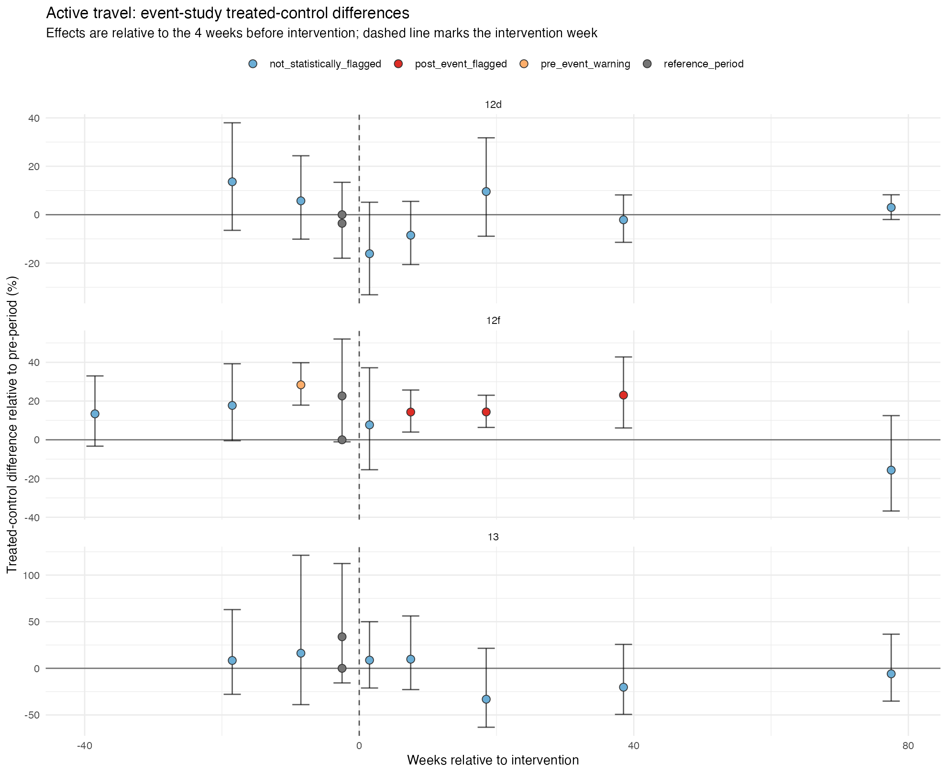
Figure 2. Pedestrian event-study treated-control differences.
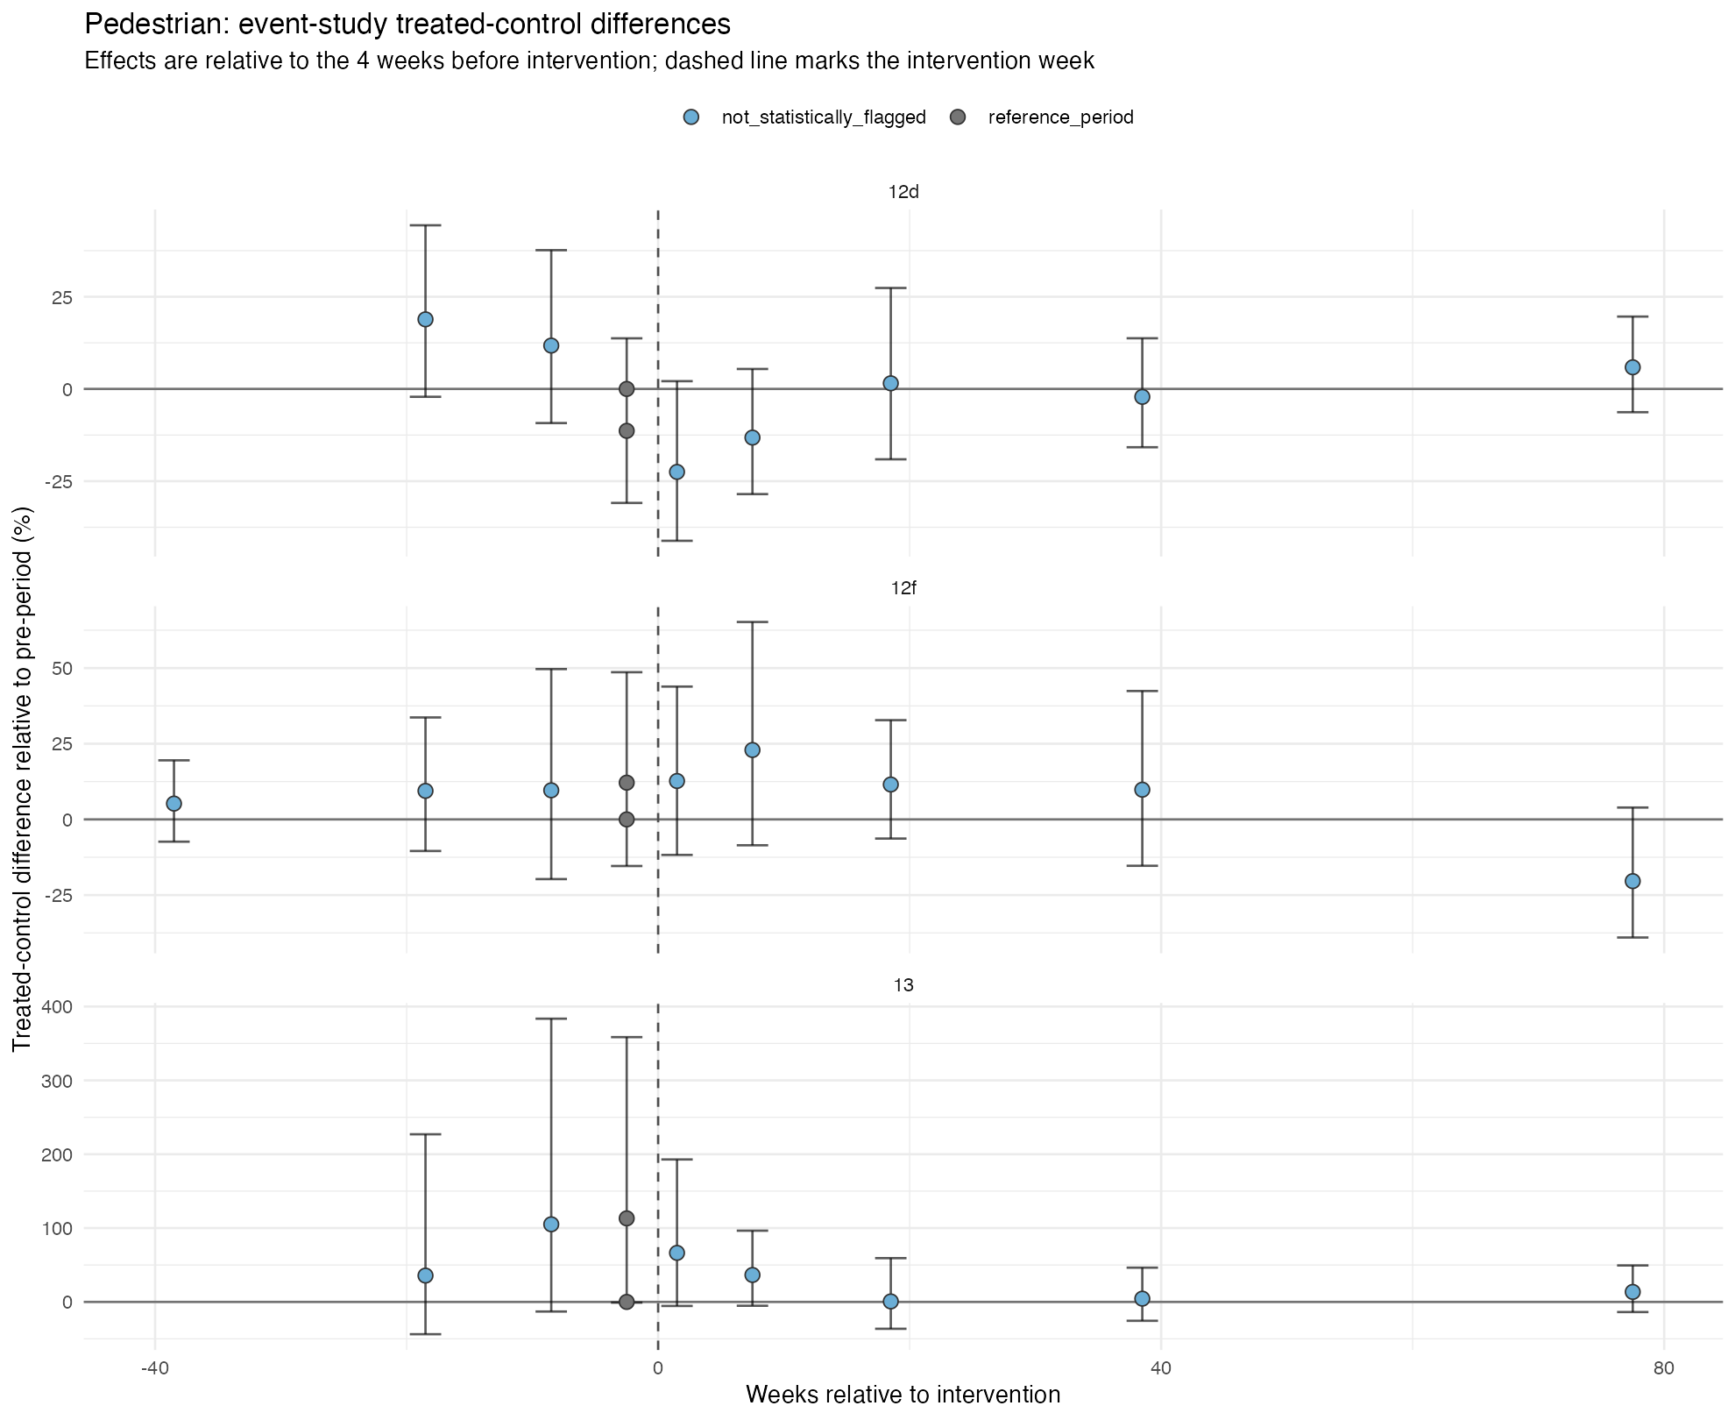
Figure 3. Cyclist event-study treated-control differences.
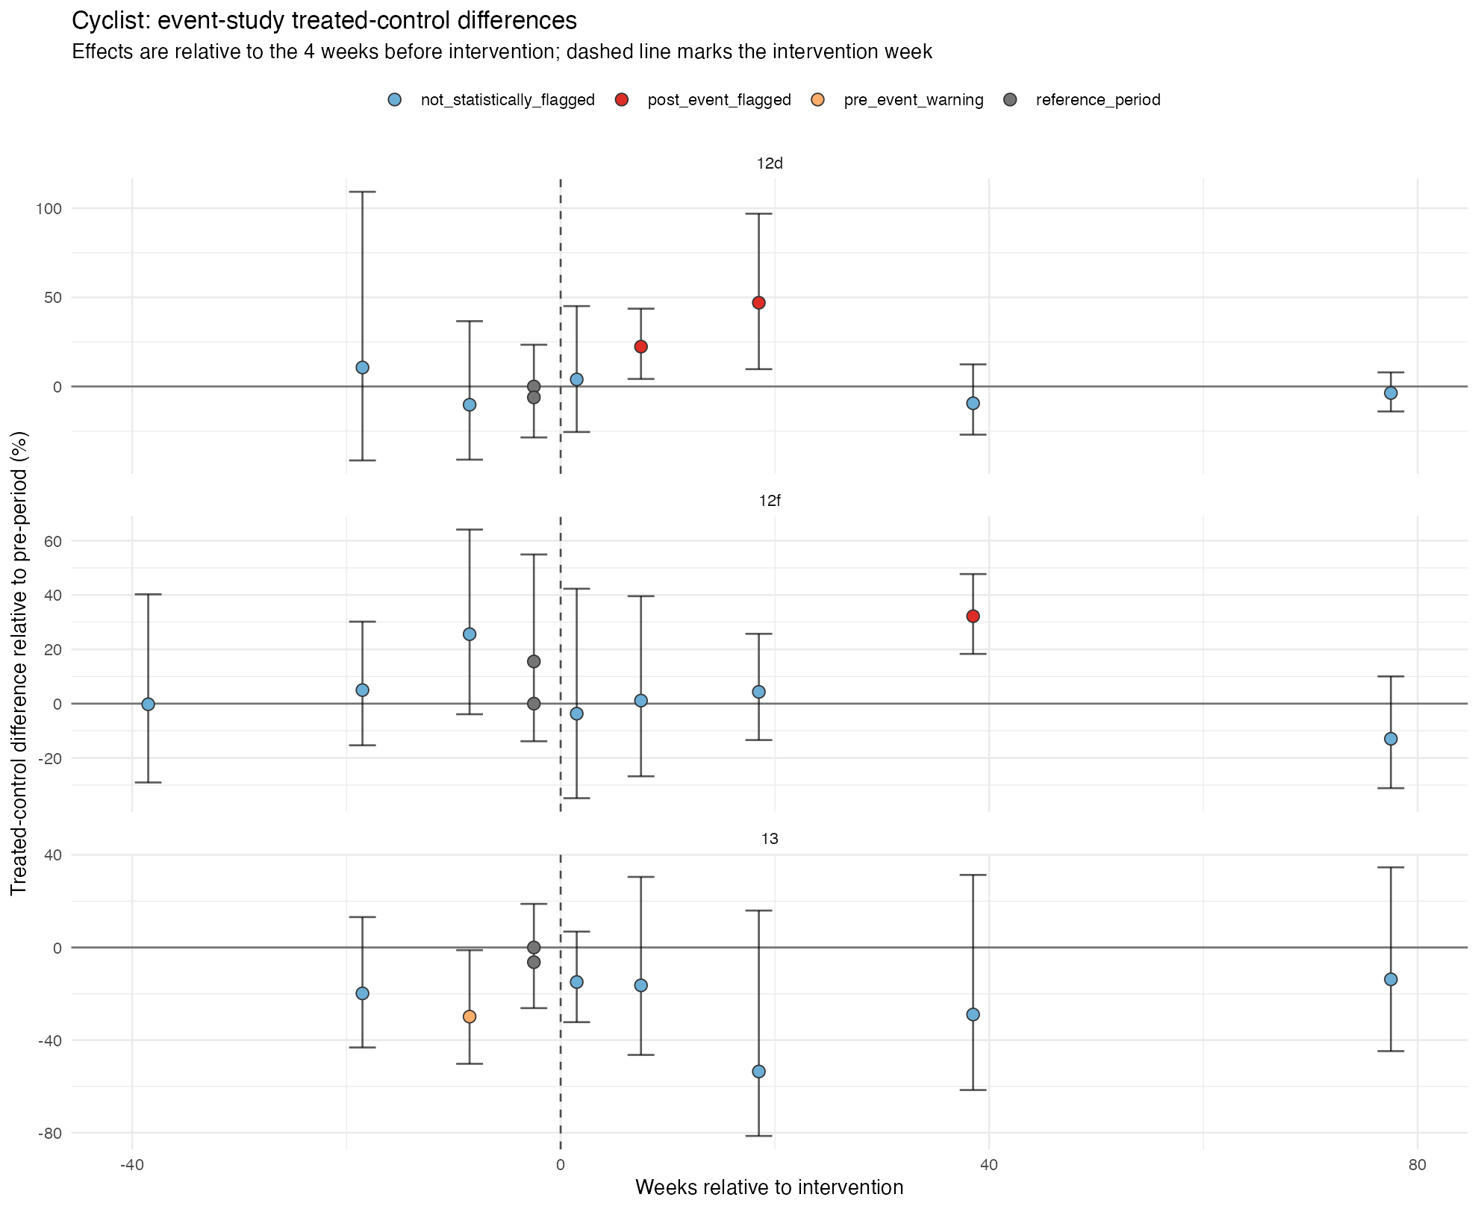
Next Step
The next dissertation step is to draft the Methodology chapter using this final modelling position. The chapter should present the causal diagnostics as a strength of the workflow, while also explaining why the final claims remain exploratory rather than definitive.

