Descriptive Data Analysis Report: Vivacity Schemes
Observed trends, mode/route patterns, pre/post summaries, equity context, and sensitivity-ready checks
Overview
This report analyses 52,144 usable daily rows across 5 schemes and 55 countlines after the full-day cutoff to 26 May 2026. These outputs are descriptive and should be used to explain observed patterns in the data; they do not resolve the causal control-validity issues identified by the diagnostic models.
1. Descriptive Trends for All Schemes
The weekly active-travel trend plot shows observed treated and control trajectories across all five schemes. Schemes 12b and 12e remain post-only treated descriptions. Schemes 12d, 12f, and 13 have pre/post treated records, but their control trajectories vary substantially, reinforcing the need for cautious causal wording.
Figure 1. Weekly active travel trends for all schemes.
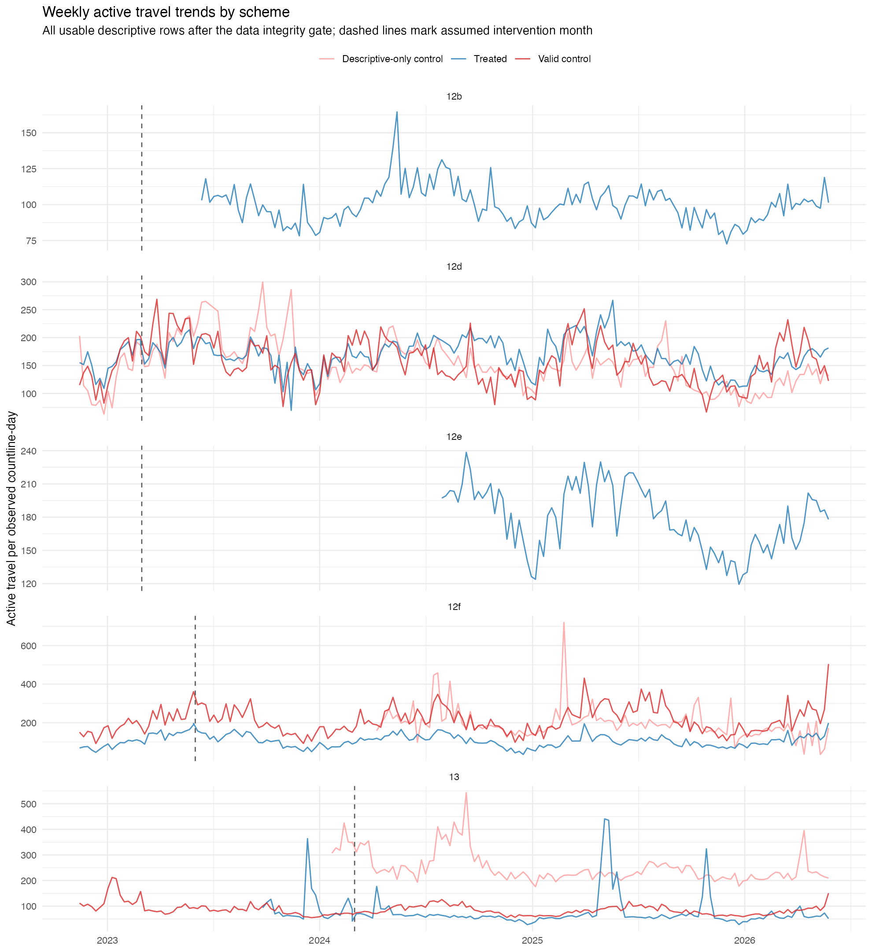
2. Mode-Specific Analysis
Pedestrian and cyclist trends differ by scheme. Combined active travel can hide this variation, especially where pedestrian counts dominate. For dissertation writing, cyclist and pedestrian outcomes should be reported separately before discussing the combined active-travel total.
Figure 2. Monthly pedestrian, cyclist, and active-travel trends.
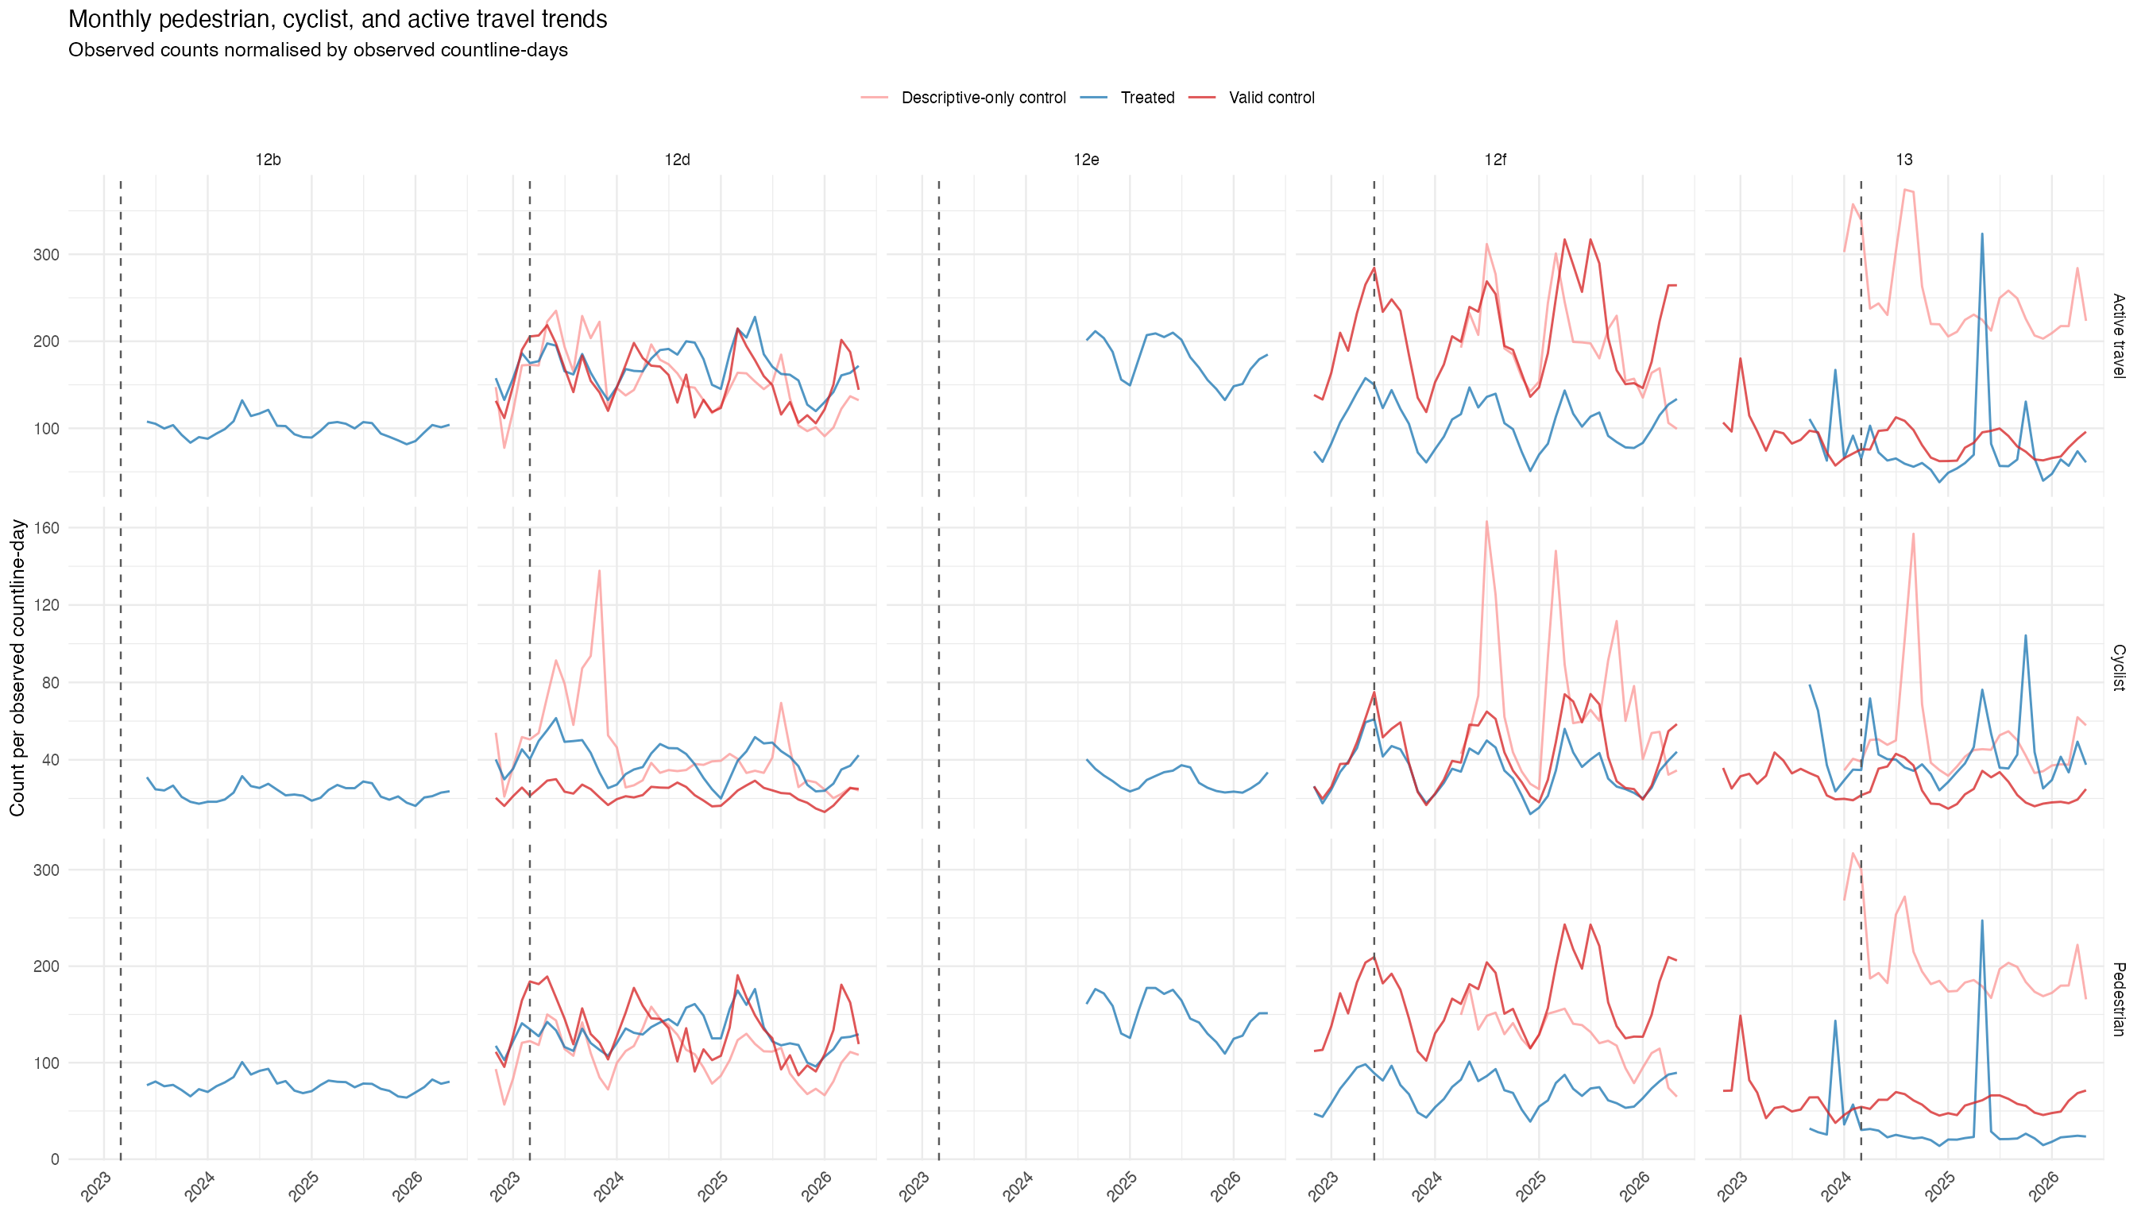
3. Route-Type Analysis
The route-type analysis separates road countlines from path/cycle-facility countlines. This helps identify whether apparent scheme effects could reflect redistribution between roads and paths rather than net growth in walking or cycling. Route-type inference was tightened using countline names where the exported metadata used generic labels.
Figure 3. Weekly active travel by route type.
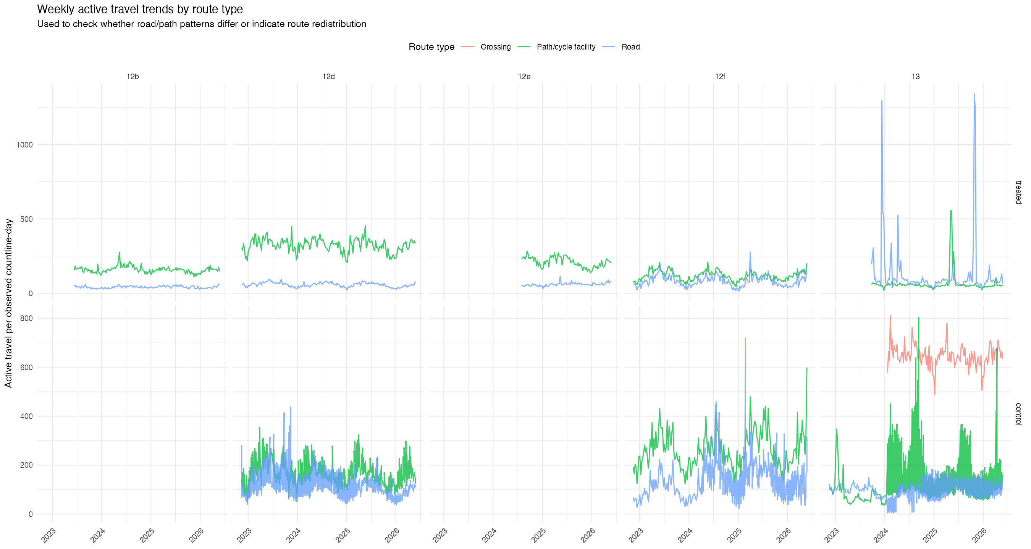
4. Pre/Post Descriptive Change
Scheme | Status | Countlines | Mean pre | Mean post | % change
12b | post_only_no_pre_baseline | 4 | NA | 100.0 | NA
12d | pre_post_available | 5 | 157.9 | 162.9 | 3.2
12e | post_only_no_pre_baseline | 5 | NA | 180.0 | NA
12f | pre_post_available | 3 | 108.8 | 105.4 | -3.1
13 | pre_post_available | 4 | 96.7 | 73.8 | -23.7
The table confirms the core data limitation: 12b and 12e have no treated pre-baseline. Among schemes with pre/post treated data, 12d shows a small average active-travel increase across treated countlines, 12f is broadly flat/slightly negative, and 13 declines on average because some Warrington Road countlines fall sharply after the intervention month.
5. Seasonality
Calendar-month profiles show clear seasonality and short-term volatility, especially for cycling. This supports the decision to avoid simple before/after interpretation and to include seasonality in the modelling strategy.
Figure 4. Calendar-month seasonality profiles.
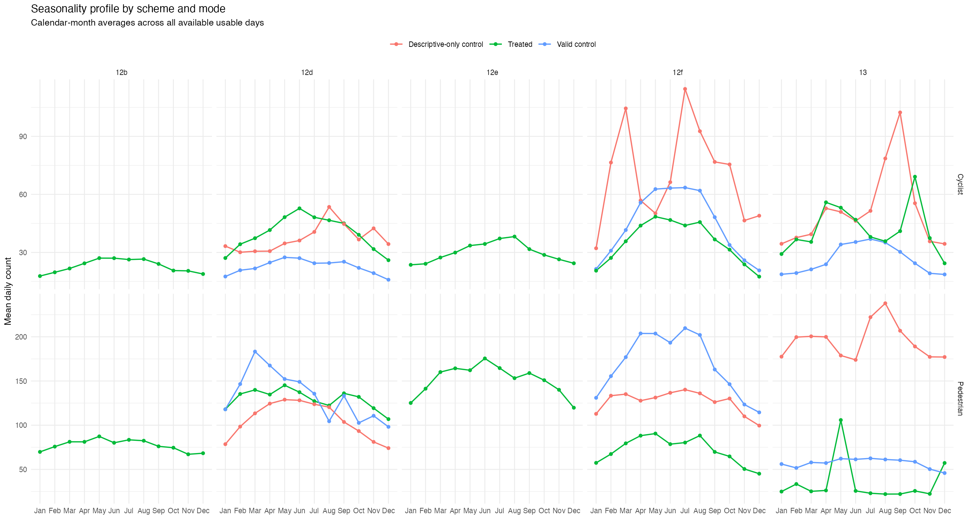
6. Deprivation-Context Descriptive Summary
Scheme | Role | IMD band | Countlines | Mean active | Mean IMD | Walk/cycle %
12b | Treated | Middle deprivation (IMD 4-7) | 4 | 100.0 | 6.0 | 2.8
12f | Treated | Middle deprivation (IMD 4-7) | 3 | 105.9 | 7.0 | 3.0
12f | Descriptive-only control | More affluent (IMD 8-10) | 1 | 196.9 | 8.0 | 3.3
12f | Valid control | More affluent (IMD 8-10) | 3 | 209.8 | 8.0 | 4.6
12d | Treated | More deprived (IMD 1-3) | 5 | 168.7 | 3.0 | 8.0
12d | Descriptive-only control | More deprived (IMD 1-3) | 12 | 143.2 | 2.2 | 11.3
12d | Valid control | More deprived (IMD 1-3) | 3 | 156.8 | 2.0 | 8.6
12e | Treated | More deprived (IMD 1-3) | 5 | 179.5 | 1.0 | 13.2
13 | Descriptive-only control | More deprived (IMD 1-3) | 8 | 243.3 | 1.0 | 18.3
13 | Valid control | More deprived (IMD 1-3) | 7 | 82.8 | 1.0 | 15.3
13 | Treated | More deprived (IMD 1-3) | 4 | 77.7 | 1.0 | 16.1
The descriptive equity table reinforces that deprived contexts are well represented, while affluent cases are limited mainly to 12f controls. This supports an equity-context discussion, not a robust deprivation-stratified causal estimate.
Figure 5. Mean daily counts by deprivation context.
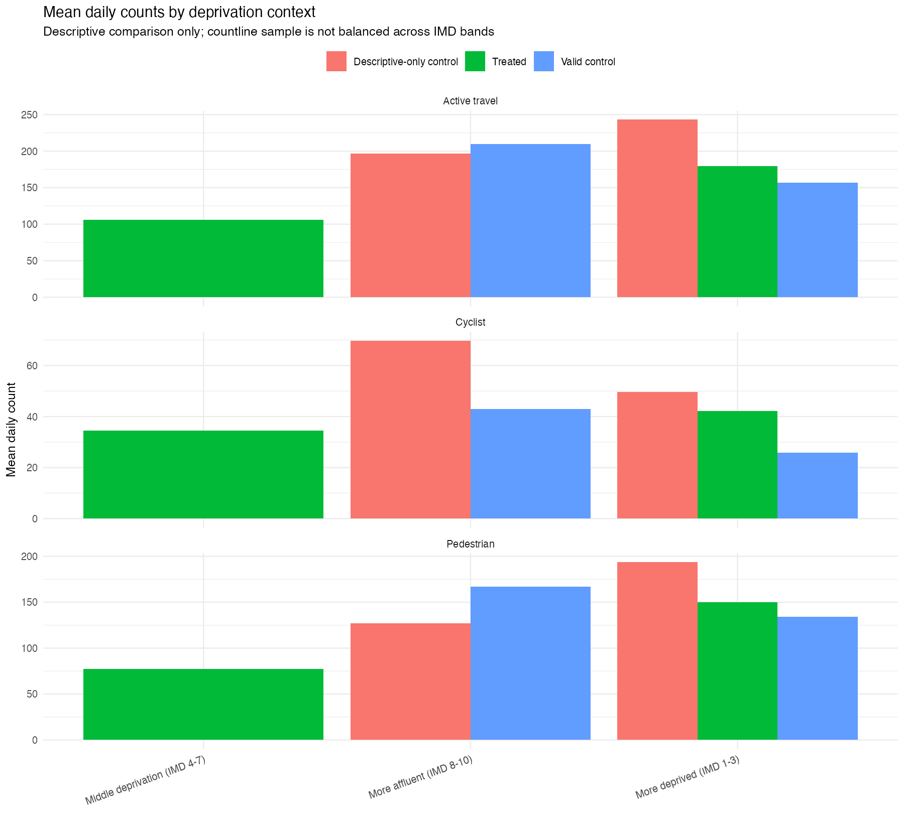
7. Control-Site Quality Review
Scheme | Control quality note | Countlines
12d | descriptive only; do not use in causal models | 12
12d | pragmatic exploratory control | 3
12f | descriptive only; do not use in causal models | 1
12f | pragmatic exploratory control | 3
13 | descriptive only; do not use in causal models | 8
13 | pragmatic exploratory control | 5
13 | strict seasonal control | 2
The control review confirms that only a subset of downloaded controls should enter exploratory causal models. Most 12d and 13 controls are descriptive-only, and only two controls meet the strict seasonal threshold.
8. Sensitivity-Ready Summaries
Scenario | Status | Rows
end_of_installation_month | available | 18
end_of_installation_month | no_post_followup | 6
end_of_installation_month | no_pre_baseline | 15
exclude_first_4_post_weeks | available | 18
exclude_first_4_post_weeks | no_post_followup | 6
exclude_first_4_post_weeks | no_pre_baseline | 15
exclude_first_8_post_weeks | available | 18
exclude_first_8_post_weeks | no_post_followup | 6
exclude_first_8_post_weeks | no_pre_baseline | 15
path_cycle_only | available | 3
path_cycle_only | no_post_followup | 21
path_cycle_only | no_pre_baseline | 27
road_only | no_post_followup | 24
road_only | no_pre_baseline | 33
start_of_installation_month | available | 18
start_of_installation_month | no_post_followup | 6
start_of_installation_month | no_pre_baseline | 15
The sensitivity-ready table shows which pre/post comparisons remain available under alternative assumptions. Date-shift and post-exclusion scenarios retain some available comparisons, while route-type-only scenarios often lose pre/post balance. This is useful for later robustness modelling but should not be treated as final causal evidence.
Conclusion
- Observed data analysis is now available for all five schemes.
- 12b and 12e remain descriptive only because treated pre-baselines are unavailable.
- Mode-specific and route-type patterns show that combined active travel totals can obscure important differences.
- Seasonality and volatility justify the modelling choice to use weekly aggregation and seasonal controls.
- Equity-context analysis is meaningful descriptively, but the sample remains too unbalanced for strong deprivation-stratified causal claims.

