Results Draft: Vivacity Exploratory Models
Current interpretation for dissertation writing and supervisor discussion
Headline Conclusion
The current Vivacity evidence does not yet support a strong causal claim that the analysed active travel schemes produced clear increases in walking or cycling relative to matched controls. The exploratory models are more consistent with mixed and uncertain relative trajectories, with two negative slope terms statistically flagged: cyclist counts for scheme 12d and active travel counts for scheme 12f.
This should be written cautiously. The strongest dissertation wording is that the analysis tests whether treated sites diverged from matched non-intervention countlines, but the current evidence should be interpreted as exploratory because the existing outputs were generated before confirmed exact dates were encoded, and control locations still need manual intervention-exposure checks.
Analysis Base
- The integrity gate covered 55 countlines: 21 treated and 34 control countlines.
- Thirteen controls met the pragmatic causal threshold; two met the stricter seasonal threshold.
- The final exploratory models were fitted only for schemes 12d, 12f, and 13.
- Schemes 12b and 12e were retained for descriptive analysis in the previous outputs; this should be rechecked using confirmed exact dates.
Scheme | Date range | Rows | Countlines | Treated | Controls | Intervention
12d | 2022-11-14 to 2026-05-25 | 1428 | 8 | 5 | 3 | 2023-03-01
12f | 2022-11-14 to 2026-05-25 | 1110 | 6 | 3 | 3 | 2023-06-01
13 | 2022-11-14 to 2026-05-25 | 1662 | 11 | 4 | 7 | 2024-03-01
Model Results
The table reports the two treated-control terms that matter most for interpretation: the immediate post-intervention relative level change and the additional treated-control weekly slope change after intervention. Percent changes are on the modelled log scale transformed back to relative percentage differences.
Scheme | Outcome | Immediate change | p | Weekly slope change | Interpretation
12d | Active travel | -5.94% | 0.384 | +0.02% per week (p=0.641) | negative, uncertain
12d | Pedestrian | -10.71% | 0.274 | +0.05% per week (p=0.324) | negative, uncertain
12d | Cyclist | +20.33% | 0.448 | -0.15% per week (p=0.020) | negative, statistically flagged
12f | Active travel | -8.47% | 0.237 | -0.11% per week (p=0.008) | negative, statistically flagged
12f | Pedestrian | -4.66% | 0.394 | -0.09% per week (p=0.370) | negative, uncertain
12f | Cyclist | -4.11% | 0.497 | -0.06% per week (p=0.268) | negative, uncertain
13 | Active travel | -29.30% | 0.361 | +0.08% per week (p=0.702) | negative, uncertain
13 | Pedestrian | -30.13% | 0.245 | -0.17% per week (p=0.371) | negative, uncertain
13 | Cyclist | -23.50% | 0.481 | +0.39% per week (p=0.109) | negative, uncertain
Scheme-Level Reading
For scheme 12d, active travel and pedestrian changes are not statistically clear. Cyclist counts show a positive but uncertain immediate level change, followed by a negative statistically flagged relative slope of about -0.15% per week. This suggests the cycling trajectory at treated countlines may have weakened relative to controls after the intervention month, but this remains exploratory.
For scheme 12f, the active travel outcome shows a negative statistically flagged relative slope of about -0.11% per week, while pedestrian and cyclist outcomes are negative but uncertain. This does not currently indicate an increase in active travel uptake relative to controls.
For scheme 13, all immediate level changes are negative but uncertain, and the post-intervention slope terms are not statistically clear. Cyclist counts have a positive but uncertain slope term, so the result should be treated as inconclusive rather than evidence of success or failure.
How This Should Be Written
- Use cautious wording: relative trajectories, exploratory comparison, and evidence consistent with.
- Avoid definitive phrases such as the scheme caused a reduction or the scheme had no effect.
- Treat statistically flagged terms as signals requiring interpretation against sensor coverage, confirmed intervention-date coding, seasonality, and site context.
- Use 12b and 12e to discuss data limitations and descriptive trends, not causal scheme effects.
Immediate Next Work
- Manually verify shortlisted control countlines against local scheme maps and street-level context.
- Produce a deprivation/affluence comparison table for treated sites and valid controls using LSOA-linked IMD and Census indicators.
- Report pedestrian and cyclist outcomes separately first, then use active travel total as a summary measure.
- Write a limitations paragraph that explicitly addresses remaining pre-intervention coverage limits and control contamination risk.
Figures for Results Chapter
The following plots are the current observed-versus-fitted model diagnostics. They are useful for the results chapter, but captions should describe them as exploratory model fits rather than final causal estimates.
Figure 1. Active travel observed and fitted weekly counts.
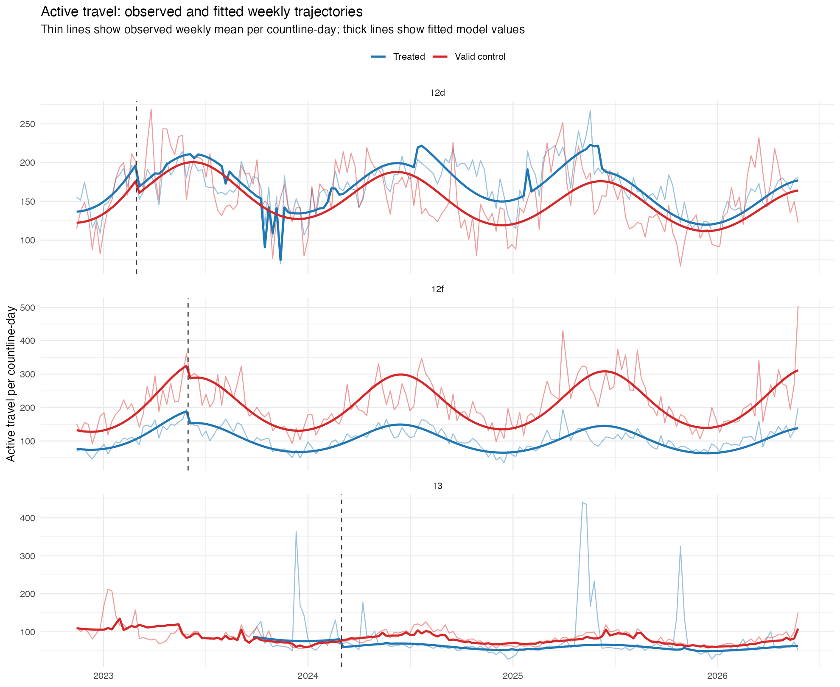
Figure 2. Pedestrian observed and fitted weekly counts.
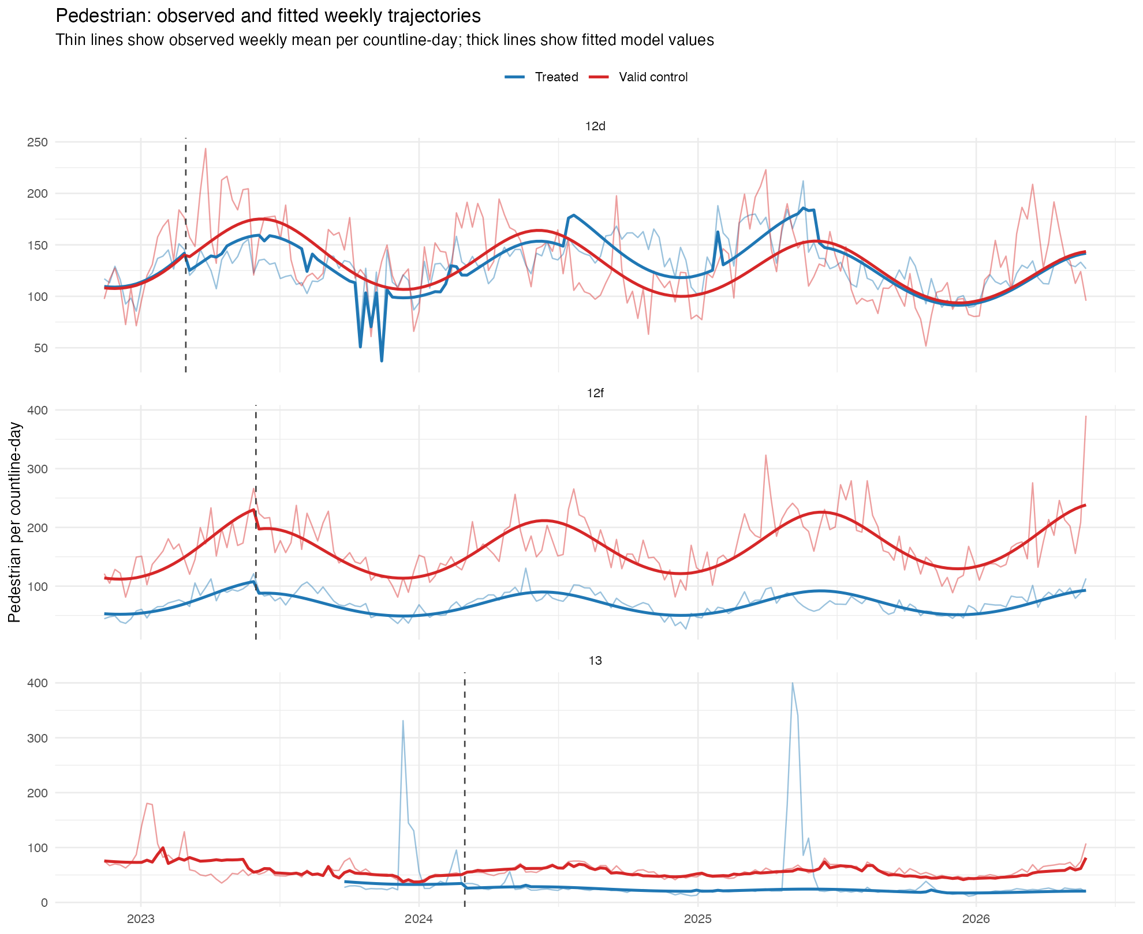
Figure 3. Cyclist observed and fitted weekly counts.
