Liverpool City Region Active Travel Monitoring
Analytical report draft for Liverpool Council: Vivacity sensor evidence and rail station movement context
Prepared from the current dissertation analysis outputs. This draft is intended for progress reporting and interpretation, not as a final causal evaluation.
Current aligned draft, 20 June 2026.
Current headline | The five-scheme Vivacity evidence is strong for descriptive monitoring and sensitivity comparison, but still cautious for causal claims. Where usable baselines exist, individual scheme active-travel changes are mixed; benchmark models generally show scheme trajectories below wider comparison trends. Rail data is useful as wider movement context, showing uneven post-pandemic recovery across Liverpool City Region stations.

1. Executive Summary
- The Council-facing evidence base combines quality-checked Vivacity pedestrian/cyclist counts with ORR rail station usage. Vivacity is the main source for scheme-area active-travel monitoring; rail data is contextual evidence about wider transport demand and recovery.
- The Vivacity workflow separates pedestrian, cyclist, active-travel total, and road/path outcomes. Daily observations are retained only when availability and completeness rules are satisfied, and exact scheme installation dates are treated as fixed inputs.
- Usable fixed-year baselines exist for schemes 12d, 12f and 13 only. Active-travel averages rose by 20.0% for 12d and 51.5% for 12f in the 2022-2025 comparison, while scheme 13 was 18.1% lower in the 2023-2025 comparison. Schemes 12b and 12e have post-installation observations but no usable positive baseline under the current quality-filtered data.
- Against wider Liverpool City Region and IMD-matched baselines, the modelled scheme trajectory for 12d and 12f is generally below comparison trends, especially for cycling. These estimates should be read as sensitivity analysis rather than proof of scheme impact. This does not contradict the rise shown in Figure 1: active-travel counts at 12d and 12f went up in absolute terms, but by less than comparable areas over the same period, so the gains track the wider post-pandemic rebound rather than a scheme-specific effect.
- Weather controls using ERA5/Open-Meteo daily temperature, precipitation, wind speed and solar radiation shift headline estimates by less than one percentage point, so weather does not explain the main direction of the findings.
- Rail demand remains uneven after COVID-19: Liverpool local-authority stations are at 86.0% of 2019/20 usage in 2024/25, while Halton and St. Helens are closer to or above recovery. Selected stations also differ: Maghull North is above 2019/20, Prescot remains below, and St Helens Junction is slightly above.

2. Evidence Base and Scope
The report uses two evidence streams. The first is the Vivacity active-travel dataset, which records pedestrian and cyclist counts at scheme and comparison countlines. The second is Office of Rail and Road Table 1415, used to summarise annual rail station entries/exits and interchanges. These sources answer different questions: Vivacity supports local street-level monitoring; rail station data supports city-region movement context.
Source | Coverage used | Main output | Role in this report
Vivacity dashboard exports | 90 official Liverpool City Region exports, 1 Jan 2020 to 31 May 2025; scheme-only validated archive extends to 26 May 2026 for selected fixed-year panels. | Daily pedestrian, cyclist and active-travel counts by countline. | Primary evidence for active-travel scheme monitoring.
Spatial/IMD context | LSOA 2021 context and IMD 2019 deprivation scores joined to sensors. | Matched context and IMD comparison groups. | Used to build fairer comparison baselines.
ERA5/Open-Meteo weather | Daily weather for twelve treated/control context centroids, 2020 to May 2025. | Weather-adjusted sensitivity models. | Checks whether daily weather alters the Vivacity interpretation.
ORR Table 1415 rail station usage | Annual station entries/exits and interchanges, 1997/98 to 2024/25. | Liverpool and LCR station trends and recovery metrics. | Contextual evidence for wider movement and transport demand.
Source files include vivacity_current_analysis.html, Vivacity analysis CSV outputs, rail_station_time_series_trends.Rmd, and ORR Table 1415 ODS in the dissertation source_documents folder.

3. Methods Used
The current Council report is a synthesis of the already generated dissertation outputs. The most important methodological choices are listed below so that readers can interpret the graphics correctly.
- Data integrity gate: Vivacity observations are kept only when the day has at least 23 valid hourly periods, non-missing pedestrian/cyclist fields, availability of at least 80%, and no dashboard data-error flag. This avoids treating incomplete sensor days as real low-activity days.
- Outcome definitions: pedestrian and cyclist counts are analysed separately; active travel is pedestrian plus cyclist. Road and path/cycle-facility outcomes are separated where route type is available.
- Fixed-year comparisons: requested calendar-year comparisons are reported only where the baseline and comparison years both have usable quality-passing observations. Counts are divided by observed countline-days.
- LCR baseline regression: a log-linear difference-in-differences sensitivity model compares schemes 12d and 12f with eligible wider LCR sensors using paired calendar days, countline fixed effects, month-day controls and weekday controls. In plain terms, difference-in-differences compares the before-to-after change at scheme sensors with the change at comparison sensors over the same dates, so trends shared across the city cancel out.
- IMD-matched context comparison: scheme contexts are paired with non-intervention streets in similar deprivation contexts. Context-level pre/post log changes are compared between scheme and control streets.
- Pre-intervention trajectory matching: pedestrian and cyclist controls are selected separately. Pre-installation series are indexed to 100 and trend matching uses log(percentage index / 100). Road/path type is recorded but not used as a matching restriction.
- Weather sensitivity: models are re-estimated with standardized ERA5 daily weather covariates: temperature, log(1 + precipitation), maximum wind speed and shortwave solar radiation.
- Rail analysis: ORR annual station entries/exits are used to show long-term station demand, local-authority recovery against 2019/20, and selected station trajectories. The 2008/09 ORR methodology break is flagged and not interpreted as real growth.

4. Vivacity Active-Travel Findings
The fixed-year comparison is useful for communicating observed changes at scheme sensors, but only three schemes currently have usable baseline-year observations after quality filtering.
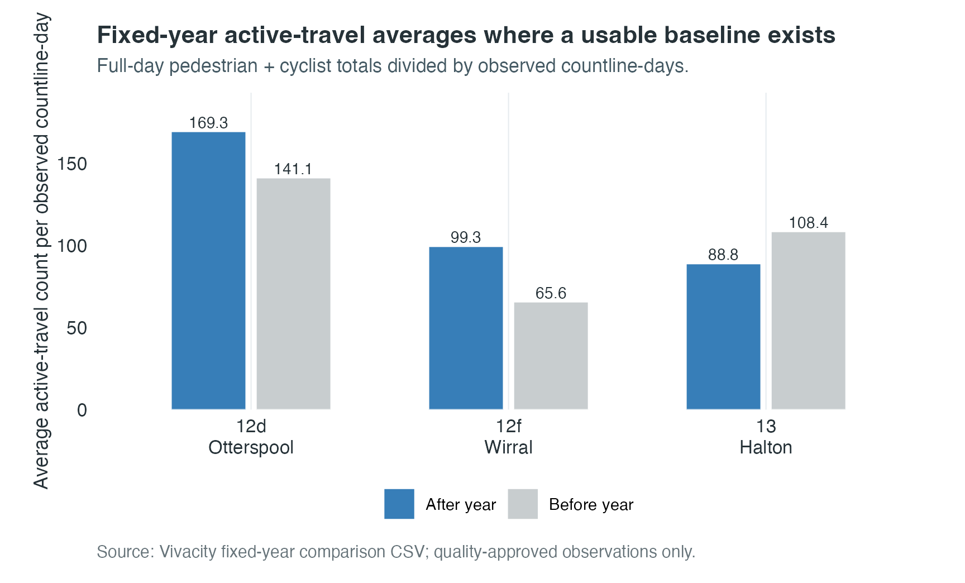
Figure 1. Fixed-year active-travel averages for schemes with usable baseline observations.
Scheme | Corridor/name | Usable comparison | Active-travel interpretation
12b | WP3a Prescot to Cronton | No usable fixed-year baseline | Post-installation values only; do not interpret as before/after change.
12d | WP1 Otterspool Promenade | 2022 vs 2025 | 141.1 to 169.3; 20.0%
12e | WP5 Sankey Canal to St Helens | No usable fixed-year baseline | Post-installation values only; do not interpret as before/after change.
12f | WP6 Leasowe to Wallasey Bridge Road | 2022 vs 2025 | 65.6 to 99.3; 51.5%
13 | LCR Cycle Network phase 2 Runcorn to Daresbury | 2023 vs 2025 | 108.4 to 88.8; -18.1%

5. Benchmark and Sensitivity Analysis
The wider comparison analyses ask a different question from the fixed-year descriptive bars: whether scheme sensors increased more or less than comparison baselines. These outputs are sensitivity analyses and should not be presented as causal proof. A negative relative figure does not contradict the positive bars in Figure 1; it means active travel at these schemes grew more slowly than the comparison areas, not that it fell. Each estimate below carries a 95% confidence interval and a p-value, and only some are statistically distinguishable from zero. Scheme 13 is not carried into these models because its usable baseline starts in 2023 and does not align with the 2022 comparison window.
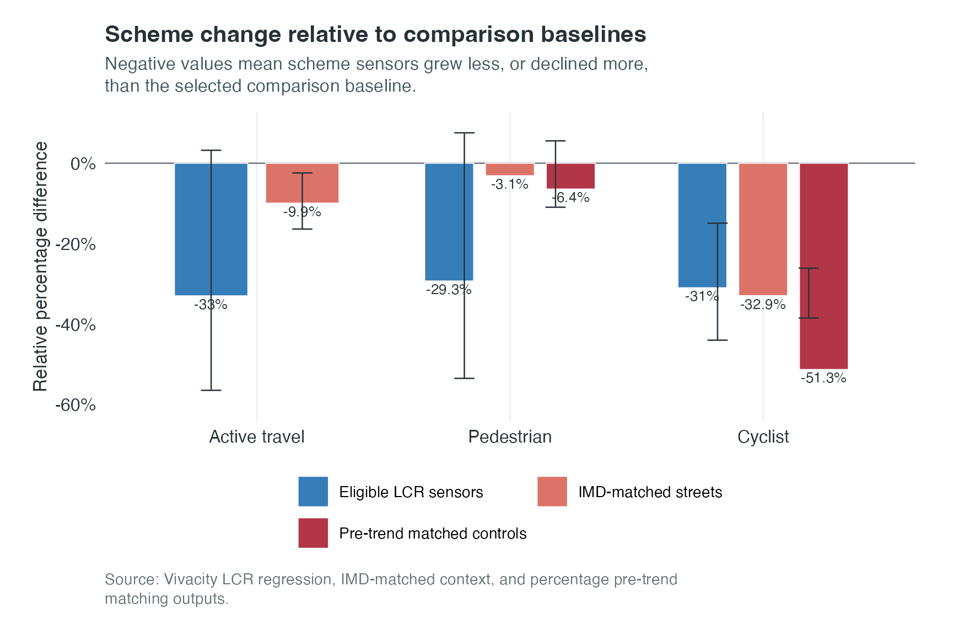
Figure 2. Scheme changes relative to wider LCR, IMD-matched and pre-trend matched baselines.
Analysis | Comparison base | Headline result | Interpretation
LCR baseline regression | Schemes 12d+12f vs 126 eligible LCR countlines | Active travel -33.0% relative to LCR (95% CI -56.5 to +3.2; p = 0.07, not significant) | Scheme trajectory is lower than the general LCR comparison trend.
IMD-matched context | Schemes 12d+12f vs selected deprivation-matched streets | Active travel -9.9% (CI -16.4 to -2.4; p = 0.01); cyclist -32.9% (CI -38.5 to -26.1; p < 0.001); pedestrian -3.1% (p = 0.47, not significant) | Cycling is consistently lower than the paired baseline; pedestrian direction is weaker.
Pre-trend matched controls | Outcome-specific controls matched on percentage pre-installation trajectories | Cyclist -51.3%; pedestrian -6.4% (matched descriptive estimates; no pooled significance test) | Uses percentage indexing to compare proportional trends, not raw volumes.
Per-scheme results differ sharply, so the pooled figures should not be read as a single scheme effect. In a per-scheme interaction model (countline fixed effects, matched month-days, weekday and weather controls, clustered standard errors), scheme 12f drives the negative active-travel result at -50.2% relative to the city benchmark (95% CI -76.5 to +5.7; p = 0.07), while scheme 12d is weaker at -14.5% (95% CI -33.5 to +10.0; p = 0.22); neither is statistically significant for active travel. For cycling, only 12f is significant (-41.7%; 95% CI -50.4 to -31.5; p < 0.001), with 12d at -21.6% (p = 0.07). The IMD-matched active-travel figure is the volume-weighted total of pedestrian and cyclist counts, so it sits between the two.
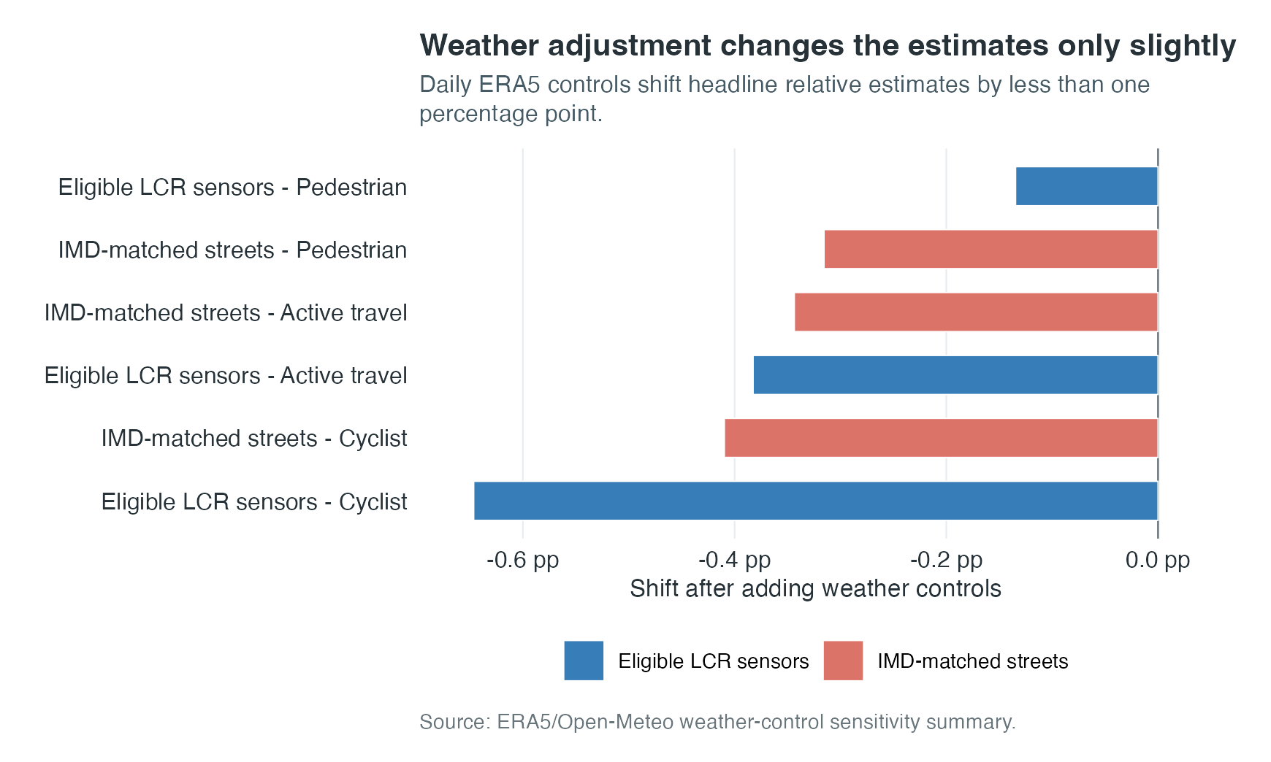
Figure 3. Weather-control sensitivity for the LCR and IMD benchmark models.
Weather adjustment does not materially change the interpretation: the active-travel relative estimate shifts by -0.38 percentage points in the LCR benchmark and -0.34 percentage points in the IMD-matched benchmark. Weather coverage is complete in the current output.

6. Rail Station Movement Context
Rail station data should be used as contextual evidence for wider movement patterns, not as a direct test of active-travel scheme impact. It is annual and station-level, while Vivacity is daily and street-level. Its value for Council reporting is that it situates active-travel changes within the wider post-pandemic transport recovery picture.
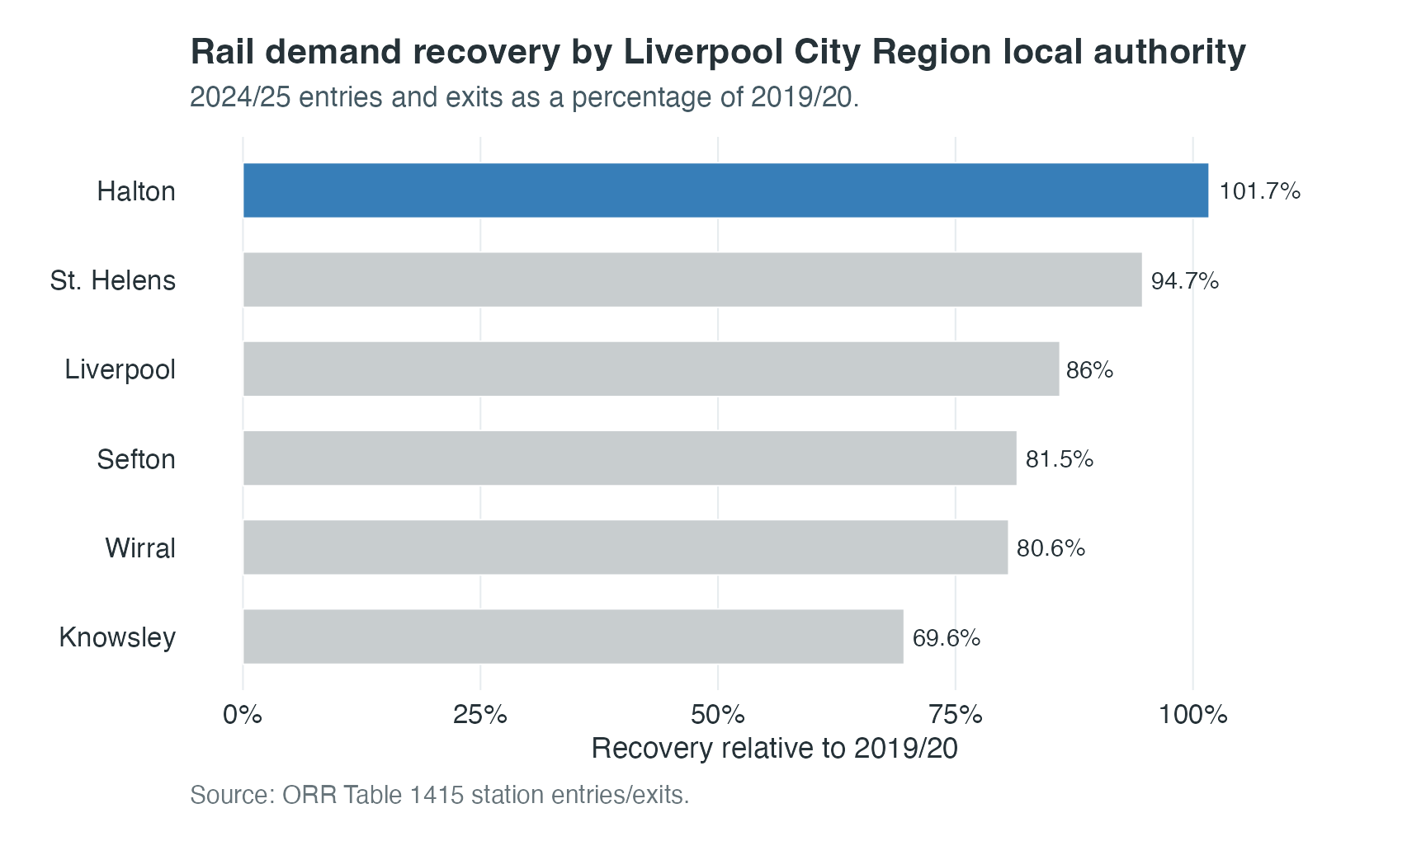
Figure 4. Liverpool City Region rail recovery by local authority, 2024/25 relative to 2019/20.
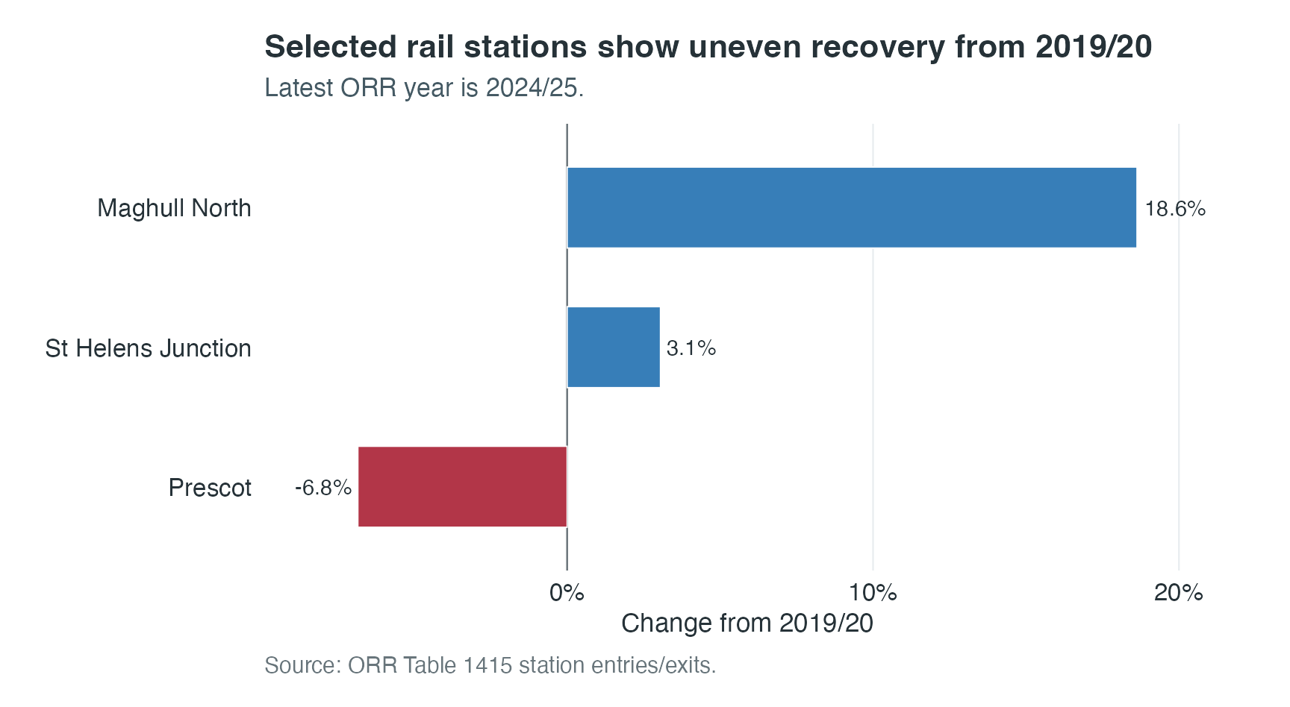
Figure 5. Selected station recovery from the 2019/20 pre-pandemic baseline.
Station | Authority | 2019/20 | 2024/25 | Change
Maghull North | Sefton | 517,166 | 613,510 | 18.6%
Prescot | Knowsley | 314,180 | 292,684 | -6.8%
St Helens Junction | St. Helens | 200,212 | 206,320 | 3.1%

7. Interpretation for Liverpool Council
- Use Vivacity as the main evidence stream for active-travel monitoring. It is the only current dataset here that directly measures pedestrian and cyclist counts near the schemes.
- Use rail station data to frame the city-region movement context. It helps explain that scheme-area changes are happening during an uneven transport recovery after COVID-19.
- Avoid claiming that rail trends explain Vivacity changes. The scales do not match: rail is annual station-level demand; Vivacity is daily street-level countline activity.
- Present benchmark results as sensitivity analysis. The current work compares schemes with city-wide, IMD-matched, pre-trend matched and weather-adjusted baselines, but the results do not prove causation.
- For Council-facing next work, the most useful addition would be a station/scheme proximity layer: nearest station to each scheme sensor, distance, station recovery rate, and whether the corridor plausibly acts as a first/last-mile route.

8. Limitations and Risks
- Some schemes, especially 12b and 12e, lack usable positive pre-installation active-travel baselines after quality filtering. They can be described post-installation, but not as reliable before/after comparisons.
- The strongest comparison models currently rely mainly on schemes 12d and 12f for 2022-2024/2025. Scheme 13 can be analysed over a shorter 2023-2025/2024 period, but this is not equivalent to the 2022 baseline comparisons.
- Comparison areas may still have unrecorded local changes, events or interventions. The current controls are selected systematically, but they are not guaranteed untreated counterfactuals.
- Weather has been tested, but public holidays, school terms, large events, roadworks and local disruptions remain useful additions if the Council needs a stronger explanatory model.
- ORR Table 1415 has a known 2008/09 methodology break and annual granularity. It should not be mixed directly with daily Vivacity observations.

9. Key Outputs and File References
Output | Path | Use in Council report
Current Vivacity HTML report | reports/analysis_reports/vivacity_current_analysis.html | Main interactive/visual evidence for fixed-year, LCR, IMD, trajectory and weather sensitivity outputs.
Fixed-year comparison CSV | reports/analysis_reports/vivacity_fixed_year_average_comparison.csv | Scheme before/after averages and availability notes.
LCR baseline regression CSV | reports/analysis_reports/vivacity_baseline_adjusted_regression_2022_2024.csv | City-region benchmark model for schemes 12d and 12f.
IMD-matched context CSV | reports/analysis_reports/vivacity_imd_matched_context_change_results.csv | Deprivation-context matched sensitivity comparison.
Pre-trend matching CSV | reports/analysis_reports/vivacity_preintervention_trajectory_results.csv | Outcome-specific percentage trajectory matching.
Weather sensitivity CSV | reports/analysis_reports/vivacity_weather_control_sensitivity_summary.csv | ERA5/Open-Meteo weather-control comparison.
Rail station report | reports/rendered_html/rail_station_time_series_trends.html | ORR station usage context and visualisations.
Rail selected station summary | reports/analysis_reports/rail_station_time_series/rail_station_entries_exits_summary.csv | Maghull North, Prescot and St Helens Junction summary.
LCR rail local-authority recovery | reports/analysis_reports/rail_station_time_series/lcr_recovery_by_local_authority.csv | Council-level rail recovery comparison.

10. References
- Office of Rail and Road. Table 1415: Time series of passenger entries and exits and interchanges by station. Source workbook stored at source_documents/table-1415-time-series-of-passenger-entries-and-exits-and-interchanges-by-station.ods.
- Office of Rail and Road station usage methodology note: 2008/09 is treated as a methodology break because ORR integrated the Origin-Destination Matrix with the MOIRA Demand Matrix and included additional PTE-area journey estimates.
- Vivacity dashboard exports for Liverpool City Region sensors, processed through the dissertation quality gate and daily aggregation workflow.
- Open-Meteo Historical Weather API: https://open-meteo.com/en/docs/historical-weather-api.
- Copernicus Climate Data Store, ERA5 single levels reanalysis: https://cds.climate.copernicus.eu/datasets/reanalysis-era5-single-levels.
- Index of Multiple Deprivation 2019 joined to LSOA 2021 context in the dissertation spatial/context workflow.

