2019-4-20

Nanxi Zhou

Business Information Systems

Final Project

COMP-254

Table of Content

**Summary** 2

**I Install the Web Server Virtual Machine** 2

**II Configure the Web Servers** 3

**1.** **Add Roles and Features (IIS Server) to the Web Server** 3

**2.** **Add websites on the WebServer** 4

**3.** **Create Hostnames for websites in DNS manager on Domain Controller** 4

**4.** **Configure the firewall setting** 5

**III Build the sharing service** 5

**1. Create users, organizational units and groups with Domain Active Directory.** 5

**2. Share files to different groups** 7

# **Summary**

This report is an introduction of how to build a valid web server on a Windows 2016 server system as well as how to set up the file sharing service. There are three main parts in this report: ***I*** ***Install the Web Server Virtual Machine***, ***II Configure the Web Server*** and ***III Build the sharing service***. Following this sequence, there are detailed information to show the processes.

# **I Install the Web Server Virtual Machine**

Since we are going to build this web server and sharing service on a Virtual Machine, the first step is to create a new Virtual Machine:

1. Open Server Manager-Tools-Hyper-V Manager
2. New-Virtual Machine
3. Specify Name: WebServer
4. Specify Generation: Generation 1
5. Assign Memory: Startup Memory: 2048MB (Can be changed later)
6. Configure Networking: Internal. (For education use, so we do not need to connect to the external internet connection)
7. Connect Virtual Hard Disk

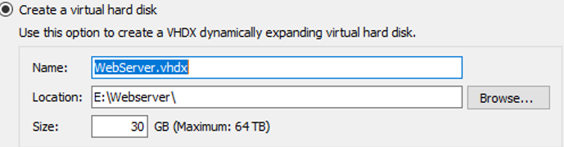

1. Installation Option

Browse to the address where the ISO file is

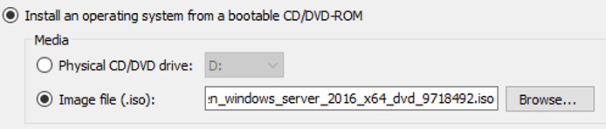

1. After finishing the previous process, start the virtual machine we had created, then it will prompt to install a Windows server 2016 Standard operation system. Choose Windows Server 2016 Standard (Desktop Experience):

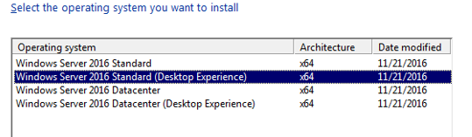

This installation will take a little while. And we also need to customize the setting. Then our web server has installed.

1. In order to share the same and correct time with domains, we need to modify the time setting. Settings - Date&Time - Time zone – (UTC-06:00) Saskatchewan

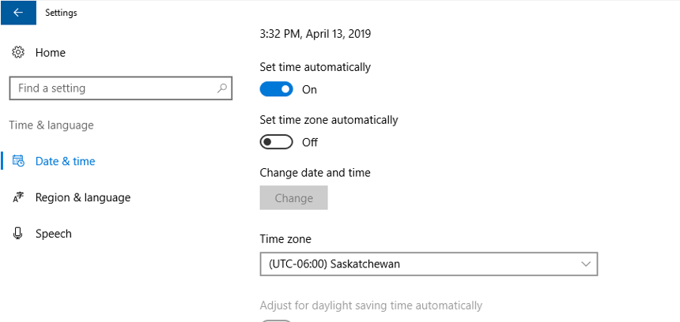

1. Modify the IP properties

Server Manager-Local Server- Ethernet

Here, we need to do 1st Uncheck the IP6, so that we will only use IP4. 2nd set the ip4 properties as follows. (Assign an available IP to this web server, one of the Alternate DNS server should be the same with domain controller)

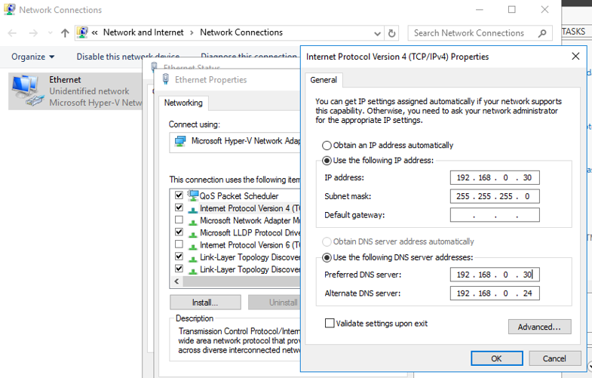

1. Change the computer’s name and join in the Fully Qualified Domain Name (FQDN) **COM254.Nanxi**.

Server Manager-Local Server-Computer Name

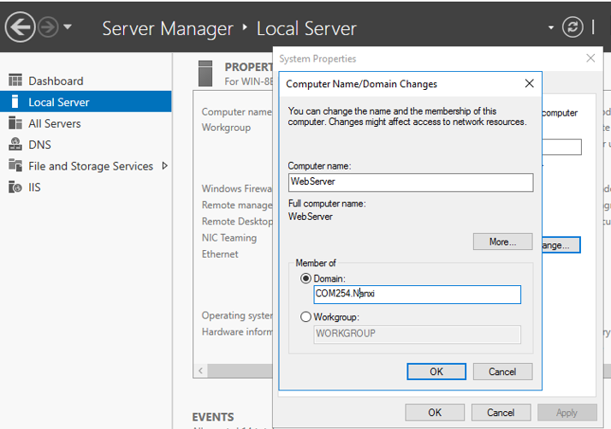

Click OK, enter your administrator’s account and password of domain controller, and your web server can now connect to your domain controller.

**II Configure the Web Servers**

Now we finished installing the virtual machine for our web server. It’s time to add the web role and feature to it.

1. **Add Roles and Features (IIS Server) to the Web Server**

In the WebServer,

1. Open Server Manager-Manage-Add Roles and Features Wizard
2. Installation Type: Role-based or feature-based installation
3. Server Selection: Select a server from the serve pool.
4. Server Roles: Web Server (IIS)-Default selections and check ASP.Net 4.6
5. Role Services: check as follows

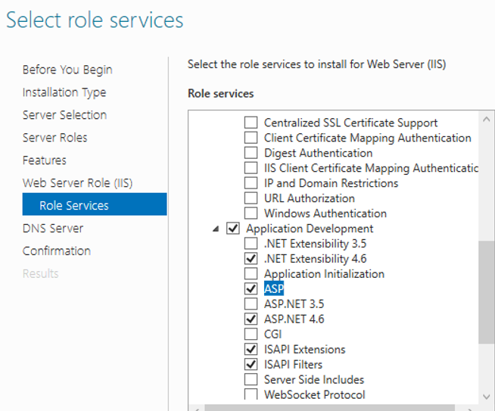

1. DNS and other features are as default. After all the process has done, features are started to be installed.

Now, we have finished all the set up to make the web server valid. Let’s test whether it can host functionally.

1. **Add websites on the WebServer**

To test whether our web server is functional, we need to add some webpages to check it out.

1. Create three sub directories called Production, Test, and Development. Those three folders should be under C:\inetpub

Example: Path for Production is: C:\inetpub\Production

1. Server Manager - Tools - Internet Information Services (IIS) Manager. Right click Sites- Add Websites. Add three of them.
2. Set the host name and port number as:

www.com254.nanxi for site Production on port 80

test.com254.nanxi for site Test on port 80

dev.com254.nanxi for site Development on port 8080

1. Add contents for the sites.

* Create production.htm and index.aspx in C:\inetpub\Production
* Create test.htm and index.aspx in C:\inetpub\Test
* Create dev.htm and index.aspx in C:\inetpub\Development

1. **Create Hostnames for websites in DNS manager on Domain Controller**

In order to make those host names functional on web server, we need to create host names for them on domain controller

1. Switch to the Domain controller (DC01), go to Server Manager-Tools-DNS
2. Go to DC01.COM254.nanxi- Forward Look up Zones. Right click and add new host names:

* Name: www; IP Address: 192.168.0.30 (The same with WebServer)
* Name: test; IP Address: 192.168.0.30
* Name: dev; IP Address: 192.168.0.30

1. **Configure the firewall setting**

Since we create a website on the port 8080.Now we need to configure the firewall to allow the traffic on that port.

1. Start-Administrative Tools- Windows firewall with Advanced Security, find Inbound Rules
2. Create a new rule as follows:

* Rule type: Port
* Protocol: TCP
* Port:8080
* Action Settings: Allow the connection
* Profile Settings: Domain, Private, Public
* Name Settings: World Wide Web Services (HTTP in on Port 8080)

Now that we have finished the web server setting. Our web server should work now.

**III Build the sharing service**

In this part, we will create a sharing service. In order to share files to other users, we need to create users, organizational units and groups on our domain. So, our first step would be:

**1. Create** **users, organizational units and groups with Domain Active Directory.**

1. On our Domain Controller DC01, Server Manager- Tools- Active Directory Users and Computers
2. Find our domain name COM254.Nanxi, and create users, organizational units and groups as follows:

* Organization Units: right click- new- Organization Unit
* Users: right click- new- user. Here we need to input the name, logon name and set up the password. We set the password as Need to Change at the First Log on.
* Group: right click- new- Group

1. Now we start to create OUs, and groups according to the following structure:

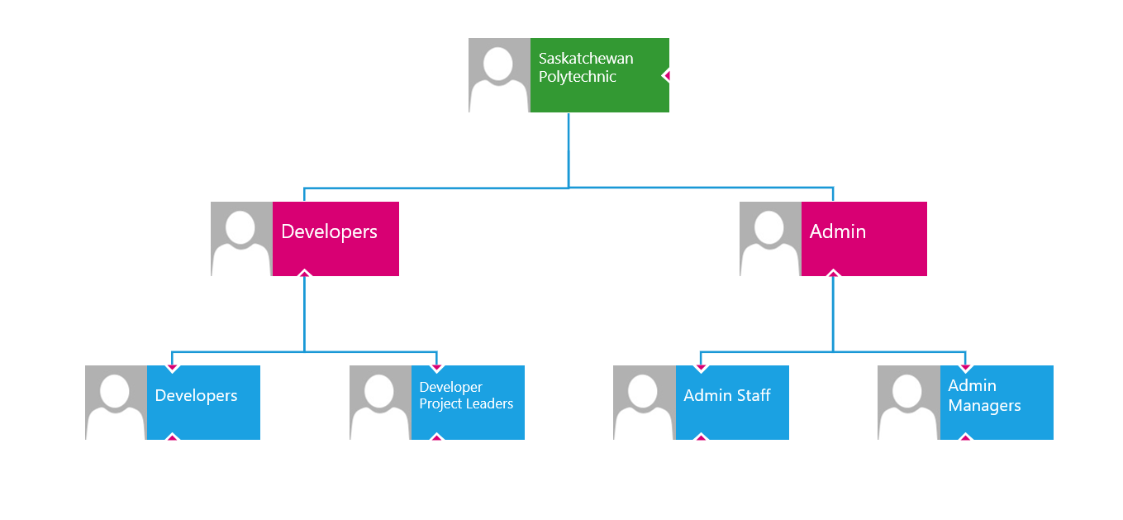

Then we create users and add them into groups:

* **Developer Users**

-Developer1, Developer2, Developer3

- Developer Security Group

* **Developer Leader Users**

- DevLead1, DevLead2

-Developer Project Leader Security Group

*Set DevLead1 as part of Developer Project Leader and Admin Managers group.

* **Admin Staff Users**

- Staff1, Staff2, Staff3

- Admin Staff Security Group

* **Admin Manager Users**

- Manager1, Manager2

- Admin Manager Security Group

1. Authorize specific groups to manage groups in the active directory

- Developer Project Leader Group:

Right click -Delegation of Control Wizard – add Developers group and delegate the tasks to Developer Project Leader Group as follows:

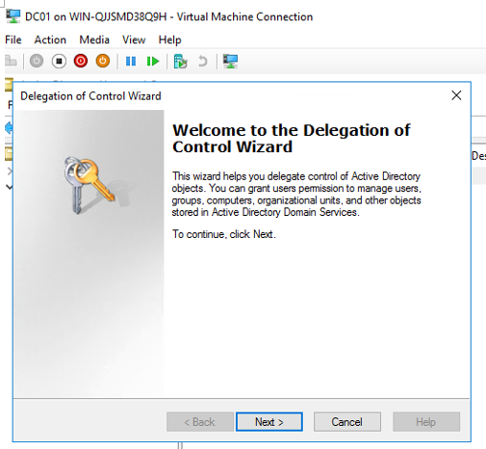

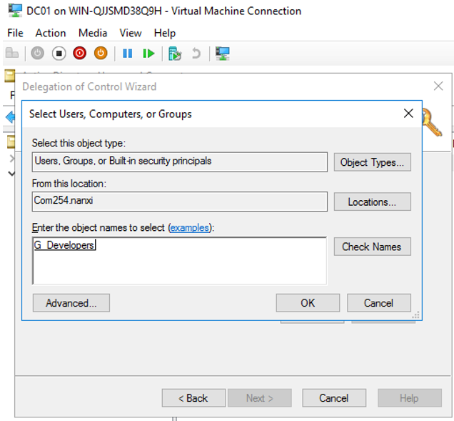

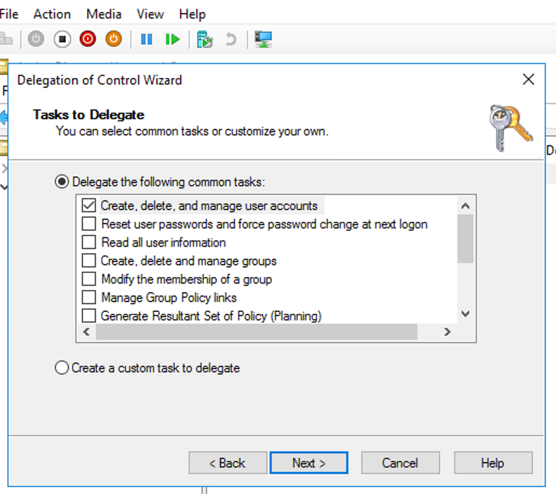

- Delegate Admin managers to manage Admin Staff as previous step

**2. Share files to different groups**

In order to share files to different target groups, we need to create some files and share them accordingly.

1. Create sharing directories in WebServer. We may create them in C:\ as follow structure

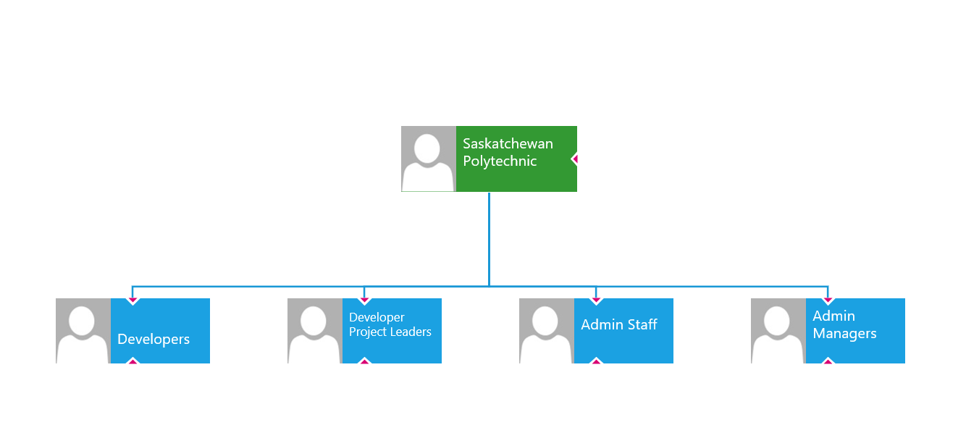

Now, we have directories like:

* C:\Saskatchewan Polytechnic
* C:\Saskatchewan Polytechnic\Developers
* C:\Saskatchewan Polytechnic\Developer Project Leaders
* C:\Saskatchewan Polytechnic\Admin Staff
* C:\Saskatchewan Polytechnic\Admin Managers

1. Find web sites directories:

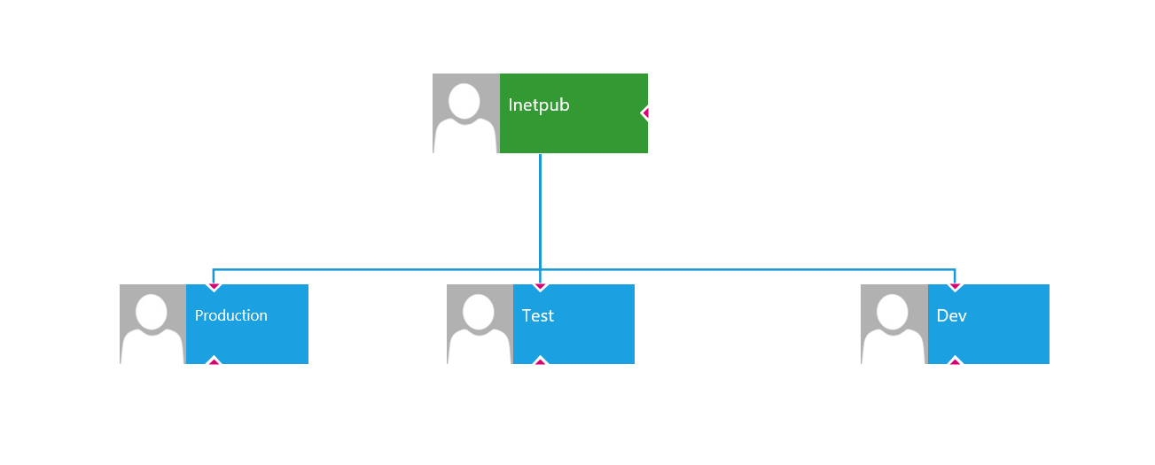

* C:\inetpub
* C:\inetpub\Production
* C:\inetpub\Test
* C:\inetpub\Development

1. Share directories to different target groups

* **For Developers**

- C:\Saskatchewan Polytechnic\Developers

- C:\inetpub\Production

- C:\inetpub\Test

- C:\inetpub\Development

* **For Developer Project Leaders**

- C:\Saskatchewan Polytechnic\Developers

- C:\inetpub\Production

- C:\inetpub\Test

- C:\inetpub\Development

- C:\Saskatchewan Polytechnic\Developer Project Leaders

* **For Admin Staff**

- C:\Saskatchewan Polytechnic\Admin Staff

* **For Admin Managers**

- C:\Saskatchewan Polytechnic\Admin Staff

- C:\Saskatchewan Polytechnic\Admin Managers

So far, we have completed all the process of building the web server and sharing service. In order to verify whether they are functional, we need to go to WIN10, and sign in by different users from different groups. Before we start our WIN10, we need to modify the memory of our domain controller DC01, otherwise WIN10 will probably give us an error. So, we need to change the memory of DC01 from 2048mb to1024mb as follow

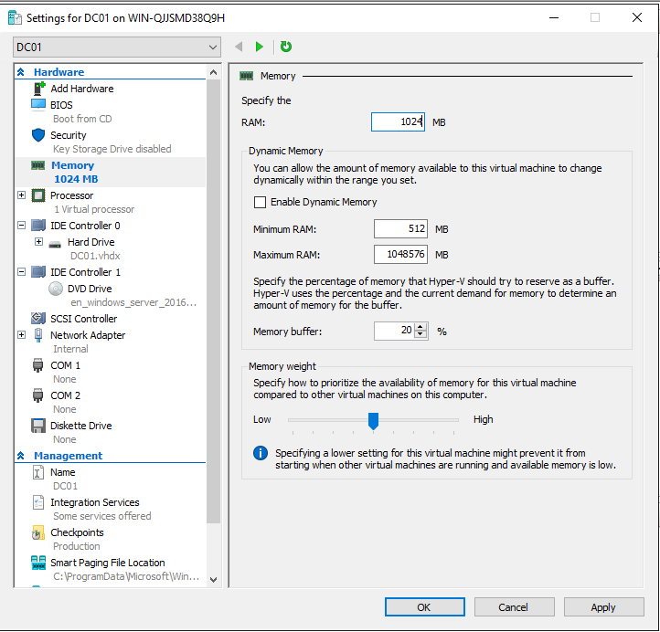

Now, we are ready to go.