|  |
| --- |
| Farmer |
| Harvest  Process  Pack  Sell |

|  |
| --- |
| Distributor |
| Buy  Ship |

|  |
| --- |
| Retailer |
| Receive |

|  |
| --- |
| Consumer |
| Purchase |

Activity Diagram

Sequential Diagram

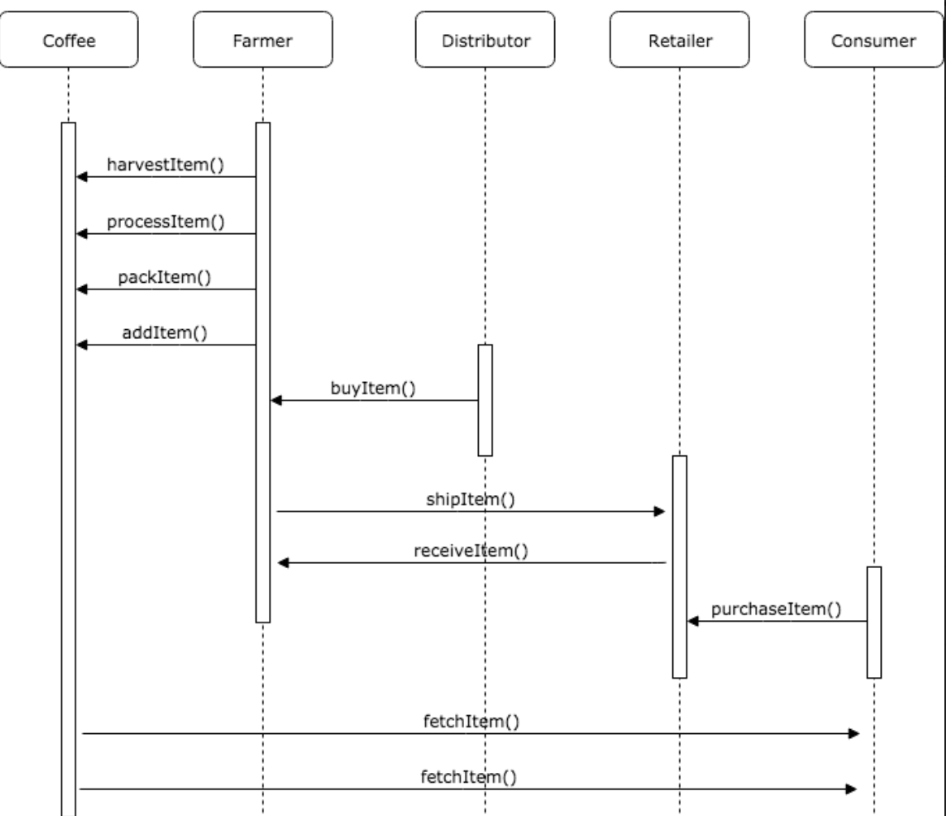

State Diagram (Coffee)

Class/ Data Model

3 types of contracts

* Access Control Contract (Roles.sol library) (Handles Access control of Roles for listed Actors)
  + Farmer.sol
  + Distributor.sol
  + Retailer.sol
  + Consumer.sol
* Base Contract (inherits the Access control contracts as well as the Core contract)
  + Handles the definition of the coffee struct and functions that move the coffee through the chain and read from it
* Core Contract
  + Handles the contract ownership and change