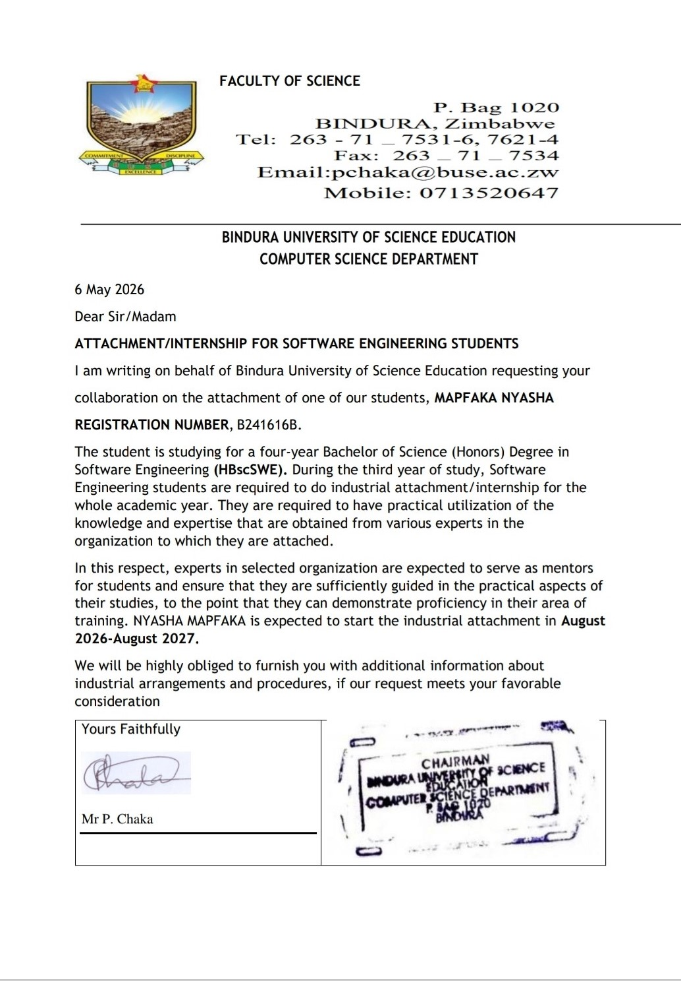
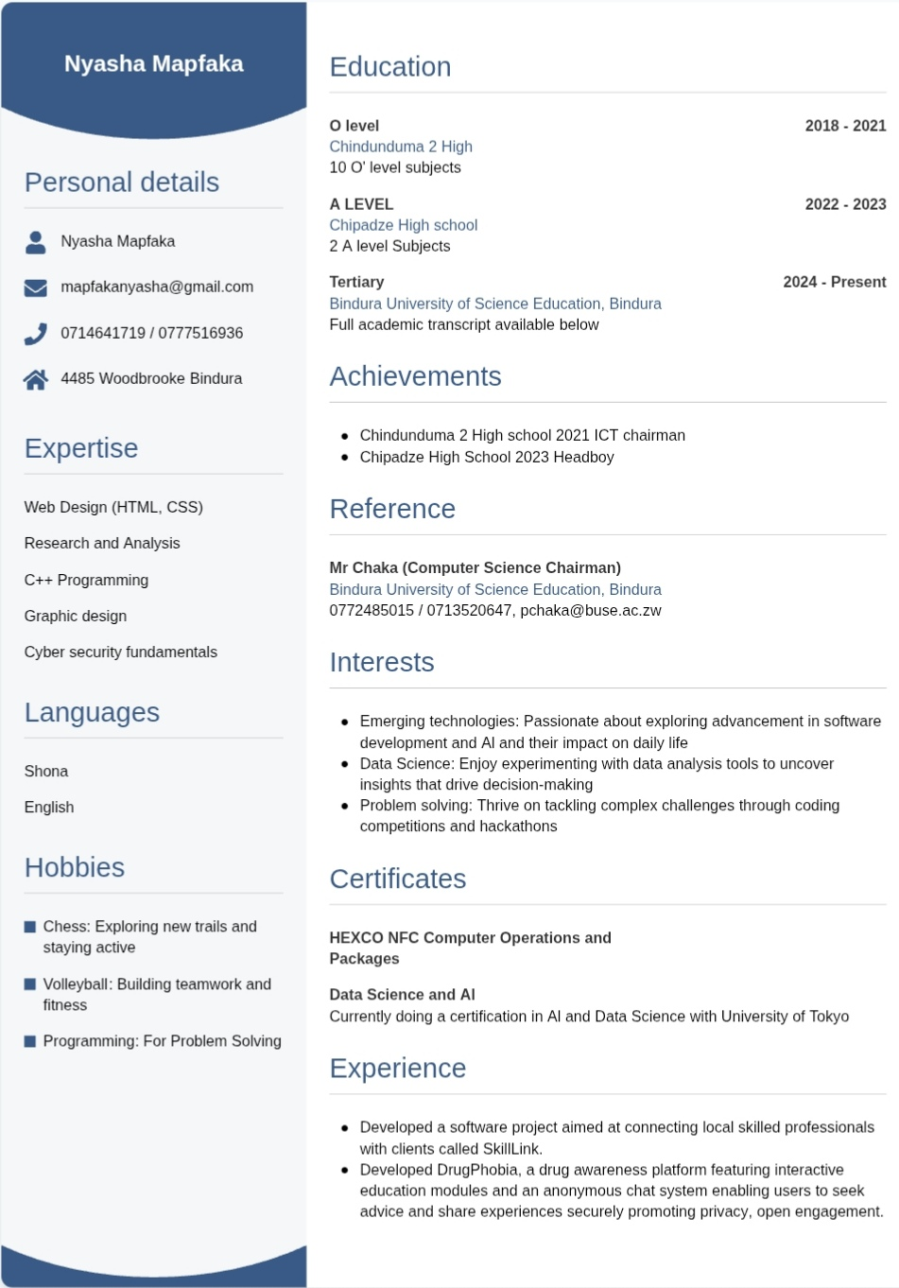4485 Woodbrooke North
Bindura
Dear Sir/ Madam
RE: APPLICATION INDUSTRIAL ATTACHMENT 2026/2027 ACADEMIC YEAR.
I am writing to express my interest in an attachment/internship opportunity at your esteemed company. I am currently pursuing a Bachelor’s degree in Software Engineering at Bindura University of Science Education. I am eager to gain practical experience in a professional environment and contribute meaningfully to your team.
Through my academic studies, I have developed a strong foundation in programming languages such as C++ and Python. My coursework has equipped me with solid knowledge in data structures, algorithms, and software development principles. Additionally, I have worked on personal projects that strengthened my skills in web development, database management, and software testing.
I am highly motivated, goal-oriented, and a strong team player with a passion for technology and continuous learning. I am confident that my dedication and technical competence would allow me to add value to your organization while gaining valuable industry experience. I have attached my Curriculum Vitae for your consideration. Thank you for taking the time to review my application. I look forward to the opportunity to discuss how I can contribute to your team.
Yours sincerely,
Mapfaka Nyasha

BINDURA UNIVERSITY OF SCIENCE EDUCATION

Academic Results
Registration #: | B241616B
Full Name: | MAPFAKA NYASHA
Programme Name: | BACHELOR OF SCIENCE HONOURS DEGREE IN SOFTWARE ENGINEERING | CONVENTIONAL
Status: | STUDENT
Degree Class: | PENDING
Awards: | None
Level: 1.1

Course Code | Course Name | Class | Decision
SWE102 | Introduction to computer programming | P | P
SWE103 | Applied statistics | P | P
BS101 | Business administration | P | P
HS102 | Health education | 2.1 | P
SWE104 | Ethics and professionalism | 1 | P
CS101 | Introduction to computer science | 2.2 | P

Level: 1.2

Course Code | Course Name | Class | Decision
SWE114 | Database systems | P | P
PC103 | Communication skills | 2.2 | P
SWE111 | Operating system concepts | 2.2 | P
SWE117 | Discrete mathematics | 2.2 | P
SWE113 | Data structures and algorithms | P | P
SWE112 | Visual design concepts and development | P | P
PC108 | Citizenship education & conflict transformation | 2.1 | P
SWE115 | Software engineering fundamentals | P | P

Level: 2.1

 | Course Code |  | Course Name |  | Class |  | Decision
 | SWE202 |  | Software architecture and design |  | 1 |  | P
 | SWE206 |  | Research methodology |  | 2.1 |  | P
 | SWE201 |  | Object oriented programming 1 |  | 2.1 |  | P
 | AC101 |  | Financial accounting 1a |  | P |  | P
 | SWE203 |  | Computer architecture |  | 2.1 |  | P
 | SWE204 |  | Requirements engineering |  | 2.2 |  | P
Level 2.2 Pending

Shaping and Creating the Future: Building Zimbabwe
Copyright © 2026 Bindura University of Science Education. All rights reserved.

