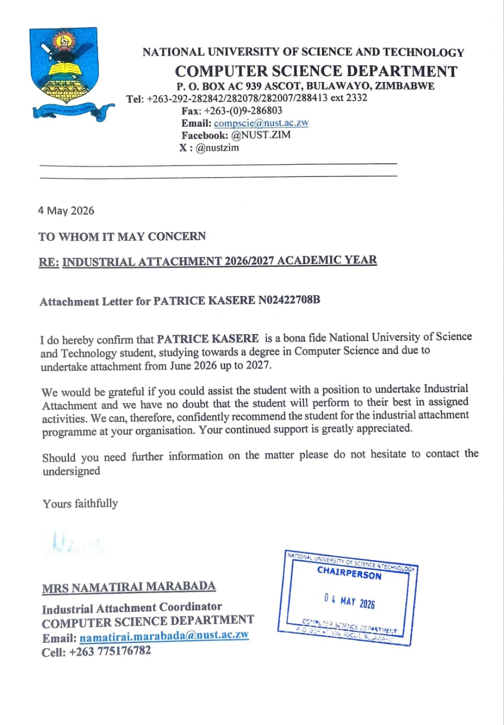

Patrice Tapiwanashe Kasere
206 Jumbe Road
Chipadze
Bindura
06 May 2026

The Human Resource Manager

RE: APPLICATION FOR COMPUTER SCIENCE INDUSTRIAL ATTACHMENT
Dear Sir/Manager
I am a dedicated second-year Computer Science Honours student at the National University of Science and Technology (NUST), writing to express my keen interest in an Industrial Attachment position within your IT department. I am currently seeking a placement in a forward-thinking, commercial environment where I can apply my technical training to real-world challenges in partial fulfilment of my degree requirements.
Throughout my academic journey, I have developed a rigorous foundation in software development, web development, and network architecture. I am not only passionate about building efficient code but also about understanding how technology serves as a backbone for business growth and decision-making. I am eager to contribute my problem-solving skills and fresh technical perspective to your team while gaining hands-on experience under industry experts.
My goal is to provide tangible value to your daily operations through hard work, adaptability, and a commitment to excellence. Please find attached my Curriculum Vitae and university-issued proof of qualification for this internship.
I look forward to the opportunity to show how my dedication can benefit your organization.
Yours faithfully
Patrice T. Kasere
+263775024738


Patrice T. Kasere
kaserepato@gmail.com
+263775024738
Male
Languages: English and Shona

OBJECTIVES
Aspiring Computer Scientist with a rigorous academic foundation in data structures and algorithmic logic. Seeking a high-impact internship to apply full-stack development skills to enterprise-level challenges. I am eager to contribute to the development of scalable, high-performance software while collaborating with cross-functional teams to solve complex architectural problems.

PERSONAL STATEMENT
Driven Computer Science student with a passion for building scalable solutions and translating complex algorithms into efficient code. I specialize in bridging the gap between theoretical computation and practical software development to drive data-informed decision-making.
Currently seeking an internship to apply my proficiency to real-world engineering challenges. I am dedicated to evolving my technical toolkit through advanced coursework and hands-on project development, ensuring I remain at the forefront of emerging industry standards.

TECHNICAL SKILLS
- Data Structures and Algorithms
- Flutter; Application Development
- Web Development (Python-Intermediate, CSS, HTML, JavaScript)
- Version Control (GitHub)
PERSONAL SKILLS
- Good Time Management
- Great Communication Skills
- Efficient Problem Solving Skills
- Team Work; Collaboration
- Understanding Boyfriend

QUALIFICATIONS
National University of Science and Bachelor of Science Honours Degree in
Technology Computer Science

Chipindura High School Certificate
Attained 2023 3 A ‘Level Passes

Mavhuradonha High School Certificate
Attained 2021 11 O ‘Level Passes; Mathematics and English Included

INTERESTS
- Playing Chess

REFERENCES
Tsitsi Zengeya Admire Bhuru
National University of Science and National University of Science and Technology
Technology Lecturer, Bulawayo Lecturer, Bulawayo
Phone Number: +263773405111 Phone Number: +263774792676

Transcript of Results
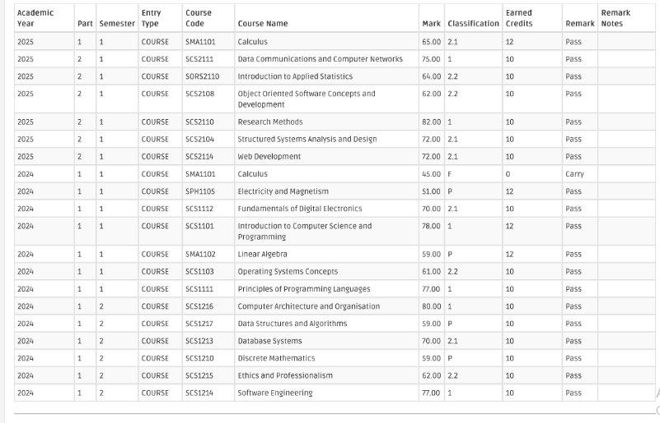

Advanced Level Result Slip
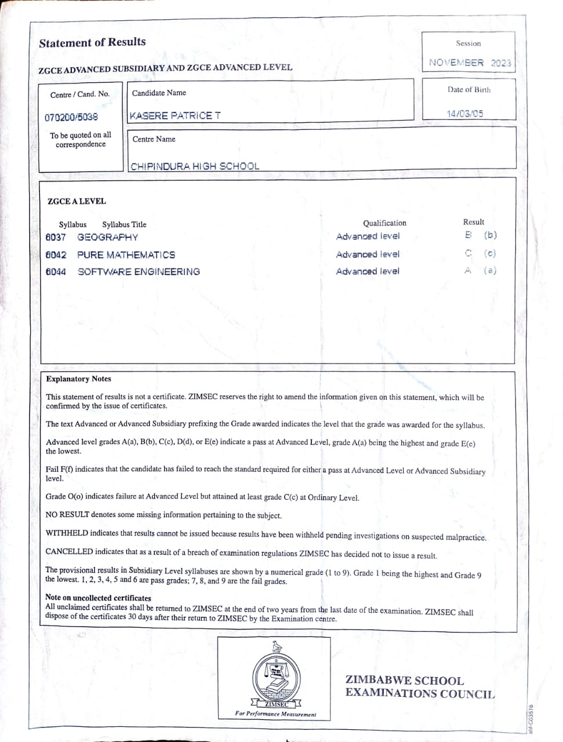

Ordinary Level Certificate
