**Term Project Proposal Paper**

**COMP 370 - ON1**

Group Members:

1. Jannine Gemmell
2. Naomi Ugwuoke
3. Shruti Verma

The objective of this project is to create an interactive map at UFV so that visitors and first time students can easily navigate the Abbotsford campus.

Our decision for proceeding with this project comes from our own experience being first time students at UFV, and each year thereafter, struggling to find exactly where our classrooms will be on campus.

This interactive map would be a webpage that can be found on the UFV website. Based on the already created Abbotsford campus UFV map (with a possibility to extend to other campuses), this map would allow the user to click on many things on the map to display more detailed information about the clicked on object. As some examples, when the user clicks a building, information would appear about that building. For all buildings, this information would include hours of operation of the building, floor numbers, room numbers. With buildings housing fast food, information on what fast food place is there, its hours of operation, and menu would appear as well (once selected by the user on the information screen). When the user clicks on a parking lot, it will display information such as how many stall numbers there are, the time of day parking is more likely available, the rate per hour that parking costs, and a link to the UFV webpage displaying parking information (<https://ufv.ca/parking/>). When the user clicks on the UFV shuttle parking, information will be displayed about its hours of operation, what route it is on at that moment, and a link to the SUS Campus website (<https://ufvsus.ca/campus-shuttle>). When the user clicks on the public bus stop, information displaying the bus schedule will be displayed, as well as a link to the website containing information on the bus and its routes (<https://transitfeeds.com/p/bc-transit/686/latest/stop/107190>).

Aside from giving detailed information on the objects found on the map, the user would also be able to input directions for finding out how to get to different parts of the campus. The user would be able to input their current location, and the destination they wish to reach and then the map would generate a route they could take to get to where they need to be from where they currently are. In order to ensure accuracy, room numbers will be taken into account when inputting both current location and destination location.

This map is intended to be more than a webpage. Another use case for this project is to be a map that is linked to hardware that is solely for the purpose of being a map. An example of where you would see this type of device is in a mall, such as the Guildford Town Centre mall in Surrey which visually displays directions to a store inside the mall. If implemented, this map would be seen at the entrances of UFV buildings so that students or visitors needing guidance can see it quickly and not get too far lost.

Our first elaborations would be determining the use cases and objects that are needed to build the webpage. Building, ParkingLot, Direction, and BusStop will all be objects that need to be implemented. Information Screen will be another such example of an object, with sub-objects such as Building information, Parking information, Bus information.

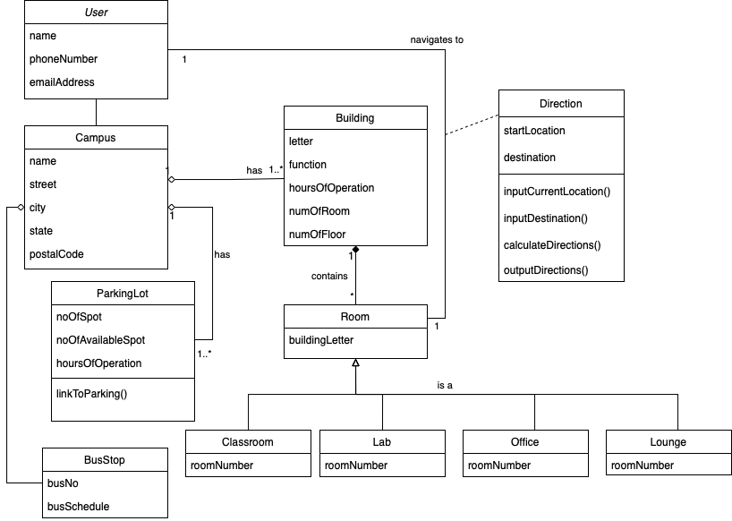

Not everything has been covered in this inception report, so more objects may be added as the project proceeds.