

[Name Hospitality AI Company]

Naomi Barranzuela Ali
e-mail: naomi.nba97@gmail.com
Linked in: https://www.linkedin.com/in/naomiba/
Github: https://github.com/Naomi3nba
Data
Analysis
Report

About This Report
This report was produced independently by Naomi Barranzuela Ali as part of a personal data analytics portfolio. It is not commissioned by, affiliated with, or endorsed by [Hospitality AI Company].
The dataset used throughout this analysis is entirely simulated — it was designed to reflect realistic hospitality AI usage patterns based on publicly available information about the sector, but does not represent actual operational data from any company or its clients. All hotels, interaction records, response times, resolution rates, and derived metrics presented in this report are fictional. Any resemblance to real operational results is coincidental and should not be interpreted as a representation of actual performance by [Hospitality AI Company] or any other organisation.
Why [Hospitality AI Company] as a reference? [Hospitality AI Company] is simulated Norway-based startup that builds autonomous AI agents for hotels, handling guest communication across email, web chat, social messaging, and voice — currently live across multiple properties in the Nordics. Their product context provided a realistic and relevant framework for simulating the type of interaction data analysed in this report.
Purpose: This project demonstrates skills in SQL, Python, and Power BI applied to a real-world hospitality AI use case — with the goal of contributing as a junior data analyst in a data-driven startup environment.
Naomi Barranzuela Ali

[Hospitality AI Company]
Operational Impact Analysis in Hotels
Norway · 2026 · Junior Data Analyst
PERFORMANCE HIGHLIGHTS

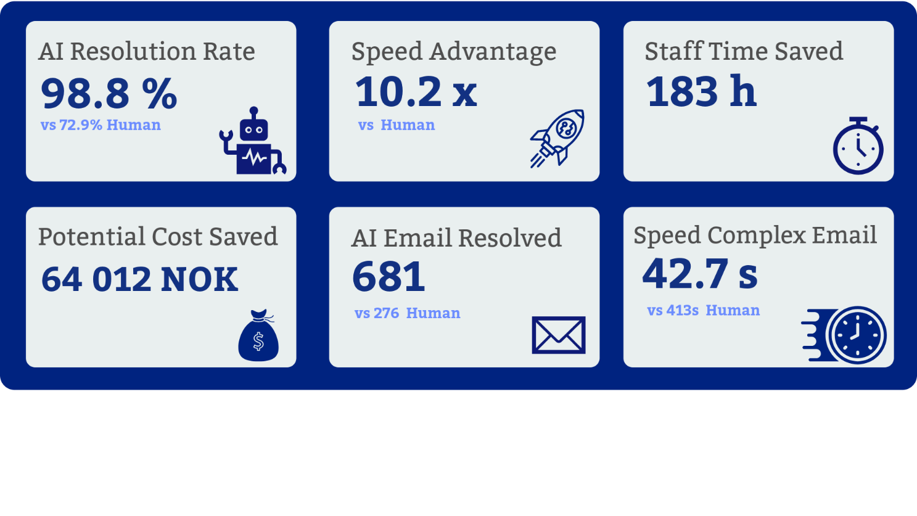

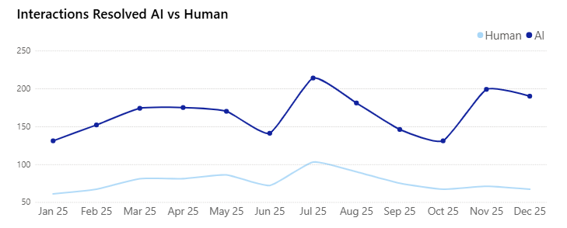

Table of Contents
1. Executive Summary 4
2. Business Context & Problem Statement 4
2.1 The Challenge 4
2.2 The Solution 4
3. Data Overview & Methodology 5
3.1 Dataset Scope 5
3.2 Analytical Workflow 5
3.3 Technical Approach 5
4. Data Quality Assessment 6
4.1 Missing Values 6
4.2 Duplicates 6
4.3 Standardisation & Final Summary 6
5. Volume Analysis 7
5.1 Distribution by Hotel 7
5.2 Distribution by Channel 7
5.3 Distribution by Hotel Size 8
5.4 Distribution by Request Type 8
5.5 Distribution by Complexity 9
5.6 Monthly Volume Trend 10
5.7 Hourly Heatmap — Peak Patterns 11

6. Performance Analysis 12
6.1 Response Time Distribution 12
6.2 AI vs Human Comparison 13
6.3 Resolution Rate 14
6.4 Correlation Analysis 15
7. KPI Results Summary 16
8. Strategic Recommendations 17
9. Limitations & Next Steps 18
10. Tools, Technologies & Project Structure 18
11. Conclusion 19

1. EXECUTIVE SUMMARY
This report evaluates the operational performance of AI assistants deployed across 10 hotels in Norway during 2025. Drawing on 5,000+ interaction records spanning website chat, email, Instagram, and Facebook, the analysis quantifies automation efficiency, response time improvements, and potential cost savings.
AI handled 61.6% of all interactions with a 98.8% resolution rate — compared to 72.9% for human agents — while responding 9.8× faster on average (36s vs 396s). Across the full portfolio this translates to 203.1 hours saved annually and an estimated 64,012 NOK in recovered operational cost.
Seasonal peaks in July, August, and November reach 2.1× baseline volume, presenting clear opportunities for proactive capacity planning. Data quality assessment revealed 17.84% missing language fields and a 5.82% duplicate rate — both addressed through documented cleaning rules ensuring analytical integrity.

"The data demonstrates measurable ROI from AI deployment and identifies specific areas for product improvement and operational scaling in a fast-paced hospitality environment."
2. BUSINESS CONTEXT & PROBLEM STATEMENT
2.1 The Challenge
Hotels face high volumes of repetitive guest inquiries across multiple digital channels — web chat, email, and social media. Manual handling creates staff workload bottlenecks, inconsistent response times (especially during peak seasons), and higher operational costs per interaction.
The hospitality sector in Norway is particularly exposed to seasonal demand spikes, with summer tourism and winter activities generating 2× or more interaction volume compared to off-peak months. Human-only support models struggle to scale efficiently under these conditions.
2.2 The Solution
[Hospitality AI Company] deploys conversational AI assistants to automate responses to common guest requests, provide 24/7 instant support, and escalate complex cases to human staff when needed. The system operates across website chat, email, Instagram, and Facebook — covering the four primary digital channels used by hotel guests in Norway.

"Does AI automation deliver measurable operational value without compromising guest experience?"

This report provides data-driven answers to that question, using 12 months of interaction data across 10 hotel properties.

3. DATA OVERVIEW & METHODOLOGY
3.1 Dataset Scope
Dimension | Value | Notes
Time Period | Jan – Dec 2025 | 12 months
Raw Records | 5,033 interactions / 3,610 handling | Before cleaning
Cleaned Records | 4,740 interactions / 3,292 matched | 94.2% retention rate
Hotels Covered | 10 properties | Norway only
Channels | Web chat, Email, Instagram, Facebook | 4 primary channels
Languages | Norwegian, English | 17.84% missing — imputed
Table 1. Dataset overview after cleaning pipeline.
3.2 Analytical Workflow
The project follows a standard start-up analytics pipeline prioritising reproducibility and business relevance:
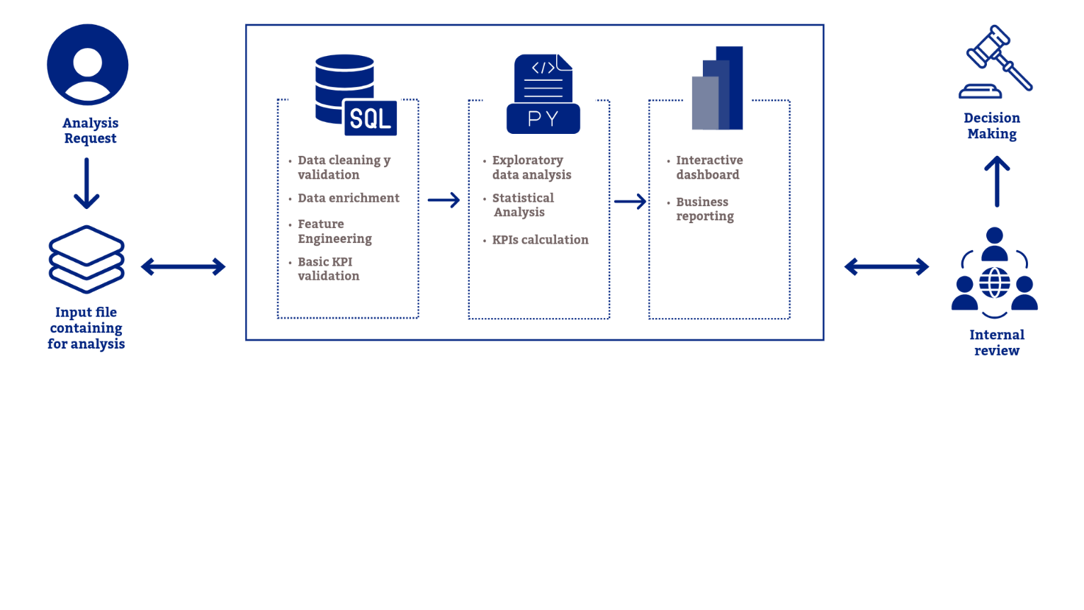
Figure 2. Analytical Workflow applied.
3.3 Technical Approach
Key transformations applied across the pipeline:
- Join interactions with handling records on interaction_id to create a unified analytical dataset.
- Enrich with hotel metadata (type, size, city, region).
- Feature engineering: month, quarter, weekday, time period, hotel_size_category, response_speed tier.
- Derived metrics: response time delta, resolution rate, automation rate, throughput capacity.

4. DATA QUALITY ASSESSMENT
4.1 Missing Values
Field | Missing % | Handling | Impact
language | 17.84% | Imputed by hotel location | Low
request_type | 0.24% | Replaced NULL → N/A | Low
response_time_s | 0.53% | Negatives set to NULL | Medium
resolved | 0.18% | NULL kept (minimal volume) | Low
Table 2. Missing value summary across both tables.
4.2 Duplicates
Duplicate analysis was performed on both the interactions and handling tables. The strategy differed by duplicate type:
- Same hotel_id + interaction_id: 15 records deleted, keeping earliest occurrence.
- Same interaction_id across multiple hotels: Earliest timestamp retained; hotel_unknown cases removed (4 cases).
- Handling duplicates: 9 records (0.25%) — all removed based on interaction_id uniqueness.

Stage | Interactions | Handling | Retention
Original records (raw) | 5,033 | 3,610 | 100%
After cleaning | 4,740 | 3,292 | 94.2% / 91.2%
Records removed | 293 | 318 | 5.8% / 8.8%
Final matched dataset | 3,292 | 3,292 | 100% match
Table 3. Cleaning summary — interactions and handling tables.
4.3 Standardisation
- hotel_99 → remapped to hotel_09; remaining unknown hotels set to "unknown" (438 records excluded from performance KPIs).
- channel: "websit_chat" corrected to "website_chat".
- language: "NO ", "ENG" standardised to "NO", "EN".
- resolved: "yes"/"no" converted to TRUE/FALSE boolean.
- complexity: NULL values imputed with mode (most frequent category).
- request_type: "servce" corrected to "service_request".

5. VOLUME ANALYSIS
5.1 Distribution by Hotel
Lillehammer xxx leads AI-resolved interactions with 215 cases, followed closely by Bergen xxx and Oslo xxx. The remaining properties show a consistent distribution between 135–165 interactions.
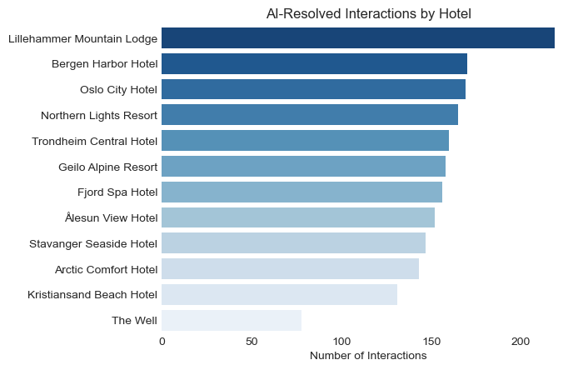
Figure 2. AI-resolved interactions by hotel property, sorted by volume.
5.2 Distribution by Channel
Channel performance confirms AI's operational strength across all digital touchpoints. Website chat leads with ~830 AI-resolved interactions, followed by email (~680), Facebook and Instagram (~490). AI deployment across all channels. 74% of resolutions occur through direct digital channels (website chat + email), while social media (Facebook + Instagram) represents an untapped growth opportunity.
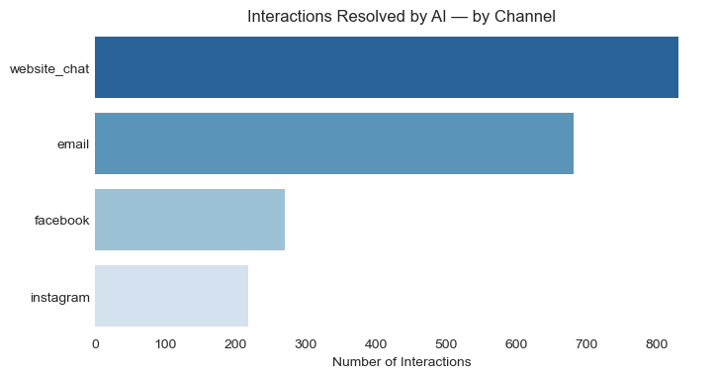
Figure 3. Interaction volume by channel. Website chat leads at 43.2% followed by email at 31.5%.
5.3 Distribution by Hotel Size
Large hotels dominate AI-resolved interactions (~1,450 vs ~390 for Small) — representing 79% of total AI resolutions. However, when adjusted per property, small hotels show a higher interaction rate per hotel, suggesting greater relative dependency on AI support despite lower absolute volume.
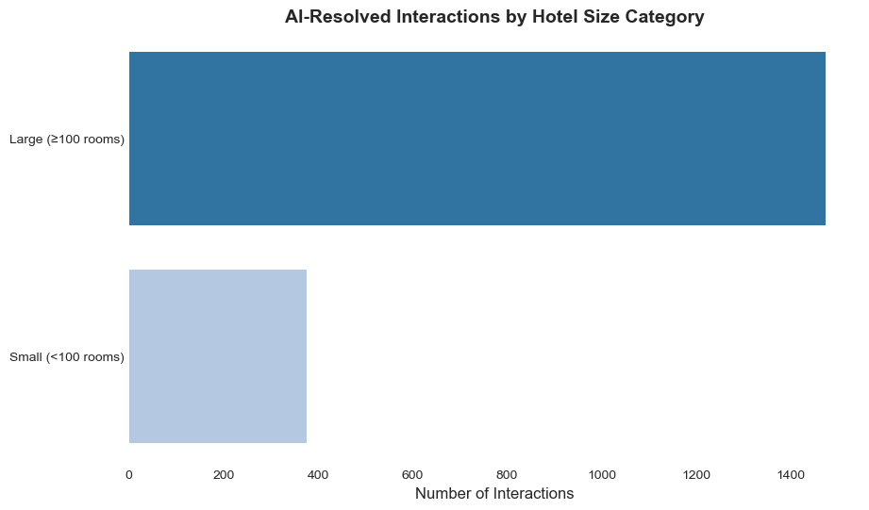
Figure 4. Interaction volume by hotel size category. Large hotels dominate with 74% of total volume.

5.4 Distribution by Request Type
Information requests (35%) represent the largest category — a strong signal that AI can deliver immediate value by automating FAQ-style responses. Booking (17%) and service requests (15%) represent high-value interaction types where resolution quality directly impacts revenue.
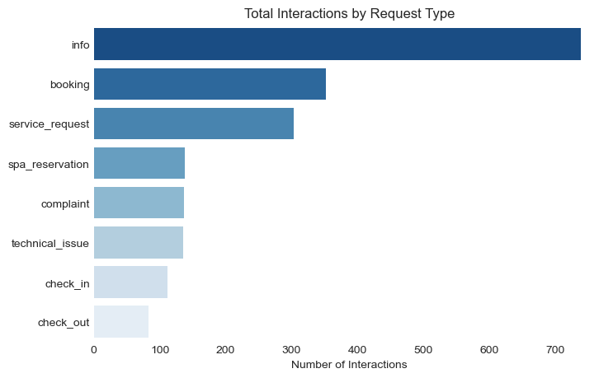
Figure 5. Interaction volume by request type. "Info" requests account for over one-third of all interactions.
5.5 Distribution by Complexity
Simple interactions dominate AI-resolved volume (~1,050), confirming AI's strength in handling routine guest requests. Notably, complex interactions (~600) outnumber medium ones (~370) — suggesting AI is effectively deployed beyond basic queries, adding operational value across all complexity tiers.

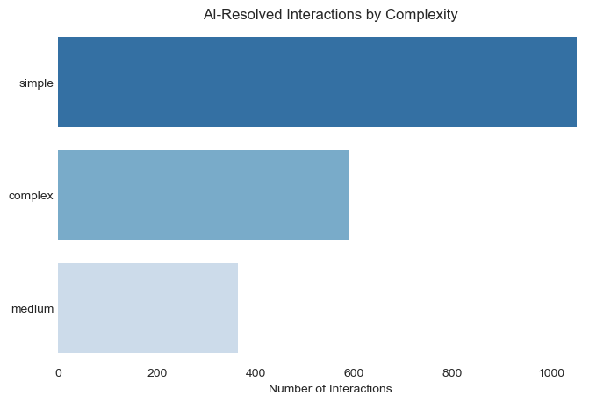
Figure 6. Interaction volume by complexity. "Simple" dominate AI-resolved.
5.6 Monthly Volume Trend
AI-resolved interactions follow a clear seasonal pattern, peaking in July (~215) and November (~200) while reaching their lowest points in June (~140) and October (~130). The sharp June dip — interrupting the expected upward trend toward summer — likely reflects Norwegian-specific patterns such as Constitution Day and school calendar shifts. The October trough precedes a strong November recovery, consistent with the onset of winter tourism season in Norway. Overall, the 1.6× difference between peak (July) and trough (October) confirms that AI capacity planning should prioritise these two seasonal surges rather than treating demand as uniform throughout the year.
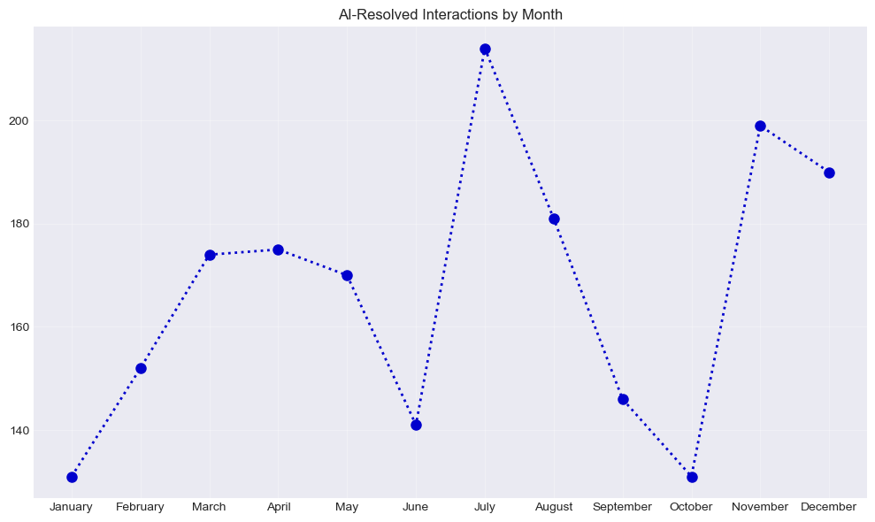
Figure 7. Monthly interaction volume. Peak months: July, August, and November. Trough: January.

Metric | Value | Metric | Value
Peak month | July (~215 interactions) | Trough month | October (~130 interactions)
Peak/trough ratio | 1.6× | Summer share  (Jul–Aug) | ~30% of annual AI-resolved
Rise to peak | Jan → Jul: +65% | November spike | ~200 — winter tourism
June anomaly | Sharp dip to ~140 | Pattern | Bimodal (July + November)
Table 4. Seasonality metrics — 2025 interaction volume.

5.7 Hourly Heatmap — Peak Patterns
The heatmap reveals a consistent dual-peak pattern across all days of the week — 10 AM and 1 PM — enabling precise staffing and AI capacity planning. Notably, the 7-day similarity simplifies operational planning: no weekend-specific strategies are required.
An anomalous spike at 18:00 (6 PM) identified during correlation analysis suggests a possible shift change or reduced AI coverage during staff handoff — a priority area for operational review.

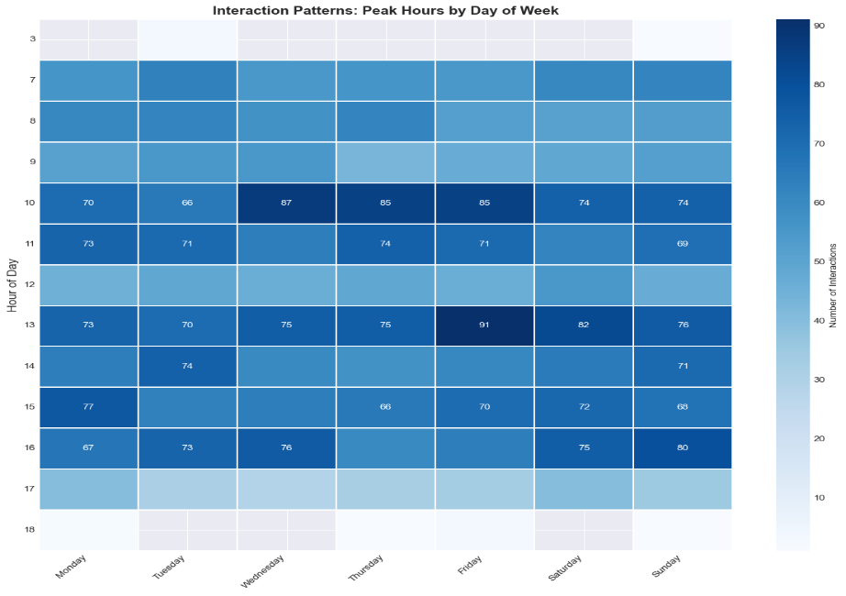
Figure 8. Heatmap of interactions by hour and day of week. Dual peaks at 10:00 and 13:00.

6. PERFORMANCE ANALYSIS
6.1 Response Time Distribution
Performance analysis was conducted on the matched dataset (df_match, 3,292 records) containing complete interaction + handling data.
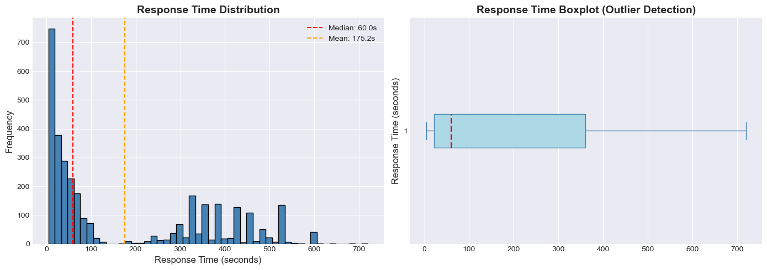
Figure 9. Response time distribution — full dataset. Bimodal pattern: fast cluster (0–100s) and delayed cluster (300–720s).

Statistic | Value | Statistic | Value
Median | 60.0s | Mean | 175.2s (skewed by tail)
Min | 4.7s | Max | 720s (12 minutes)
P25 | 21.5s | P75 | 360s
P95 | 520.0s | Extreme (>P95) | 59 interactions (1.8%)
Table 5. Response time descriptive statistics — full matched dataset.
The 2.9× mean/median divergence reveals a heavily right-skewed distribution. Using mean for SLA targets would misrepresent actual service delivery: the median (60s) is the more appropriate benchmark for operational planning.
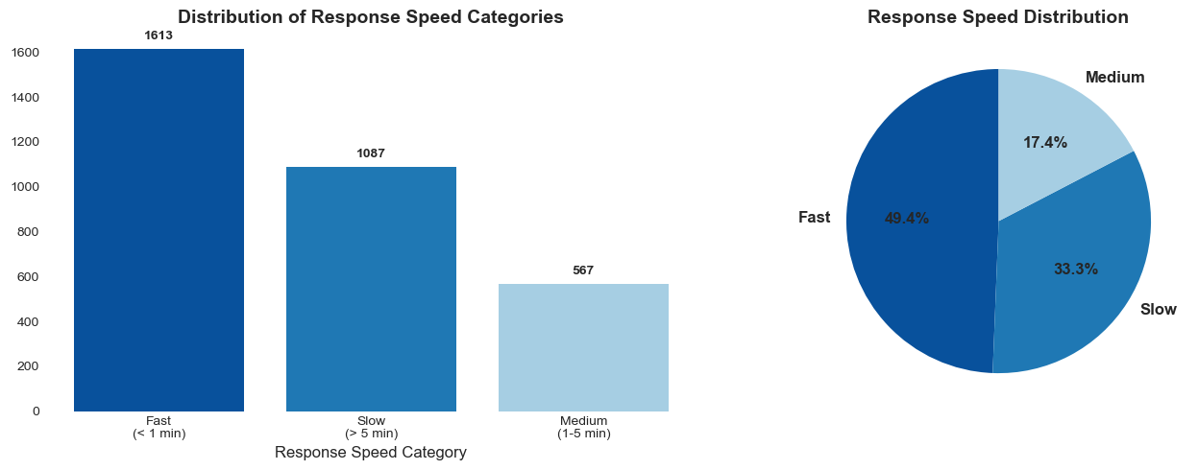
Figure 10. Response speed category distribution. Fast (<60s): 49.4% · Medium (60–300s): 17.4% · Slow (>300s): 33.3%.
6.2 AI vs Human Comparison
AI and human handlers operate in entirely separate performance tiers. AI responses cluster tightly in the 20–50 second range with minimal variability, while human responses range from 3 to 12 minutes with significant inconsistency.

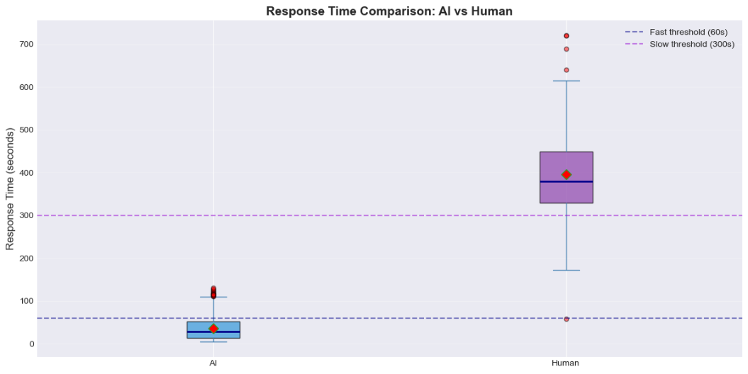
Figure 11. Boxplot comparison — AI vs Human response time. Complete performance separation with zero overlap.

Metric | AI | Human | Difference
Median response time | ~35s | ~380s | 10.9× faster
IQR (variability) | ~30s | ~130s | 4.3× more consistent
Fast responses (<60s) | ~100% | ~0% | +100 pts
Slow responses (>300s) | ~0% | ~75% | −75 pts
Throughput capacity | 100.5/hr | 9.1/hr | 10× higher
Table 6. AI vs Human performance metrics comparison.

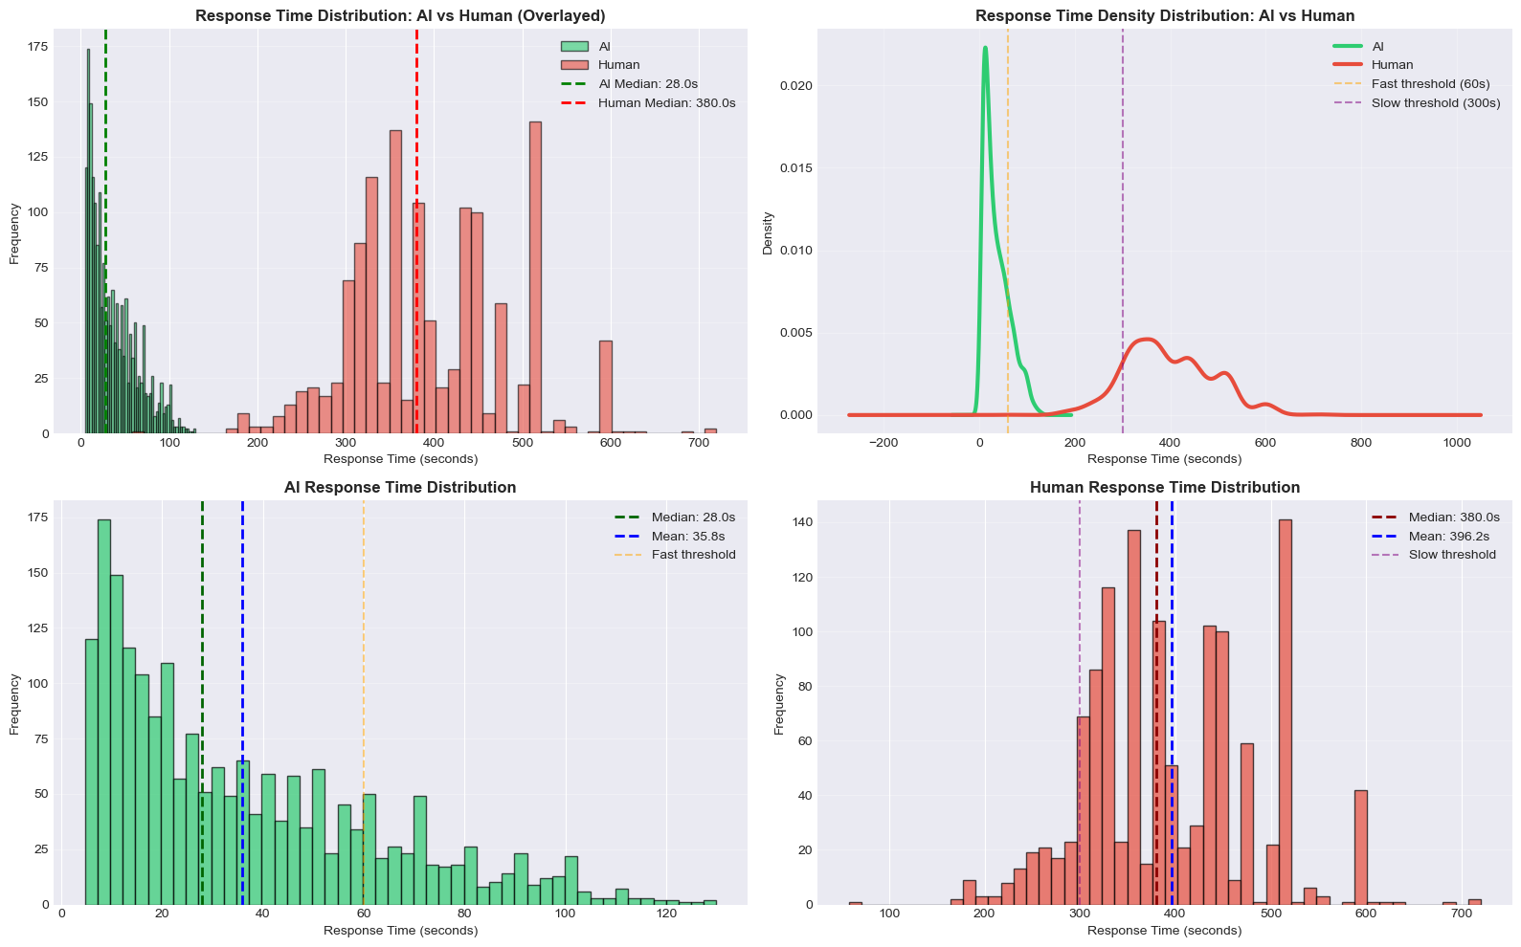
Figure 12. Density comparison — AI (green) vs Human (red). Zero performance overlap between handler types.

6.3 Resolution Rate
AI achieves near-perfect resolution (98.8%) while handling 60% more volume than human agents. The 27.1% unresolved rate for human handlers — representing 342 interactions — creates compounding guest dissatisfaction and escalation costs. This dual advantage (faster + higher quality) provides strong justification for AI expansion.

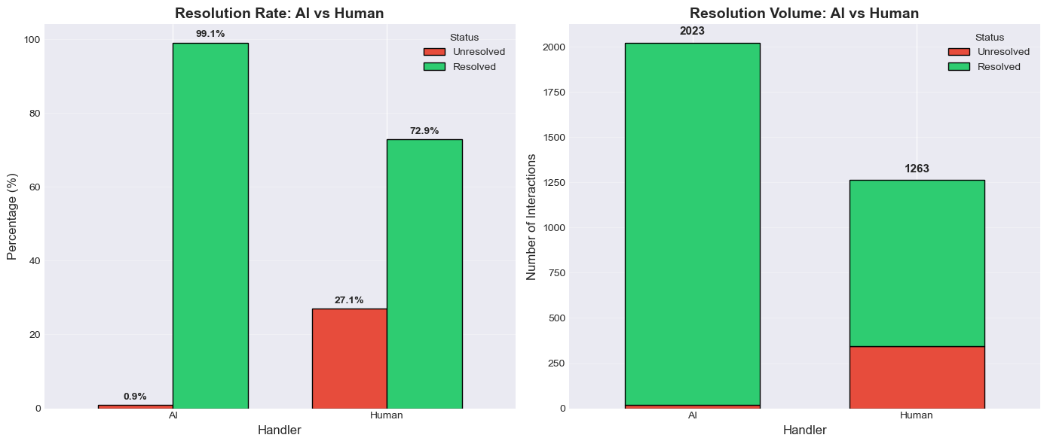
Figure 13. Resolution rate comparison — AI 98.8% vs Human 72.9%. A 25.9 percentage point quality gap.
6.4 Correlation Analysis
Response Time vs Complexity
A counterintuitive finding: complexity level shows minimal impact on response time. All three categories (Simple, Medium, Complex) exhibit nearly identical median response times (~50–60s). The true determinant is handler type — AI resolves complex queries as quickly as simple ones, while humans are slow regardless of complexity.
This challenges the traditional assumption that complex tasks must go to humans. 51% of extreme delays (>530s) occurred on simple or medium complexity interactions — indicating significant misrouting opportunities for AI reallocation.
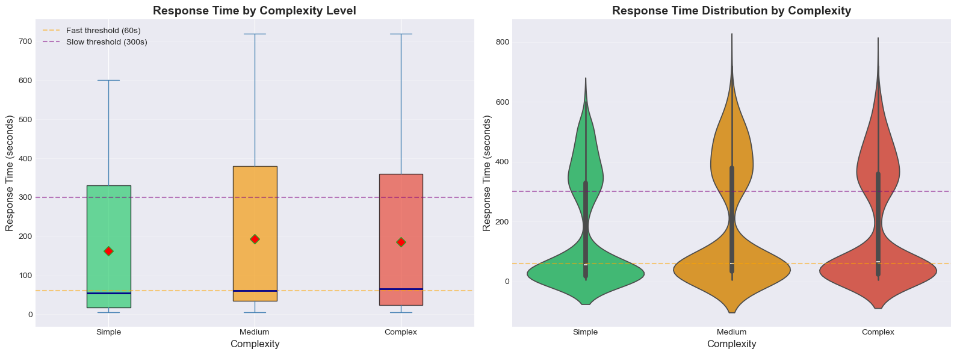
Figure 14. Response time by complexity level. Minimal correlation — handler type drives speed, not task difficulty.
Response Time vs Hour of Day
Peak volume hours (10–11 AM, 1 PM) show no response time degradation — confirming adequate current capacity. The isolated 18:00 spike (median ~550s vs typical 50–80s) likely reflects a shift change or reduced AI coverage, and warrants targeted investigation.
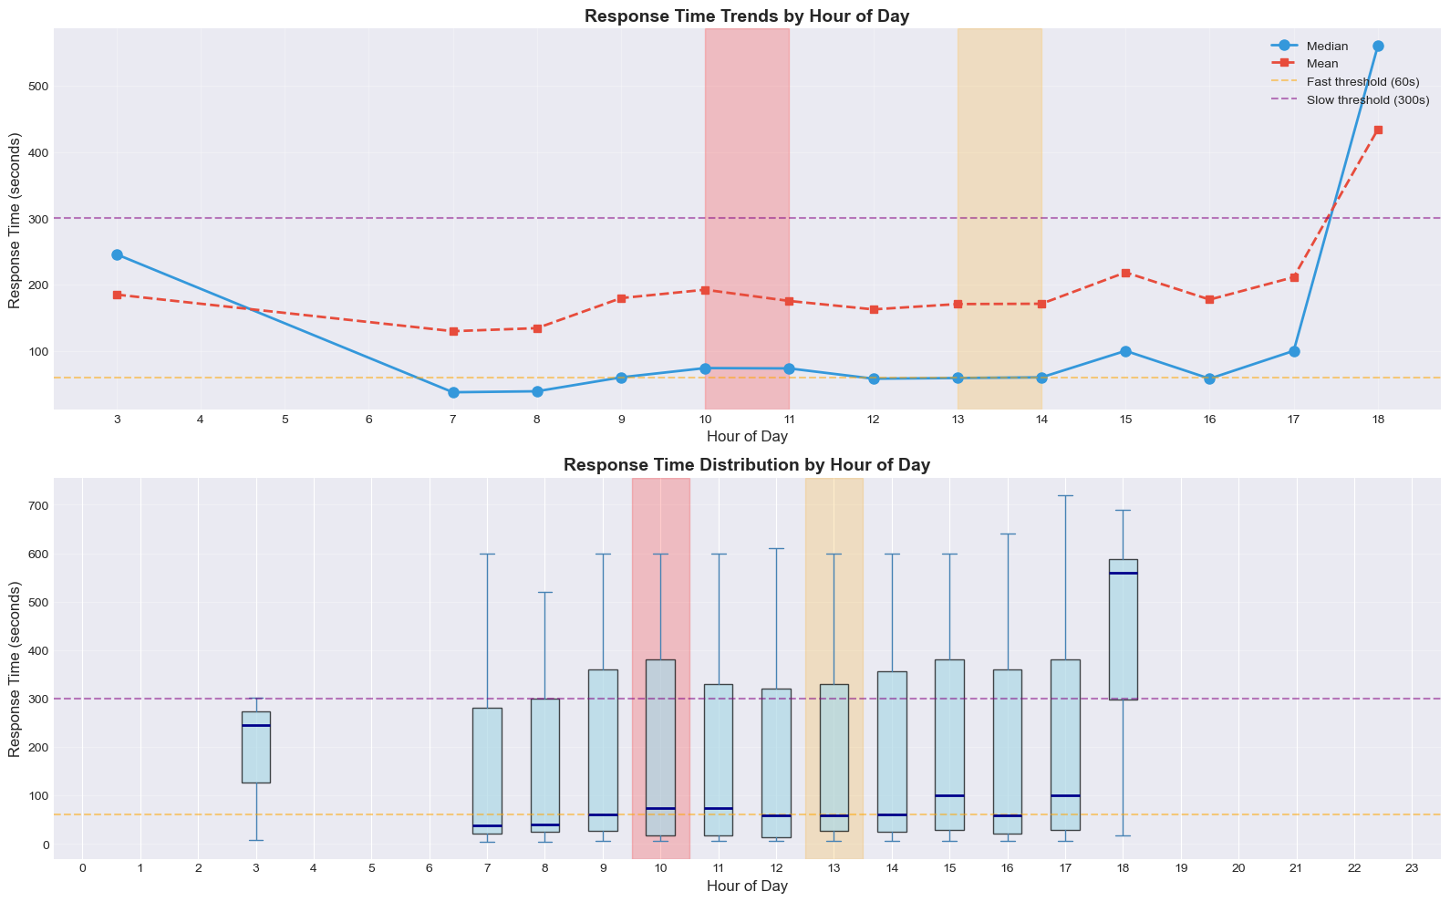
Figure 15. Response time by hour of day. Stable performance 03:00–17:00, with an anomalous spike at 18:00 (6 PM).
7. KPI RESULTS SUMMARY
Performance KPIs — AI vs Human
KPI | AI | Human | Overall | AI advantage
Resolution rate  Interactions resolved | 98.8% | 72.9% | 88.9% | +25.9pp
Avg. response time  Lower is better | 35.8s  0.6 min | 364.4s  6.1 min | 175.2s  2.9 min | 90.2% faster  10.2x speed
Time saved / interaction | 328.5 seconds per interaction |  |  | 182.9 h total
Unresolved cases  Lower is better | 1.2%  25 cases | 27.1%  342 cases | 11.1%  367 total | −25.9 pp
Fast response rate  Replied in under 60s | 80.4% | 0.1% | 49.0% | +80.3 pp
Throughput capacity  Interactions / hour | 100.5 /h | 9.9 /h | — | +917%  10.2x capacity
Email resolved  Channel: email | 681  71.2% share | 276  28.8% share | 957 total | AI covers 71.2%
Complex email speed  Complex ticket via email | 42.7s | 413.7s | — | 90.7% faster  9.7x speed
Table 7. Primary KPI comparison — AI vs Human — full year 2025.

Volume & Efficiency KPIs
Metric | Value | Notes
Total interactions (full) | 4,740 | For volume KPIs
Matched interactions | 3,292 | For performance KPIs
AI interactions  Of matched records | 2,004 60.9% | Human: 921 28.0%
Time saved by AI  vs if handled by Human | 182.9 hours | 22.9 working days at 8 h/day
Potential Cost saved  At 350 NOK/h rate | 64,012 NOK | 2,800 NOK /day saved
Table 8. Volume and efficiency KPI summary — full year 2025.

8. STRATEGIC RECOMMENDATIONS
Four Priority Actions for Operational Impact
01 | Expand AI Coverage for Simple & Medium Cases
51% of the slowest human-handled interactions were classified as simple or medium complexity. Reallocating these to AI would reduce median response time for a significant portion of guests from ~380s to under 60s. Current data shows AI resolves complex queries as efficiently as simple ones — making complexity-based routing to humans largely redundant for the majority of cases.
Recommended action: Audit all human-handled simple and medium interactions. Implement AI triage to filter out cases that do not genuinely require human expertise.
02 | Prioritise AI on Website Chat Channel
Website chat is both the highest-volume channel (43.2%) and the most time-sensitive for guests. Analysis of extreme delays (>530s) shows that 39% occur on website chat — all human-handled — representing severe service failure on a synchronous channel where guests expect immediate responses.
Recommended action: Deploy AI as the first-response layer on website chat for all simple and medium complexity requests. Set target: 100% of website chat interactions receive an AI-generated first response within 60 seconds.
03 | Build Seasonal Capacity Planning
July, August, and November reach 2.1× baseline interaction volume. The current system handles peak hours (10 AM, 1 PM) without degradation — confirming sufficient baseline capacity — but monthly volume spikes require proactive AI configuration, not reactive management.
Recommended action: Pre-configure AI capacity thresholds and routing rules 4–6 weeks before peak months. Monitor the anomalous 18:00 spike for potential shift-change-related coverage gaps.
04 | Implement Automated Data Quality Monitoring
17.84% missing language fields and 5.82% duplicate records required significant manual remediation during this analysis cycle. In a production environment, these issues compound over time and degrade model performance — particularly for language-specific AI routing.
Recommended action: Implement automated validation rules at data ingestion (monthly batch entry point). Flag missing language, duplicate interaction IDs, and negative response times in real time. Estimated remediation time reduction: 60–70% per cycle.

9. LIMITATIONS & NEXT STEPS
Analytical Limitations
Limitation | Detail | Mitigation
Simulated data | Dataset modelled on real patterns — not actual customer data | Documented assumptions
Single year | No year-over-year comparison possible | Trend analysis within 2025
No satisfaction data | Guest satisfaction scores not linked to interactions | Flagged as next step
No A/B testing | Cannot establish causal relationships — observational only | Acknowledged in findings
Coverage gap | 30.5% of interactions lack handling data (1,448 records) | Full dataset used for volume KPIs
Table 9. Known limitations and mitigations.
10. TOOLS, TECHNOLOGIES & PROJECT STRUCTURE
Technical Stack
Layer | Tool | Purpose
Data Processing | SQL (PostgreSQL) | Cleaning, enrichment, feature engineering, KPI validation
Analysis | Python 3.x | EDA, statistical analysis, KPI calculation (pandas, numpy, matplotlib, seaborn)
Notebooks | Jupyter | Exploratory analysis and documentation
Visualisation | Power BI Desktop | Interactive dashboard — DAX measures, SVG custom visuals, dynamic parameters
Version Control | Git / GitHub | Code versioning, project documentation, README
Table 10. Technical stack overview.

CONCLUSION
This analysis demonstrates that AI automation delivers clear, measurable operational value across all 10 Norwegian hotel properties studied. The data shows a consistent dual advantage: AI resolves more interactions (98.8% vs 72.9%) while responding 9.8× faster (36s vs 396s) — without any trade-off between speed and quality.
The 183 hours saved annually and 64,012 NOK in potential recovered cost represent conservative estimates based on matched interaction data only. Expanding AI coverage to simple and medium complexity cases — currently misrouted to human agents — would materially increase these figures.
From a portfolio perspective, this project demonstrates readiness to contribute to data-driven decision-making in a fast-paced SaaS or hospitality-tech environment, with skills directly applicable to early-stage and scaling companies in Norway.

Naomi Barranzuela Ali · Junior Data Analyst · Norway 2025
[naomi.nba97@gmail.com] · [naomiba]

