BUSINESS ANALYSIS PROJECT
E-Commerce Order Management System
Karoo Market
Industry: E-commerce
Role: Business Analyst
Project Type: Digital Process & System Improvement

Portfolio Case Study

Naomi Mohlala
naomimohlala2@gmail.com
https://naomimohlala.github.io/portfolio/

Table of Contents
Table of Contents 2
1. Business Case 4
1.1 Project Overview 4
1.2 Business Problem 4
1.3 Business Objectives 4
1.4 Current Performance Baseline 4
2. Stakeholder Analysis 4
3. Problem Statement & Scope 5
3.1 Problem Statement 5
3.2 In Scope 5
3.3 Out of Scope 5
4. Requirements 5
4.1 Functional Requirements 5
4.2 Non-Functional Requirements 6
5. User Stories & Acceptance Criteria 6
US-001 — Place an Order 6
US-002 — Track an Order 7
US-003 — Update Inventory 7
US-004 — Process Payment 7
US-005 — Manage Fulfilment 7
6. Business Rules 8
7. Order Management Process 8
7.1 As-Is Process 8
7.2 Key As-Is Problems 9
7.3 To-Be Process 10
7.4 Process Improvement Summary 11
8. Use Case — Place an Order 11
8.1 Main Flow 11
8.2 Alternative Flows 11
9. Data Analysis & KPIs 12
10. Test Cases 12
11. Requirements Traceability Matrix 13
12. Risks & Mitigations 13
13. Final Recommendation 13
13.1 Recommended Solution 13
13.2 Implementation Priorities 13
13.3 Expected Business Benefits 14
13.4 Conclusion 14
14. Portfolio Summary 14

1. Business Case

1.1 Project Overview
Karoo Market is an e-commerce business experiencing operational issues across its order lifecycle. Orders are currently processed through disconnected systems, creating delays, inaccurate inventory information, payment-related failures, limited order visibility, and avoidable customer complaints.

1.2 Business Problem
The current order-management process does not provide a single, reliable view of orders, inventory, payments, and fulfilment status. Manual processing and system fragmentation increase the risk of incorrect stock information, duplicate orders, delayed fulfilment, and poor customer communication.

1.3 Business Objectives
- Centralise order information and processing.
- Improve inventory accuracy and availability visibility.
- Integrate payment processing into the order lifecycle.
- Provide customers with reliable order tracking.
- Reduce manual order-processing activities.
- Reduce order-related complaints and processing delays.

1.4 Current Performance Baseline
Metric | Current | Target
Order processing time | 14 minutes | < 5 minutes
Inventory accuracy | 82% | 98%
Payment failure rate | 8% | < 3%
Order-related complaints | 16% | < 7%
Manual processing | 65% | < 20%

2. Stakeholder Analysis
Stakeholders are individuals or groups affected by the order-management process or involved in implementing the solution.
Stakeholder | Role / Interest | Influence | Key Need
Customers | Purchase products and track orders | High | Accurate orders and visibility
Sales Team | Supports sales and customer orders | High | Reliable order status
Warehouse | Picks, packs and dispatches orders | High | Accurate inventory
Finance | Handles payments, refunds and reconciliation | High | Reliable payment data
Customer Service | Handles order-related queries | High | Real-time order information
IT Team | Implements and supports solution | High | Clear technical requirements
Management | Owns business outcomes | High | Efficiency and revenue improvement
Delivery Partners | Fulfil customer deliveries | Medium | Accurate shipment details

3. Problem Statement & Scope

3.1 Problem Statement
Karoo Market's fragmented order-management process creates inconsistent information between sales, inventory, payment, warehouse and customer-service activities. This leads to slow processing, incorrect stock visibility, payment failures, duplicate orders and poor customer experience.

3.2 In Scope
- Customer order creation and checkout.
- Inventory validation and update.
- Payment processing integration.
- Order confirmation and notifications.
- Order-status tracking.
- Order cancellation and refund initiation.
- Warehouse order visibility.
- Operational reporting.

3.3 Out of Scope
- Product manufacturing.
- Supplier procurement systems.
- Payroll and HR systems.
- Redesign of the company's entire accounting platform.

4. Requirements

4.1 Functional Requirements
ID | Requirement | Priority
FR-001 | The system must allow customers to add products to a shopping cart. | High
FR-002 | The system must validate product availability before order confirmation. | Critical
FR-003 | The system must calculate the order total, including applicable delivery charges. | High
FR-004 | The system must process payments through an approved payment provider. | Critical
FR-005 | The system must create an order after successful payment. | Critical
FR-006 | The system must update inventory after a successful order. | Critical
FR-007 | The system must generate order confirmation. | High
FR-008 | Customers must be able to view order status. | High
FR-009 | Customers must be able to request order cancellation where business rules permit. | Medium
FR-010 | The system must support refund initiation for eligible cancelled orders. | High
FR-011 | Warehouse staff must be able to view orders requiring fulfilment. | High
FR-012 | Management must be able to access order and operational performance reports. | Medium

4.2 Non-Functional Requirements
ID | Requirement | Priority
NFR-001 | Checkout pages should respond within 3 seconds under normal operating conditions. | High
NFR-002 | Customer payment information must be protected using appropriate security controls. | Critical
NFR-003 | The solution should be available 99.5% of the time. | High
NFR-004 | The system must maintain an audit trail for key order-status changes. | High
NFR-005 | The solution must support desktop and mobile users. | High
NFR-006 | The system should support concurrent users during peak sales periods. | High

5. User Stories & Acceptance Criteria

US-001 — Place an Order
As a customer, I want to place an order online so that I can purchase products without contacting customer service.
Acceptance Criteria:
- Customer can add an available product to the cart.
- System validates stock before order confirmation.
- Customer can select a valid payment method.
- Successful payment creates an order.
- Customer receives an order confirmation.

US-002 — Track an Order
As a customer, I want to track my order so that I know its status and expected delivery.
Acceptance Criteria:
- Customers can view the order from their account.
- Current order status is displayed.
- Estimated delivery date is displayed where available.
- Tracking information is displayed when provided by the delivery partner.

US-003 — Update Inventory
As a warehouse employee, I want inventory to update automatically when an order is completed so that stock levels remain accurate.
Acceptance Criteria:
- Inventory decreases after successful order creation.
- Unavailable products cannot be oversold.
- Updated stock is visible to authorised users.

US-004 — Process Payment
As a customer, I want my payment to be processed securely so that my order can be confirmed.
Acceptance Criteria:
- Payment request is sent to the approved payment provider.
- Successful payment returns a success response.
- Failed payment does not create a confirmed order.
- Customer receives appropriate payment feedback.

US-005 — Manage Fulfilment
As a warehouse employee, I want to see paid orders requiring fulfilment so that I can pick, pack and dispatch them.
Acceptance Criteria:
- Paid orders appear in the fulfilment queue.
- Order details and quantities are visible.
- Order status can be updated as fulfilment progresses.

6. Business Rules
ID | Business Rule
BR-001 | An order cannot be confirmed unless required customer and delivery information is provided.
BR-002 | A product must have sufficient available stock before it can be ordered.
BR-003 | A confirmed order must have a successful payment response or an approved alternative payment status.
BR-004 | Inventory must be updated when an order is successfully confirmed.
BR-005 | A cancelled order may only be refunded according to the applicable refund policy.
BR-006 | Orders already dispatched cannot be cancelled through the standard customer workflow.
BR-007 | Only authorised staff may change order status manually.
BR-008 | Every material order-status change must be recorded in the audit trail.

7. Order Management Process

7.1 As-Is Process
Customer places an order → Sales/order system receives order → Stock is checked manually or through a separate system → Payment is processed → Warehouse receives order → Order is fulfilled → Customer is updated.
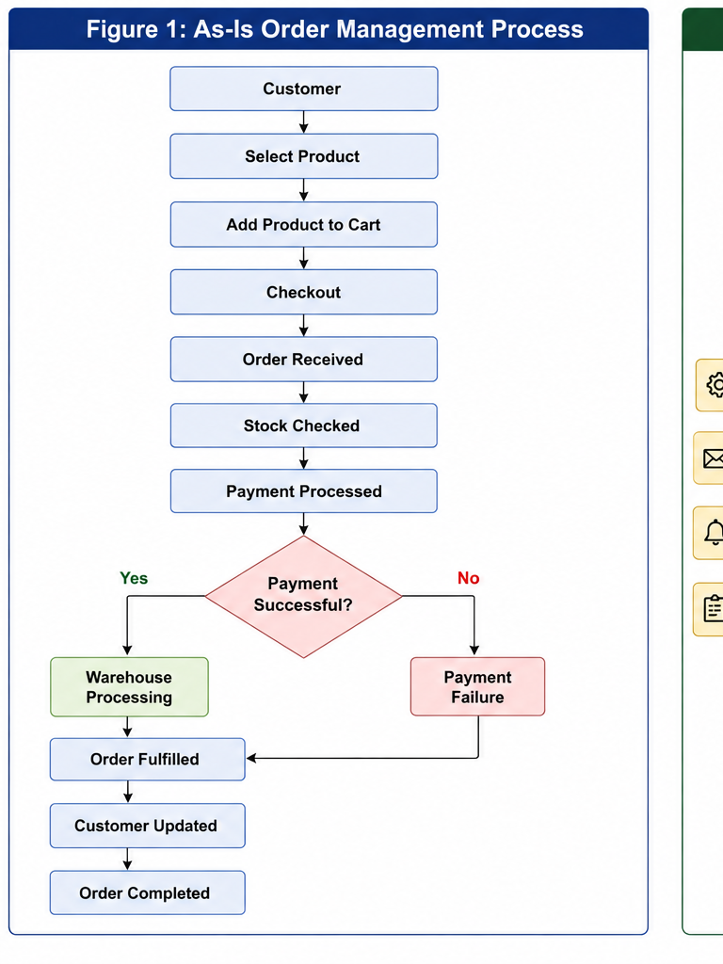

7.2 Key As-Is Problems
- Disconnected systems create inconsistent order information.
- Inventory information may not be updated immediately.
- Payment and order confirmation are not fully integrated.
- Customers have limited real-time order visibility.
- Manual intervention increases processing time and errors.

7.3 To-Be Process
Customer selects product → System validates stock → Customer checks out → Payment is processed → Order is created automatically → Inventory is updated → Confirmation is sent → Warehouse receives fulfilment request → Order is dispatched → Tracking is updated → Customer receives status notifications.
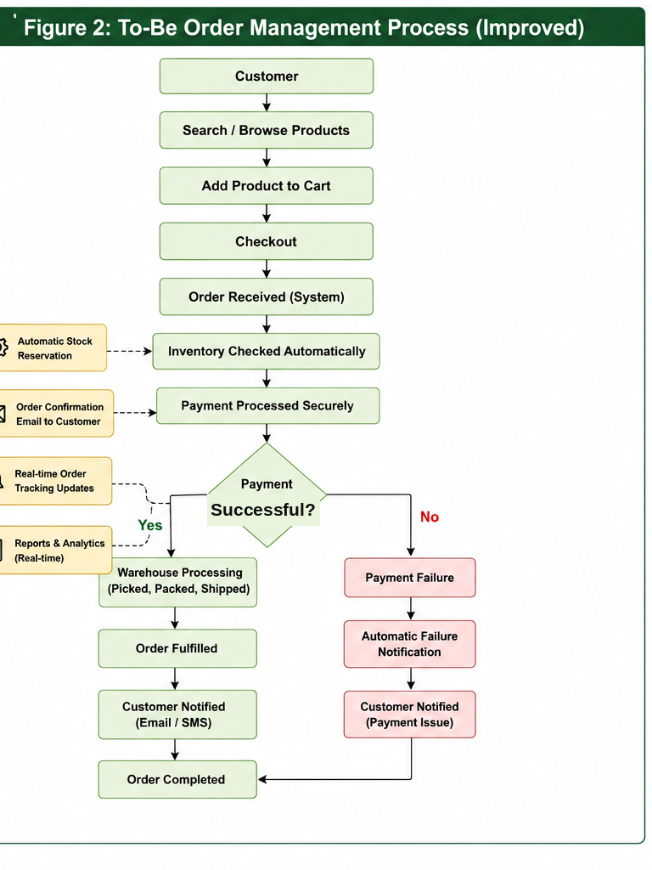

7.4 Process Improvement Summary
Area | Current Process | Proposed Process
Order creation | Multiple/manual steps | Centralised
Stock validation | Disconnected/manual | Real-time validation
Payment | Separate process | Integrated
Inventory update | Delayed risk | Automatic
Customer tracking | Limited | Self-service tracking
Notifications | Manual/inconsistent | Automated
Reporting | Fragmented | Centralised reporting

8. Use Case — Place an Order
Field | Description
Use Case ID | UC-001
Use Case | Place an Order
Primary Actor | Customer
Supporting Actors | Payment Provider, Inventory Service, Warehouse
Preconditions | Products are available and customers have provided required checkout information.
Trigger | Customer selects 'Place Order'.
Postcondition | Confirmed order exists and inventory is updated after successful payment.

8.1 Main Flow
- Customer reviews cart.
- System validates stock.
- System calculates order total.
- Customer submits payment.
- Payment provider returns successful payment response.
- System creates confirmed order.
- System updates inventory.
- System sends order confirmation.
- Warehouse receives fulfilment requests.

8.2 Alternative Flows
- If stock is unavailable, the customer is informed and the order cannot be confirmed for that item.
- If payment fails, the order remains unconfirmed and the customer is prompted to retry or select another payment method.
- If a technical failure occurs after payment, the transaction must be reconciled before the order is confirmed or refunded.

9. Data Analysis & KPIs
The BA should use operational data to validate the problem, establish a baseline and monitor the solution after implementation.
KPI | Current | Target | Business Purpose
Order processing time | 14 min | < 5 min | Measure operational efficiency
Inventory accuracy | 82% | 98% | Reduce stock-related issues
Payment failure rate | 8% | < 3% | Improve successful checkout
Order-related complaints | 16% | < 7% | Improve customer experience
Manual processing | 65% | < 20% | Reduce operational workload
Order fulfilment SLA | 78% | 95%+ | Improve delivery readiness
Order cancellation rate | 9% | < 6% | Identify avoidable order issues

10. Test Cases
Test ID | Requirement | Test Scenario | Expected Result
TC-001 | FR-001 | Add an available product to cart | Products appear in carts with correct quantity.
TC-002 | FR-002 | Attempt to purchase an out-of-stock product | System prevents confirmation and displays availability message.
TC-003 | FR-003 | Complete checkout with delivery charges | Correct total is calculated.
TC-004 | FR-004 | Submit valid payment | Payment succeeds and response is recorded.
TC-005 | FR-005 | Complete successful payment | Confirmed order is created with unique order number.
TC-006 | FR-006 | Complete successful order | Inventory quantity is reduced correctly.
TC-007 | FR-007 | Complete successful order | Customer receives confirmation.
TC-008 | FR-008 | Open an existing order | Status and delivery information are displayed.
TC-009 | FR-009 | Cancel an eligible order | Cancellation requests are accepted according to policy.
TC-010 | FR-010 | Process eligible refund | Refund requests are initiated and recorded.
TC-011 | FR-011 | Warehouse opens fulfilment queue | Paid orders requiring fulfilment are displayed.
TC-012 | FR-012 | Manager requests performance report | Relevant order KPIs are generated.

11. Requirements Traceability Matrix
Requirement ID | Requirement | User Story | Test Case | Priority
FR-001 | Shopping cart | US-001 | TC-001 | High
FR-002 | Stock validation | US-001 | TC-002 | Critical
FR-003 | Order total calculation | US-001 | TC-003 | High
FR-004 | Payment processing | US-004 | TC-004 | Critical
FR-005 | Order creation | US-001 | TC-005 | Critical
FR-006 | Inventory update | US-003 | TC-006 | Critical
FR-007 | Order confirmation | US-001 | TC-007 | High
FR-008 | Order tracking | US-002 | TC-008 | High
FR-009 | Order cancellation | US-001 | TC-009 | Medium
FR-010 | Refund initiation | US-001 | TC-010 | High
FR-011 | Fulfilment queue | US-005 | TC-011 | High
FR-012 | Operational reporting | — | TC-012 | Medium

12. Risks & Mitigations
Risk | Severity | Potential Impact | Mitigation
Incorrect inventory data | High | Overselling and customer complaints | Real-time stock validation and reconciliation
Payment integration failure | High | Orders cannot be confirmed | Error handling, retry logic and payment reconciliation
Poor user adoption | Medium | Staff continue manual workarounds | Training, stakeholder involvement and monitoring
System downtime | High | Lost sales and customer disruption | Availability monitoring and recovery procedures
Data security breach | Critical | Customer and financial impact | Access controls, security testing and audit logging

13. Final Recommendation

13.1 Recommended Solution
Karoo Market should implement a centralised Order Management System that integrates order creation, inventory validation, payment processing, fulfilment, customer notifications and order tracking.

13.2 Implementation Priorities
- Phase 1: Centralise order creation, stock validation and payment integration.
- Phase 2: Integrate warehouse fulfilment and customer order tracking.
- Phase 3: Implement notifications, dashboards and continuous KPI monitoring.

13.3 Expected Business Benefits
- Faster order processing.
- Higher inventory accuracy.
- Fewer payment-related order failures.
- Reduced manual processing.
- Improved customer visibility and satisfaction.
- Better operational reporting and decision-making.

13.4 Conclusion
The proposed Order Management System addresses the main process and information gaps identified in Karoo Market's current environment. By centralising order data and automating key activities, the business can improve operational efficiency, reduce avoidable errors and provide customers with more reliable purchasing experience.

14. Portfolio Summary
This case study demonstrates practical Business Analyst capabilities including business problem analysis, stakeholder analysis, requirements engineering, user stories, acceptance criteria, business rules, process analysis, use cases, KPI definition, test-case design, requirements traceability, risk analysis and solution recommendation.
Suggested portfolio title: Karoo Market — E-Commerce Order Management System Business Analysis Case Study.

