BUSINESS ANALYSIS PROJECT
Customer Service Process Improvement
Ubuntu Retail
Industry: Retail / E-commerce
Role: Business Analyst
Project Type: Digital Process & System Improvement

Portfolio Case Study

Naomi Mohlala
naomimohlala2@gmail.com
https://naomimohlala.github.io/portfolio/

1. Business Case

1.1 Business Problem
Ubuntu Retail is experiencing delays in its customer service process. Customer support tickets are taking too long to receive a response and resolve, resulting in customer dissatisfaction, frequent escalations, and inefficient manual processes.

1.2 Current Performance
Metric | Current Performance
Average response time | 18 hours
Average resolution time | 42 hours
First-contact resolution | 54%
Escalation rate | 22%
Customer satisfaction | 71%

1.3 Project Objective
The objective of this project is to improve Ubuntu Retail's customer service process by reducing response and resolution times, increasing first-contact resolution, reducing unnecessary escalations, and improving overall customer satisfaction.

1.4 Target Performance
Metric | Target
Average response time | < 6 hours
Average resolution time | < 24 hours
First-contact resolution | 75%
Escalation rate | < 10%
Customer satisfaction | 85%+

1.5 Expected Business Benefits
- Faster customer response times
- Faster issue resolution
- Fewer unnecessary escalations
- Improved customer satisfaction
- More efficient support operations
- Better visibility into unresolved customer issues

2. Stakeholder Analysis
Stakeholders are individuals or groups affected by the customer service process or involved in improving it.
Stakeholder | Role / Interest | Influence | Key Needs
Customers | Submit support requests | High | Fast and accurate resolution
Customer Service Agents | Handle customer issues | High | Easy access to customer information
Team Leaders | Manage support teams | High | Performance and SLA visibility
Operations Manager | Oversees customer service operations | High | Efficient processes and reduced costs
IT Team | Supports and implements the solution | High | Clear technical requirements
Finance | Handles refunds and payment issues | Medium | Accurate financial information
Warehouse | Handles stock and delivery issues | Medium | Accurate order information
Senior Management | Approves business improvements | High | Improved customer satisfaction and efficiency

2.1 Key Stakeholder Priorities
The most important stakeholders for this project are:
- Customers — need faster and more effective support.
- Customer Service Agents — need the right information and tools to resolve issues.
- Team Leaders — need visibility into ticket volumes, escalations, and performance.
- Operations Manager — needs measurable improvements in efficiency.
- IT Team — needs clear and complete requirements to implement the solution.

3. Problem Statement & Business Objectives

3.1 Problem Statement
Ubuntu Retail's current customer service process relies on manual ticket assignment, inconsistent escalation procedures, and limited access to customer and order information.
As a result, customer support tickets take too long to resolve, some tickets are transferred unnecessarily, and customers do not always receive timely updates.

3.2 Business Objectives
The project aims to:
- Reduce the average customer response time from 18 hours to less than 6 hours.
- Reduce the average resolution time from 42 hours to less than 24 hours.
- Increase first-contact resolution from 54% to 75%.
- Reduce the escalation rate from 22% to below 10%.
- Increase customer satisfaction from 71% to at least 85%.
- Improve visibility of unresolved and escalated customer tickets.
- Reduce unnecessary manual processes within customer support.

3.3 Success Criteria
The project will be considered successful when the agreed target KPIs are achieved and the improved customer service process is consistently being followed by the relevant teams.

4. Requirements
Requirements describe what the improved customer service solution must be able to do.

4.1 Functional Requirements
ID | Requirement | Priority
FR-001 | The system must allow customers to submit support tickets. | High
FR-002 | The system must automatically categorise support tickets. | High
FR-003 | The system must assign a priority level to each ticket. | High
FR-004 | The system must automatically route tickets to the appropriate department. | High
FR-005 | Customer service agents must be able to view customer information and order history. | High
FR-006 | Agents must be able to update ticket status. | High
FR-007 | The system must notify customers when their ticket status changes. | Medium
FR-008 | The system must notify supervisors when a ticket is approaching its SLA deadline. | High
FR-009 | Supervisors must be able to view unresolved and escalated tickets. | High
FR-010 | The system must generate customer service performance reports. | Medium

4.2 Non-Functional Requirements
ID | Requirement | Priority
NFR-001 | The system should be available during business operating hours with minimal downtime. | High
NFR-002 | Customer information must be protected from unauthorised access. | Critical
NFR-003 | Common system actions should respond within 3 seconds. | Medium
NFR-004 | The system should support multiple customer service agents simultaneously. | High
NFR-005 | The system should maintain an audit trail of ticket updates. | High

5. User Stories
User stories describe what different users need from the proposed solution and why they need it.
US-001 — Submit Support Ticket
As a customer,
I want to submit a support ticket online,
so that I can request assistance without contacting the company by phone.
Acceptance Criteria
- Customer can submit a support ticket.
- Customer must provide the required information.
- A unique ticket number is generated.
- Customer receives confirmation after submission.

US-002 — Categorise Support Ticket
As a customer service agent,
I want support tickets to be automatically categorised,
so that tickets can be handled by the appropriate team.
Acceptance Criteria
- A category is assigned when a ticket is created.
- The category can be reviewed by an agent.
- Incorrect categories can be updated.

US-003 — View Customer Information
As a customer service agent,
I want to view customer and order information from the ticket,
so that I can resolve customer issues without requesting information repeatedly.
Acceptance Criteria
- Customer details are displayed.
- Relevant order history is displayed.
- Information is available from the support ticket.
- Only authorised employees can access the information.

US-004 — Automatic Ticket Routing
As a team leader,
I want tickets to be automatically routed to the correct department,
so that tickets are handled without unnecessary transfers.
Acceptance Criteria
- Tickets are routed according to their category.
- The assigned department is visible.
- Tickets can be manually reassigned when necessary.

US-005 — SLA Monitoring
As a team leader,
I want to receive alerts when tickets are approaching their SLA deadline,
so that I can act before the SLA is breached.
Acceptance Criteria
- The system monitors ticket deadlines.
- A warning is generated before the SLA deadline.
- Team leaders can view tickets approaching their SLA.
- Escalated tickets are clearly identified.

6. As-Is Process

6.1 Current Customer Service Process
The current process relies heavily on manual ticket handling and communication between departments.

Process Flow
1. Customer submits complaint
↓
2. Customer Service receives ticket
↓
3. Agent reviews ticket
↓
4. Agent determines whether they can resolve the issue
↓
5A. If YES → Agent resolves issue
↓
Customer is notified
↓
Ticket is closed
5B. If NO → Agent escalates ticket
↓
Ticket is sent to another department
↓
Department investigates issue
↓
Issue is resolved
↓
Customer is notified
↓
Ticket is closed

6.2 Current Process Problems
Problem | Impact
Manual ticket assignment | Tickets may reach the wrong team
No consistent escalation rules | Unnecessary escalations
Limited customer information | Agents spend time requesting information
Poor SLA visibility | Tickets may become overdue
Manual communication | Customers may not receive timely updates
Multiple departments involved | Longer resolution times

6.3 Key Observation
The current process contains several manual steps and relies on employees to determine ticket priority, assignment, and escalation. These activities contribute to delays and inconsistent customer service outcomes.
Figure 1: Current Customer Service Process (As-Is)
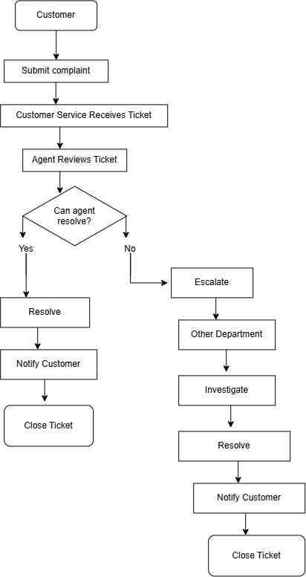

7. To-Be Process

7.1 Improved Customer Service Process
The proposed process introduces automated ticket categorisation, priority assignment, routing, and SLA monitoring.
Proposed Process Flow
1. Customer submits support ticket
↓
2. System creates ticket number
↓
3. System automatically categorises ticket
↓
4. System assigns ticket priority
↓
5. System routes ticket to the appropriate department
↓
6. Agent reviews ticket and customer/order information
↓
7. Can the agent resolve the issue?
YES → Resolve issue → Notify customer → Close ticket
NO → Escalate according to SLA rules → Specialist team investigates → Resolve issue → Notify customer → Close ticket

7.2 Improvements
(See the detailed area-by-area comparison in section 7.4.)

7.3 Expected Outcome
The improved process should reduce manual work, improve ticket routing, reduce resolution times, minimise unnecessary escalations, and provide customers with faster and more consistent support.

7.4 Process Improvement Summary
The proposed To-Be process improves the current customer service process by introducing automation and standardised decision-making.
Area | Current Process | Improved Process
Ticket creation | Manual | Automated
Categorisation | Manual | Automatic
Priority | Inconsistent | Standardised
Routing | Manual | Automatic
Customer information | Limited | Available to agent
SLA monitoring | Manual | Automated
Escalation | Inconsistent | SLA-based
Reporting | Limited | Automated
Expected Improvement
The redesigned process should reduce manual effort, improve ticket routing, accelerate issue resolution, and provide better visibility of customer service performance.

Figure 2: Proposed Customer Service Process (To-Be)
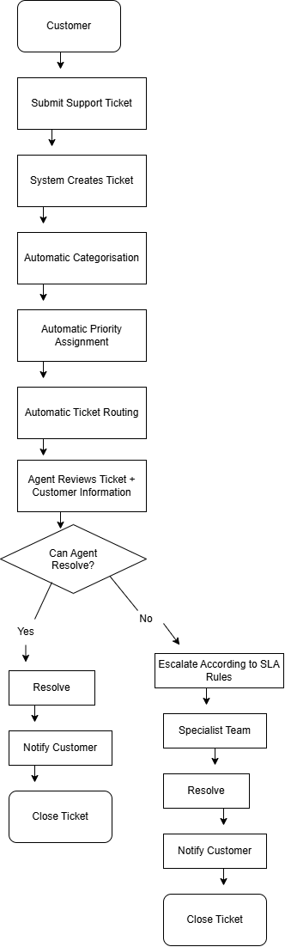

8. Business Rules
The following business rules will govern the improved customer service process.
ID | Business Rule
BR-001 | Every customer support request must receive a unique ticket number.
BR-002 | Every ticket must have a category before it can be assigned to an agent.
BR-003 | Every ticket must be assigned a priority based on the severity of the customer's issue.
BR-004 | Tickets must be routed to the department responsible for resolving the issue.
BR-005 | Critical tickets must be escalated immediately to the appropriate supervisor.
BR-006 | Tickets approaching their SLA deadline must trigger an alert to the responsible team.
BR-007 | Only authorised employees may access customer and order information.
BR-008 | A ticket may only be closed after the customer's issue has been resolved or an approved resolution has been provided.
BR-009 | All ticket status changes must be recorded for audit purposes.
BR-010 | Customers must be notified when there is a significant change to their ticket status.

8.1 Priority Rules
Priority | Example | Response Target
Critical | Payment issue preventing an order from being completed | < 1 hour
High | Failed delivery or incorrect order | < 4 hours
Medium | Product information or general complaint | < 8 hours
Low | General enquiry or feedback | < 24 hours

9. KPIs & Success Measures
The following Key Performance Indicators (KPIs) will be used to measure the success of the improved customer service process.
KPI | Current | Target | Purpose
Average Response Time | 18 hrs | < 6 hrs | Measure how quickly customers receive an initial response
Average Resolution Time | 42 hrs | < 24 hrs | Measure how quickly customer issues are resolved
First-Contact Resolution | 54% | 75% | Measure how many issues are resolved without escalation
Escalation Rate | 22% | < 10% | Measure unnecessary ticket escalations
Customer Satisfaction | 71% | ≥ 85% | Measure customer experience
SLA Compliance | 70% | ≥ 95% | Measure whether tickets are resolved within agreed times
Unresolved Tickets | 1,500/month | < 500/month | Measure the outstanding support workload

9.1 Success Criteria
The project will be considered successful if:
- Average response time is reduced to less than 6 hours.
- Average resolution time is reduced to less than 24 hours.
- First-contact resolution reaches at least 75%.
- Escalation rate falls below 10%.
- Customer satisfaction reaches at least 85%.
- SLA compliance reaches at least 95%.
- Unresolved tickets are reduced significantly.

9.2 Measurement Approach
Performance will be monitored through customer service reports and dashboards. KPI results will be reviewed regularly by the Customer Service Team Leader and Operations Manager to identify further improvement opportunities.

10. Test Cases
Test cases are used to verify that the proposed customer service solution meets the defined requirements.
Test ID | Requirement | Test Scenario | Expected Result
TC-001 | FR-001 | Customer submits a support ticket | Ticket is created and a unique ticket number is generated
TC-002 | FR-002 | Customer submits a ticket with a known issue type | System automatically assigns the correct category
TC-003 | FR-003 | Customer submits a critical issue | System assigns Critical priority
TC-004 | FR-004 | Ticket is created for a delivery issue | Ticket is routed to the appropriate department
TC-005 | FR-005 | Agent opens a customer ticket | Customer and relevant order information is displayed
TC-006 | FR-006 | Agent updates ticket status | New status is saved successfully
TC-007 | FR-007 | Ticket status changes | Customer receives a notification
TC-008 | FR-008 | Ticket approaches its SLA deadline | Supervisor receives an SLA warning
TC-009 | FR-009 | Supervisor opens ticket dashboard | Unresolved and escalated tickets are visible
TC-010 | FR-010 | Manager requests a performance report | System generates the required customer service metrics

10.1 Example Detailed Test Case
TC-003 — Critical Ticket Priority
Requirement: FR-003
Scenario: A customer submits a critical payment issue.
Given: The customer is submitting a support ticket.
When: The issue is classified as a critical payment problem.
Then: The system should automatically assign the ticket a Critical priority.
Expected Result:
The ticket is assigned Critical priority and follows the appropriate response and escalation rules.
Status: Not Tested

11. Requirements Traceability Matrix
The Requirements Traceability Matrix (RTM) ensures that each requirement can be traced from its original business need through to testing.
Requirement ID | Requirement | User Story | Test Case | Priority | Status
FR-001 | Customer can submit support tickets | US-001 | TC-001 | High | Not Tested
FR-002 | Tickets are automatically categorised | US-002 | TC-002 | High | Not Tested
FR-003 | Tickets receive priority levels | US-001 | TC-003 | High | Not Tested
FR-004 | Tickets are routed to the correct department | US-004 | TC-004 | High | Not Tested
FR-005 | Agents can view customer/order information | US-003 | TC-005 | High | Not Tested
FR-006 | Agents can update ticket status | US-001 | TC-006 | High | Not Tested
FR-007 | Customers receive status notifications | US-001 | TC-007 | Medium | Not Tested
FR-008 | Supervisors receive SLA alerts | US-005 | TC-008 | High | Not Tested
FR-009 | Supervisors can view unresolved tickets | US-004 | TC-009 | High | Not Tested
FR-010 | System generates performance reports | N/A (system-only) | TC-010 | Medium | Not Tested

11.1 Traceability
The RTM provides a clear connection between:
Requirement → User Story → Test Case
This helps ensure that important requirements are not missed during development and testing.

12. Risk Analysis
The following risks have been identified for the proposed customer service improvement project, along with recommended mitigations.
Risk | Likelihood | Impact | Mitigation
Agents resist new automated workflows and revert to manual habits | Medium | High | Provide training and a phased rollout; involve agents in UAT before go-live
Automatic categorisation misclassifies tickets, causing incorrect routing | Medium | Medium | Allow agents to manually reassign tickets; monitor categorisation accuracy during early rollout
Customer and order data quality issues undermine agent decision-making | Low | High | Run a data-cleansing pass on customer/order records before go-live
SLA targets prove unrealistic once automation is live, causing false breach alerts | Medium | Medium | Review SLA targets against pilot-phase data before full rollout

13. Final Recommendation

13.1 Recommended Solution
Ubuntu Retail should implement an improved customer service management process supported by automated ticket categorisation, priority assignment, ticket routing, SLA monitoring, customer notifications, and performance reporting.
The proposed solution addresses the main weaknesses identified in the current process and provides customer service teams with better visibility and more efficient tools.

13.2 Expected Business Benefits
The proposed solution is expected to:
- Reduce customer response and resolution times.
- Increase first-contact resolution.
- Reduce unnecessary escalations.
- Improve SLA compliance.
- Increase customer satisfaction.
- Reduce manual administrative work.
- Improve visibility of customer service performance.
- Provide management with reliable performance data.

13.3 Implementation Priorities
The recommended implementation should prioritise:
Phase 1 — Core Ticket Management
- Ticket creation
- Ticket categorisation
- Priority assignment
- Ticket routing
Phase 2 — Customer Service Improvements
- Customer/order information
- Customer notifications
- SLA monitoring
- Escalation management
Phase 3 — Reporting & Optimisation
- KPI dashboards
- Performance reporting
- Process monitoring
- Continuous improvement

13.4 Conclusion
The analysis indicates that Ubuntu Retail's current customer service process can be significantly improved through automation, standardised business rules, better access to information, and improved performance monitoring.
The proposed solution is aligned with the company's objectives of improving operational efficiency and customer satisfaction. Success should be measured against the defined KPIs and reviewed regularly to identify additional opportunities for improvement.

