**WEEK 8**

**Exercise 1:**

git –version

git version 2.x.x

git config --global user.name "Naren"

git config --global user.email [Naren@example.com](mailto:Naren@example.com) git config --global –list

git config --global core.editor "code --wait" git config --global -e

mkdir GitDemo cd GitDemo

git init ls -a

echo "Welcome to Git Demo" > welcome.txt cat welcome.txt

git status

git add welcome.txt git commit

Added welcome.txt git status

git remote add origin https://github.com/Naren/GitDemo.git Output:

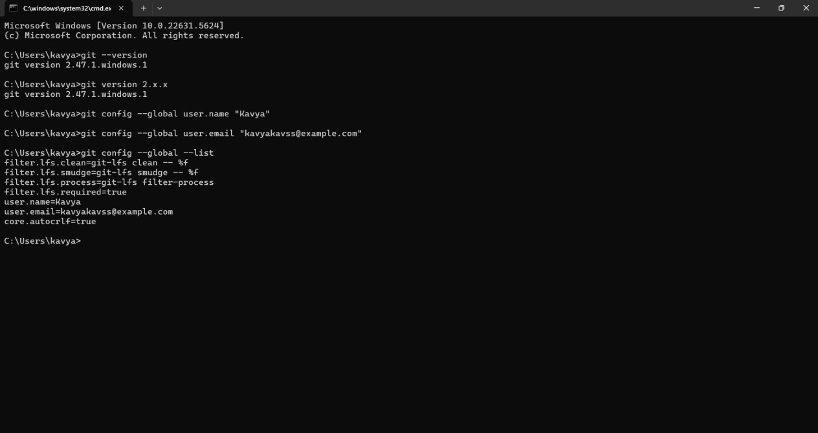

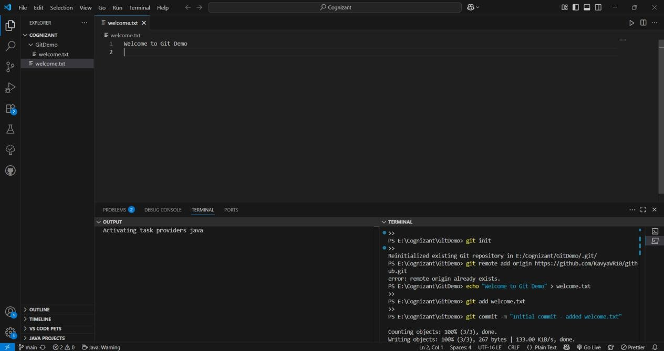

**Exercise 2:**

echo "This is a log file" > debug.log mkdir log

echo "Log data" > log/output.txt echo "*.log" > .gitignore

echo "log/" >> .gitignore git status

git add .gitignore

git commit -m "Added .gitignore to ignore .log files and log folder" git push

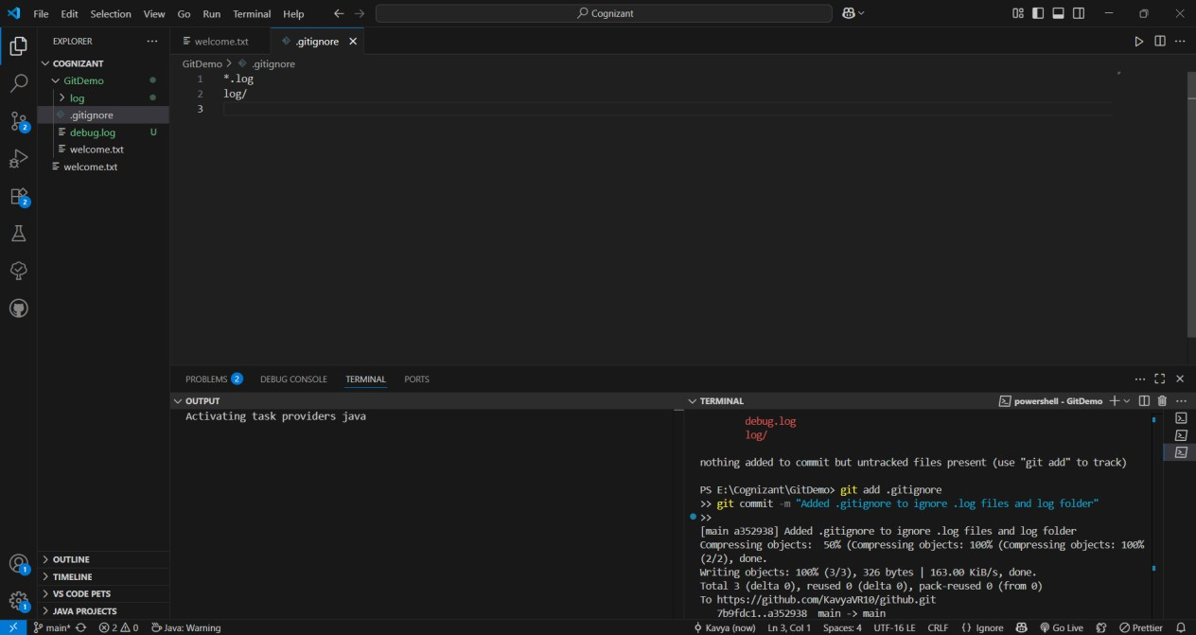Output:

**Exercise 3:Branching**

git branch GitNewBranch git branch

git branch -r

git checkout GitNewBranch

echo "This is a new file" > newfile.txt git add newfile.txt

git commit -m "Added newfile.txt in GitNewBranch" git status

Merging:

git checkout master

git diff master GitNewBranch

git difftool master GitNewBranch git merge GitNewBranch

git log --oneline --graph --decorate git branch -d GitNewBranch

git status Output:

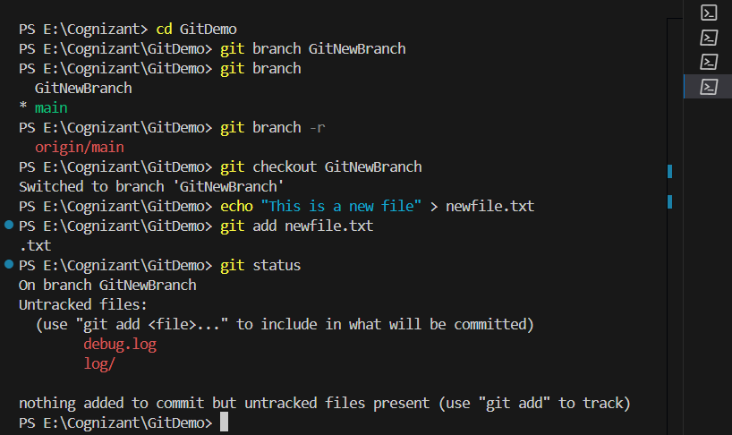

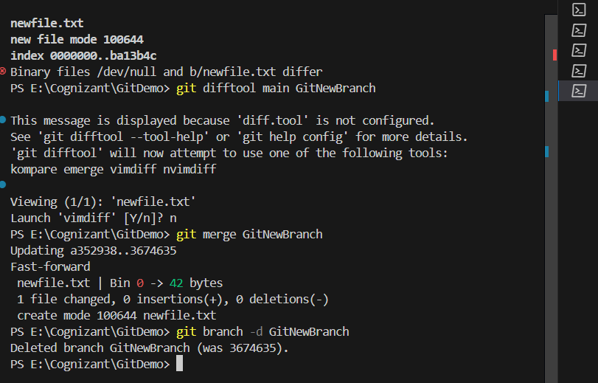

Exercise 4:

git checkout main git status

git branch GitWork

git checkout GitWork

echo "<message>Hello from GitWork</message>" > hello.xml git status

git add hello.xml

git commit -m "Added hello.xml with updated content in GitWork" git checkout main

echo "<message>Hello from Main branch</message>" > hello.xml git add hello.xml

git commit -m "Added hello.xml with different content in main" git log --oneline --graph --decorate –all

git diff main GitWork

git config --global diff.tool p4merge

git config --global merge.tool p4merge

git config --global mergetool.p4merge.path "C:/Program Files/Perforce/p4merge.exe" git difftool main GitWork

git checkout main git merge GitWork git mergetool

git add hello.xml

git commit -m "Merged GitWork into main with conflict resolved" echo "*.orig" >> .gitignore

git status

git add .gitignore

git commit -m "Added .gitignore for backup files" git branch

git branch -d GitWork

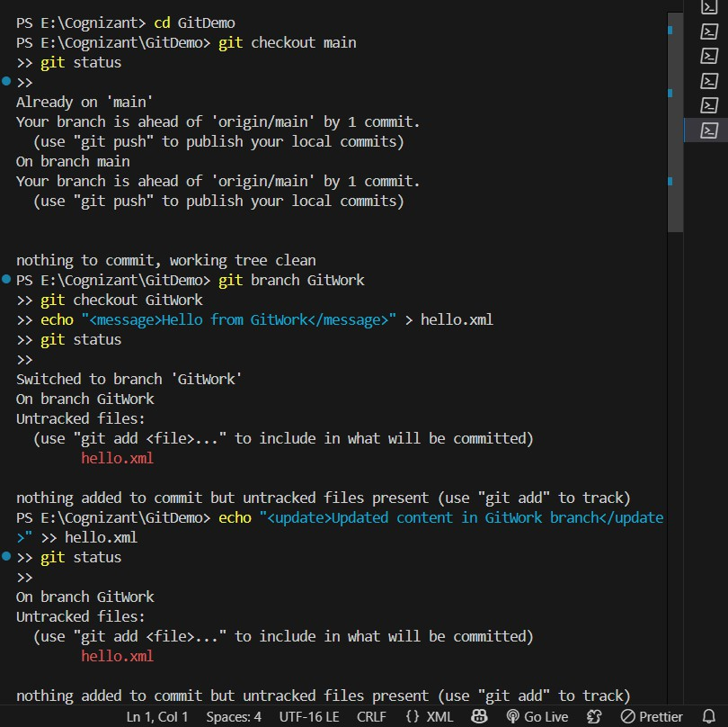git log --oneline --graph --decorate Output:

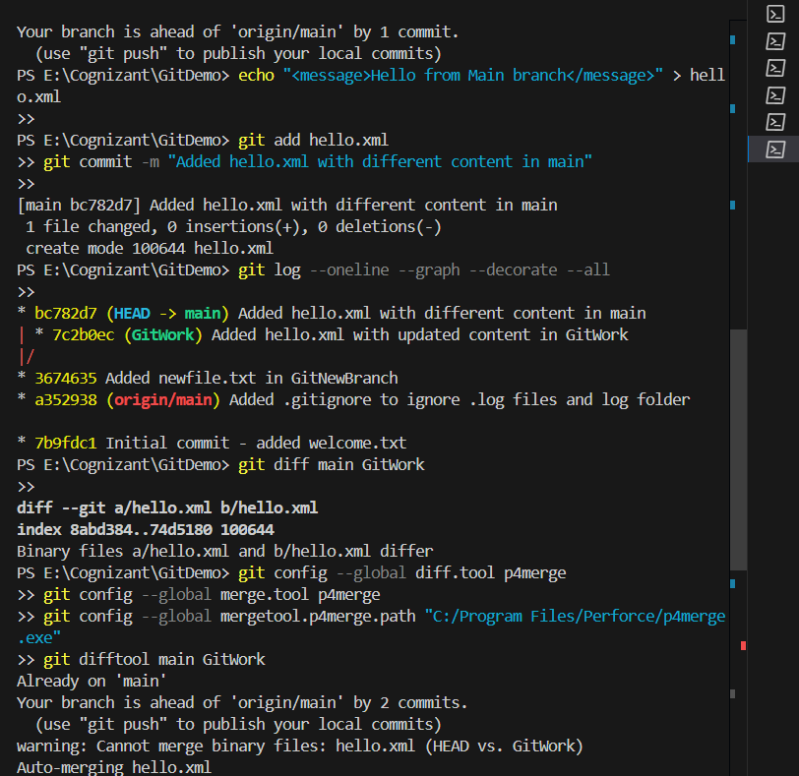

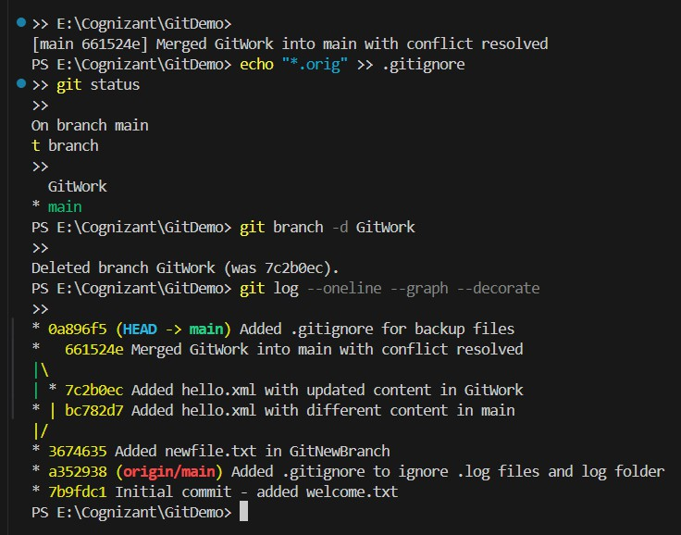

Exercise 5:

git branch -a

git fetch origin

git checkout -b Git-T03-HOL_002 origin/Git-T03-HOL_002 git push origin main

git checkout -b Git-T03-HOL_002 git push origin Git-T03-HOL_002 Output:

