# Exercise 9 App.java:

import React from "react";

**WEEK 7**

import ListofPlayers from "./components/ListofPlayers"; import Scorebelow70 from "./components/Scorebelow70"; import OddPlayers from "./components/OddPlayers"; import EvenPlayers from "./components/EvenPlayers";

import ListofIndianPlayers from "./components/ListofIndianPlayers"; function App() {

const players = [

{ name: "Kohli", score: 92 },

{ name: "Dhoni", score: 88 },

{ name: "Rohit", score: 45 },

{ name: "Pant", score: 62 },

{ name: "Bumrah", score: 33 },

{ name: "Hardik", score: 75 },

];

const T20Players = ['First Player', 'Second Player', 'Third Player'];

const RanjiTrophyPlayers = ['Fourth Player', 'Fifth Player', 'Sixth Player']; const IndianPlayers = [...T20Players, ...RanjiTrophyPlayers];

const flag = false; if (flag === true) { return (

<div>

<h1>List of Players</h1>

<ListofPlayers players={players} />

<hr />

<h1>List of Players with Score &lt 70</h1>

<Scorebelow70 players={players} />

</div>

);

} else { return (

<div>

<h1>Indian Team</h1>

<OddPlayers players={IndianPlayers} />

<EvenPlayers players={IndianPlayers} />

<hr />

<h1>Merged List of Indian Players:</h1>

<ListofIndianPlayers IndianPlayers={IndianPlayers} />

</div>

);

}

}

export default App;

## EvenPlayers.java

import React from "react";

export default function EvenPlayers({ players }) {

const evenPlayers = players.filter((_, index) => index % 2 === 0);

return (

<div>

<h2>Even Indexed Players</h2>

<ul>

{evenPlayers.map((player, index) => (

<li key={index}>{player}</li>

))}

</ul>

</div>

);

}

# OddPlayers.java

import React from "react";

export default function OddPlayers({ players }) {

const oddPlayers = players.filter((_, index) => index % 2 !== 0); return (

<div>

<h2>Odd Indexed Players</h2>

<ul>

{oddPlayers.map((player, index) => (

<li key={index}>{player}</li>

))}

</ul>

</div>

);

}

# ListofIndianPlayers.java

import React from "react";

export default function ListofIndianPlayers({ IndianPlayers }) { return (

<ul>

{IndianPlayers.map((player, index) => (

<li key={index}>{player}</li>

))}

</ul>

);

}

# ListofPlayers.js

import React from "react";

export default function ListofPlayers({ players }) { return (

<div>

{players.map((item, index) => (

<div key={index}>

<li>

Mr. {item.name} <span> {item.score} </span>

</li>

</div>

))}

</div>

);

}

# Scorebelow70.java

import React from "react";

export default function Scorebelow70({ players }) { const players70 = [];

players.map((item) => { if (item.score <= 70) { players70.push(item);

}

});

return (

<div>

{players70.map((item, index) => (

<li key={index}>

{item.name} - {item.score}

</li>

))}

</div>

);

}

**Output:**

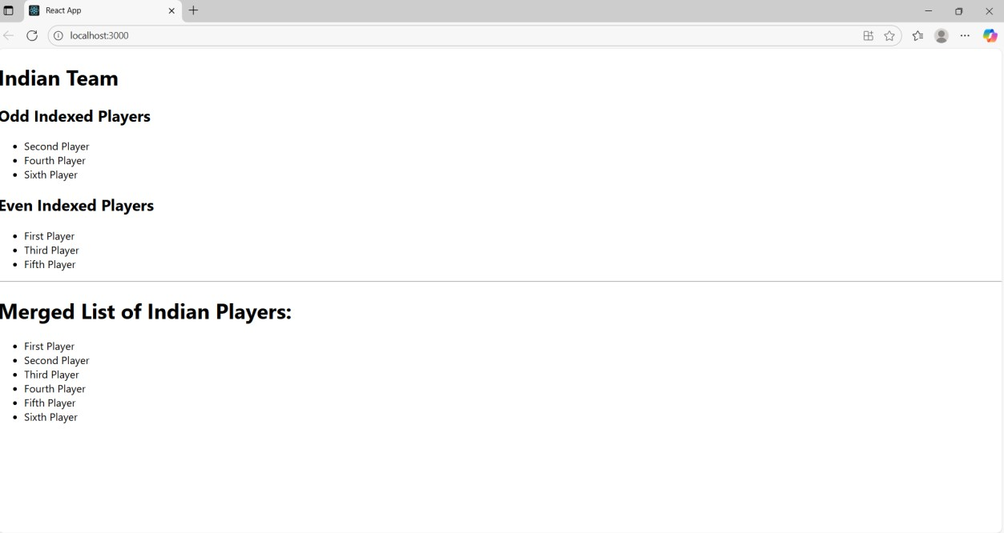

# Exercise 10 App.java

import React from "react"; import "./App.css"; function App() {

const singleOffice = { name: "Tech Park ", rent: 58000,

address: "123 IT Highway, Chennai", image:"./image.png",

};

const officeList = [

{

name: "Innovate Hub", rent: 45000,

address: "Downtown Business Center, Bengaluru", image:"./image.png",

},

{

{

name: "Prime ", rent: 7000,

address: "Cyber City, Gurugram", image:

"./image.png",

},

];

return (

<div className="App">

<h1>Office Space Rental App</h1>

<div className="office-card">

<h2>{singleOffice.name}</h2>

<img src={singleOffice.image} alt={singleOffice.name} width="300" />

<p>Address: {singleOffice.address}</p>

<p

style={{ color: singleOffice.rent < 60000 ? "red" : "green" }}

>

Rent: ₹{singleOffice.rent}

</p>

</div>

<hr />

<h2>Available Office Spaces</h2>

<div className="office-list">

{officeList.map((office, index) => (

<div key={index} className="office-card">

<h3>{office.name}</h3>

<img src={office.image} alt={office.name} width="300" />

<p>Address: {office.address}</p>

<p style={{ color: office.rent < 60000 ? "red" : "green" }}>

Rent: ₹{office.rent}

</p>

</div>

))}

</div>

</div>

);

}

export default App;

## App.css

.App {

text-align: center;

font-family: Arial, sans-serif; padding: 20px;

}

.office-card {

border: 1px solid #ccc; border-radius: 10px; padding: 15px; margin: 15px auto; width: 350px;

box-shadow: 0 2px 8px rgba(0, 0, 0, 0.1);

}

.office-list { display: flex;

justify-content: center; flex-wrap: wrap;

gap: 20px;

}

# Output:

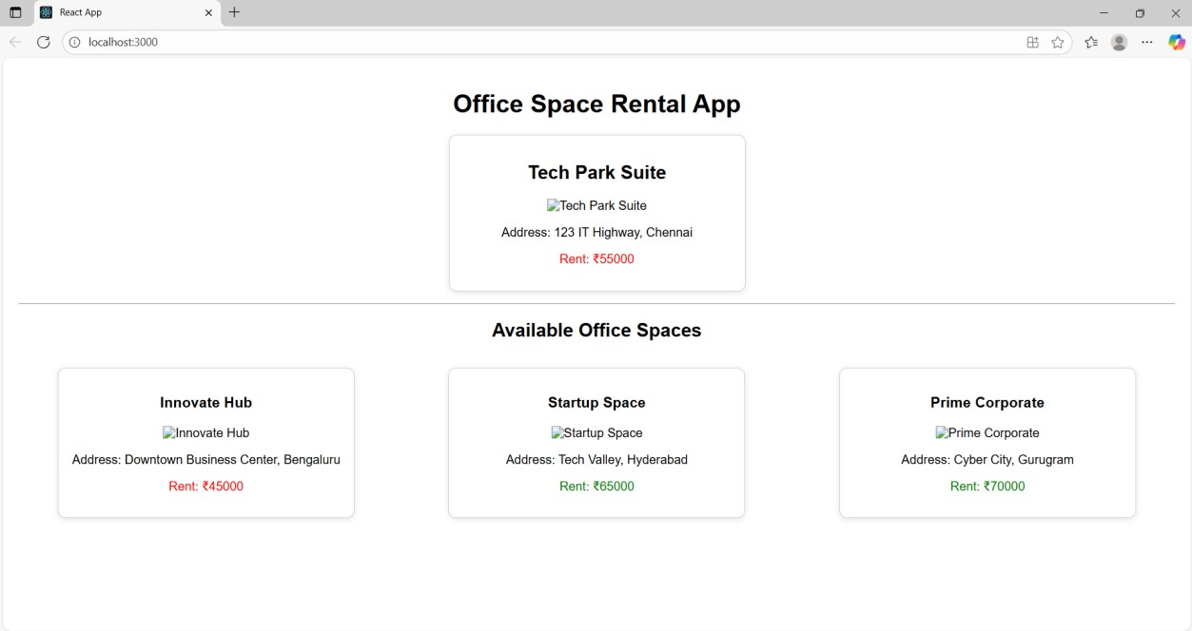

## Exercise 11:

**App.js**

import React from "react";

import Counter from "./components/Counter";

import WelcomeButton from "./components/WelcomeButton"; import ClickMessage from "./components/ClickMessage";

import CurrencyConvertor from "./components/CurrencyConvertor"; function App() {

return (

<div>

<h1>Event Examples App</h1>

<Counter />

<WelcomeButton />

<ClickMessage />

<CurrencyConvertor />

</div>

);

}

export default App;

## Counter.js

import React, { useState } from "react"; export default function Counter() { const [count, setCount] = useState(0); const sayHello = () => {

console.log("Hello! Keep clicking...");

};

const handleIncrement = () => { setCount(count + 1); sayHello();

};

const handleDecrement = () => { setCount(count - 1);

};

return (

<div>

<h2>Counter: {count}</h2>

<button onClick={handleIncrement}>Increment</button>

<button onClick={handleDecrement}>Decrement</button>

</div>

);

}

## WelcomeButton.js

import React from "react";

export default function WelcomeButton() { const showWelcome = (message) => { alert(message);

};

return (

<div>

<button onClick={() => showWelcome("Welcome!")}>Say Welcome</button>

</div>

);

}

## ClickMessage.js

import React from "react";

export default function ClickMessage() { const handleClick = (event) => { alert("I was clicked");

};

return <button onClick={handleClick}>Click Me</button>;

}

## CurrencyConvertor.js

import React, { useState } from "react"; export default function CurrencyConvertor() { const [rupees, setRupees] = useState(""); const [euros, setEuros] = useState("");

const handleSubmit = () => { const rate = 0.011; // example rate

setEuros((parseFloat(rupees) * rate).toFixed(2));

};

return (

<div>

<h2>Currency Converter</h2>

<input type="number" value={rupees}

onChange={(e) => setRupees(e.target.value)} placeholder="Enter INR"

/>

<button onClick={handleSubmit}>Convert</button>

{euros && <p>EUR: €{euros}</p>}

</div>

);

}

**Output:**

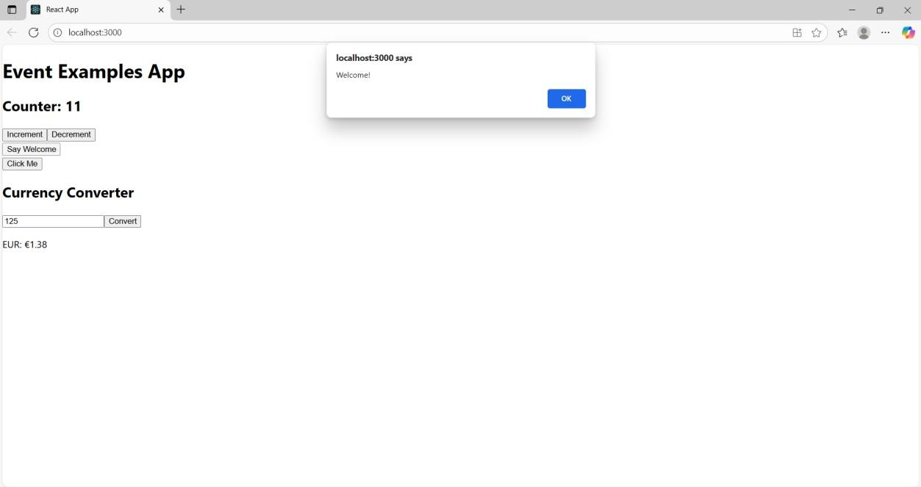

**Exercise 12:**

**App.js**

import React, { useState } from 'react';

import GuestPage from './components/GuestPage'; import UserPage from './components/UserPage';

import LoginControl from './components/LoginControl'; function App() {

const [isLoggedIn, setIsLoggedIn] = useState(false); const handleLogin = () => setIsLoggedIn(true); const handleLogout = () => setIsLoggedIn(false); return (

<div>

<h1>Ticket Booking App</h1>

<LoginControl isLoggedIn={isLoggedIn} onLogin={handleLogin} onLogout={handleLogout} />

{isLoggedIn ? <UserPage /> : <GuestPage />}

</div>

);

}

export default App;

## LoginControl.js

import React from 'react';

export default function LoginControl({ isLoggedIn, onLogin, onLogout }) { return (

<div>

{isLoggedIn ? (

<button onClick={onLogout}>Logout</button>

) : (

<button onClick={onLogin}>Login</button>

)}

</div>

);

}

## GuestPage.js

import React from 'react';

export default function GuestPage() { return (

<div>

<h2>Welcome Guest! </h2>

<p>Here are the available flights:</p>

<ul>

<li>Chennai to Delhi - ₹4500</li>

<li>Mumbai to Bangalore - ₹3500</li> </ul>

<p> Please login to book tickets.</p>

</div>

);

}

## UserPage.js

import React from 'react';

export default function UserPage() { return (

<div>

<h2>Welcome User! </h2>

<p>You can now book your tickets:</p>

<ul>

<li> Chennai to Delhi - ₹4500 <button>Book</button></li>

<li> Mumbai to Bangalore - ₹3500 <button>Book</button></li>

</ul>

</div>

);

}

## Output:

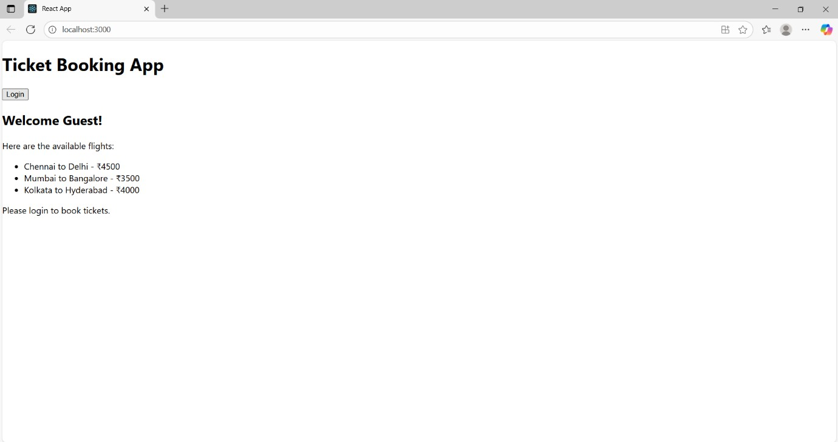

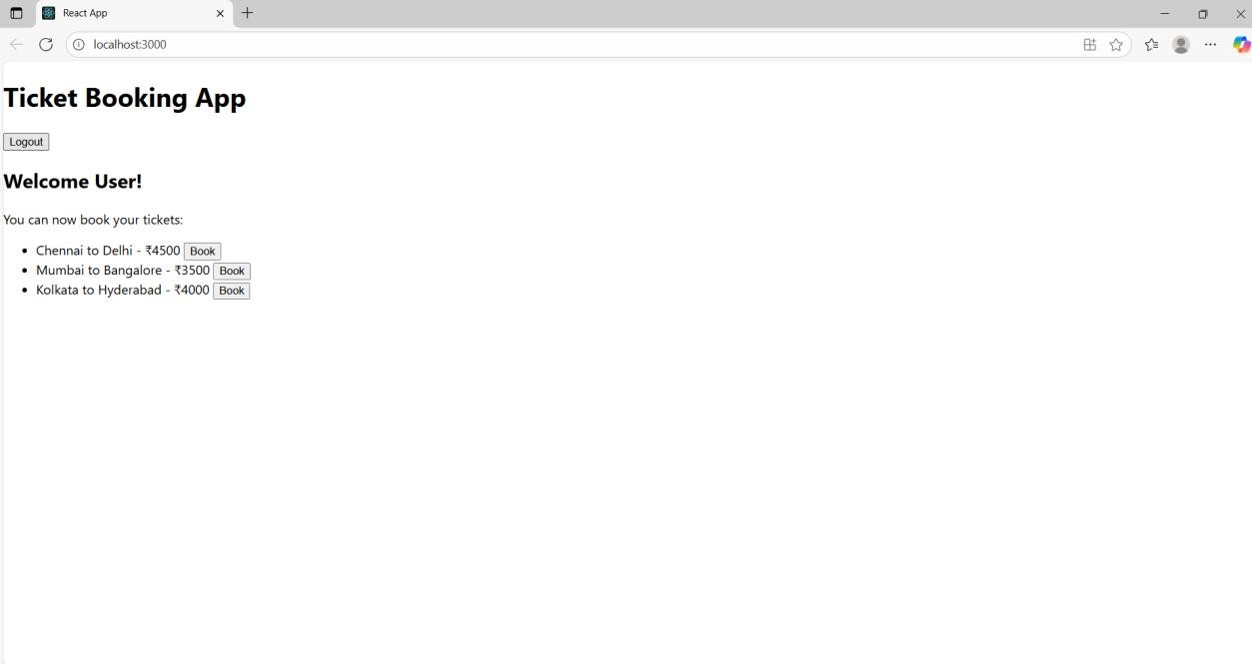

**Exercise 13 App.js**

import React, { useState } from "react";

import BookDetails from "./components/BookDetails"; import BlogDetails from "./components/BlogDetails"; import CourseDetails from "./components/CourseDetails"; function App() {

const [view, setView] = useState("books"); return (

<div>

<h1>Blogger App</h1>

<button onClick={() => setView("books")}>Show Books</button>

<button onClick={() => setView("blogs")}>Show Blogs</button>

<button onClick={() => setView("courses")}>Show Courses</button>

{view === "books" && <BookDetails />}

{view === "blogs" && <BlogDetails />}

{view === "courses" && <CourseDetails />}

</div>

);

}

export default App;

## BlogDetails.js

import React from 'react'; function BookDetails() { const books = [

{ id: 1, title: 'The Alchemist', author: 'Paulo Coelho', rating: 85 },

{ id: 2, title: 'Atomic Habits', author: 'James Clear', rating: 92 }, ]; const lowScoreBooks = books.filter(book => book.rating < 70); const indianBooks = [

{ id: 5, title: 'Wings of Fire', author: 'A.P.J. Abdul Kalam' }

];

const allBooks = [...books, ...indianBooks]; return (

<div>

<h2>All Books</h2>

<ul>

{allBooks.map(book => (

<li key={book.id}>

{book.title} by {book.author}

</li>

))}

</ul>

<h2>Books with Rating &lt; 70</h2>

<ul>

{lowScoreBooks.map(book => (

<li key={book.id}>

{book.title} by {book.author} — Rating: {book.rating}

</li>

))}

</ul>

</div>

);

}

export default BookDetails;

## BookDetails.js

function BookDetails() {

return <h2>Book Details Page</h2>;

}

export default BookDetails;

## CourseDetails.js

import React from 'react'; function CourseDetails() { const courses = [

{ id: 1, name: "Frontend Development", duration: "6 weeks" },

{ id: 2, name: "Data Structures in Java", duration: "8 weeks" },

];

return (

<div>

<h2>Course Details</h2>

<table border="1" cellPadding="8">

<thead>

<tr>

<th>Course Name</th>

<th>Duration</th>

</tr>

</thead>

<tbody>

{courses.map((course) => (

<tr key={course.id}>

<td>{course.name}</td>

<td>{course.duration}</td>

</tr>

))}

</tbody>

</table>

</div>

);

}

export default CourseDetails;

**Output:**

