**WEEK 4**

**Spring-Boot**

**Exercise 1: Demonstrate creation of Spring Boot Application and explain benefits**

1. Go to:
   * File > New > Spring Starter Project
2. Fill in details:
   * Name: spring-learn
   * Type: Maven
   * Packaging: Jar
   * Java Version: 17 (or 8 if you use older JDK)
   * Group: com.cognizant
   * Artifact: spring-learn
3. Click Next
4. Select Dependencies Spring Web

Spring Boot DevTools

1. Click Finish

Eclipse will now create a Spring Boot project automatically.

Benefits: Embedded Tomcat, minimal XML config, fast dev, no boilerplate

**Exercise 2: Demonstrate loading bean from spring configuration file (country.xml)**

Created country.xml in src/main/resources

Defined <bean> with id="country" and properties code, name Used ClassPathXmlApplicationContext to load XML and get bean Printed using toString()

Directory Structure: src/main/java/com/cognizant/springlearn/... src/main/resources/country.xml, application.properties

1. **Country.java**

package com.cognizant.springlearn.model; public class Country {

private String code; private String name; public Country() {

System.out.println("DEBUG: Inside Country Constructor");

}

public String getCode() { System.out.println("DEBUG: getCode() called");

return code;

}

public void setCode(String code) { System.out.println("DEBUG: setCode() called"); this.code = code;

}

public String getName() { System.out.println("DEBUG: getName() called"); return name;

}

public void setName(String name) { System.out.println("DEBUG: setName() called"); this.name = name;

}

@Override

public String toString() { return "Country{" +

"code='" + code + '\'' +

", name='" + name + '\'' +

'}';

}

}

1. country.xml (placed inside src/main/resources)

<?xml version="1.0" encoding="UTF-8"?>

<beans xmlns=["http://www.springframework.org/schema/beans"](http://www.springframework.org/schema/beans) xmlns:xsi=["http://www.w3.org/2001/XMLSchema-instance](http://www.w3.org/2001/XMLSchema-instance)" xsi:schemaLocation=["http://www.springframework.org/schema/beans](http://www.springframework.org/schema/beans) [http://www.springframework.org/schema/beans/spring-beans.xsd"](http://www.springframework.org/schema/beans/spring-beans.xsd)>

<bean id="country" class="com.cognizant.springlearn.model.Country">

<property name="code" value="IN"/>

<property name="name" value="India"/>

</bean>

</beans>

1. SpringLearnApplication.java package com.cognizant.springlearn;

import com.cognizant.springlearn.model.Country; import org.slf4j.Logger;

import org.slf4j.LoggerFactory;

import org.springframework.boot.SpringApplication;

import org.springframework.boot.autoconfigure.SpringBootApplication; import org.springframework.context.ApplicationContext;

import org.springframework.context.support.ClassPathXmlApplicationContext; @SpringBootApplication

public class SpringLearnApplication {

private static final Logger LOGGER = LoggerFactory.getLogger(SpringLearnApplication.class);

public static void main(String[] args) { SpringApplication.run(SpringLearnApplication.class, args); displayCountry();

}

public static void displayCountry() {

ApplicationContext context = new ClassPathXmlApplicationContext("country.xml"); Country country = context.getBean("country", Country.class); LOGGER.debug("Country : {}", country.toString());

}

}

**Exercise:3 Write REST service that returns Hello World**

Created HelloController.java

Mapped GET /hello to sayHello() method Returns "Hello World!!"

Tested via browser & Postman

1. HelloController.java

package com.cognizant.springlearn.controller; import org.slf4j.Logger;

import org.slf4j.LoggerFactory;

import org.springframework.web.bind.annotation.GetMapping; import org.springframework.web.bind.annotation.RestController; @RestController

public class HelloController {

private static final Logger LOGGER = LoggerFactory.getLogger(HelloController.class); @GetMapping("/hello")

public String sayHello() { LOGGER.info("Start sayHello()"); LOGGER.info("End sayHello()"); return "Hello World!!";

}

}

Output:



**Exercise 4:Create REST API to return India country object from country.xml**

Used ApplicationContext to load country.xml Retrieved country bean and returned in JSON **Code:**

**CountryController.java**

package com.cognizant.springlearn.controller; import com.cognizant.springlearn.model.Country;

import com.cognizant.springlearn.service.CountryService; import org.springframework.beans.factory.annotation.Autowired; import org.springframework.context.ApplicationContext;

import org.springframework.context.support.ClassPathXmlApplicationContext; import org.springframework.web.bind.annotation.*;

import java.util.List; @RestController

public class CountryController { @Autowired

private CountryService countryService; @RequestMapping("/country")

public Country getCountryIndia() {

ApplicationContext context = new ClassPathXmlApplicationContext("country.xml"); return context.getBean("country", Country.class);

}

@GetMapping("/countries/{code}")

public Country getCountry(@PathVariable String code) throws Exception { return countryService.getCountry(code);

}

}

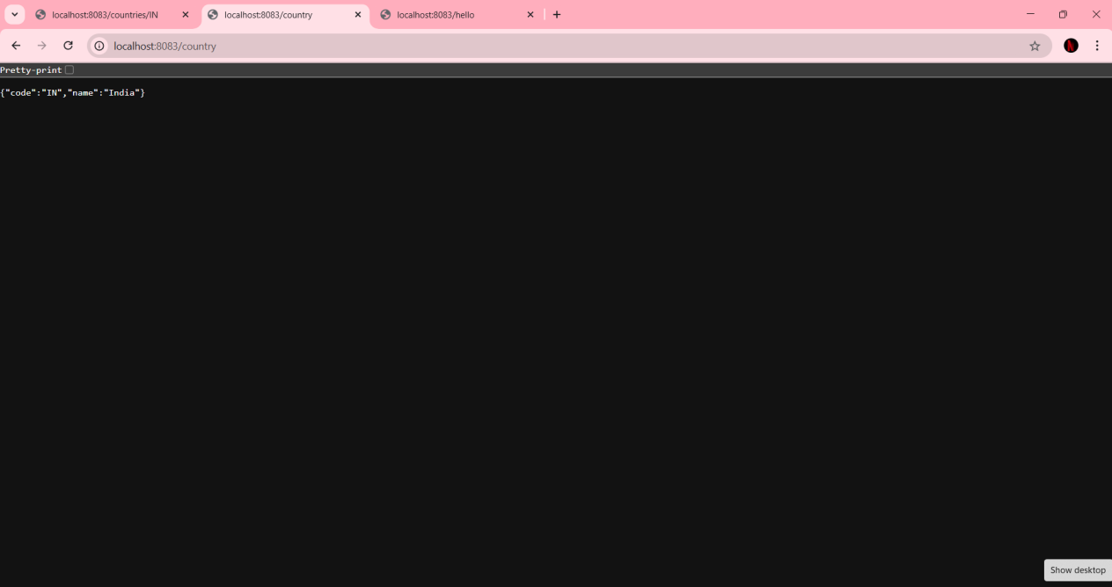Output:

**Exercise 5:Implement getCountry service with dynamic code (case-insensitive)**

countryService.getCountry(code)

Filters country list based on input code ignoring case

**Code:**

1. **CountryService.java**

package com.cognizant.springlearn.service; import com.cognizant.springlearn.model.Country;

import org.springframework.context.ApplicationContext;

import org.springframework.context.support.ClassPathXmlApplicationContext;

import org.springframework.stereotype.Service; import java.util.ArrayList;

import java.util.List; @Service

public class CountryService {

public Country getCountry(String code) throws Exception {

ApplicationContext context = new ClassPathXmlApplicationContext("country.xml"); List<Country> countries = new ArrayList<>(); countries.add(context.getBean("country", Country.class)); // Add more beans if defined

return countries.stream()

.filter(country -> country.getCode().equalsIgnoreCase(code))

.findFirst()

.orElseThrow(() -> new Exception("Country Not Found"));

}

}

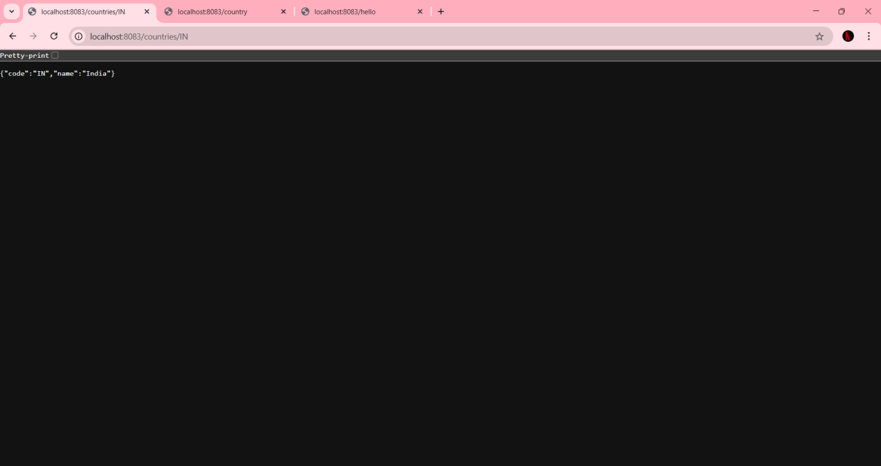Output:

1. application.properties server.port=8083

logging.level.root=DEBUG

1. pom.xml - dependencies section

<!-- Spring Web -->

<dependency>

<groupId>org.springframework.boot</groupId>

<artifactId>spring-boot-starter-web</artifactId>

</dependency>

<!-- Logging -->

<dependency>

<groupId>org.springframework.boot</groupId>

<artifactId>spring-boot-starter-logging</artifactId>

</dependency>

<!-- Spring Boot DevTools -->

<dependency>

<groupId>org.springframework.boot</groupId>

<artifactId>spring-boot-devtools</artifactId>

<scope>runtime</scope>

</dependency>

<!-- Spring Context for XML config -->

<dependency>

<groupId>org.springframework</groupId>

<artifactId>spring-context</artifactId>

</dependency>