Moon-temperature-SamShen2018.R

sshen

Sat Jan 27 12:24:46 2018

setwd("~/Desktop/MyDocs/teach/SIOC290-ClimateMath2017/R Code/Ch6")  
d19=read.table("tbol_snapshot.pbin4d-19.out-180-0.txt",header=FALSE)  
dim(d19)

## [1] 259200 3

#[1] 259200 3 #259200 grid points at 0.5 lat-lon resolution  
#259200=720*360, starting from (-179.75, -89.75) going north  
#then back to south pole then going north   
#until the end (179.75, 89.75)  
m19=matrix(d19[,3],nrow=360)  
dim(m19)

## [1] 360 720

#[1] 360 720  
  
library(maps)  
Lat1=seq(-89.75,by=0.5,len=360)  
Lon1=seq(-189.75,by=0.5, len=720)  
mapmat=t(m19)  
#mapmat=pmin(mapmat,10)  
#mapmat= mapmat[,seq(length(mapmat[1,]),1)], no flipping  
plot.new()  
#png(filename=paste("Moon Surface Temperature Observed by NASA Diviner, Snapshot=",   
# 19,".png"), width=800, height=400)  
int=seq(0,400,length.out=40)  
rgb.palette=colorRampPalette(c('skyblue', 'green', 'blue', 'yellow', 'orange', 'pink','red',   
 'maroon', 'purple', 'black'),interpolate='spline')  
filled.contour(Lon1, Lat1, mapmat, color.palette=rgb.palette, levels=int,  
 plot.title=title("Moon Surface Temperature Observed by NASA Diviner, Snapshot 19",  
 xlab="Longitude", ylab="Latitude"),  
 plot.axes={axis(1); axis(2);grid()},  
 key.title=title(main="deg K"))

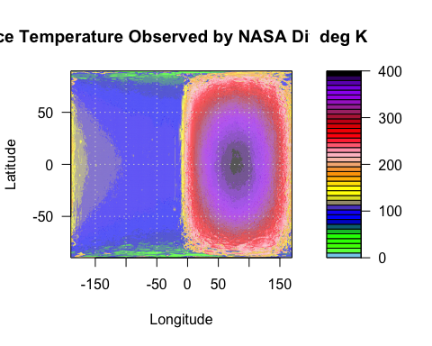

#dev.off()  
  
#Plot the equator temperature for a snapshot   
#plot.new()  
#png(filename=paste("Moon's Equatorial Temperature at Snapshot", 19,".png"),   
# width=600, height=400)  
plot(Lon1,m19[180,],type="l", col="red",lwd=2,   
 xlab="Longitude", ylab="Temperature [deg K]",  
 main="Moon's Equatorial Temperature at Snapshot 19")  
text(-100,250,"Nighttime",cex=2)  
text(80,250,"Daytime",cex=2, col="orange")

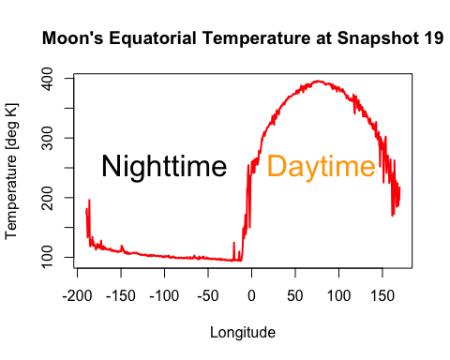

#dev.off()  
  
#Plot the noon time meridional temperature for a snapshot   
#plot.new()  
#png(filename=paste("Moon's Noon Time Meridional Temperature at Snapshot", 19,".png"),   
# width=600, height=400)  
plot(Lat1,m19[,540],type="l", col="red",lwd=2,   
 xlab="Latitude", ylab="Temperature [deg K]",  
 main="Moon's Noon Time Meridional Temperature at Snapshot 19")

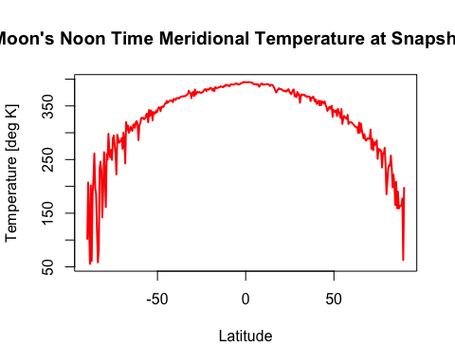

#dev.off()  
  
#Compute the bright side average temperature  
bt=d19[129601:259200,]  
aw=cos(bt[,2]*pi/180)  
wbt=bt[,3]*aw  
bta=sum(wbt)/sum(aw)  
bta

## [1] 302.7653

#[1] 302.7653 deg K  
  
#Compute the dark side average temperature  
dt=d19[0:12960,]  
aw=cos(dt[,2]*pi/180)  
wdt=dt[,3]*aw  
dta=sum(wdt)/sum(aw)  
dta

## [1] 124.7387

#[1] 124.7387 deg K