HOME (HTML)
<!DOCTYPE html> <!--Declaration of html document type-->
<html lang="en"> <!--Declaration of coding language.-->
<head>
<meta charset="UTF-8">
<title>Richfield Connect - Home</title>
<link rel="stylesheet" href="JuniorCss.css"> <!--Reference of CSS file-->
</head>
<body>
<header>
<h1>Richfield Connect</h1>
<div style="display: flex;"> <!--Displaying image and navigation side by side-->
<div><img src="C:\Users\napht\Downloads\ConnectLogo.jpg" alt="RichfielConnectLogo" height="200px" width="200px"></div>
<div>
<nav>
<a href="Home.html">Home</a> <!--HyperLink to Home page-->
<a href="about.html">About</a> <!--Hyperlink to about page-->
<a href="signup.html">Sign Up</a> <!--HyperLink to signup page-->
<a href="profile.html">Profile</a> <!--Hyperlink to profile page-->
<a href="feed.html">Feed</a> <!--Hyperlink to feed page.-->
</nav>
</div>
</div>
</header>
<div class="container">
<h2>Welcome to Richfield Connect</h2>
<p>Richfield connect is a social media, secure, academic platform for Richfield students to connect, share, and collaborate with one another.</p>
</div>

<div style="display: flex;"> <!--Displaying logo and paragraph side by side.-->
<img src="C:\Users\napht\Downloads\ConnectLogo.jpg" alt="RichfielConnectLogo" height="200px" width="200px">
<p>Richfield Graduate Institute of Technology is a leading private higher education provider in South Africa, known for its strong focus on Information Technology, Business, and Management studies. Established to meet the growing demand for skilled professionals, Richfield offers accredited degrees, diplomas, and higher certificates across multiple disciplines. The institution emphasizes practical, career-oriented learning, blending academic theory with hands-on training to prepare students for the modern workplace. With campuses across the country and a robust online learning platform, Richfield provides accessible education to a diverse student body. Its mission centers on empowering graduates with the knowledge and skills needed to thrive in a rapidly evolving digital economy, while fostering innovation, leadership, and lifelong learning.</p>
</div>

<footer>&copy 2026| Created by Ramawa Naphtal Junior</footer>
</body>
</html>

About HTML
<!DOCTYPE html> <!--Declaration of html document type-->
<html lang="en"> <!--Declaration of coding language.-->
<head>
<meta charset="UTF-8"> <!--Declaration of charachter set-->
<title>About - Richfield Connect</title>
<link rel="stylesheet" href="JuniorCss.css"> //Reference of CSS file
</head>
<body>
<header>
<h1>About Richfield Connect</h1>
<div style="display: flex;"> <!--Displaying image and navigation side by side-->
<div><img src="C:\Users\napht\Downloads\ConnectLogo.jpg" alt="RichfielConnectLogo" height="200px" width="200px"></div>
<div>
<nav>
<a href="Home.html">Home</a> <!--HyperLink to Home page-->
<a href="about.html">About</a> <!--Hyperlink to about page-->
<a href="signup.html">Sign Up</a> <!--HyperLink to signup page-->
<a href="profile.html">Profile</a> <!--Hyperlink to profile page-->
<a href="feed.html">Feed</a> <!--Hyperlink to feed page.-->
</nav>
</div>
</div>
</header>
<div class="container">
<p>Richfield Connect is a social media platform designed by a student for students to foster academic engagement, collaboration, and networking among students in a secure institutional environment.</p>
<p>Here on this platform, students can post thoughts, and comments and share content in a secure environment.</p>
<p>Richfield Connect web was created by Ramawa Naphtal Junior in the academic year of 2026.</p>
<p></p>
</div>
<footer>&copy 2026| Created by Ramawa Naphtal Junior</footer>
</body> <!--Closing of body-->
</html> <!--Closing of Html code-->

SIGNUP HTML
<!DOCTYPE html> <!--Declaration of html document type-->
<html lang="en"> <!--Declaration of coding language.-->
<head>
<meta charset="UTF-8"> <!--Declaration of charachter set-->
<title>Sign Up - Richfield Connect</title>
<link rel="stylesheet" href="JuniorCss.css"> <!--Reference of CSS file-->
<script src="https://code.jquery.com/jquery-3.6.0.min.js"></script> <!--Link to Jquery file-->
<script src="Juniorsignup.js" defer></script> <!--Link to Javascript for sign up page-->
</head>
<body>
<header>
<h1>Sign Up</h1>
<div style="display: flex;"> <!--Displaying image and navigation side by side-->
<div><img src="C:\Users\napht\Downloads\ConnectLogo.jpg" alt="RichfielConnectLogo" height="200px" width="200px"></div>
<div>
<nav>
<a href="Home.html">Home</a> <!--HyperLink to Home page-->
<a href="about.html">About</a> <!--Hyperlink to about page-->
<a href="signup.html">Sign Up</a> <!--HyperLink to signup page-->
<a href="profile.html">Profile</a> <!--Hyperlink to profile page-->
<a href="feed.html">Feed</a> <!--Hyperlink to feed page.-->
</nav>
</div>
</div>
</header>
<div class="container">
<h1>Create Your Account</h1>
<!--Form creation with class container-->
<form id="signupForm" class="Rform">
<label>Full Name <input type="text" id="name"></label>
<span class="error"></span>

<label>Student Number <input type="text" id="studentNumber"></label>
<span class="error"></span>

<label>Campus/DL <input type="text" id="campus"></label>
<span class="error"></span>

<label>Email <input type="email" id="email"></label>
<span class="error"></span>

<label>Password <input type="password" id="password"></label>
<span class="error"></span>

<label>Confirm Password <input type="password" id="confirmPassword"></label>
<span class="error"></span>

<label>Interests <input type="text" id="interests"></label>
<span class="error"></span>

<label>Short Bio <textarea id="bio"></textarea></label>
<span class="error"></span>

<button type="submit">Register</button>
</form>
<!--Live Preview of form-->
<div id="livePreview">
<h2>Live Profile Preview</h2>
<p><strong>Name:</strong> <span id="previewName"></span></p>
<p><strong>Bio:</strong> <span id="previewBio"></span></p>
<p><strong>Interests:</strong> <span id="previewInterests"></span></p>
</div>
</div>
<footer>&copy 2026| Created by Ramawa Naphtal Junior</footer>
</body>
</html>

PROFILE HTML
<!DOCTYPE html> <!--Declaration of html document type-->
<html lang="en"> <!--Declaration of coding language.-->
<head>
<meta charset="UTF-8"> <!--Declaration of charachter set-->
<title>Profile - Richfield Connect</title>
<link rel="stylesheet" href="JuniorCss.css"> <!--Reference of CSS file-->
<script src="https://code.jquery.com/jquery-3.6.0.min.js"></script> <!--Link to Jquery file-->
<script src="Juniorprofile.js" defer></script> <!--Link to Javascript for sign up page-->
</head>
<body>
<header>
<h1>Profile</h1>
<div style="display: flex;"> <!--Displaying image and navigation side by side-->
<div><img src="C:\Users\napht\Downloads\ConnectLogo.jpg" alt="RichfielConnectLogo" height="200px" width="200px"></div>
<div>
<nav>
<a href="Home.html">Home</a> <!--HyperLink to Home page-->
<a href="about.html">About</a> <!--Hyperlink to about page-->
<a href="signup.html">Sign Up</a> <!--HyperLink to signup page-->
<a href="profile.html">Profile</a> <!--Hyperlink to profile page-->
<a href="feed.html">Feed</a> <!--Hyperlink to feed page.-->
</nav>
</div>
</div>
</header>
<div class="container">
<h2 id="profileName"></h2> <!--Profile display-->
<p><strong>Student Number:</strong> <span id="profileNumber"></span></p>
<p><strong>Campus:</strong> <span id="profileCampus"></span></p>
<p><strong>Email:</strong> <span id="profileEmail"></span></p>
<p><strong>Bio:</strong> <span id="profileBio"></span></p>
<div><strong><p>Interests:</strong> <div id="profileInterests"></div></div></p>
</div>
</body>
<footer>&copy 2026| Created by Ramawa Naphtal Junior</footer>
</html>

FEED HTML
<!DOCTYPE html> <!--Declaration of html document type-->
<html lang="en"> <!--Declaration of coding language.-->
<head>
<meta charset="UTF-8"> <!--Declaration of charachter set-->
<title>Profile - Richfield Connect</title>
<link rel="stylesheet" href="JuniorCss.css"> <!--Reference of CSS file-->
<script src="https://code.jquery.com/jquery-3.6.0.min.js"></script> <!--Link to Jquery file-->
<script src="Juniorfeed.js" defer></script> <!--Link to Javascript for sign up page-->
</head>
<body>
<header>
<h1>Profile</h1>
<div style="display: flex;"> <!--Displaying image and navigation side by side-->
<div><img src="C:\Users\napht\Downloads\ConnectLogo.jpg" alt="RichfielConnectLogo" height="200px" width="200px"></div>
<div>
<nav>
<a href="Home.html">Home</a> <!--HyperLink to Home page-->
<a href="about.html">About</a> <!--Hyperlink to about page-->
<a href="signup.html">Sign Up</a> <!--HyperLink to signup page-->
<a href="profile.html">Profile</a> <!--Hyperlink to profile page-->
<a href="feed.html">Feed</a> <!--Hyperlink to feed page.-->
</nav>
</div>
</div>
</header>
<div class="post"> <!--Community Feed-->
<div class="feedContainer">
<h1>Community Feed</h1>
<textarea id="postContent" placeholder="Share your thoughts..."></textarea>
<button id="postBtn">Post</button>
<div id="feedContainer"></div>
</div>
</div>
</body>
<footer>&copy 2026| Created by Ramawa Naphtal Junior</footer>
</html>

JAVASCRIPTS
FEED JS
//Feed JavaScript
$(document).ready(function() {
let user = JSON.parse(localStorage.getItem("richfieldUser"));
let posts = JSON.parse(localStorage.getItem("richfieldPosts")) || [];

// Render posts from localStorage
function renderPosts() {
$("#feedContainer").empty();
posts.forEach((post, index) => {
$("#feedContainer").append(`
<div class="post" data-index="${index}">
<p><strong>${post.username}</strong> - ${post.timestamp}</p>
<p>${post.content}</p>
<button class="likeBtn ${post.liked ? 'liked' : ''}">
❤️ Like (<span class="likeCount">${post.likes}</span>)
</button>
<button class="deleteBtn">🗑 Delete</button>
</div>
`).children().last().hide().fadeIn(500); // fade-in effect
});
}

renderPosts();

// Create Post
$("#postBtn").click(function() {
if (!user) {
alert("Please sign up first.");
return;
}
let content = $("#postContent").val().trim();
if (content) {
let newPost = {
username: user.name,
timestamp: new Date().toLocaleString(),
content: content,
likes: 0,
liked: false
};
posts.push(newPost);
localStorage.setItem("richfieldPosts", JSON.stringify(posts));
renderPosts();
$("#postContent").val("");
}
});

// Like Functionality
$("#feedContainer").on("click", ".likeBtn", function() {
let index = $(this).closest(".post").data("index");
posts[index].liked = !posts[index].liked;
posts[index].likes += posts[index].liked ? 1 : -1;
localStorage.setItem("richfieldPosts", JSON.stringify(posts));
renderPosts();
});

// Delete Post
$("#feedContainer").on("click", ".deleteBtn", function() {
let index = $(this).closest(".post").data("index");
if (confirm("Delete this post?")) {
posts.splice(index, 1);
localStorage.setItem("richfieldPosts", JSON.stringify(posts));
renderPosts();
}
});
});

PROFILE JS
//profile javascript coding
$(document).ready(function() {
let user = JSON.parse(localStorage.getItem("richfieldUser"));
if (user) {
$("#profileContainer").html(`
<h2>${user.name}</h2>
<p><strong>Student Number:</strong> ${user.studentNumber}</p>
<p><strong>Campus:</strong> ${user.campus}</p>
<p><strong>Email:</strong> ${user.email}</p>
<p><strong>Bio:</strong> ${user.bio}</p>
<p><strong>Interests:</strong> ${user.interests}</p>
`).hide().fadeIn(1000); // jQuery fade-in effect
} else {
$("#profileContainer").html("<p>No profile found. Please sign up first.</p>");
}
});

FEED JS
$(document).ready(function() {
// Live preview updates
$("#name").on("input", function() {
$("#previewName").text($(this).val());
});

$("#bio").on("input", function() {
$("#previewBio").text($(this).val());
});

$("#interests").on("input", function() {
let interests = $(this).val().split(",");
$("#previewInterests").empty();
interests.forEach(i => {
$("#previewInterests").append(`<span class="tag">${i.trim()}</span> `);
});
});

// Form validation and storage
$("#signupForm").on("submit", function(e) {
e.preventDefault();
let valid = true;

$(".error").text(""); // reset errors

if ($("#name").val().trim() === "") {
$("#name").next(".error").text("Name required");
valid = false;
}
if (!/^\d+$/.test($("#studentNumber").val())) {
$("#studentNumber").next(".error").text("Must be numeric");
valid = false;
}
if ($("#password").val().length < 8) {
$("#password").next(".error").text("Min 8 characters");
valid = false;
}

PROFILE JS
//profile javascript coding
$(document).ready(function() {
let user = JSON.parse(localStorage.getItem("richfieldUser"));
if (user) {
$("#profileContainer").html(`
<h2>${user.name}</h2>
<p><strong>Student Number:</strong> ${user.studentNumber}</p>
<p><strong>Campus:</strong> ${user.campus}</p>
<p><strong>Email:</strong> ${user.email}</p>
<p><strong>Bio:</strong> ${user.bio}</p>
<p><strong>Interests:</strong> ${user.interests}</p>
`).hide().fadeIn(1000); // jQuery fade-in effect
} else {
$("#profileContainer").html("<p>No profile found. Please sign up first.</p>");
}
});

OUTPUT CODE
HOME

ABOUT

SignUp
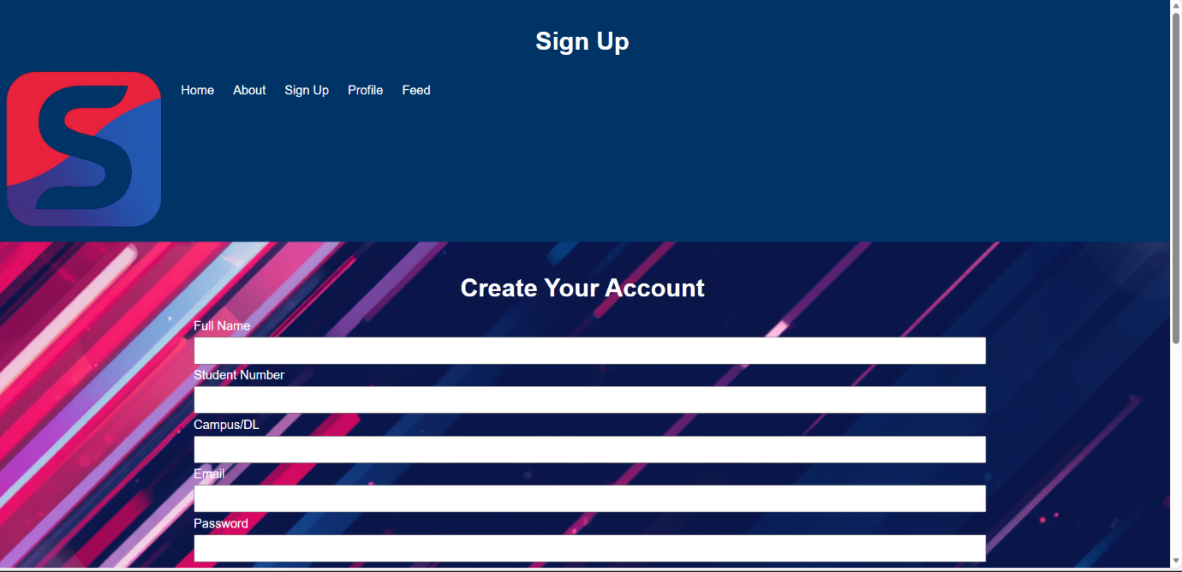
FEED

FEED
