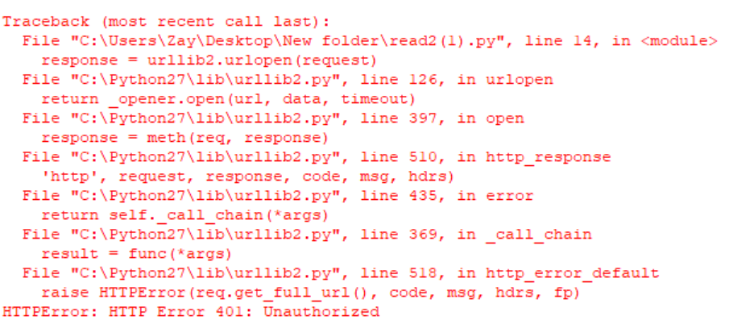

**Figure 1.0 False Token**

The error message will be shown if a user put incorrect token to access the website.

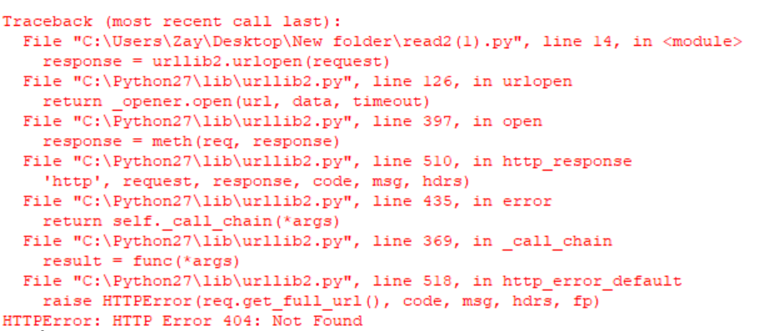

**Figure 1.1 Wrong Header**

This error will pop up in output because of the wrong URL address.

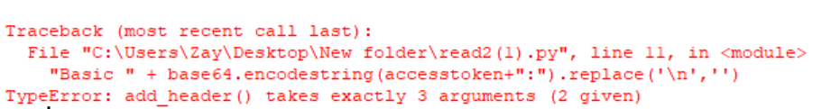

**Figure 1.2 No Authorization**

This can’t access to the website because the authorization header is not given in program.