|  |
| --- |
|  |
| Fantasy & Ash |
| Calum Mathison 40406464  Arran Smedley 40406581 |

|  |
| --- |
|  |

# Table of Contents

Contents

Table of Contents 1

Document History 3

Overview and Vision Statement 4

Inspirations 4

Player Experience Goals 5

Audience and Platform 5

Legal Analysis 5

Gameplay 7

Overview 7

Player Mode 7

Screen Mock-up(s) 7

Formal Elements 7

Players 7

Objectives 7

Procedures 7

Rules 8

Resources 8

Conflict 8

Boundaries 8

Outcomes 8

Controls 9

Win Conditions 9

User Interface 9

Flowchart 10

Characters 11

Party Characters 11

Story 11

Required Media List 12

2D 12

Sound 12

Technical Specification 13

Development Platform and Tools 13

Delivery Mechanism 13

Game Engine 13

Controls Technical Specification 13

# Document History

|  |  |  |  |
| --- | --- | --- | --- |
| **Date of Change** | **Change Description** | **Developer** | **Version** |
| 22/02/2020 | Completed first full version of GDD | Calum, Arran | Version 1.0 |
| 24/02/2020 | Added project schedule | Calum | Version 1.1 |
| 24/02/2020 | Transposed original GDD onto supplied GDD template | Calum, Arran | Version 2.0 |

# Overview and Vision Statement

A 2D pixel art fantasy JRPG style game but the player plays as a high-level adventurer who has been reborn after falling to an unknown foe in a routine quest and must build up their power and party to piece together what happened.

# Inspirations

* Early JRPGs (Final Fantasy/Dragon Quest)
  + Video Game
  + 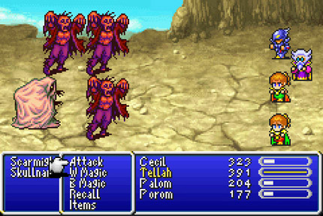The early JRPG game have influenced this title through its story telling, gameplay mechanics and graphical style. Specific influences may be prevalent in the games combat mechanics and overall style.
* Fantasy Novels (LOTR/Redwall/Grimgar)
  + Literature
  + 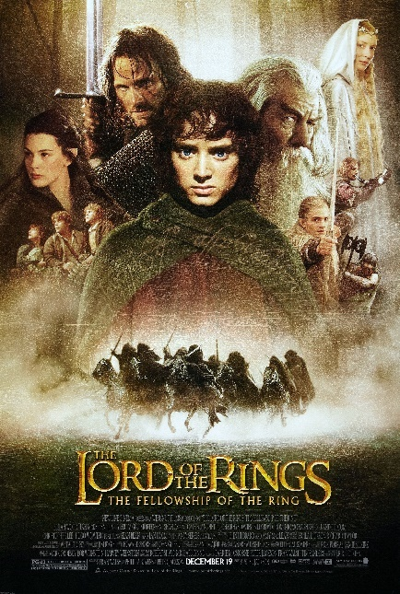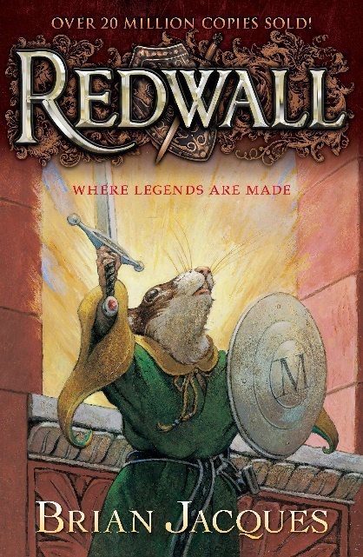Fantasy novels will influence this title through their world building and storytelling styles. Fantasy novels can build large believable worlds, and while that will not be in the scope of this project, it is something we will be taking influence from.
* Tabletop RPGs (D&D)
  + 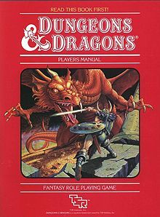Tabletop games will influence this title through the different gameplay styles the player can use.

# Player Experience Goals

* Complete the story
* Complete Quests
* Level up characters
* Earn gold/experience

# Audience and Platform

* PC (Windows)  
  Due to the time limitations and the current framework, we will only be targeting the Windows PC platform, however this will allow us to target a good-sized audience.
* For our target audience we will define an audience profile[1]. Firstly, looking at the platform we will be developing for, PC gaming has continued to increase consistently over the previous 5+ years. Looking at the age of our profile, the average age for both male and female gamers is 36/37, this is a good target age for us as those most familiar with the titles that this products takes inspiration from and would allow us to possibly tap into the nostalgia affect. However, there will be nothing in this product to dissuade gamers of any age.

## Legal Analysis

* The game will be uploaded to **itch.io** and therefore will be free although will allow those that download the game, the option to pay anything they want.
* SFML  
  We will be using the SFML[2] (Simple and Fast Multimedia Library) as it gives us a good framework to start from. License information can be found here: <https://www.sfml-dev.org/license.php>
* Visual Studio  
  Visual Studio 2019 will be used to write the code. License information can be found here: <https://visualstudio.microsoft.com/license-terms/mlt031819/>

# Gameplay

## Overview

The core gameplay will revolve around exploring the overworld map and fighting enemies to increase the power of your party by gaining experience and gold.

### Player Mode

* Single player

## Screen Mock-up(s)

Please see the UI section contained within the technical section.

## Formal Elements

### Players

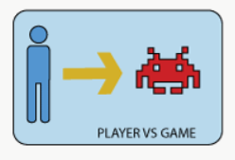The player will be interacting through the main character and the party, with the game. The player will be pitted against the game and will have some freedom to choose their own playstyle (at least during combat).

### Objectives

The player is free to create their own set of objectives, however the game will set out objectives such as

* Attaining exp to level up their characters
* Attaining enough levels to be able to defeat the games final boss
* Completing quests to advance the games storyline

The games objectives will revolve around the Exploration and Outwit objectives, outlined by the Fullerton model.

### Procedures

* Starting

The player will use the main menu to access the game either by selecting new game or by loading their save.

* Progression

This will include procedures such as combat and dialogue.

* Special

These procedures will be things such as levelling up.

* Resolving

The actions that will bring the game to an end will be either the player defeating the final boss or the player being defeated in combat.

### Rules

* Players cannot travers water, mountains or wall.
* Players cannot hold more than 5 potions
* Party members or enemies who’s health drops to or below zero will die (until resurrected).

### Resources

* Health (HP)
* Mana (MP)
* Experience (EXP)
* Gold (Currency)
* Potions
* Spells/Abilities

### Conflict

* An obstacle for the player will be to avoid enemies that are too powerful for their current party while attempting to become more powerful by battling weaker enemies. The player may also choose to risk loosing by battling more powerful enemies early for a greater reward.

### Boundaries

* The player will be bound to the overworld map by an expanse of water or mountains surrounding the map.

### Outcomes

* Different players may expect different outcomes, therefore it may be hard to create outcomes that satisfy all players. Ideally having the players resolve the mystery within the story may be the best outcome.

## Controls

### Win Conditions

* Defeating the final boss.

### User Interface

#### Title Screen/Main Menu

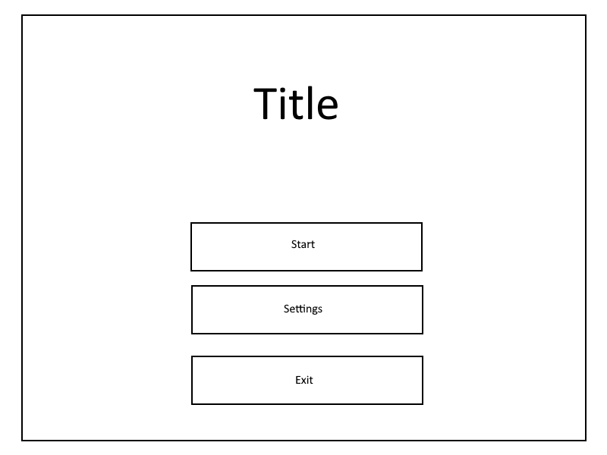This UI will consist of three menu buttons (Start, Settings, Exit). The start button will launch the game, while the exit button will close the game. Settings will open another menu which will allow the player to view a variety of settings for the game such as controls and audio.

#### In-Game Menu

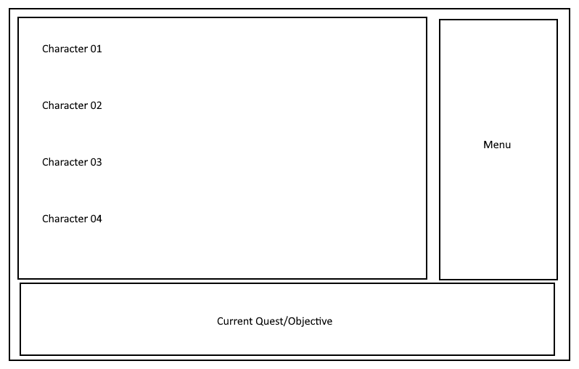This UI will allow the player to view the current status of their party and current quest. It will display the stats for each party member such as health etc and show their sprite and name.

#### Combat UI

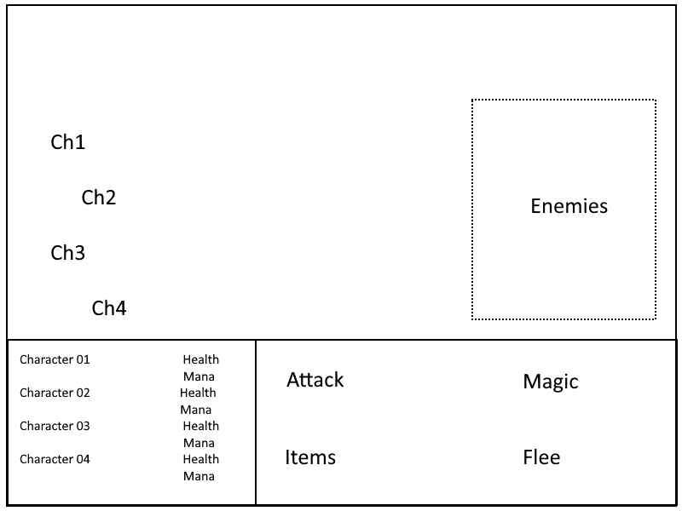This UI will display when the player is in combat. It will display the players current party health and mana. It will also display the combat menu for the party member who’s turn it currently is. Enemy health will not be shown and will be hidden from the player.

## Flowchart

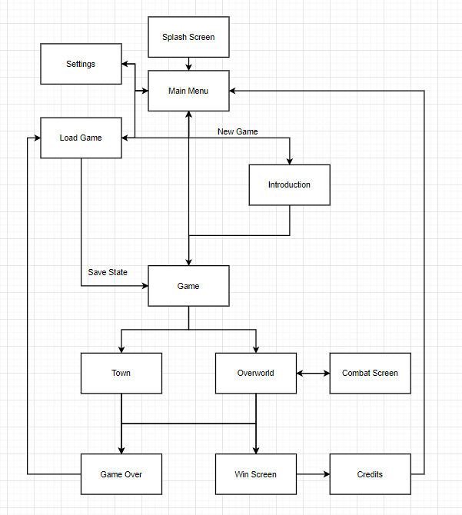

## Characters

### Party Characters

ID: PC01  
Name: Andrel   
Narrative Role: Main Character  
Combat Class: Thief/Rogue  
Physical Description:

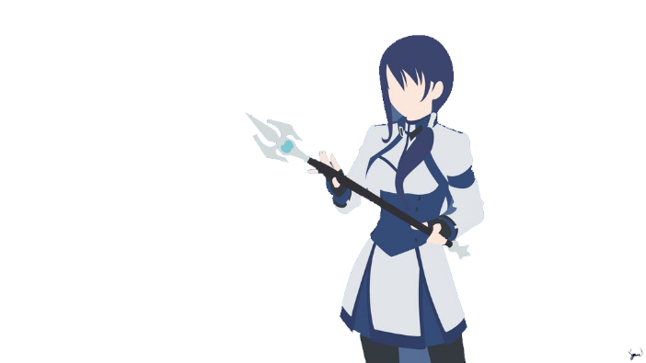

ID: PC02  
Name: Charity  
Narrative Role: Party Character  
Combat Class: Priest/Cleric  
Physical Description:

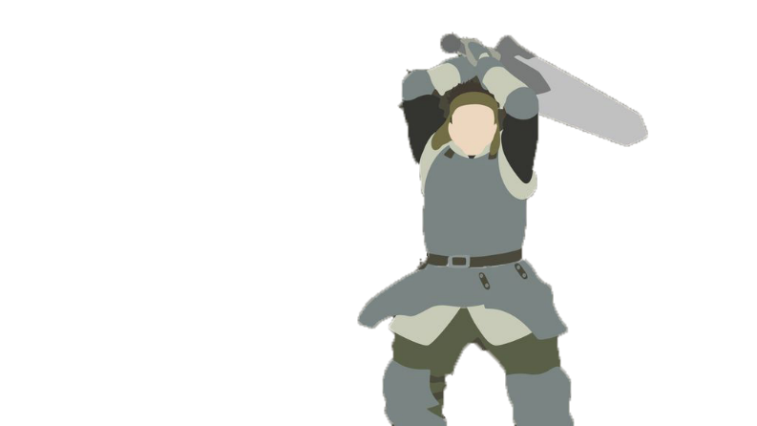

ID: PC03  
Name: Helmaer  
Narrative Role: Party Character  
Combat Class: Warrior/Knight  
Physical Description:

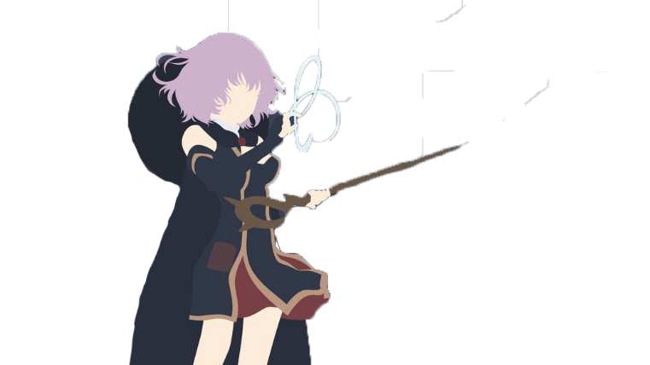

ID: PC04  
Name: Horo  
Narrative Role: Party Character  
Combat Class: Mage  
Physical Description:

## Story

Set in the land of Kyntera, Andrel, a high-level member of a local adventurer’s guild is killed on a routine quest under suspicious circumstances. He awakens to find that they have been reborn as a level 1 adventurer. He must work his way back to his previous position by completing quests and hunting monsters, all while trying to uncover what happened.

# Required Media List

## 2D

|  |  |  |
| --- | --- | --- |
| ID | Name | Format |
| PC01 | Andrel | .PNG |
| PC02 | Charity | .PNG |
| PC03 | Helmaer | .PNG |
| PC04 | Horo | .PNG |
| E01 | Slime | .PNG |
| E02 | Goblin | .PNG |
| E03 | Skeleton | .PNG |
| E04 | Adventurer | .PNG |
| TILE01 | Grass | .PNG |
| TILE02 | Mud | .PNG |
| TILE03 | Rock | .PNG |
| TILE04 | Snow | .PNG |
| TILE05 | Water | .PNG |
| TILE06 | Wall | .PNG |
| ENV01 | Tree | .PNG |
| ENV02 | Bush | .PNG |
| ENV03 | Rock | .PNG |
| ENV04 | House | .PNG |
| UI01 | Text | .TFF |
| UI02 | Image | .PNG |
| NPC01 | Shopkeeper | .PNG |
| NPC02 | Guild Receptionist | .PNG |

## Sound

|  |  |  |
| --- | --- | --- |
| ID | Name | Format |
| SD01 | UI Music | .WAV |
| SD02 | Main game music | .WAV |
| SD03 | Combat music | .WAV |
| SE01 | UI Button press sound effects | .WAV |
| SE02 | Combat sound effects | .WAV |
| SE03 | Enemy sound effects | .WAV |

# Technical Specification

## Development Platform and Tools

We will be using SFML as a base framework and will be creating our own engine from it. Visual Studio will be used for editing and creating code. Photoshop will be used for creating graphical elements.

## Delivery Mechanism

A single .exe file will be supplied to act as an installer/uninstaller and will install any dependencies required for the game.

## Game Engine

* SFML Libraries
* Entity Management Library
* Math Library
* Input Manager (Singleton)
* Audio Manager (Singleton)

## Controls Technical Specification

Control Scheme

|  |  |  |
| --- | --- | --- |
| **Action** | **Keyboard** | **Controller** |
| Walk Up/Move Selection Up | W | Dpad – Up |
| Walk Down/Move Selection Down | S | Dpad – Down |
| Walk Left/Move Selection Left | A | Dpad – Left |
| Walk Right/Move Selection Right | D | Dpad – Right |
| Interact/Confirm Selection | Enter | A |
| Open In-game Menu | Tab | B |
| Pause/Open Menu | Escape | Start |

## Files

The GitHub, and more fuller versions of the GDD can be found here at: <https://github.com/NapierGamesEngTeamA/Coursework>

1. For more statistics see here: <https://www.wepc.com/news/video-game-statistics/#gamers-demographic>
2. Further information available at: <https://www.sfml-dev.org/>