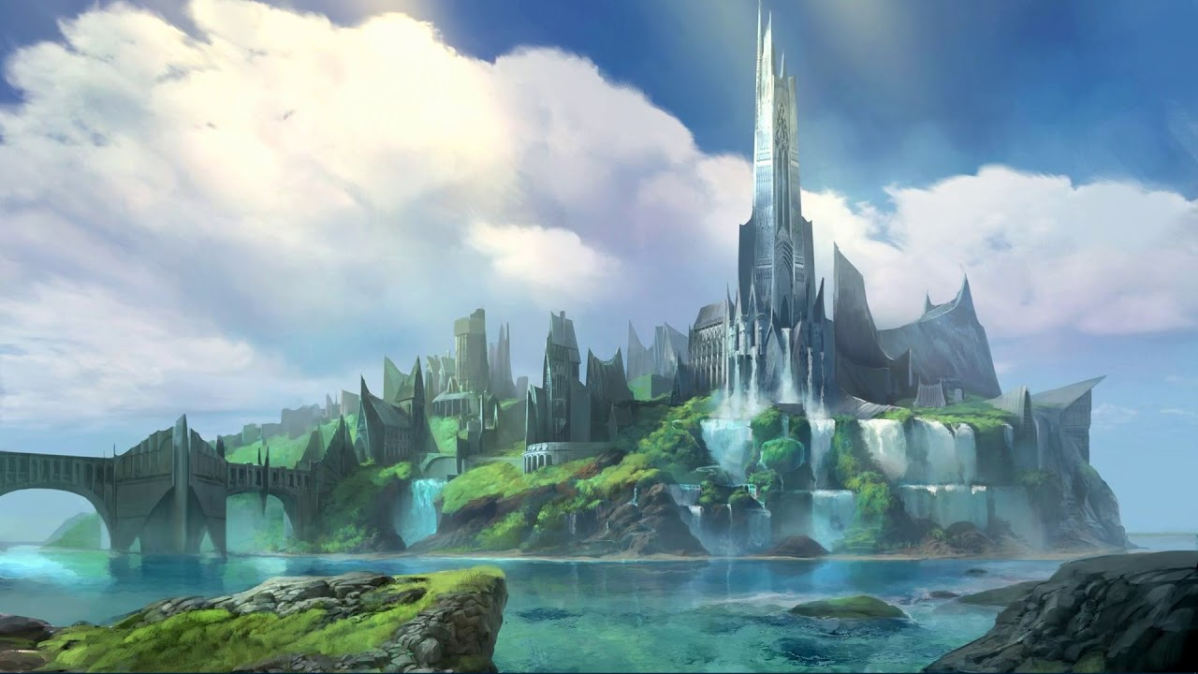

Game Design Document

Fantasy & Ash

[Date]

Mathison, Calum

Smedley, Arran

Woad Stoat Studio

Contents

Overview 3

Theme/Setting/Genre 3

Targeted Platforms 3

Monetization Model 3

Project Scope 3

Licenses / Hardware 3

Influences 3

Elevator Pitch 3

Project Description (Brief) 3

Project Description (Detailed) 3

Story and Gameplay 3

Core Gameplay Mechanics (Brief) 3

Core Gameplay Mechanics (Detailed) 3

Story (Brief) 3

Story (Detailed) 3

Gameplay (Brief) 3

Gameplay (Detailed) 3

Technical Document 3

Control Scheme 4

User Interface 4

Assets/Media List 4

2D 4

Sound 4

Code 4

Schedule 4

# Overview

## Theme/Setting/Genre

[Fantasy & Ash] is a 2D high fantasy RPG.

## Targeted Platforms

* PC (Windows)

## Monetization Model

The game will be uploaded to **itch.io** and therefore will be free although subject to donations.

## Project Scope

* Time Scale

The time scale for development is 7 weeks, between the 24th of February and 6th April.

* Team Size
  + Core Team
    - Calum Mathison
      * Programmer/Designer
    - Arran Smedley
      * Programmer/Designer

## Licenses / Hardware

* SFML
* Visual Studio
* C++

## Influences

* Early JRPGs (Final Fantasy/Dragon Quest)
  + Video Game
  + The early final fantasy games have lent influences to this title through its story telling and game mechanics, as well as its JRPG style. Specific influences may be prevalent in the games combat mechanics.
* Fantasy Novels (LOTR/Redwall/Grimgar)
  + Literature
  + Fantasy novels lend influence to this title through their world building and storytelling styles.
* Tabletop RPGs (D&D)
  + Tabletop games lend influence to this title through different gameplay styles.

## Elevator Pitch

## Project Description (Brief)

## Project Description (Detailed)

# Story and Gameplay

## Core Gameplay Mechanics (Brief)

The core gameplay mechanics will involve the following:

* Player Controller (Left, Right, Up, Down)
* Levelling Up
* Gold In take
* Small Open World Map (Tile map)
* Collisions
* Turn Based Combat System
* NPC(Enemy) Interaction
* NPC(Enemy) Artificial Intelligence
* NPC(Enemy) Types

## Core Gameplay Mechanics (Detailed)

### Player Controller (Left, Right, Up, Down)

The player controller will allow the player to venture the open world map by movement such as up, down, left and right ensuring that the player can move wherever they want by using the WASD keys on the keyboard.

### Levelling Up

Levelling up within the game will be determined on the amount of enemies being killed, while levelling up in game enemies will be getting stronger so it is imminent that the player has attained a certain level by killing smaller enemies and as you progress you can kill the larger enemies.

### Gold in Take

While killing enemies the player will receive an income of gold, this gold will be used to complete the game for the player to pay his/her way to a haven. The tougher the enemy the more gold the player will receive.

### Small Open World Map (Tile map)

The map is going to be a small open world tile map that will consist of multiple terrains (Grass, Mud, Lakes, Snow), that the player can venture around finding small, medium and large enemies to fight, reason it being a small open world map is because if a large one was to be implemented, not enough content would be available In game to apply an immersive experience for the player making the game very boring and a lot of running around with nothing happening.

### Collisions

The collision will be minimal within this game as the combat system is turn based and wont really require collision. The main collision that will be within this game will consist of:

* Collision against water, lakes, boundaries where players aren’t allowed to be in.
* Collision detection when a player walks into an enemy NPC.

### Turn Based Combat System

A turn-based combat system will be implemented where the player can choose rather to fight (Melee or Magic), Heal or Run. Where the enemy will base decisions based on the player disadvantages for example if the player is low on health or just attacking.

### NPC(Enemy) Interaction

Enemy interaction will be very much player orientated as the player will be able to choose if they want to fight the enemy or leave it be (The enemy won’t be chasing the player). The enemy will be roaming around the map around a certain area of the map (So if the enemy is based in the snow it stays within that biome).

### NPC(Enemy) Artificial Intelligence

The artificial intelligence within the combat system will be all about decision making, deciding what to do next if the player is making reckless or rash decisions the AI should take advantage of that for example if the player is low on health always attack or if the enemy Is low on health the AI will heal.

### NPC(Enemy) Types

There will be three enemy difficulties and multiple types of enemy. The three types will consist of:

* Easy
* Medium
* Hard

The harder the enemy the bigger the sprite will be.

## Story (Brief)

## Story (Detailed)

Set in the lands of (Name). Daruk a small-town thief has been captured and extradited to the hellish lands of (Name) where other convicts and monsters lurk in the darkness. To be exonerated Daruk must pay the elven lords a small bribe in order access the heavenly lands of (Name). By attaining this gold Daruk must kill and obtain any gold the monsters have. By killing monsters Daruk will attain experience which in turn can aid him to kill larger monsters.

## Gameplay (Brief)

## Gameplay (Detailed)

# Technical Document

## Control Scheme

## User Interface

# Assets/Media List

## 2D

## Sound

## Code

# Schedule