IoT Lab Assignment 6
RSA Protected Socket Programming

Part 2 – Socket Programming
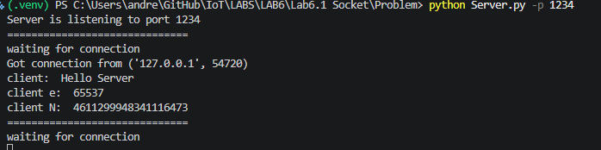
Used multiple terminal windows.

Part 3 – RSA

Example 1 | p | 1637842597
 | q | 2657124709
 | N | 4351952033941429273
 | e | 65537
 | d | 327573422070677585
 | m | 2146210639644006206
 | c | 768594581363479181
Example 2 | p | 1900493143
 | q | 2394474161
 | N | 4550681724071178023
 | e | 65537
 | d | 4530892222390974593
 | m | 914533224344639919
 | c | 3295824207614022858
Example 3 | p | 1907263091
 | q | 2387704201
 | N | 4553980094792945291

 | e | 65537
 | d | 1438314751868679473
 | m | 3135653864232958471
 | c | 3360043531845750575
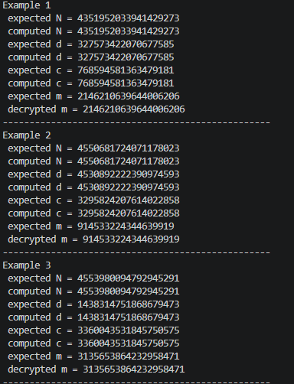

 | p | 1998847601
Exercise 1 | q | 2296119677
 | N | 4589593307980344877
Undergrad
 | e | 65537
and
Graduate | d | 2006025606665969473
Students | m | 10001
 | c | 1258515386968475538
Exercise 2 | N | 4400141856896539081
Undergrad | d | 2764011776369096961
and
 | m | 123456
Graduate
 | c | 2503673653585535070
Students
Exercise 3 | p | 1940829017
 | q | 2354138273
Graduate
 | N | 4568979870268667641
Students
 | e | 139241
Only
 | d | 610100779569588057

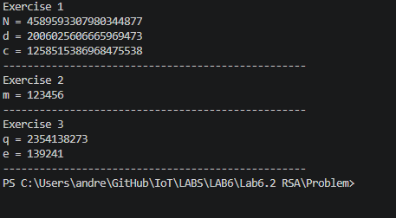
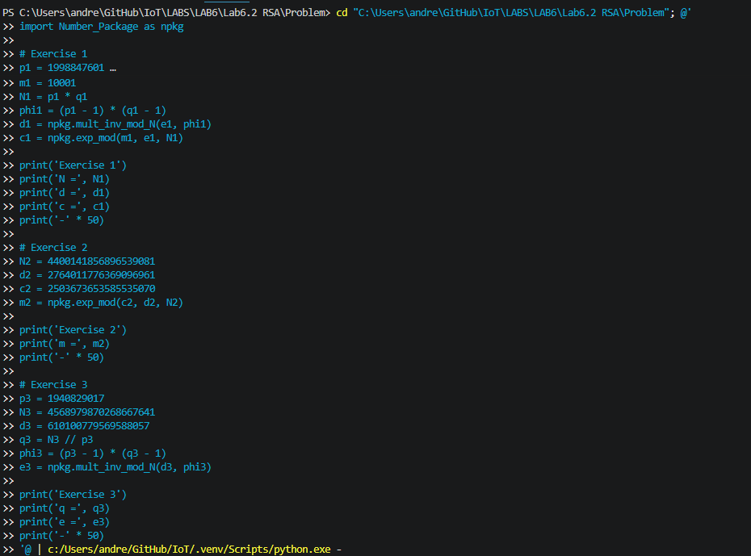

Part 4 – RSA Protected Socket

Is it advisable to use RSA for transmitting large amounts of data (for example, encrypting a 1GB file)?
No, it is not advisable. RSA is inefficient for large data because:
- Performance cost: RSA modular exponentiation is much slower than symmetric ciphers like AES, especially for gigabyte-scale payloads.
- Size limits per RSA operation: RSA can only encrypt small blocks (smaller than key size minus padding overhead), so large files must be split into many chunks, which is impractical and error-prone.
- Padding and security constraints: Secure RSA requires padding schemes (like OAEP), which further reduce per-block payload size.
- Poor scalability: Encrypting 1GB directly with RSA would be extremely slow and resource-heavy compared with modern symmetric encryption.
Best practice:
- Generate a random symmetric key (for example AES key).
- Encrypt the 1GB file with AES (fast).
- Encrypt only the AES key with RSA.
- Send RSA-encrypted key + AES-encrypted file.
This hybrid approach is what TLS and most secure systems use.

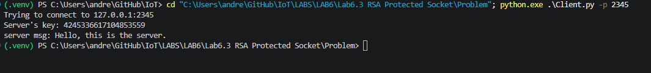
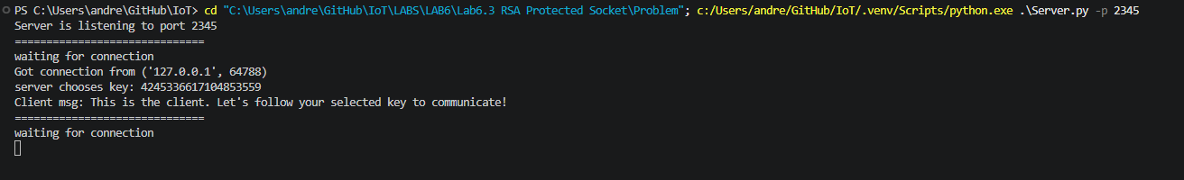
Part 5 – MITM Attack

How can the MITM attack be defended against?
- Authenticate public keys: Use digital certificates signed by a trusted CA (TLS/PKI), or pre-shared trusted public keys.
- Use TLS instead of raw sockets: TLS provides server authentication, key exchange integrity, and encrypted channels that prevent silent key substitution.
- Add certificate/public-key pinning: The client accepts only the expected server key fingerprint, so a fake key is rejected.
- Use mutual authentication (optional but stronger): Require both client and server certificates so each side verifies the other.
- Add handshake integrity checks: Use signed key exchange or authenticated key agreement (for example ECDHE + signatures) so tampering is detectable.

Code

6.1 Client
s = socket.socket()

# connect to server with input ip and port
s.connect((ip, port))

# message transmission
# send "Hello Server" to the server
tmsg = "Hello Server"
s.send(tmsg.encode())

# receive server's reply (a bytearray)
rmsg_byte = s.recv(1024) #< change to an appropriate function
rmsg = rmsg_byte.decode()
print("Server: ", rmsg)

# structured data transmission
# send sdata to the server (hint: use json to transfer back and forth between structured data and bytes)
# public key of RSA with p:2127836173 q:2167131101 d:855599238897129473
tdata = {'N': 4611299948341116473, 'e': 65537}
tdata_byte = json.dumps(tdata).encode() #< python dictionary to byte conversion.
#< you can use your way to do the conversion. For example, json.dump, or the "to_bytes" function
s.send(tdata_byte) #< send the byte array to the server

# receive server's data (check Server.py for detail)
rdata_byte = s.recv(4096) #< receive byte array from the socket
c = json.loads(rdata_byte.decode())['c'] #< interpret the byte array
print("Server: ", c) #< print the cipher sent by the server

6.1 Server
s = socket.socket()

# bind to input port
s.bind(("", port))
print("Server is listening to port %d" %(port))
#put at most 2 connections in backlog (or say 3 connections at most). Refuse more connections
s.listen(2)

msg = b''
addr=''
while True:
print("="*30)
print("waiting for connection")
# Establish connection with client, where c is the connection handler and addr is the client's ip
c, addr = s.accept()
print ('Got connection from', addr)

## message transmission
# receive message from the client
rmsg_bytes = c.recv(1024) #< receive the welcome message but in byte array
rmsg = rmsg_bytes.decode() #< convert byte array to char string
print("client: ", rmsg)

# reply the client with tmsg
tmsg = 'Hello, this is the server'
c.send(tmsg.encode())
## data transmission
rdata = json.loads(c.recv(4096).decode()) #< necessary codes to process the RSA parameter from the client
e = rdata['e'] #< interpret the e from the received data
N = rdata['N'] #< interpret N
print("client e: ", e)
print("client N: ", N)

# We will focusing on generating the key in the next section.
# Here, we temporarily use the cipher that is provided
# reply
tdata = {'c':2438923152802212086} # c is a RSA cipher
c.send(json.dumps(tdata).encode())
# Close the connection with the client
c.close()

6.2 RSA_Offline
gap = random.randint(2**27, 2**29) #

p = npkg.find_prime_smaller_than_k(2**31 - gap) #< the first prime number by seeking down from 2**31-gap
q = npkg.find_prime_greater_than_k(2**31 + gap) #< the first prime number by seeking up from 2**31+gap
e = 65537 # 65537 is a typical selection of e

# follow the RSA algorithm
N = p * q
d = npkg.mult_inv_mod_N(e, (p - 1) * (q - 1))

print("Alice choose:\np:{p}\nq:{q}\nN:{N}\ne:{e}\nd:{d}".format(p=p, q=q, N=N, e=e, d=d))
"""
Step 2:
Alice sends (N, e) to Bob

Notes:
For this lab, you DON'T need to write anything here. This will be integrated into the socket example in the next section.
"""
# This task is done magically in this section.
"""
Step 3:
Bob uses the received (N, e)
"""
m = random.randint(0, N) # a randomly chosen message in GF(N). You can replace this line with any desinated message in the future
c = npkg.exp_mod(m, e, N) # encrypt m
print("Bob chooses to encrypt plaintext:", m)
print("Bob sends ciphertext :", c)
"""
Step 4:
Bob sends the encrypted message to Alice
For this lab, you DON'T need to write anything here. You can think about adding socket communication codes here in the future.

Step 5:
Alice uses her private key d to decrypt Bob's ciphertext.

Ideally, m = m_decrypt
"""
m_decrypt = npkg.exp_mod(c, d, N) #< decrypt c with Alice's private keys
print("Alice decrypts Bob's msg and get:", m_decrypt)

6.3 RSA Protected Socket Client
#########Fill your RSA implementation here from Lab6.2########

def RSA_keygen():
gap = random.randint(2**27, 2**29)

# your code to implement RSA_keygen
p = npkg.find_prime_smaller_than_k(2**31 - gap)
q = npkg.find_prime_greater_than_k(2**31 + gap)
e = 65537
N = p * q
d = npkg.mult_inv_mod_N(e, (p - 1) * (q - 1))

return e, d, N

def RSA_decrypt(c, d, N):

# your code to implement RSA_decrypt
m = npkg.exp_mod(c, d, N)

return m

##############################################################

s = socket.socket()

# connect to server with input ip and port
s.connect((ip, port))

# generate public and private keys
e, d, N = RSA_keygen()

# send public keys to the server
tdata = {'N': N, 'e': e}
# send tdata to the server.
s.send(json.dumps(tdata).encode())

# receive server's cipher (an integer)
rdata_bytes = s.recv(4096)
rdata = json.loads(rdata_bytes.decode())
c = rdata['c']

# decrypt cipher
key = RSA_decrypt(c, d, N)
print("Server's key:", key)

# for real applications, "m" can be treated as an initial key to encrypt the following transmission by choosing DES, tri-DES, AES, etc.
# encrypt following message using provided bytearray_xor()
plaintext = "This is the client. Let's follow your selected key to communicate!"
ciphertext_bytes = bytearray_xor(key, plaintext.encode()) #< encrypt the message based on the key

# send ciphertext_bytes to the server
s.send(ciphertext_bytes)

# receive server's reply
rciphertext_bytes = s.recv(1024)
rplaintext_bytes = bytearray_xor(key, rciphertext_bytes)
print("server msg:", rplaintext_bytes.decode())

6.3 RSA Protected Socket Server
# put at most 2 connections in backlog (or say 3 connections at most). Refuse more connections
s.listen(2)

while True:
print("="*30)
print("waiting for connection")

# Establish connection with client, where c is the connection handler and addr is the client's ip
c, addr = s.accept()
print ('Got connection from', addr)

# receive client's public keys 'e' and 'N'
rdata_bytes = c.recv(4096)
# use json to parse the receive data
rdata = json.loads(rdata_bytes.decode())
e, N = rdata['e'], rdata['N']

# randomly choose a key
key = random.randint(1, N - 1)
print("server chooses key:", key)

# encrypt m
tdata = {'c':RSA_encrypt(key, e, N)}
# send tdata to the client
c.send(json.dumps(tdata).encode())

# for real applications, "m" can be treated as an initial key to encrypt the following transmission by choosing DES, tri-DES, AES, etc.
ciphertext_bytes = c.recv(1024)
plaintext_bytes = bytearray_xor(key, ciphertext_bytes)
print("Client msg:", plaintext_bytes.decode())

# server sends a reply message
plaintext = "Hello, this is the server."
ciphertext_bytes = bytearray_xor(key, plaintext.encode())
c.send(ciphertext_bytes)
# Close the connection with the client
c.close()

6.4 Mallory

import random

#########Fill your RSA implementation here from Lab5.2########

def RSA_encrypt(m, e, N):
c = npkg.exp_mod(m, e, N)
return c

def RSA_keygen():
gap = random.randint(2**27, 2**29)
p = npkg.find_prime_smaller_than_k(2**31 - gap)
q = npkg.find_prime_greater_than_k(2**31 + gap)
e = 65537
N = p * q
d = npkg.mult_inv_mod_N(e, (p - 1) * (q - 1))
return e, d, N

def RSA_decrypt(c, d, N):
m = npkg.exp_mod(c, d, N)
return m

#

def bytearray_xor(key, msg_bytes):
key_bytearray = key.to_bytes(math.ceil(math.log2(key)), byteorder="big")

key_len, msg_len = len(key_bytearray), len(msg_bytes)

return bytearray(msg_bytes[i] ^ key_bytearray[i % key_len] for i in range(msg_len))

################# write your code after this line############################

# put no connections in backlog (or say 3 connections at most). Refuse more connections
s_clt.listen(0)

while True:
print("="*30)
print("waiting for victim to connect")
# Establish connection with client.

"""deal with the connected victim"""
c, addr = s_clt.accept()
print('Got connection from victim', addr)

# receive client's public keys 'e' and 'N'
rdata_bytes = c.recv(4096)
rdata = json.loads(rdata_bytes.decode())

e4vic, N4vic = rdata['e'], rdata['N']

"""build up the connection to the real server"""
s_svr = socket.socket()
# connect to the real server
s_svr.connect((server_ip, server_port))

# generate a new set of keys to communicate with the server
e4svr, d4svr, N4svr = RSA_keygen() # generate the (e, d, N) for the server

# send public keys to the server
tdata = {'N': N4svr, 'e': e4svr}
s_svr.send(json.dumps(tdata).encode()) # send the public keys to the server

# receive server's cipher
rdata_bytes = s_svr.recv(4096)
rdata = json.loads(rdata_bytes.decode())
c4svr = rdata['c']

# decrypt out server's selected key
key = RSA_decrypt(c4svr, d4svr, N4svr) # decrypt the key chosen by the server
print("Server's key:", key)

# encrypt key and send to the victim (client)
tdata = {'c': RSA_encrypt(key, e4vic, N4vic)}
# send tdata to the victim
c.send(json.dumps(tdata).encode())

"""So far, Mallory has acquired the key and set up connections to both the real server and the victim client."""
# get the victim's message, decrypt and then encrypt using server's key and send out
ciphertext_from_victim_bytes = c.recv(1024)
plaintext_from_victim_bytes = bytearray_xor(
key, ciphertext_from_victim_bytes)
print("Victim -> Server:", plaintext_from_victim_bytes.decode())
# send to the server
s_svr.send(ciphertext_from_victim_bytes)

# receive server's reply, decrypt the ciphertext locally to get the message
ciphertext_from_server_bytes = s_svr.recv(1024)
plaintext_from_server_bytes = bytearray_xor(
key, ciphertext_from_server_bytes)
print("Server -> Client:", plaintext_from_server_bytes.decode())
# send client the received ciphertext
c.send(ciphertext_from_server_bytes)

# Close the connection with the client and the server
c.close()
s_svr.close()

