Lab 2: PHY-Layer Simulation Using GNURadio
Author: Andrew J Napieraj
Class: ESCE 6660 Internetworking of Things (IoT)
Instructor: Prof. Ish Jain
TA: Chibuikem Ezemaduka
Due Date: February 14, 2026

Description
This lab explores the use of the GNURadio application, and the implementation of Binary Phase Shift Key (BPSK), and Quadrature Phase Shift Key (QPSK) modulation schemes within a prebuilt lab environment. For ECSE 6660 course we will additionally explore the use of grey codes and discuss why they improve Bit-Error Rate (BER) overall within a modulation scheme.
Part 1 of this lab will focus on setup steps to include some difficulties from initial setup, lessons learned, and tools acquired from the conduct of the lab. Additionally, we will include screen captures of the minor (aesthetic and flexibility) changes to the data flow graphs (DFGs). These changes do not change the overall functionality of the source code.
Part 2 will include requisite BER tables and semiology graphs of BER in the various modulation schemes.
The appendix will contain the code blocks for the various modulation schemes, which will also be available via the GitHub link provided in the materials list.

Materials
- Iot_Virtualbox
- Source Code for out of tree (OOT) module
- BPSK Source Code
- QPSK Source Code
- Gnuradio GUI 3.10.1.1
- Modulation Scheme Codex

Part 1: Lab setup, difficulties, and lessons learned
Overall, the setup of this lab was very straightforward, and easy to accomplish. A minor sticking point was initially using the Gradescope copy of the lab documentation, which has the incorrect link for the QPSK source code, but this was easily corrected by simply going to the Piazza version of the lab documentation, which has been adequately discussed as the source information for the course.
From the first Lab to this lab the Ubuntu setup was seamless from learning how to properly set up the VirtualBox and extracting it using the correct tools. Additionally, the process of updating and upgrading Linux VirtualBox was very easy now that I know the base commands within the Linux environment.
From initial install to setup, I made some minor adjustments to the DFG to more quickly run through the lab without having to enable or disable blocks as I troubleshot code modulation schemes. Figure 1, Figure 2, and Figure 3 correspond to BPSK, QPSK, and QPSK (Gray) respectively. For Figure 3, we see the ground truth code block go away since initially it was coded for a standard modulation block [0, 1, 2, 3] vice [0, 1, 3, 2], and results in erroneously (and expectedly) high BER.
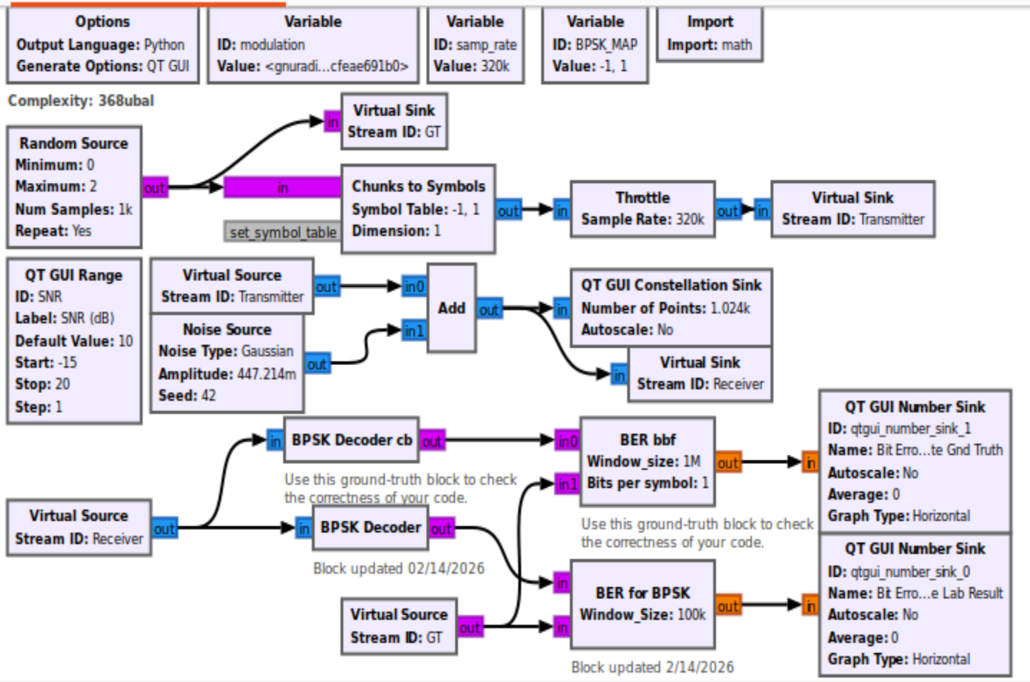
Figure 1: BPSK DFG
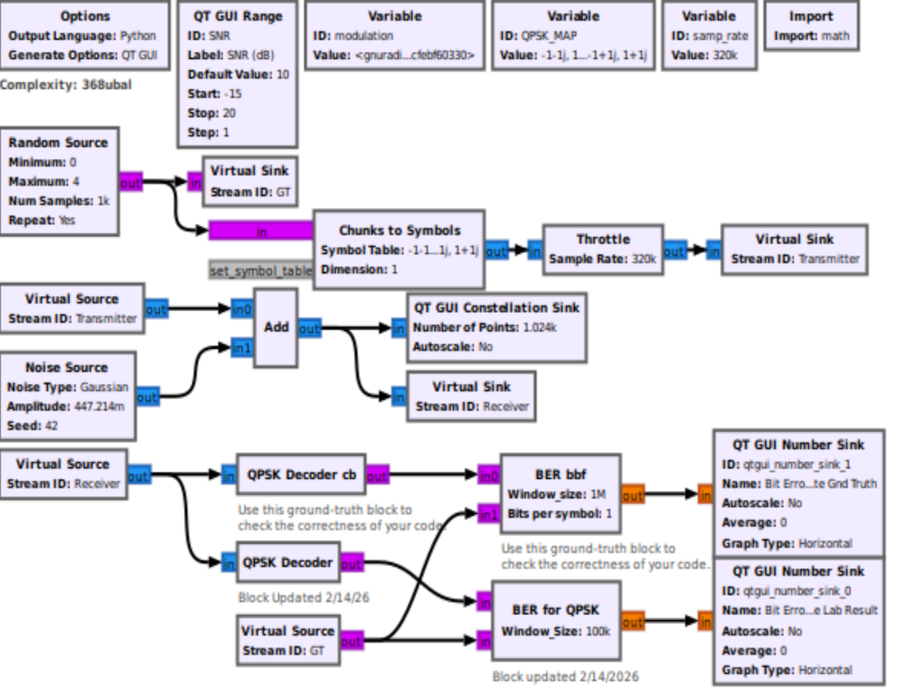
Figure 2: QPSK DFG
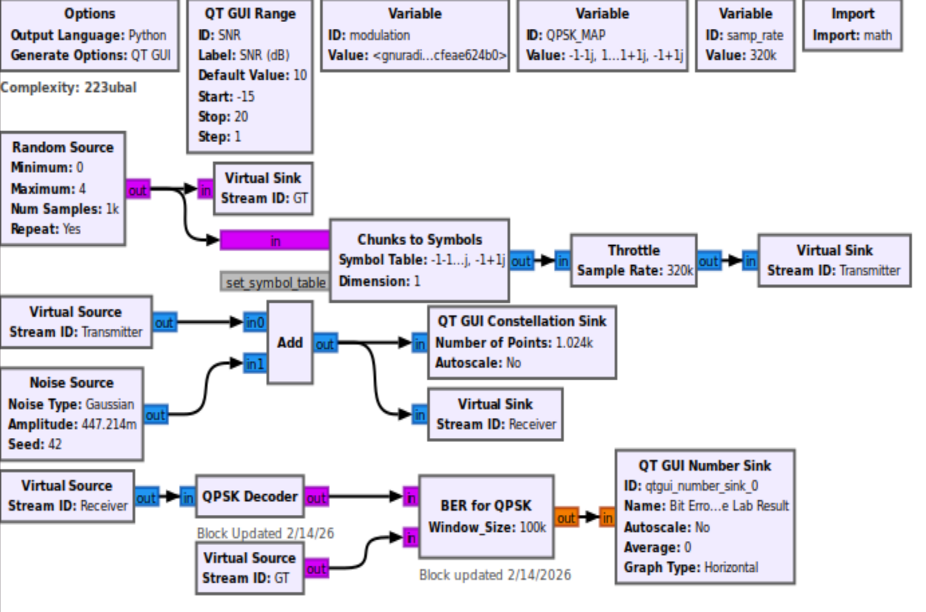
Figure 3: QPSK (Gray) DFG

