mIRONOV ARSENIY

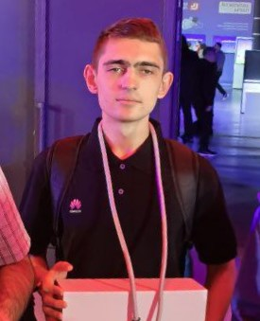 | Birthdate 01.04.2004, 20 years old  City Nizhny Novgorod  Phone number +7 (917) 618-94-15  Email arseniy.mironov.01@mail.ru  GitHub github.com/Napkin-AI  Telegram @xNapkin

Education
University | N. I. Lobachevsky State University of Nizhny Novgorod
Year of graduation | 2026
Education level | 3rd Year of Bachelor's Degree
Major | Fundamental Informatics and Information Technologies
Form of Education | Full-time

sKILLS

Programming languages | C++, Python, SQL.
Libraries | OpenCV, NumPy, Pandas, Scikit-learn, Matplotlib.
Others | Jupyter Notebook, Excel, Word, Linux, Git.
Soft Skills | Handles stress easily, responsible, able to work in a team,
 | English level A2

Projects
Optimization of QR and ArUco Detection Algorithm in OpenCV Library
During my work on the "ITLab" project at university, I explored various approaches to improving the image preprocessing algorithm and utilizing image pyramids. My personal contribution involved optimizing the algorithm for detecting rectangular contours in images. As a result, I prepared and submitted a Pull Request to the OpenCV repository with a new algorithm for detecting rectangular contours, which was subsequently approved and merged into the main branch of the library.

Additional information
Driving license category: B

Hobbies and Interests
- Improving my English language skills
- Going to the gym
- Playing chess occasionally

Competitions:
ICPC 2023-2024
- Qualification (Nizhny Novgorod): 41st place, 3rd degree diploma
- Quarterfinal (Saratov) 37th place.
ICPC 2024-2025
- Qualification (Nizhny Novgorod): 25th place, 2nd degree diploma
- Quarterfinal (Saratov) 59th place.
TECHARENA Volga Challenge 2023
- 18th place, 3rd degree diploma
TECHARENA Volga Challenge 2024
- 14th place

