Nicholas Naples and Lou Mayans

CS38101 Intro to Game Programming

Professor Maha Allouzi

11/28/2017

Project : Platformer

For our project, we decided to create a platformer that included a projectile shooting mechanic. The projectiles were given two different types in the form of abilities, which could be toggled with the buttons in the top-right corner of the UI. We also created enemies that will provide knockback to the player and damage them when their colliders interact.

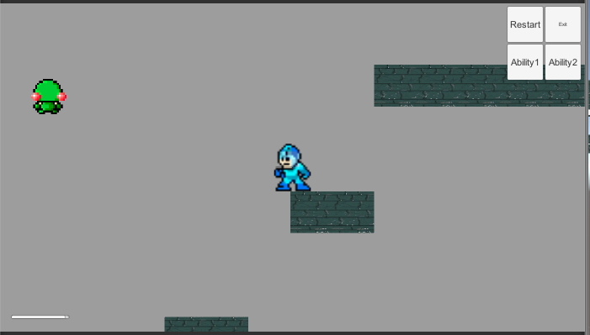

We added a dashing mechanic to allow the player additional movement options when platforming and also when generally moving around.

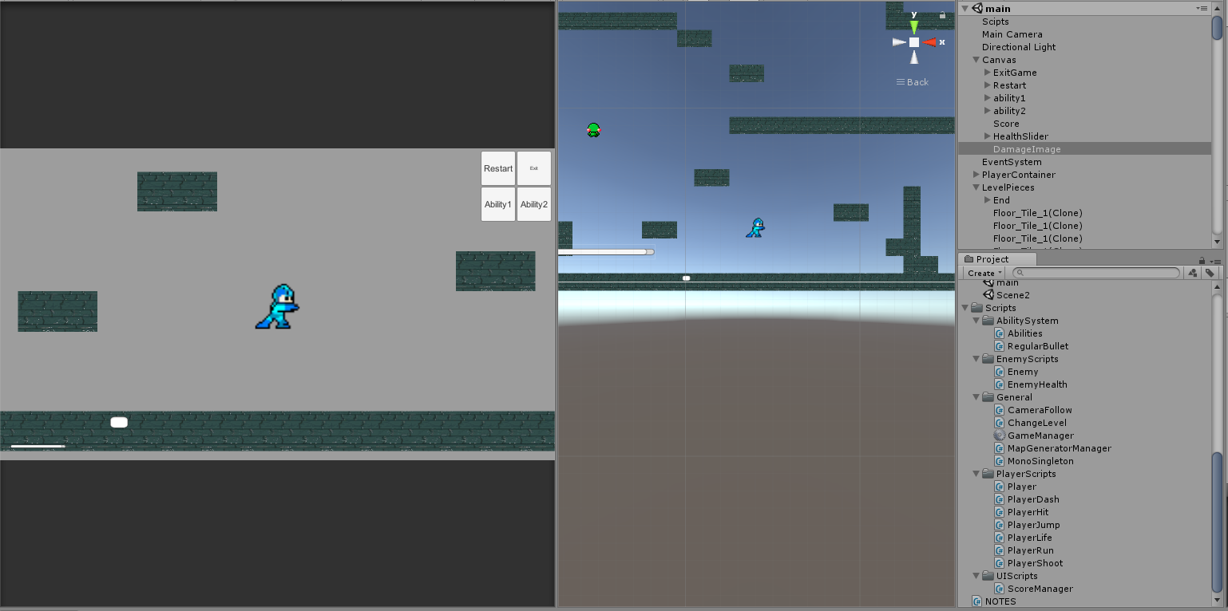

The player is fully animated with running, jumping, idle, and dashing animations. Finally, the UI is set up so that the player can see their health, change their abilities, and restart or exit their game. Unfortunately, we didn’t have time to get into level design or creating an intuitive platforming experience, but we were able to implement all of the basic features we wanted into the game.