作文题
例子：
题目：
1. 建设绿色校园很重要
2. 绿色校园不仅指绿色的环境……
3. 为了建设绿色校园，我们应该……
答案
Creating a Green Campus
Recently, with the idea of making and maintaining “a green earth” being the focus of the society, “green campus” has become a more and more popular concept in universities or colleges, which, undoubtedly, will bring us an ever-lasting benefit to both our campus and our society.
The concept of “green campus” does not only mean a green environment but also refers to an environmental sense in people’s mind. Campus plays a crucial role in educating the young generation and the consciousness of “green campus” will definitely produce a profound effect on students’ various environmental protection activities after their graduation. What’s more, the young generation is under the burden of severe environmental pollution and there are many problems waiting for them to solve.
To make “green campus” come true, firstly, it is necessary to work out effective principles for the development of sustainable and recyclable campus. Secondly, it calls for people’s awareness of the serious pollution around us and actual action to reduce the waste. Last but not least, it is necessary to strengthen the ties between campus and society, so as to ensure that “green campus” can work smoothly with the co-effort of the whole society.
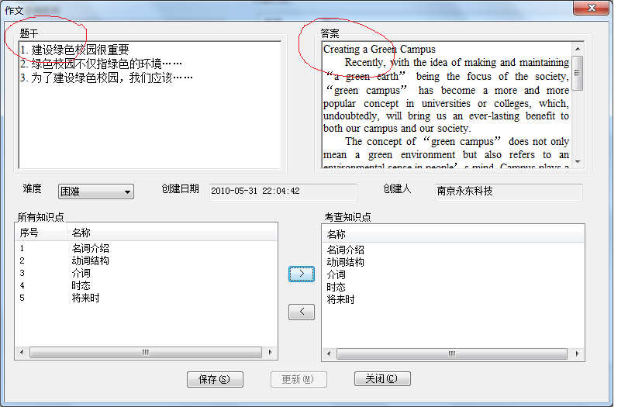

阅读理解题
规范：录入题目要移除原来试卷的题号

快速阅读理解
文章
Colleges taking another look at value of merit-based aid
Good grades and high tests scores still matter—a lot—to many colleges as they award financial aid.
But with low-income students projected to make up an ever-larger share of the college-bound population in coming years, some schools are re-examining whether that aid, typically known as “merit aid”, is the most effective use of precious institutional dollars.
George Washington University in Washington, D.C., for example, said last week that it would cut the value of its average merit scholarships by about one-third and reduce the number of recipients(接受者), pouring the savings, about $2.5 million, into need-based aid. Allegheny College in Meadville, Pa., made a similar decision three years ago.
…..
问题
- 选择题
1.（1.要移除题号） With more and more low-income students pursuing higher education, a number of colleges are ________.
A) offering students more merit-based aid B) revising their financial aid policies
C) increasing the amount of financial aid D) changing their admission processes
A)B)C)D)选项序号有录题系统提供


- N，NG题
题目：
Robert Ellis Smith believes identity theft is difficult to detect and one can hardly do anything to prevent it.
答案：N

- 填空题
9. Applicants for athletic merit scholarships need a recommendation from a coach or a referee who ______ their exceptional athletic performance.


阅读填空
Every year in the first week of my English class, some students inform me that writhing is too hard. They never write, unless assignments 47 it . They fine the writing process 48 and difficult.
How awful to be able to speak in a language but not to write in it- 49 English , with its rich vocabulary . Being able to speak but not write is like living in an 50 mansion(豪宅) and never leaving one small room . When I meet students who think they can’t write, I know as a teacher my 51 is to show them the rest of the rooms . My task is to build fluency while providing the opportunity inherent in any writing activity to 52 the moral and emotional development of my students . One great way to do this is by having students write in a journal in class every day.
Writing ability is like strength training. Writing needs to be done 53 , just like exercise ; just as muscles grow stronger with exercise , writing skills improve quickly with writing practice. I often see a rise in student confidence and 54 after only a few weeks of journal writing .
Expressing oneself in writing is one of the most important skills I teach to strengthen the whole student. When my students practice journal writing, they are practicing for their future academic, political, and 55 lives . They build skills so that some day they might write a great novel, a piece of sorely needed legislation, or the perfect love letter. Every day that they write in their journals puts them a step 56 to fluency , eloquence (雄辩), and command of language .
- closer I) painful
- daily J) performance
- emotional K) profession
- enhance L) remarkably
- enormous M) require
- especially N) sensitive
- hinder O) urge
- mission
- 将下划线去掉增加括号，并且修改序号
Every year in the first week of my English class, some students inform me that writhing is too hard. They never write, unless assignments (1) it . They fine the writing process (2) and difficult.
How awful to be able to speak in a language but not to write in it- (3) English , with its rich vocabulary . Being able to speak but not write is like living in an (4) mansion(豪宅) and never leaving one small room . When I meet students who think they can’t write, I know as a teacher my (5) is to show them the rest of the rooms . My task is to build fluency while providing the opportunity inherent in any writing activity to (6) the moral and emotional development of my students . One great way to do this is by having students write in a journal in class every day.
Writing ability is like strength training. Writing needs to be done (7) , just like exercise ; just as muscles grow stronger with exercise , writing skills improve quickly with writing practice. I often see a rise in student confidence and (8) after only a few weeks of journal writing .
Expressing oneself in writing is one of the most important skills I teach to strengthen the whole student. When my students practice journal writing, they are practicing for their future academic, political, and (9) lives . They build skills so that some day they might write a great novel, a piece of sorely needed legislation, or the perfect love letter. Every day that they write in their journals puts them a step (10) to fluency , eloquence (雄辩), and command of language .
- 录入


普通阅读理解题


听力

听力问题四个备选答案录入


听力填空


完形填空
和听力一样，注意文章下划线替换为（1）括号加序号，序号重新编号

选择题
明显

翻译题
明显

