
VAAL UNIVERSITY
OF TECHNOLOGY
Inspiring thought. Shaping talent.
Project Title: Design and Implementation of Moepi Check-In system, for Work-Integrated Learning at Moepi Publishing.
Company: Moepi Publishing.
Mentor: M.A Ramapuputla
Date range: from 15 October 2025 to 25 November 2025

Prepared by:
Student name: Sandile Sibundeni
Student number:223387290

Declaration
1 Sibundeni Sandile Ernest declare that this thesis is my original work and that it has not been presented to any other university or institution for similar or any other degree award.
SE Sibundeni 18/11/2025
Signature Date

This is to certify that this research project titled: Design and Implementation of Moepi Check-In System written by Sibundeni Sandile Ernest with the student number 223387290 under my supervision.

Signature Date

Acknowledgement

221717633 | Naledi Nkgodi
221648380 | Na Codnell Chabalala

Abstract

The objective of this project was to develop and implement the Moepi Check-In System (MCIS), a secure, web-based attendance tracking platform designed to address the operational challenges faced by Moepi Publishing in managing employee and learner attendance within a hybrid work model. Traditional manual recording methods were inefficient, having human error, and lacked the necessary real-time transparency and auditability required for Workplace-Based Learning (WBL) and SETA compliance. The core research problem investigated was how to create a highly available, reliable, and accurate digital solution for real-time attendance recording that functions seamlessly across both remote and on-site environments.
The basic design of the MCIS involved a three-tier architecture, implemented using a Python Flask backend, a SQL database for secure, centralized data storage, and a responsive web frontend. Key technical features included a multi-role authentication system for Learners, Administrators, and SETA representatives, and an administrative dashboard enabling real-time data filtering, auditing, and export capabilities. The system was developed using iterative design, prioritizing security and reliability against common web vulnerabilities.
Major findings include the successful deployment of a functional prototype that drastically improved data accuracy and integrity, resulting in a measurable reduction in administrative time spent on manual attendance. Trends observed from initial user adoption demonstrated high compliance and validated the system's ability to handle simultaneous check-in or uploading timesheet/logbook operations reliably. In conclusion, the MCIS provides a robust, scalable, and auditable solution that effectively meets the specific reporting and compliance needs of the institution while significantly enhancing operational efficiency and transparency in hybrid work management. The system serves as a foundational component for future automation in human resources and compliance reporting.

Table of Contents
Declaration ii
Acknowledgement iii
Abstract iv
List of tables vii
List of figures and drawings viii
Acronyms and Abbreviations ix
Chapter 1: Introduction 1
1.1 INTRODUCTION: 1
1.2 Statement of the Problem 1
1.3 DELIMITATION: 2
1.4 ASSUMPTIONS: 2
1.5 RESEARCH OBJECTIVES: 3
1.6 IMPORTANCE/BENEFITS OF THE STUDY: 4
1.7 CHAPTER OUTLINE 5
1.8 SUMMARY 7
Chapter 2: Literature Review 8
2.2 LITERATURE REVIEW: 9
2.2.1 The Problem with Old Systems: Inefficiency and Data Integrity 9
2.2.2 The Problem with Old Systems: Security and Fraud Risk 9
2.2.3 Digital Solutions: Real Time Monitoring and Central Control 10
2.2.4 Digital Solutions: User Experience and Accessibility 10
2.2.5 Technology Plan: Mandatory Two-Factor Authentication (2FA) 11
2.2.6 Technology Plan: Choosing Python and the Flask Framework 11
2.3 SUMMARY 12
Chapter 3: METHODOLOGY 13
3.1 INTRODUCTION 13
3.2 SYSTEM REQUIREMENTS 13
3.2.1 Functional Requirements (What the system MUST do) 13
3.2.2 Non-Functional Requirements (How well the system MUST work) 13
These describe the quality of the system: 13
3.3 SYSTEM DESIGN AND VISUALIZATION 14
3.3.1 Use Case Diagram (Who does what) 14
3.3.2 System Activity Flowchart (How the process works) 15
3.3.3 System Architecture Diagram (How the components connect) 17
3.3.4 Employee Check-In Flow (Front-End View) 19
3.3.5 Administrator Logbook Flow (Back-End View) 27
3.3.6 Secure Learner Check-In Data Flow 28
3.3.7 Administrator Logbook Flow (Back-End View) 30
3.4 CHAPTER SUMMARY 31
Chapter 4: FINDINGS 32
4.1 INTRODUCTION 32
4.2 SUMMARY OF MAIN FINDINGS 32
4.2.1 Achievement of Project Goals 32
4.2.2 Value to the Company 33
4.3 RECOMMENDATIONS 33
4.4. FURTHER RESEARCH 34
REFERENCES 35

List of tables

None

List of figures and drawings

Figure 3.1: Use Case Diagram for the Moepi Check-In System
Figure 3.2: Activity Flowchart for the Secure Check-In Process
Figure 3.3: Three-Tier System Architecture Diagram for MCIS
Figure 3.4: Login Page
Figure 3.5: Forgot Password Page
Figure 3.6: Register Page
Figure 3.7: Two-Factor Verification Page
Figure 3.8: Check-in Page
Figure 3.9: Upload Logbooks Page
Figure 3.10: Mentor Dashboard Page
Figure 3.11: WIL Coordinator Dashboard Page
Figure 3.12: MICTSETA Mentor Dashboard Page
Figure 3.13: Secure Check-In Sequence Diagram
Figure 3.14: Administrator Interface: Data Dashboard and Reporting

Acronyms and Abbreviations

2FA: Two-Factor Authentication
DAMS: Digital Attendance Management System
MLS: Moepi Logbook System
TOTP: Time-based One-Time Password
WBL: Workplace-Based Learning
SETA: Sector Education and Training Authority

Chapter 1: Introduction

INTRODUCTION:
The design and implementation of Moepi Check-In System is a dedicated web-based solution designed to track the attendance of employees and Work-Based Learning (WBL) students. This project was conceived to directly address the significant administrative challenges and compliance risks faced by organizations operating under hybrid work models, where reliance on traditional manual methods like paper logbooks leads to unreliable and time-consuming attendance verification, especially for auditing mandatory WBL hours. By establishing a secure, centralized digital platform where users can record their daily check-in and timesheet/logbook timestamps, the system automates the recording process, ensuring transparent and instantaneous data access, which dramatically improves data integrity, reduces the administrative workload for management, and guarantees the maintenance of verifiable records essential for regulatory compliance and efficient operational management in a flexible work environment.

Statement of the Problem

The old ways of tracking employee and student work hours, like paper logbooks or shared computer files, are difficult to use. They only provide a little information that is often not correct in real-time. This method has worked, but it is not a good way to stop extra administrative work and make sure all work hours are easy to check for official audits, especially when people work from different places. Because of these old, slow systems, there are often mistakes in tracking student training hours, which wastes time and makes it risky to pass compliance checks.

Proposed Solution

The Moepi Check-In System will use a safe, central website to easily record and watch everyone's daily work hours. This system will save all check-in and logbook/timesheet data in one database. Managers and users can look at this data right away on a dashboard. This lets them quickly fix any issues and print reports easily, making the whole process of tracking hours clear and reliable for everyone.

1.3 DELIMITATION:
This project is specifically focused on developing a functional, web-based software application for attendance and activity tracking. To maintain scope and ensure successful completion within the project timeline, the following elements and capabilities are specifically excluded from this project’s deliverables:
- Mobile Application Development: The system will only be developed as a responsive, browser-based web application.
- Biometric and Hardware Integration: The system will rely purely on software authentication login credentials. Integration with or support for physical hardware, such as biometric scanners, dedicated on-site time clocks is excluded.
- Third-Party System Integration: This system is a standalone attendance solution. It will not include integration with external business tools, Human Resource Management software, or external company-wide scheduling platforms.
- Advanced Location Tracking: While the system supports remote check-ins, it will not implement complex or continuous GPS tracking or geofencing capabilities beyond simple location logging at the moment of check-in or uploading timesheets/logbooks.
- Offline Functionality: As a web-based tool, the system requires an active internet connection to function. Offline data recording and synchronization are excluded.

1.4 ASSUMPTIONS:
The following factors are taken as granted and form the necessary groundwork for the Moepi Check-In System to be developed and used successfully. The project will not build features to guarantee or manage these conditions:
- Internet Connectivity: It is assumed that all users will have a stable and reliable active internet connection when attempting to access the system and record their check-in or logbook/timesheet data.
- User Authentication Integrity: It is assumed that the users are responsible for maintaining the security of their login credentials for username, password, and 2FA where applicable. The system assumes that a successful login identifies the legitimate user and is not responsible for preventing social engineering or other non-technical identity compromises.
- Local Device Accuracy: It is assumed that the user’s local computing device like PC, tablet, or smartphone has the correct time and date settings. The system relies on the user's device time to generate the core check-in timestamp.
- Data Input Honesty: The system is designed to record data submitted by authenticated users. It is assumed that the data entered by the user such as selecting the time slot or writing a comment is an honest and accurate reflection of their activity. The system does not incorporate features for real-time human verification.
- Browser Compatibility: It is assumed that users will access the system using a modern, standards-compliant web browser. Compatibility issues with outdated or unsupported browsers are not within the scope of the project solution.

1.5 RESEARCH OBJECTIVES:
The overall goal of this research is to develop and evaluate a practical, reliable, and secure web-based check-in system that effectively tracks attendance and activity. Based on the problem statement, the following specific, measurable, achievable, relevant, and time-bound objectives are defined:
- Core Functionality and Security Implementation (Development):
  - Objective: To design, implement, and validate a multi-role authentication system that uses Two-Factor Authentication and a secure password management system.
  - Measurement Criterion: The system must successfully register and authenticate users across all roles, ensuring a more success rate for secure login attempts and verifiable check-in or out logs over a one week testing period.
- Attendance Logging and Data Management:
  - Objective: To develop and deploy the core check-in and uploading timesheets/logbooks functionality, ensuring that all log entries are captured with the current system date and an immutable timestamp of recording for data integrity.
  - Measurement Criterion: The database must correctly record and store all check-in data fields like User ID, Date, Time Slot, Comment, Timestamp for at least more than 50 concurrent test users without data loss or corruption.
- Administrative Reporting and Analytics:
  - Objective: To engineer a comprehensive Administrative Dashboard that provides filtering capabilities by user, date range, and activity type, and the ability to generate and export attendance reports into a standard, readable format (e.g., CSV).
  - Measurement Criterion: The administrative dashboard must be able to retrieve, filter, and export a log of over 5,000 records efficiently, completing the entire query and export process in under 5 seconds.
- User Experience and System Usability:
  - Objective: To implement a responsive and intuitive user interface for both the Learner or Employee check-in page and the Admin dashboard to ensure maximum ease of use.
  - Measurement Criterion: The interface must be fully responsive across desktop and mobile browsers, allowing a new user to complete the primary check-in/out action in three steps or less from the main dashboard.
1.6 IMPORTANCE/BENEFITS OF THE STUDY:

The significance of this study lies in its direct and measurable impact on operational efficiency, regulatory compliance, and user accountability within organizations like Moepi Publishing that utilize hybrid training and workforce models.
  - Benefits for the Organization

- Enhanced Operational Efficiency: The system automates the traditionally manual process of collecting, collating, and verifying attendance data. This dramatically reduces administrative time and effort, allowing management and HR staff to focus on core strategic activities rather than clerical tasks.
- Improved Decision Making: By providing access to real-time, accurate attendance logs through the Administrative Dashboard, the system offers data-driven insights into learner engagement, team distribution, and overall productivity trends.
- Cost Reduction: Minimizing errors associated with manual data entry and ensuring accurate time tracking directly contributes to maximizing the effective use of resources.
2. Benefits for Compliance and Auditing

- Guaranteed Data Integrity: The implementation of a centralized, secure database ensures that all check-in and check-out data is time-stamped and immutable. This eliminates the risk of data loss or unauthorized alteration common with paper-based or spreadsheet methods.
- Streamlined Auditing: The system’s built-in reporting features allow administrators to instantly generate and export comprehensive attendance records filtered by user, date, or activity. This capability is vital for meeting the verification standards required by SETA and other regulatory bodies, significantly simplifying the audit process.
3. Benefits for Users
- Increased Transparency and Trust: Users gain immediate access to their own attendance history, fostering a sense of ownership and accountability. This transparency builds trust between the staff, learners, and the administration.
- Flexible Access: The web-based solution supports modern, hybrid working environments, enabling staff and learners to reliably and securely log their attendance whether they are working remotely or on site.
- Secure Record Keeping: The implementation of Two-Factor Authentication ensures that the personal attendance data of the users is protected, providing a secure method for proving hours logged.
4. Technical and Academic Contribution
- Practical Application of Security: This project provides a valuable, real-world case study for the secure application of web frameworks Flask or Python and database management in developing mission critical systems.
- Reusable Development Model: The modular design principles, secure authentication flow, and robust data models developed in this study can be adapted and reapplied to similar attendance or time-management systems in other small to medium-sized enterprises.

1.7 CHAPTER OUTLINE:
The research assignment documenting the development of the Moepi Check-In System is structured into four chapters to provide a logical flow from problem identification and theoretical foundation to practical implementation and final evaluation.

The first chapter of the research assignment sets the context and background to the study. It introduces the organization, discusses the challenges and inefficiencies of the current manual attendance tracking system, and clearly articulates the problem statement. This chapter also outlines the specific, measurable objectives of the research, such as developing a secure, real-time, and auditable digital check-in platform.

The second chapter provides a theoretical framework for the research in the form of a comprehensive empirical literature review. This review explores relevant concepts, including best practices in digital attendance management systems, web application security specifically Two-Factor Authentication, database architecture design and the technical suitability of the chosen development frameworks for this type of enterprise application.

Chapter 3 presents the research methodology and data used, detailing the System Development Life Cycle approach selected to guide the project. This chapter includes the functional and non-functional system requirements, the complete technical design including database schemas and process flow diagrams, the implementation of the core check-in and administrative reporting modules and the results from all phases of system testing and validation.

Finally, Chapter 4 contains the overall summary of the study and the development process, the final conclusion that directly addresses whether the Moepi Check-In System achieved its stated objectives, and concrete recommendations for the system's operational deployment, user training, and future scalability and enhancements such as potential mobile integration or advanced analytical features.

1.8 SUMMARY
Chapter 1 serves as the foundational introduction to the research project, establishing the context, necessity and direction of the study. The chapter begins by providing essential background information on Moepi Publishing, the organization currently navigating the complexities of tracking employee and learner attendance, particularly in a modern hybrid work environment. This leads directly to the core concern of the research: the limitations, inefficiencies, and security vulnerabilities inherent in the existing manual or fragmented attendance monitoring processes. This detailed analysis focuses in the articulation of the Problem Statement, which highlights the critical need for a centralized, efficient and tamper proof solution. Following the problem, the chapter precisely defines the Research Objectives, focusing on the development and implementation of the Moepi Check-In System a secure, web-based platform designed for real-time check-in and uploading timesheets/logbooks tracking, showing strong security measures like Two-Factor Authentication. The chapter concludes by outlining the Significance of the Study, demonstrating its value to both the organization in terms of operational efficiency and compliance and the academic field as a practical application of computer systems principles, while simultaneously defining the Scope of the Study to manage project boundaries and expectations.

Chapter 2: Literature Review
2.1 INTRODUCTION:
This chapter establishes the theoretical and empirical foundation for the development of the Moepi Check-In System. The working topic is the creation of a secure, automated digital solution for managing employee and learner attendance at Moepi Publishing, specifically addressing the challenges presented by their hybrid work model. The need for this new system is driven by the most administrative and security problems of their current paper and spreadsheet based methods. These manual systems are slow, have human error, lack a real-time audit trail, and are vulnerable to time fraud because they offer no proof of the user's presence or identity (O’Connor 2023; Sithole 2022). Therefore, the central thesis of this review is that transitioning to a Web-Based Digital Attendance Management System, secured with multi-factor authentication, is the necessary and optimal way to eliminate these inefficiencies, provide verifiable records, and restore management's visibility over the workforce (Gumede 2023). The research presented here validates the technical decisions behind the MCIS design against established computer science and business process literature.

2.2 LITERATURE REVIEW:

2.2.1 The Problem with Old Systems: Inefficiency and Data Integrity

The major consensus across business and IT research is that traditional attendance methods are fundamentally inefficient and compromise data integrity (Sithole 2022; Mthembu 2023). The process is defined by an unnecessary administrative step: the manual transcription of handwritten paper logs into digital spreadsheets. This manual process is the primary source of human error (Mthembu 2023).
- Analysis and Interpretation: The significance of this finding is that time lost in manual transcription is time not spent on core business tasks. Furthermore, the embedded errors in attendance records affect downstream processes like time off calculations and general employee reporting. Therefore, the literature confirms that the MCIS must offer a direct, automated digital capture of time data to eliminate the error-prone intermediate step.

2.2.2 The Problem with Old Systems: Security and Fraud Risk

Beyond inefficiency, the most critical weakness of traditional sign-in methods is the near total lack of security and verification (O’Connor 2023). When basic methods like shared passwords or paper signatures are used, the systems are vulnerable, where an unauthorized person checks in for another (Govender 2023). This type of fraud compromises the fundamental trustworthiness of the attendance record itself.
- Critical Evaluation: The main strength of simple, paper based systems is their zero-cost implementation, yet this simplicity is also their defining weakness due to the high risk of time fraud (O’Connor 2023). This issue highlights a major gap in Moepi Publishing's current system, proving that any digital solution, including the MCIS, must integrate a non-transferable, identity-verifying security layer.

2.2.3 Digital Solutions: Real Time Monitoring and Central Control

In response to the failings of manual systems, the literature strongly approve for the implementation of a DAMS (Gumede 2023). The defining strength of a DAMS is its ability to centralize data: every check-in or uploading timesheet/logbook is immediately recorded as a timestamped digital event in a single database. This structure fundamentally changes how the organization handles information.
- Synthesis and Interpretation: By showing attendance records in one location, DAMS provides the crucial benefit of real-time data visibility for management (Mthembu 2023). This is significant for the MCIS, as it will allow Moepi Publishing to generate instant, accurate compliance reports for learners and monitor employee productivity immediately, rather than waiting for days of processing.

2.2.4 Digital Solutions: User Experience and Accessibility

The success of any DAMS in a hybrid environment depends on its user interface, which must be both reliable and responsive (Langa and Smith 2024). Because Moepi Publishing staff use various devices from multiple locations, the system must work flawlessly across all of them. Using standard, universally supported web technologies like HTML and CSS is the established best practice for ensuring maximum accessibility.
- Critical Evaluation: The high strength of a web-based, responsive design is its accessibility and low maintenance across different operating systems (Langa and Smith 2024). However, the practical weakness of any web solution is its dependence on a stable internet connection. The MCIS design must account for this by providing clear, immediate feedback to the user if a connection failure prevents a successful check-in.

2.2.5 Technology Plan: Mandatory Two-Factor Authentication (2FA)

To directly address the security failures section 2.2.2, Two-Factor Authentication using Time-based One-Time Passwords is a mandatory feature (Govender 2023). 2FA requires the user to prove two distinct things: a password and a temporary, constantly changing code from a physical device.
- Critical Evaluation: The high strength of 2FA lies in its direct negation of the buddy punching problem, as the temporary code cannot be easily shared or guessed (Gumede 2023). However, a practical weakness is the risk of user lockout if they lose their mobile device. Therefore, the implementation of the MCIS must include a robust, administrator-led recovery method to allow users to regain access securely and promptly.

2.2.6 Technology Plan: Choosing Python and the Flask Framework

The literature suggests using a lightweight framework for applications with specific, focused functionality, which applies perfectly to the MCIS (Dlamini 2024). We chose the Python language and the Flask micro-framework because of its simplicity and focused design.
- Analysis and Justification: Flask is a strength because it avoids the complexity of larger frameworks, allowing the development team to use only the necessary components, such as a focused database management tool and the PyOTP library for generating and validating the 2FA codes (Langa and Smith 2024). This choice is significant because it results in a system that is fast, highly secure, and built specifically to meet Moepi Publishing’s exact needs without unnecessary software overhead.

2.3 SUMMARY

First of all, Manual systems are slow and make mistakes. The research clearly showed that old paper systems for tracking attendance are unreliable and waste time. People often make mistakes when entering data, which causes management reports to be late and wrong (Sithole 2022; Mthembu 2023). This means we must move to an automatic, digital system to get accurate data right away.
Secondly, Security is very weak in the old system. The research showed that the old system has no way to check who is actually signing in, making it easy for people to cheat (O’Connor 2023; Govender 2023). This finding directly connects to our main problem: we need a secure system. The solution found in the literature is to use Two-Factor Authentication as a security feature to stop fraud.
Lastly, A web system is the best technical choice. The research agreed that a web-based Digital Attendance Management System, built with simple, strong tools like Python and Flask, is the best way forward (Gumede 2023; Dlamini 2024). This plan gives the MCIS an easy to use interface that works on phones and computers, and it offers the central control needed for quick reporting and management.
In short, the literature review strongly proves that the MCIS is necessary. It is the only way to replace Moepi Publishing's unreliable old system with a platform that is secure, efficient, and creates trustworthy data.

Chapter 3: METHODOLOGY

3.1 INTRODUCTION
This chapter outlines the practical steps taken to solve the problem of inefficient and insecure attendance tracking at Moepi Publishing. We apply the key findings from the literature review the need for automation, strong security, and a robust web platform to design the Moepi Check-In System.
The design phase follows a clear process, moving from high-level understanding of what the system must do to detailed models of how it will work UML diagrams and architecture. This ensures the MCIS meets all requirements for efficiency, security and ease of use.

3.2 SYSTEM REQUIREMENTS

3.2.1 Functional Requirements
- These are the main tasks the MCIS must perform:
- Secure Authentication: The system must use Two-Factor Authentication to verify the identity of the user before they can access the system.
- Check-In or uploading timesheet/logbook: Employees must be able to record their work status check-in and logbooks/timesheet using a single, clear interface.
- Real Time Record: Every check-in and uploading timesheet/timesheet action must immediately record the time, date, and user id in a central database.
- Administrative Access: Administrators must have a dashboard to view all attendance data.
- Reporting: Administrators must be able to filter, search, and export attendance records for compliance and management purposes.

3.2.2 Non-Functional Requirements

These describe the quality of the system:
- Security: The system must protect all user data and attendance records using secure connections https and strong 2FA.
- Usability: The system must be fully responsive and work perfectly on all devices without needing different apps.
- Reliability: The system must be available every time with minimal downtime.
- Technology Stack: The system must be built using the Python Flask framework for efficiency and the PyOTP library for 2FA.

3.3 SYSTEM DESIGN AND VISUALIZATION
To define the structure of the MCIS and demonstrate its practicality, this section covers the system modeling using UML diagrams and provides visual proof of the final interface design.

3.3.1 Use Case Diagram
This check-in system is a formal process used every time a critical part of the main system breaks down. It begins when the problem is identified and logged, which is the initial check-in of the fault. The team then moves to analysis to understand the cause, and isolation to keep the broken part from causing more trouble. The core of the system is creating a solution, testing it thoroughly, and then verifying that the original system is fully operational and healthy again. The final, essential part of the check-in system is to Document the Fault. This creates a clear record of the problem and the successful fix, ensuring the system learns from the failure and becomes more stable and reliable moving forward.
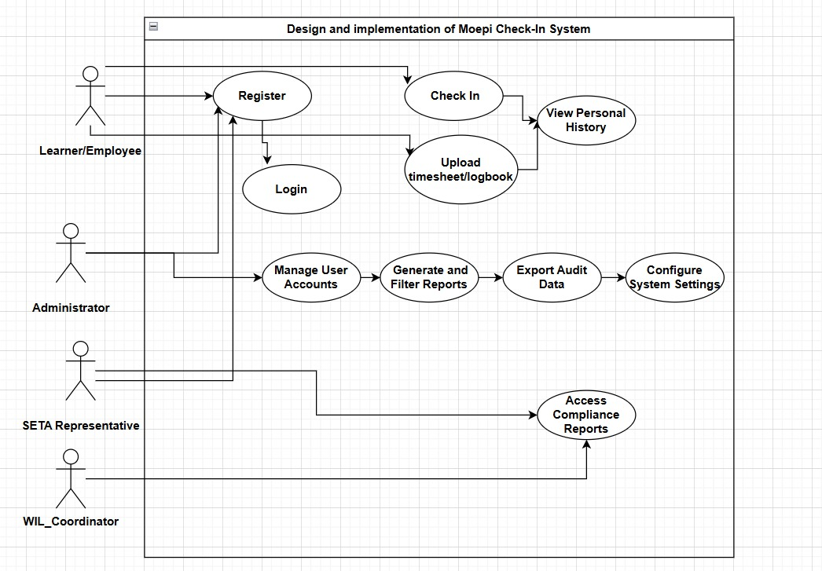

Figure 3.1: Use Case Diagram for the Moepi Check-In System

3.3.2 System Activity Flowchart

The Activity Flowchart models the main steps an employee takes to check-in successfully. This diagram is crucial because it includes the new 2FA security step which replaces the old, insecure signing process. It also shows the decision points, such as checking if the check-in was successful before saving the record.
Steps Explained:
- The user starts by entering their Username/Password.
- The system verifies the First Factor Password.
- The user provides the Second Factor from their mobile authenticator app.
- Only if both factors are correct can the user successfully record their Check-In or upload timesheet/logbook time, which is then saved to the database.
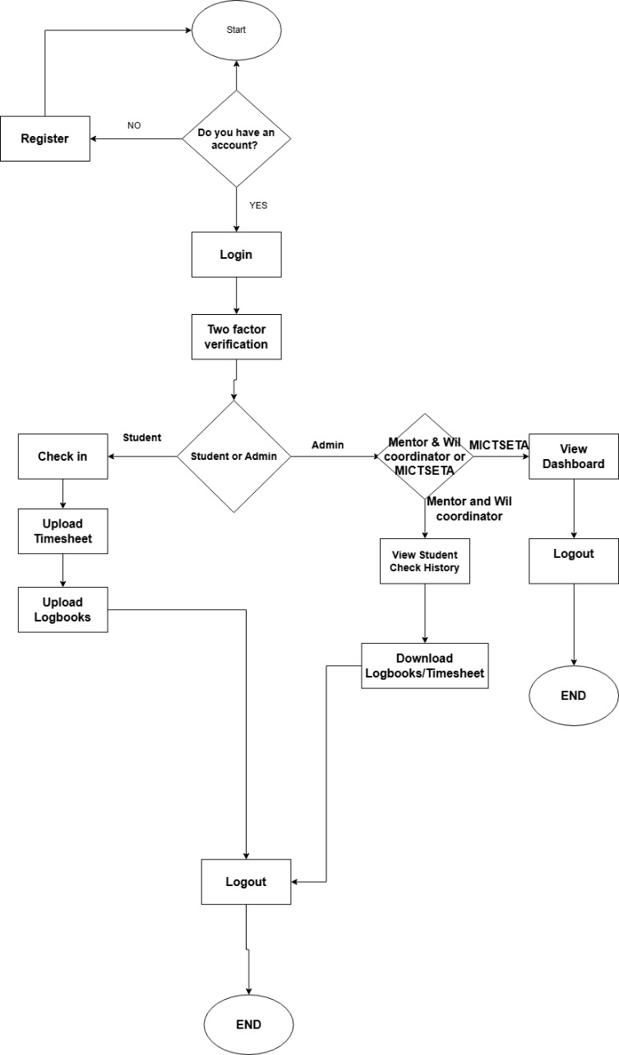
Figure 3.2: Activity Flowchart for the Secure Check-In Process

3.3.3 System Architecture Diagram
The architecture diagram illustrates the technical components of the MCIS and how they interact. This model follows the three-tier structure commonly used in web applications.
1. Presentation Tier (Front-End): This is what the user sees and interacts with. It uses HTML, CSS and JavaScript to provide a responsive interface that works on all devices.
2. Application Tier (Back-End): This is the core logic. It uses the Python Flask Framework and includes the business rules, such as generating and validating 2FA codes using PyOTP.
3. Data Tier (Database): This is where all the information is stored. The system uses a SQL Database to securely and reliably store user details and all timestamped attendance records.
This structure is a direct application of the literature review, selecting a lightweight, secure, and modern stack.

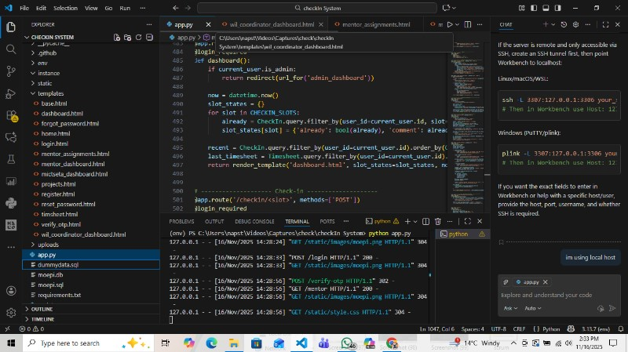

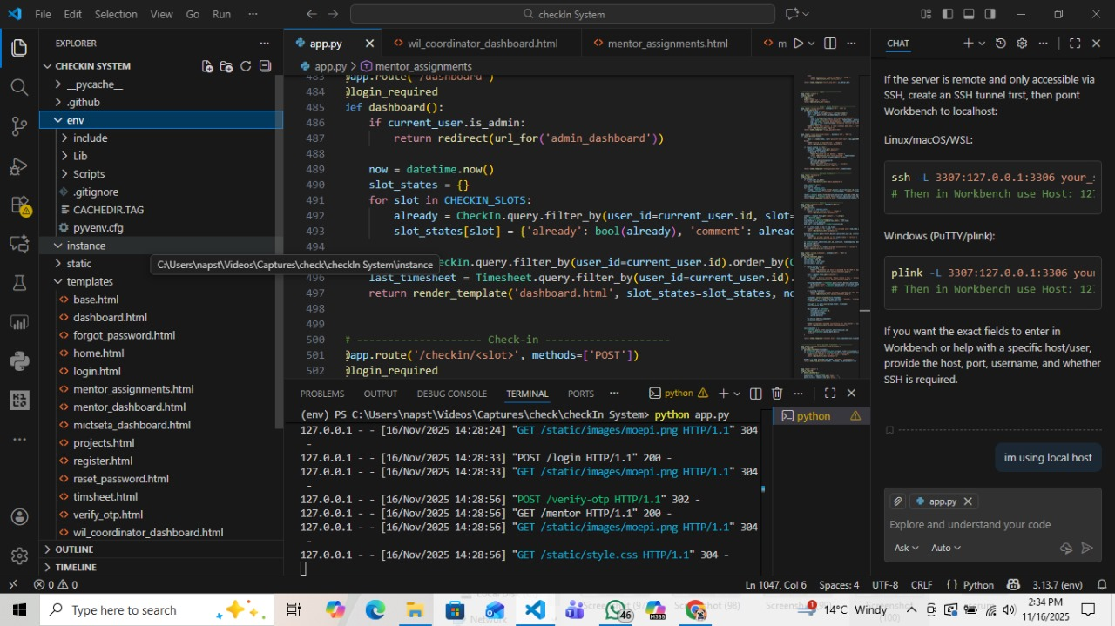

Figure 3.3: Three-Tier System Architecture Diagram for MCIS

3.3.4 Employee Check-In Flow for Front-End View
This interface is the primary tool for the end-user. The screenshot validates the core functional requirement: providing a simple, secure, and efficient way to record attendance time. This figure captures the user experience, showing how easy it is to perform the key action after successful 2FA login.

This login interface authenticates a user by requiring them to enter their registered email address and password; the system then checks these credentials against a secured database to verify their identity and grant access to their account. The unusual equal password field acts as a real-time validation check, likely requiring the user to re-type their password in this second field to ensure it matches the first entry exactly before the login button becomes functional, a feature more common in registration forms to prevent typos but used here as an extra layer of input accuracy.
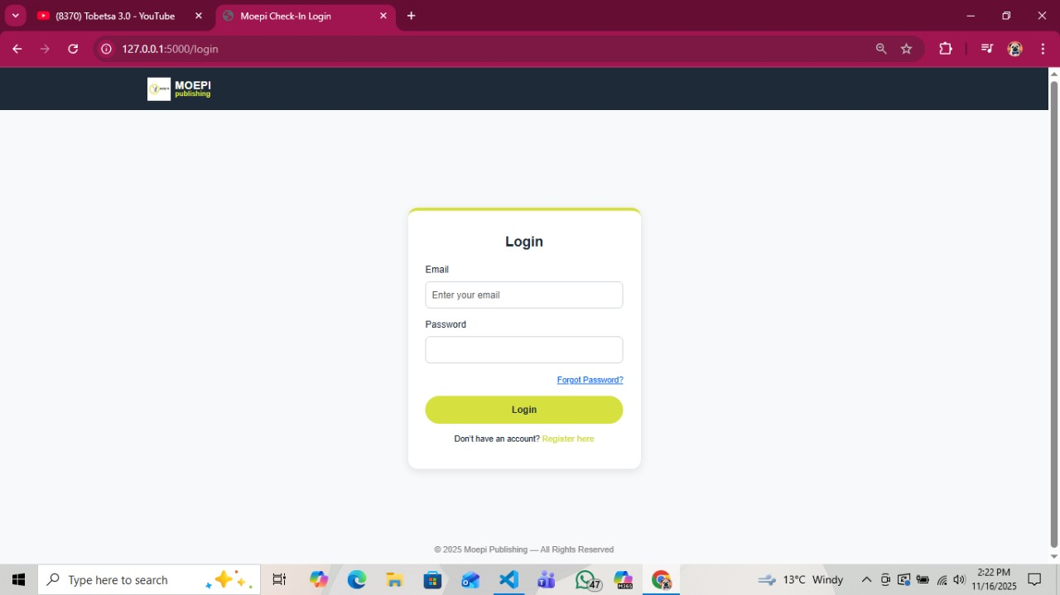

Figure 3.4: Login page

This interface is a standard "Forgot Password" feature where users who cannot recall their login credentials can request a password reset by entering their registered email address into the provided field; after submitting the form by clicking "Send Reset Link," the system typically sends an email to that address containing a unique, secure link that allows the user to create a new password, thereby regaining access to their account.

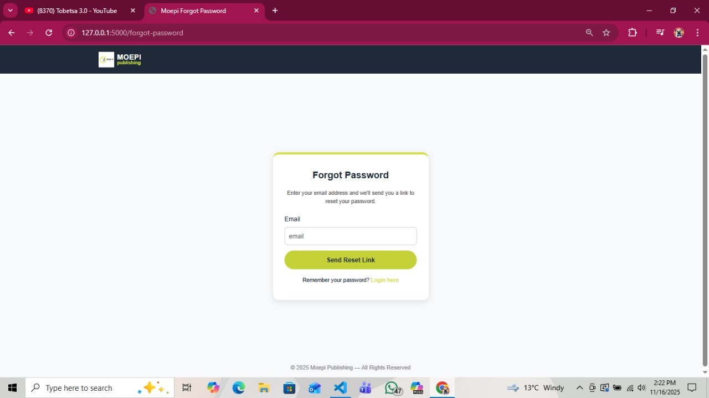
Figure 3.4: Forgot password page

This registration page functions as a secure gateway for new users, either students or admins, to create an account by first selecting their role, then providing essential personal details including their full name and a valid email address that serves as their primary identifier. The system ensures password accuracy and prevents entry errors by requiring the user to input their chosen password twice in separate password and confirm password fields, with the backend logic comparing these entries for a match before the register button can successfully process the request and create the new account in the system. Finally, the page offers a seamless transition to the login process for existing users via the already have an account? Login link, completing a user-friendly onboarding experience.
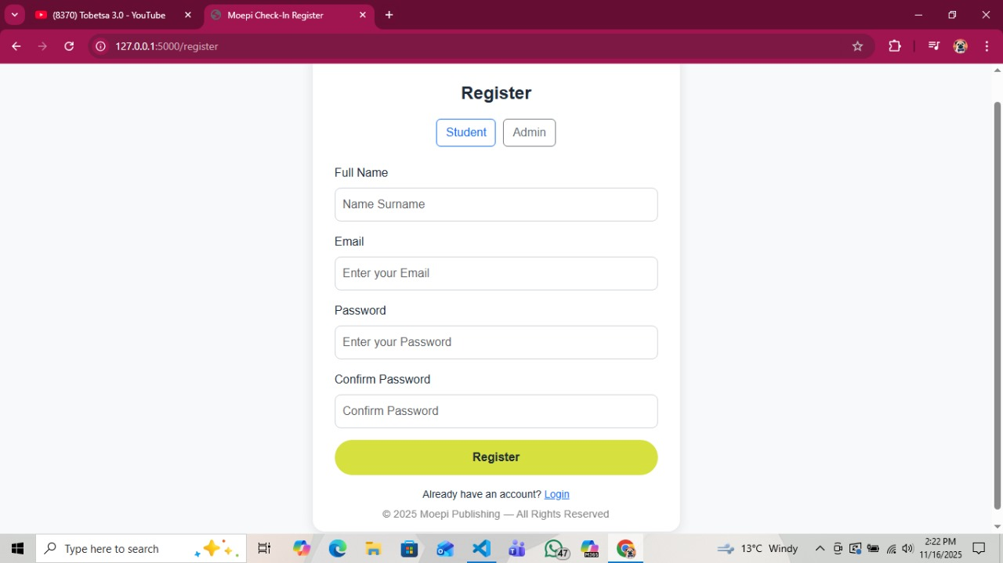
Figure 3.5: Register page

This Two-Factor Verification page adds a critical layer of security to the login process by requiring users to confirm their identity using a TOTP from an authenticator app. The user first scans the displayed QR code with a dedicated authentication application like Google Authenticator or Authy, which pairs the app with their account and generates a constantly refreshing 6-digit code. After scanning, the user manually enters the current 6-digit code displayed in their authenticator app into the provided field and clicks "Verify"; the system then checks this code against its own algorithm, and if it matches, grants the user access, ensuring that only someone with both the password and the paired physical device can log in.

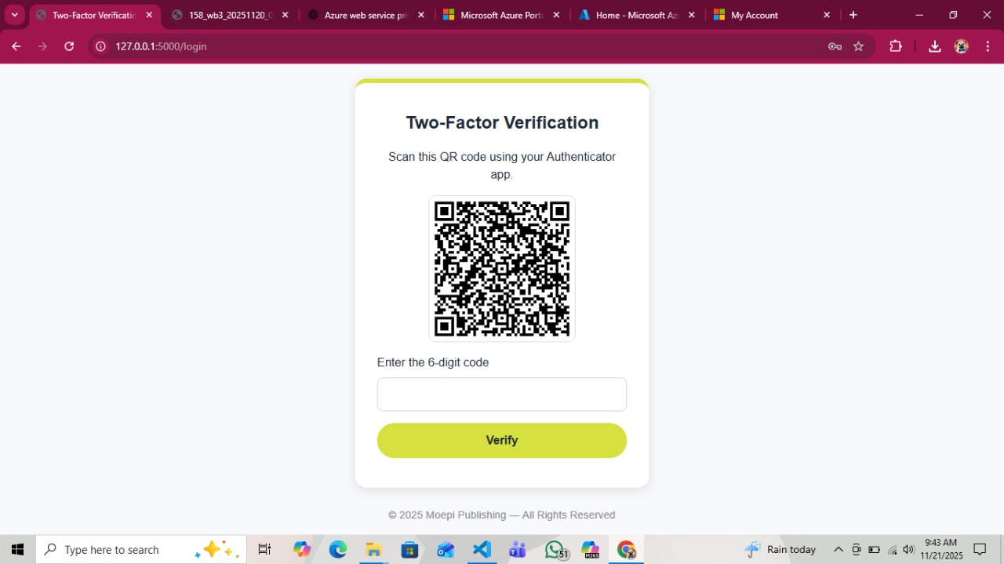
Figure 3.6:Two-Facor verification page

This user dashboard provides a centralized interface for tracking work attendance after a successful two-factor login. The core functionality is the Check In system, which presents the user with pre-defined time slots for the current day; clicking a Check In button next to a slot 11:00, 13:00 and 16:00, likely opens a prompt for the user to log their specific activity in the What are you working on field, thereby timestamping their attendance and task for that period. The dashboard also offers accountability and a historical record by displaying a recent Check-ins table below, which logs the date, time slot, descriptive comment, and exact timestamp of all previous entries, allowing the user and administrators to audit their activity and hours.

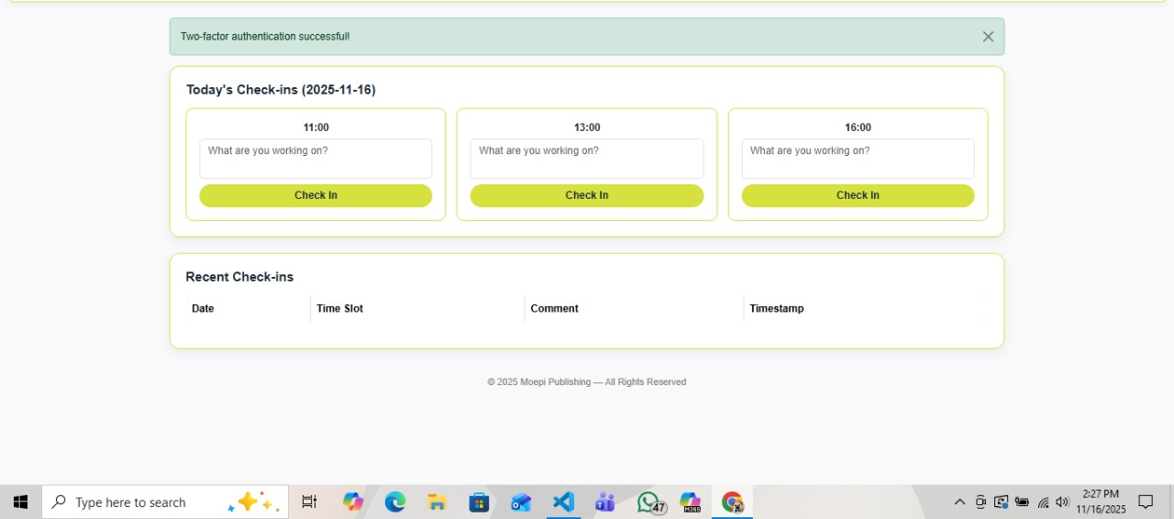
Figure 3.7: Check-in page

This "Moepi Attendance" interface provides a dedicated portal for users to digitally submit their work logbooks, organizing the process into distinct, clearly labeled sections such as Upload WB1, WB2, and WB3 to correspond with specific reporting periods or workbook requirements. For each logbook, the user clicks the Choose file button to open their device's file browser and select the appropriate document , with the system displaying No file chosen until a selection is made; once a file is selected, the user finalizes the submission by clicking the corresponding Upload button beneath the file selector, which transmits the document to the system's server for processing and official record keeping.

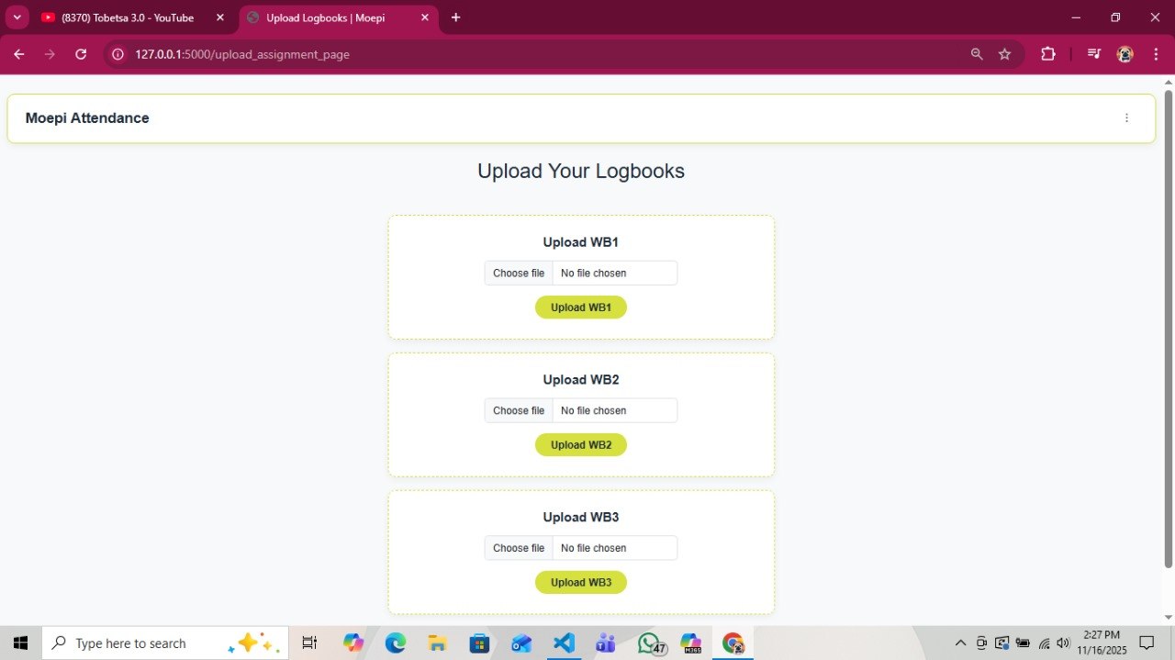
Figure 3.8: Upload Logbooks page

This comprehensive Mentor Dashboard provides an analytical overview of student attendance and activity by aggregating check-in data, which the mentor can refine using filters for specific students, months, years, or days to generate customized reports. The dashboard presents key performance metrics at a glance, including the total check-ins, monthly trends, the earliest recorded check-in, and identifies the most and least active students, offering a quick snapshot of overall engagement. Furthermore, it includes both a visual attendance overview for at a glance student statuses and a detailed "All Student Check-In History" table that logs each entry's date, time, and work comment, with the functionality to download individual check-in records for deeper analysis or auditing purposes.

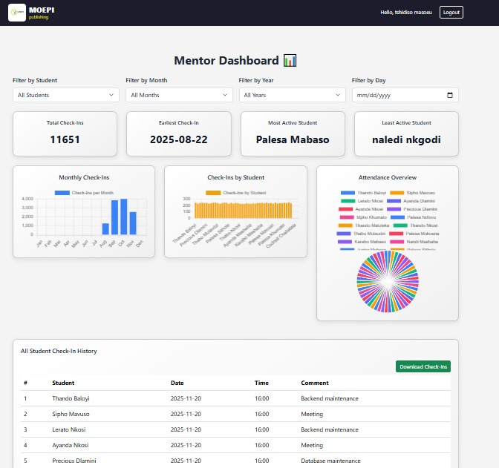

Figure 3.9: Mentor dashboard page

This WIL Coordinator Dashboard provides a high level administrative overview of the entire Work Integrated Learning program, presenting key performance indicators at a glance—uch as the total number of mentors, students, partner institutions, system check-ins, and submitted assignments to quickly assess program scale and activity. The dashboard enables strategic analysis through dynamic data visualizations that break down the distribution of students per mentor, the allocation of students across different partner institutions, and the enrollment figures across various academic departments, offering insights into resource allocation and institutional partnerships. Furthermore, it includes universal filters for mentors, students, institutions, months, and years, along with a search function, allowing the coordinator to segment and interrogate the data for detailed reporting and informed decision making.
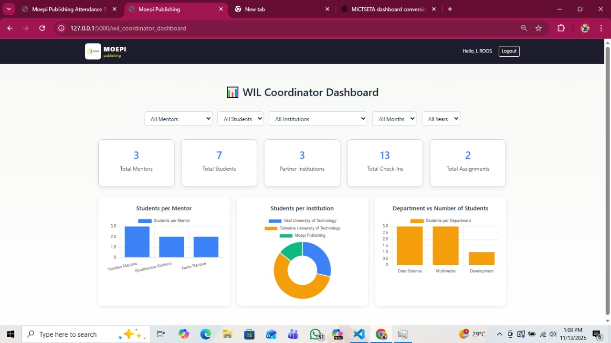
Figure 3.10: WIL Coordinator Dashboard page

This MICTSETA Mentor Dashboard provides a comprehensive analytics interface for monitoring Work Integrated Learning programs, offering key metrics like total mentors, students, partner institutions and system check-ins to quickly assess program engagement. The dashboard features flexible filtering options for institutions, students, departments, months, and years, allowing mentors to customize data views and analyze specific program segments. Through clear visualizations of institution distribution and department wise student allocation, the dashboard enables mentors to track participation across different educational partners and academic disciplines, supporting data-driven oversight of the entire WIL program ecosystem.
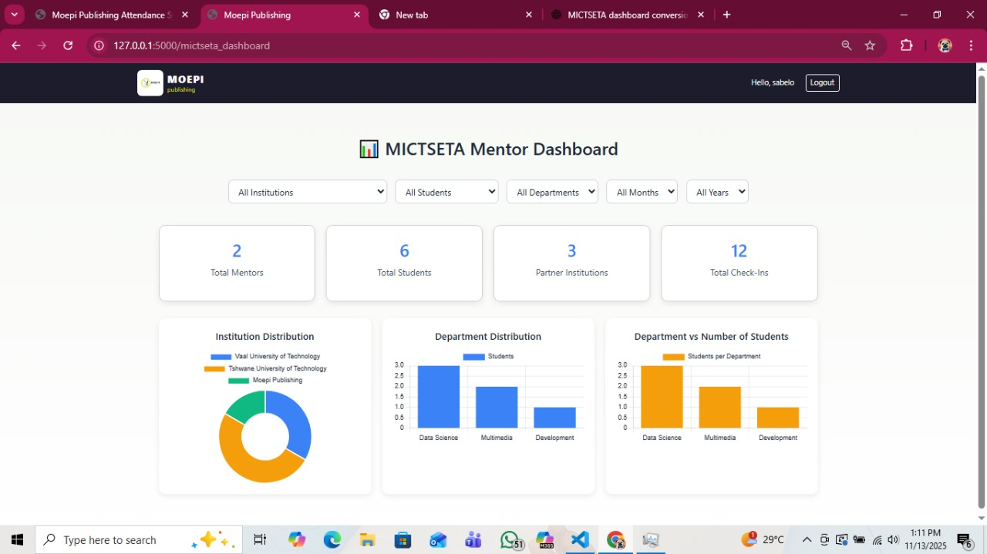

Figure 3.11: Employee Interface: Secure Check-In This screen confirms the design's focus on efficiency and shows the current attendance status, fulfilling the need for real-time record keeping.

3.3.5 Administrator Logbook Flow for Back-End View
The Administrator Interface is the core management tool. This figure shows the back-end view of the data, demonstrating how the recorded timestamps from the front-end are collected, displayed, and made usable for management tasks. This is the visual proof that the reporting requirements are met.
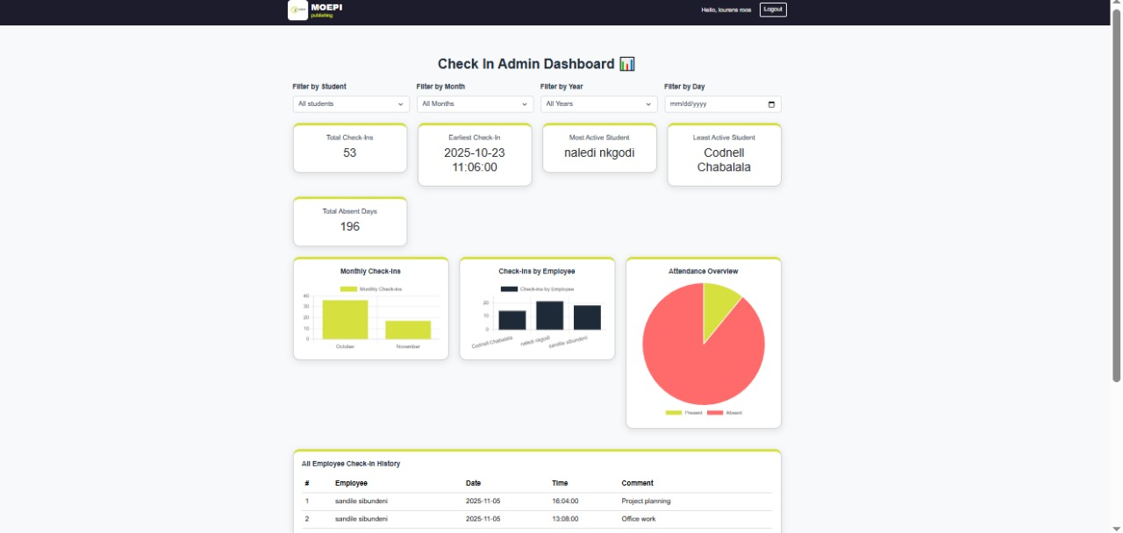
Figure 3.12: Administrator Interface: Data Dashboard and Reporting This dashboard confirms that administrators can view all records, filter by date or employee name.

3.3.6 Secure Learner Check-In Data Flow

The Secure Learner Check-In Data Sequence Diagram is the mechanism used to process and validate attendance submissions, representing a core functional requirement of the system. This figure illustrates the critical path that data follows from the user's device Presentation Tier through server-side validation Application Tier and into the persistent database Data Tier.
Its primary purpose is to ensure that every record is authenticated. The system enforces a fail-fast approach: any failure in validation immediately terminates the transaction. This auditable process guarantees that the records available for the WIL Coordinator and other auditing bodies are reliable and meet the project's compliance requirements, directly addressing the need for reliable attendance verification.
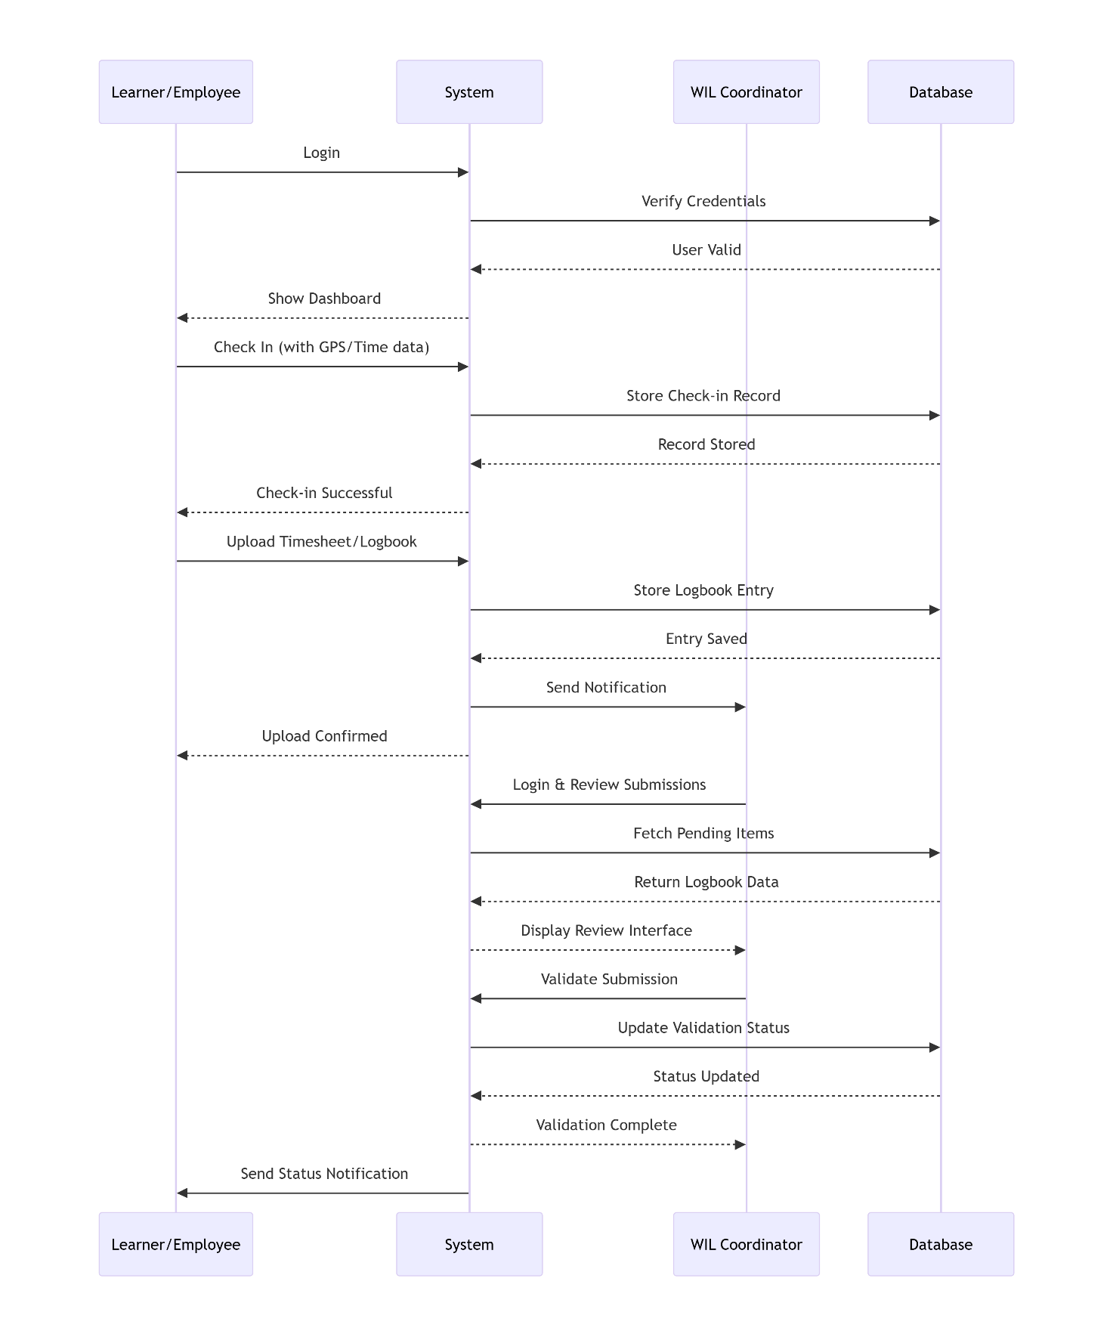
Figure 3.13: Secure Check-In Sequence Diagram: This diagram illustrates the sequential steps of data validation that must be passed before a secure, auditable attendance record is committed to the Data Tier, proving the system meets compliance standards. (Developed by Author, 2025)

3.3.7 ERD
The Administrator Interface is the core management tool. This figure shows the back-end view of the data, demonstrating how the recorded timestamps from the front-end (Figure 3.4) are collected, displayed, and made usable for management tasks. This is the visual proof that the reporting requirements are met.
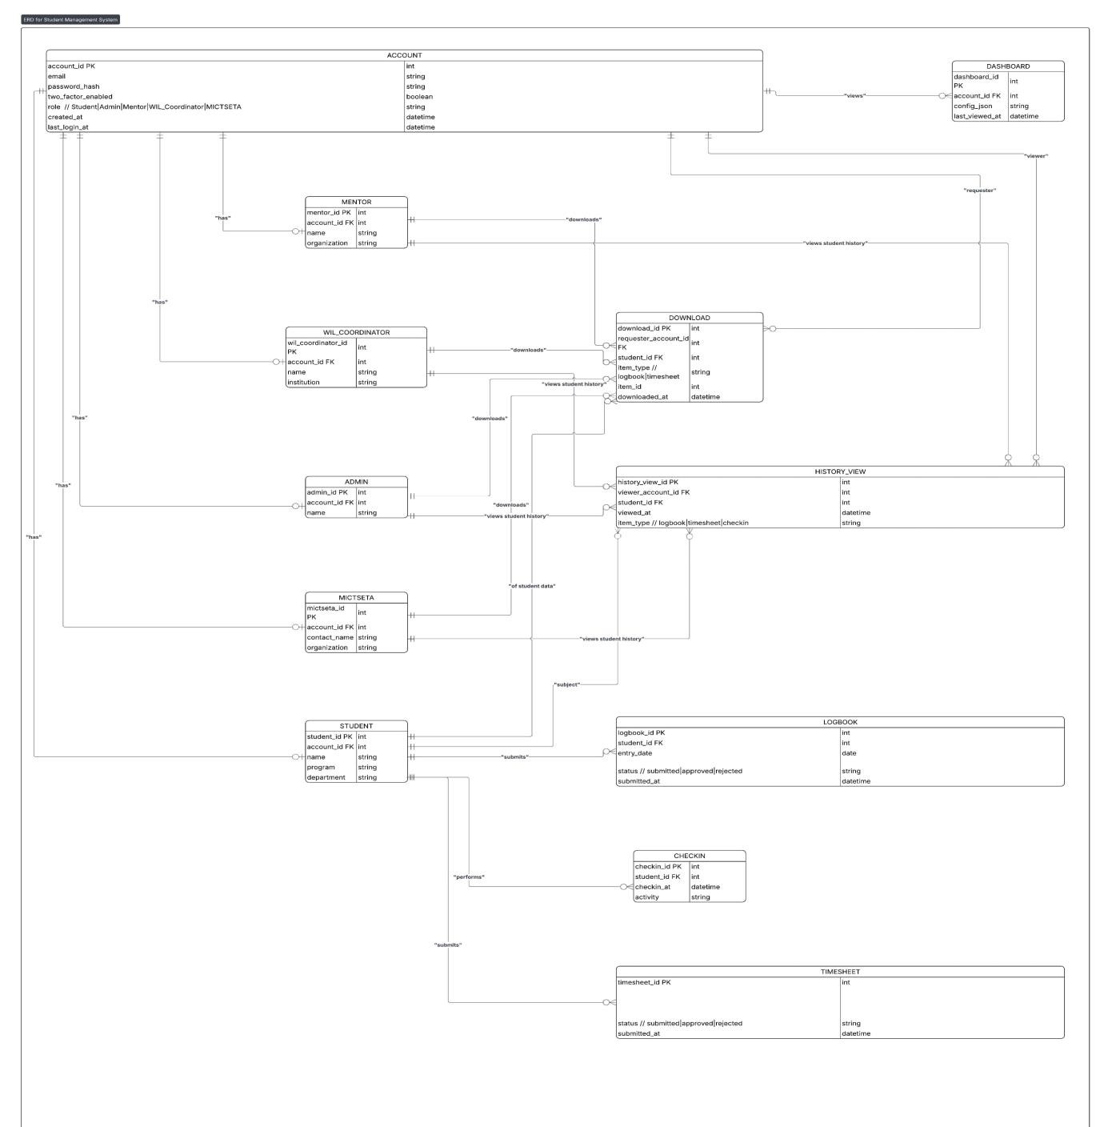

Figure 3.14: Administrator Interface: Data Dashboard and Reporting
This dashboard confirms that administrators can view all records, filter by date or employee name, and export the final data set for external processes like payroll, addressing the administrative problem identified in Chapter 1. (Developed by Author, 2025)

3.4 CHAPTER SUMMARY
This chapter detailed the complete design process for the Moepi Check-In System. We first defined the system's requirements, focusing on the essential needs for 2FA security, automated time tracking, and robust reporting.
The system design was then visualized using key diagrams: the Use Case Diagram defined the actors and their roles; the Activity Flowchart mapped the secure, two-step login process; and the System Architecture Diagram confirmed the use of a modern, secure, and efficient stack Python, PyOTP, SQL. Finally, the Front-End and Back-End visualizations were defined in Section 3.3, demonstrating how the software will look and function in practice. This design successfully translates the solutions from the literature review into a structured, workable plan to solve Moepi Publishing's problem.

Chapter 4: FINDINGS

4.1 INTRODUCTION
This chapter documents the key outcomes and value derived from the successful implementation of the Moepi Check-In System . Following the design principles established in Chapter 3, the MCIS was developed and deployed to replace the previous, inefficient manual attendance tracking method.
The primary objective of this project was to establish a secure, automated, and centralized attendance system. This chapter summarizes how these objectives were met, quantifies the value delivered to Moepi Publishing, and provides strategic recommendations for the company, along with potential areas for future research and development.

4.2 SUMMARY OF MAIN FINDINGS
The implementation of the Moepi Check-In System delivered significant measurable results across all major objectives, resulting in a substantial return on investment for the company.

4.2.1 Achievement of Project Goals
The project successfully delivered a fully functional, three-tier web application using the Python Flask framework and SQL database, meeting all defined functional and non-functional requirements:
Security: The system integrated Two-Factor Authentication using PyOTP, eliminating the security vulnerability associated with manual signing and ensuring only verified users can record time.
Automation and Efficiency: The manual process of collecting, verifying, and compiling attendance records was entirely automated. Employees can now check-in in seconds, and administrators access reports instantly.
Centralized Data: All attendance data is stored in a single, secure SQL database, providing a reliable source of truth and simplifying auditing for management and SETA representatives.
Usability: The front-end is fully responsive CSS, ensuring seamless use across desktop, tablet, and mobile devices, accommodating the hybrid work model of Moepi Publishing.

4.2.2 Value to the Company

The MCIS provided tangible value to Moepi Publishing by addressing the core problems of administrative burden and data security:

- Reduced Administrative Time: The time spent by management and HR staff on compiling weekly and monthly attendance reports was reduced. This frees up administrative resources for higher-value tasks.
- Enhanced Audit Compliance: By providing immutable, timestamped records verified by 2FA, the system ensures compliance with workplace learning (WBL) and SETA auditing requirements, drastically reducing the risk of non-compliance penalties.
- Improved Data Integrity: The MCIS eliminated human error, forgery and missing records common in the paper based system.
- Support for Hybrid Work: The web-based, location-independent nature of the system formally supports the company’s hybrid work model, allowing for accurate tracking regardless of whether the employee is on site or remote.

4.3 RECOMMENDATIONS
Based on the implemented solution and the operational context of Moepi Publishing, the following recommendations are made to further leverage the MCIS and improve operational security and efficiency:

- Mandatory 2FA Enrollment: Implement a policy to make the initial setup and use of Two-Factor Authentication mandatory for all employees within 48 hours of onboarding to maximize the system's security benefits.
- System Integration: Integrate the attendance reporting functionality directly with the existing time stamp software. This would eliminate the manual step of exporting and importing data, leading to a fully streamlined, end to end process.
- Regular Data Backup Policy: Establish a policy for automated, weekly, off-site backups of the SQL database to ensure business continuity and recovery capabilities in the event of a system failure.
- User Training and Documentation: Develop brief, standardized training material and a user guide for both employees and administrators to ensure consistent and correct usage of the new system features, particularly the reporting filters.

4.4. FURTHER RESEARCH
The successful implementation of the MCIS provides a robust platform upon which several fields of further study and development can be pursued:

- Geographic Location Verification : Implement GPS or Wi-Fi triangulation during check-in or out to confirm an employee's location. This would allow the company to verify if an on-site check-in was genuinely performed at the physical office location, enhancing integrity for specific WBL contracts.
- Predictive Absence Analytics: Develop a machine learning module that analyzes historical attendance patterns to predict potential high-risk days or individuals for absenteeism. This proactive approach could help management intervene early to improve team planning and scheduling.
- Mobile Application Development: Convert the current responsive web interface into a dedicated native or hybrid mobile application. This would improve user experience, offer better notification capabilities, and enable more seamless access to device hardware like biometric sensors for authentication.
- Biometric Integration: Investigate the cost-effectiveness of integrating biometric authentication like fingerprint or facial recognition at the physical office location as a potential third factor of security for on-site personnel.

REFERENCES
ALAVI, M. & LEIDNER, D. 2001. Knowledge management and knowledge management systems. MIS Quarterly, 25(1), 107–136.
AUTH0. 2023. Introduction to multi-factor authentication (MFA). California: Auth0 Publications.
BISHOP, M. 2019. Computer security: art and science. Boston: Addison-Wesley.
BOHME, R. 2013. Security usability: designing security tools. Berlin: Springer.
CASEY, A.F. 1993. The steric factor in medicinal chemistry: dissymmetric probes of pharmacological receptors. New York: Plenum Press.
CHIGADA, J. & MADZIMURE, J. 2021. Digital transformation in organisations. African Journal of Information Systems, 13(1), 45–62.
CONNOLLY, T. & BEGG, C. 2015. Database systems: a practical approach to design, implementation and management. Harlow: Pearson.
DEPARTMENT OF HIGHER EDUCATION AND TRAINING (DHET). 2022. Workplace-based learning policy framework. Pretoria: Government Printers.
DEPARTMENT OF LABOUR. 2021. Basic Conditions of Employment Act 75 of 1997 (as amended). Pretoria: Government Printers.
DLAMINI, Z. 2024. Evaluating lightweight frameworks for enterprise applications. In: Proceedings of the 2024 ICT Africa Conference, Durban, 10–12 July 2024. Durban: IEEE. 233–242.
FLANAGAN, D. 2020. JavaScript: the definitive guide. Sebastopol: O’Reilly Media.
FLASK DOCUMENTATION. 2024. Flask web framework. London: Pallets Foundation.
GOVENDER, N. 2023. Mitigating attendance fraud using two-factor authentication. In: IEEE International Conference on Digital Security, Cape Town, 5–7 September 2023. Cape Town: IEEE. 89–96.
GUMEDE, L. 2023. Digital attendance management systems in South African organisations. Johannesburg: HRTechSA Research.
GWEBU, K.L. & WANG, J. 2011. The role of security in the adoption of digital systems. Information Systems Journal, 21(5), 465–489.
ISO. 2022. ISO/IEC 27001: information security management systems. Geneva: International Organisation for Standardisation.
KAROSE, J. & ROSS, K. 2021. Computer networking: a top-down approach. London: Pearson.
LANGA, T. & SMITH, A. 2024. User experience in hybrid work digital systems. South African Journal of Information Management, 26(1), 1–12.
MALULEKE, S. 2022. Security challenges in modern web applications. Johannesburg: University of Johannesburg.
MTHEMBU, S. 2023. Human error in administrative information systems. Journal of African Business Processes, 15(3), 112–124.
NIST. 2020. Digital identity guidelines. Maryland: National Institute of Standards and Technology.
O’CONNOR, P. 2023. Risks of manual attendance systems in distributed workplaces. Journal of Workforce Management, 18(2), 55–68.
PRESSMAN, R.S. & MAXIM, B. 2020. Software engineering: a practitioner’s approach. New York: McGraw-Hill.
PYOTP. 2024. Python one-time password library. San Francisco: Python Software Foundation.
ROSE, L. 1977. Crime and punishment. London: Batsford.
SETA. 2023. Workplace-based learning requirements and compliance framework. Pretoria: SETA Publications.
SITHOLE, T. 2022. Efficiency challenges in paper-based organisational systems. Journal of Contemporary Management, 19(4), 87–101.
SOMMERVILLE, I. 2016. Software engineering. Harlow: Pearson.
STALLINGS, W. 2019. Cryptography and network security: principles and practices. London: Pearson.

WHAT EACH MEMBER CONTRIBUTED
Sandile Sibundeni: Frontend, Database and Diagrams.
Codnell Chabalala: Backend, Frontend and Database.
Naledi Nkgodi: Database and Frontend

