**Assignment 2:**

**README**

This code implements Causal Multicast ordering in a N node distributed system. The code reads the value of N from a file named “NoOfProc.txt”.

Processes send multicasts based on the timestamps given to them through “inputn.txt” file. Here ‘n’ represents the nth process ID.

The following makefile is used to compile and run the code.

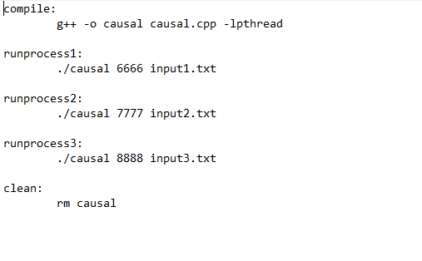

**How to compile the code:**

Type the following command in the command prompt:

* make compile

**How to run each process:**

Type the following command for launching each process 1, 2 and 3

* make runprocess1
* make runprocess2
* make runprocess3

**How to delete the object file:**

Type the following command for deleting the object file

* make clean:

How to run the code:

Each process once launched, takes the following inputs from the user:

* The process ID
* Whether the process would connect to any machine or not? (Yes=1, No=2)
* If yes above, then the number of processes to connect with.
* The port number of the machine to connect to.

For simplicity, let assume the system has 3 processes:

* Each process in the 3-node distributed system is given a unique ID (1,2 and 3 in this case)
* For process with ID= 1, say yes to connect to machine, give the total no of processes to connect to as 2, enter the port number of those processes.
* For process with ID= 2, say yes to connect to machine, give the total no of processes to connect to as 1, enter the port number of that process.
* For process with ID=3, just say no to connect to a machine.

***Note: For correctness purposes, the ID which connects to all the processes in the system, should be the last to do so i.e. for the above scenario, the process with ID =2 is first connected with process with ID =3 , and then the process with ID =1 should be connected with process with ID =2, and ID =3***

Once all the processes are launched and running, each of the processes start sending out multicast messages based on the timestamps as provided in the input file.

--X--