**Assignment 3:**

**README**

This assignment contains two separate codes for server and clients.

The server program is named as myserver.cpp and the client is named as myclient.cpp.

The server program acts as a coordinator and the clients act as process needing the shared resource (a file with a counter value in this case.)

1. **Compiling the program:** The following makefile is used for compiling the code

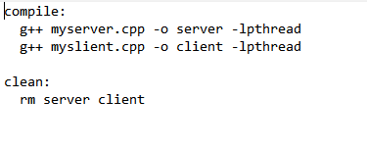

Type the following command in the command prompt to compile the code:

* make compile

Type the following command to remove the objects files created

* make clean

1. **Running the program:** One command prompt window should be launched for the server. To run the server, type the below command
   * + ./server <port number>

Launch multiple command prompt windows based on the number of processes value given while running the server code. Type the following code to run the multiple clients

* ./client <port number>

Note: The port number given at the clients window should be same as that given at the server.