**Results 1**:

Plot shows the average time taken to execute a transaction1: 4 109 d 500

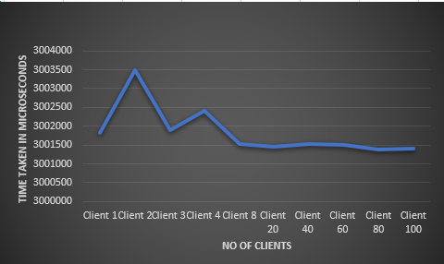

Plot shows the average time taken to execute a transaction: 5 110 d 400

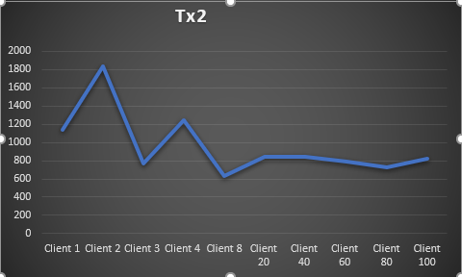

Plot shows the average time taken to execute a transaction: 7 111 w 100

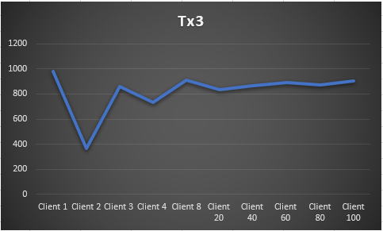

Plot shows the average time taken to execute a transaction: 8 112 w 5000

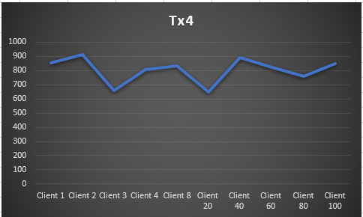

**Result 2**:

Below plots show time taken to run a set of transactions being sent from 25 different clients at different time intervals of .1, .2, …… 1.

Plot shows average time taken to execute tx1: 4 109 d 500

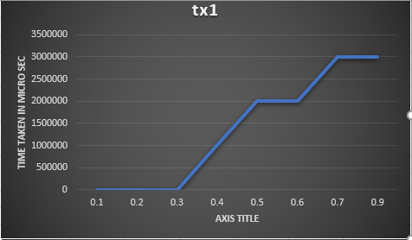

Plot shows the average time taken to execute a transaction: 5 110 d 400

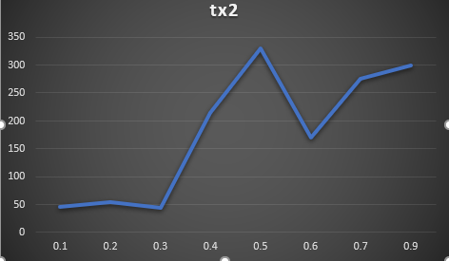

Plot shows the average time taken to execute a transaction: 7 111 w 100

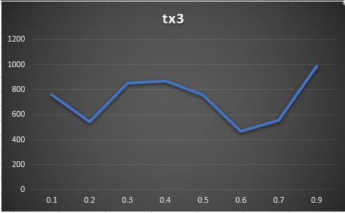

Plot shows the average time taken to execute a transaction: 8 112 w 5000

