

CSE370 : Database Systems
Project Report
Project Title : EvergreenBonds

Group No : 4, CSE370 Lab Section : 15, Summer 2026
ID | Name | Contribution
24341028 | Md Ismail Mahmood | Features 4, 7 & 9
24301244 | Quazi Naqibul Alam | Features 1, 3 & 6
24301369 | Ahnaf Abir Amjad | Features 2 , 5 & 8

Table of Contents

Section  No | Content | Page No
1 | Introduction | 3
2 | Project Features | 4
3 | ER/EER Diagram | 5
4 | Schema Diagram | 6
5 | Normalization | 7-8
6 | Frontend Development | 9-13
7 | Backend Development | 14-18
8 | Source Code Repository | 19
9 | Conclusion | 19
10 | References | 20

Introduction

Family is not just solely defined by blood, but by love, security, and belonging. While the idea of adoption is lovely, the quest for a perfect pairing for adoption or kind companionship for a person can get quite complicated legally, emotionally, and in other ways. So, why not leverage technology to connect these two types of people? To enact this, we developed a fully integrated digital matchmaking platform. But simply creating a platform for adopters and adoptees is not enough. Due to the extremely vulnerable nature of adoption, legal and personal safety as well as fit is just as vital as the match itself. As a result, we have developed a system that not only connects families, but the network which safeguards their relationships. By creating dedicated roles for legal officers, system moderators, and legal guardians, our platform seeks to ensure the matchmaking and adoption processes are clear, legal, and monitored. We will go over how we developed the architecture and system designed not only to pass information, but to make profound, life changing connections.

Project Features

ID,  Name | Features [3 per member]
24341028,  Md Ismail Mahmood | Ft 1 | Life-Time Tracking
24341028,  Md Ismail Mahmood | Ft 2 | Needs-Based Wishlist
24341028,  Md Ismail Mahmood | Ft 3 | Profile Verification
24301244,  Quazi Naqibul Alam | Ft 1 | Family Registration & Profile Management
24301244,  Quazi Naqibul Alam | Ft 2 | Adoption & Senior Care Application
24301244,  Quazi Naqibul Alam | Ft 3 | Donation & Sponsorship Portal
24301369,  Ahnaf Abir Amjad | Ft 1 | Browse Children & Senior Profiles
24301369,  Ahnaf Abir Amjad | Ft 2 | Smart Family Matching System
24301369,  Ahnaf Abir Amjad | Ft 3 | Application Progress Tracker

ER/EER Diagram

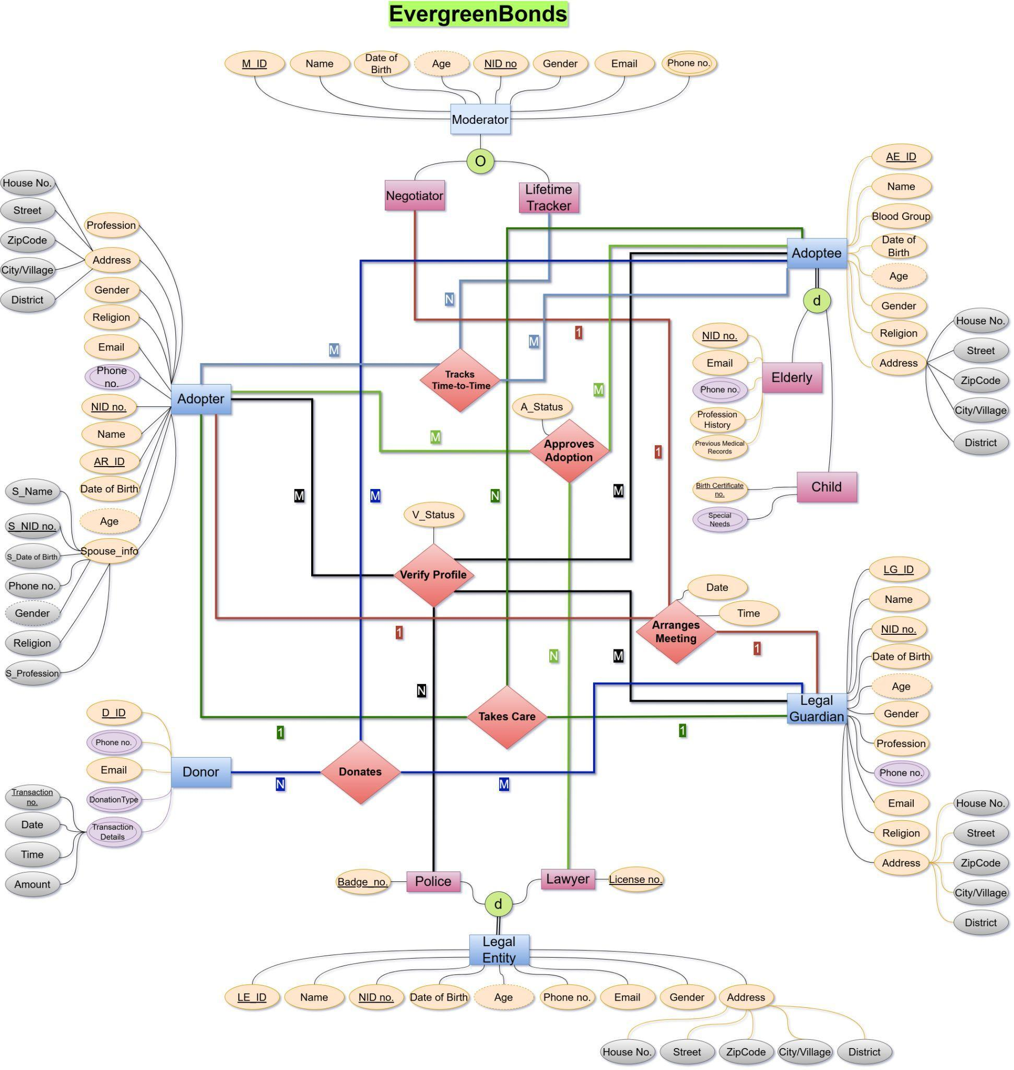

Schema Diagram

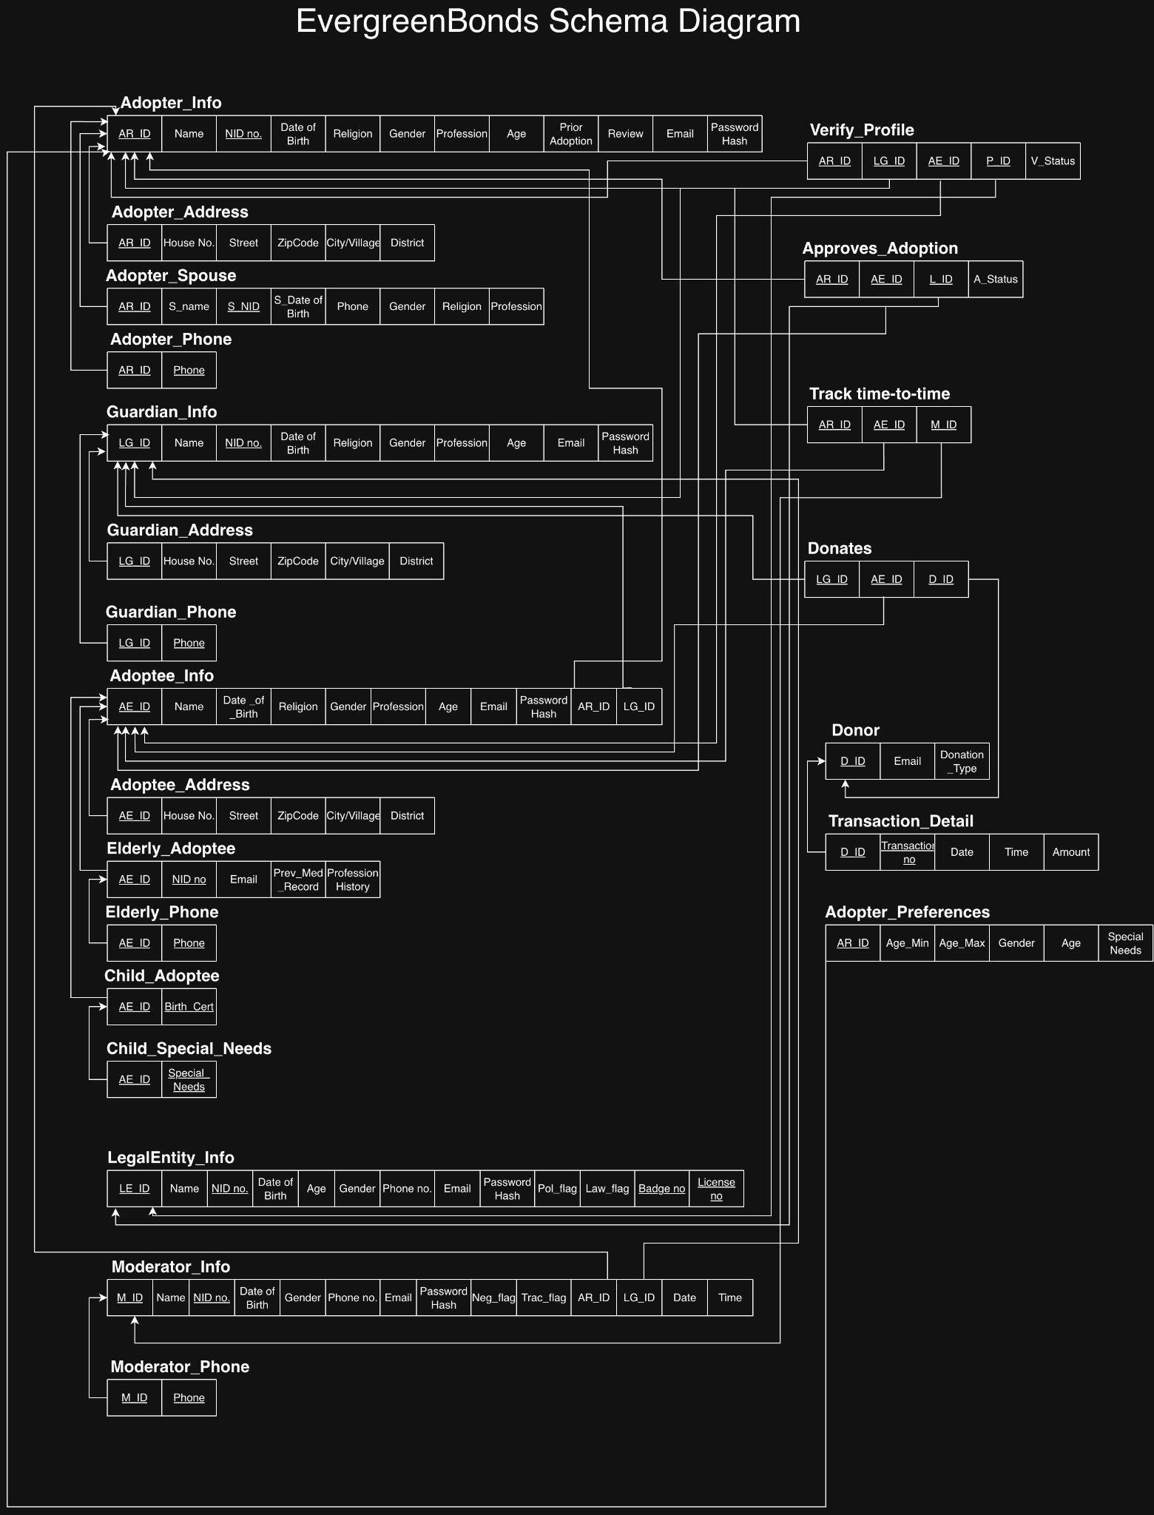

Normalization

Our schema is in 1NF as every attribute contains only atomic values (no nested relations), and there are no composite or multivalued attributes within a single table.

Our schema is in 2NF as it does not have any partial dependency on the primary key.

Our schema is not in 3NF because of transitive dependencies like ZipCode on House no. and Street, and derived attribute age which is dependent on Date of Birth. Therefore, normalizing to 3NF, we get:
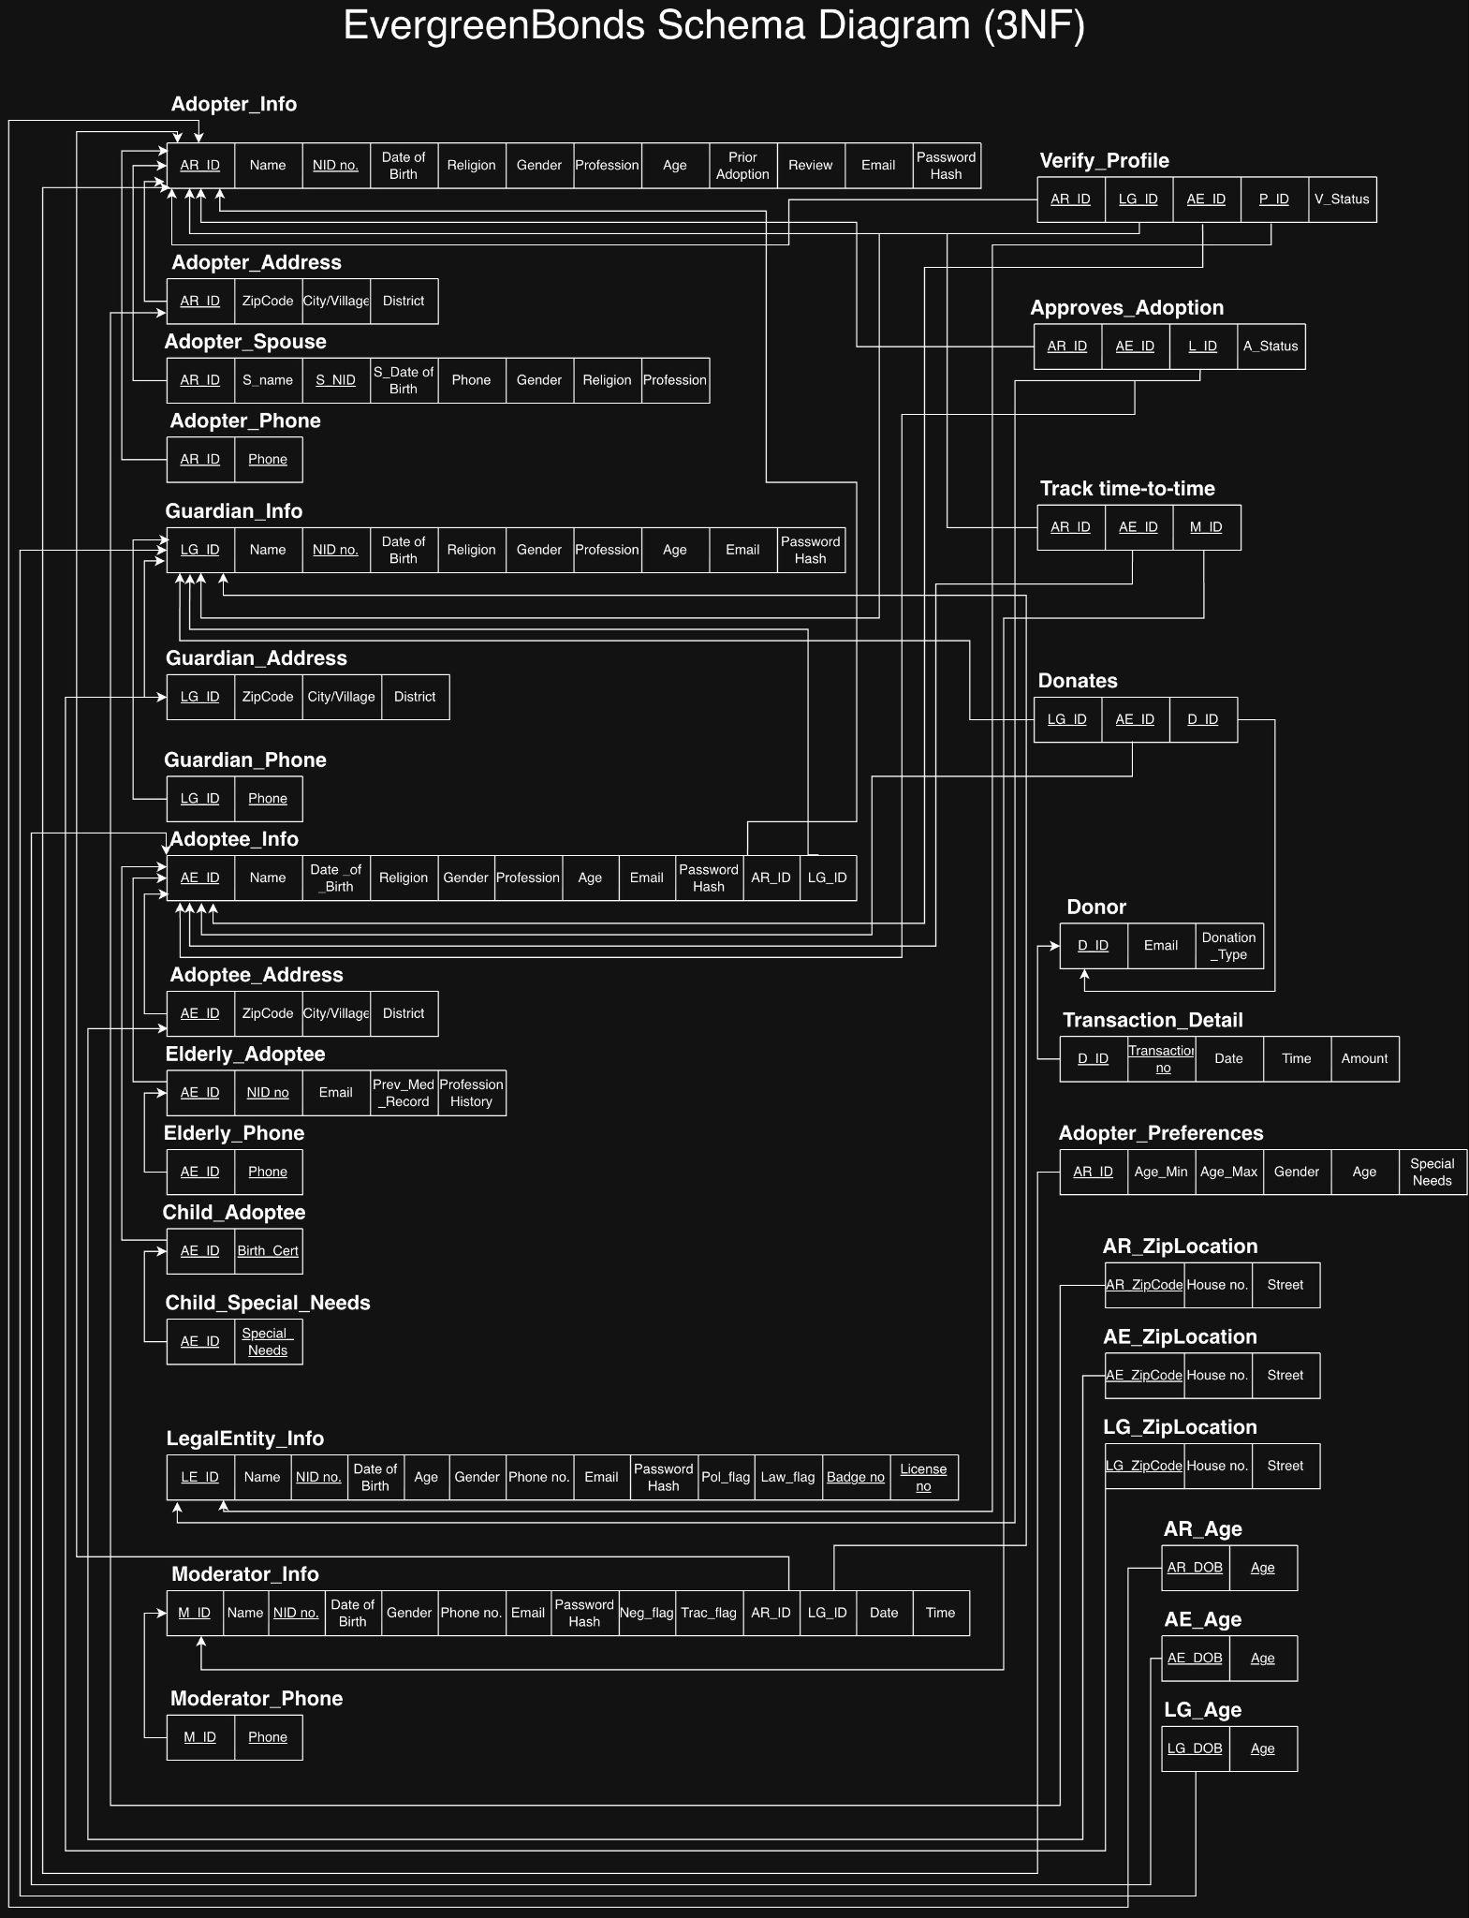

Frontend Development

Contribution of ID : 24341028, Name : Md Ismail Mahmood
Profile Verification
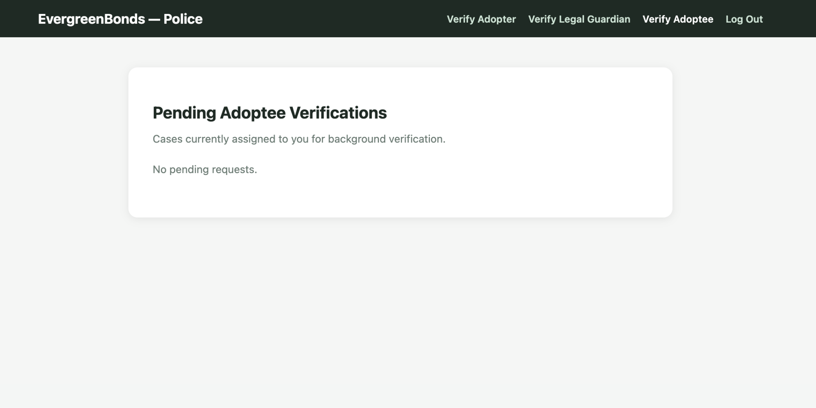
Need Based Wishlist
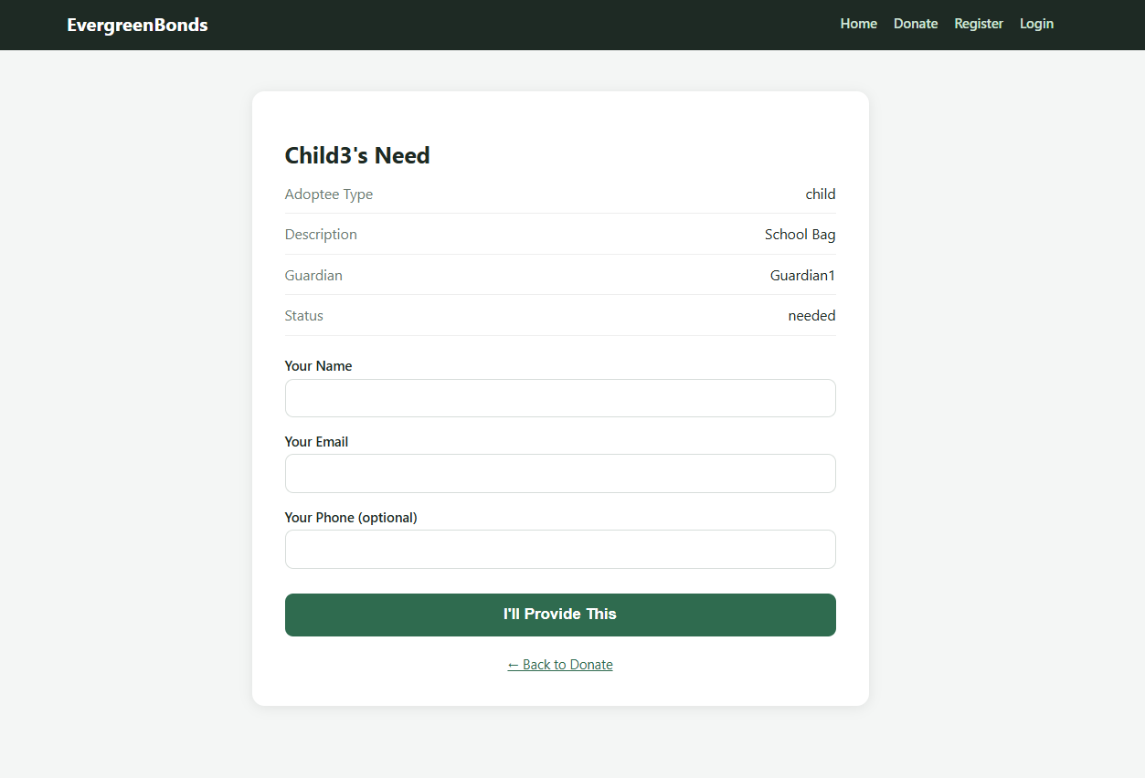

Lifetime Tracking
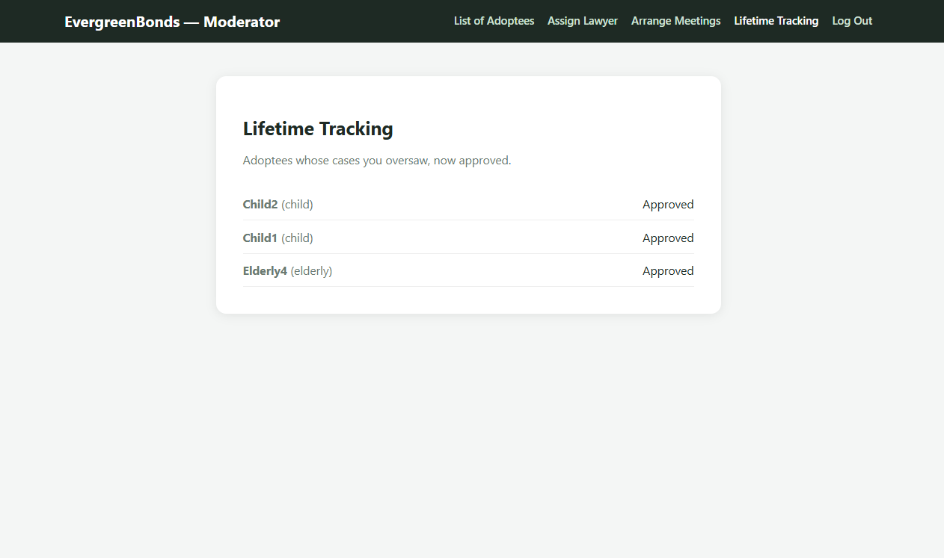

Contribution of ID : 24301244, Name : Quazi Naqibul Alam

Family Registration
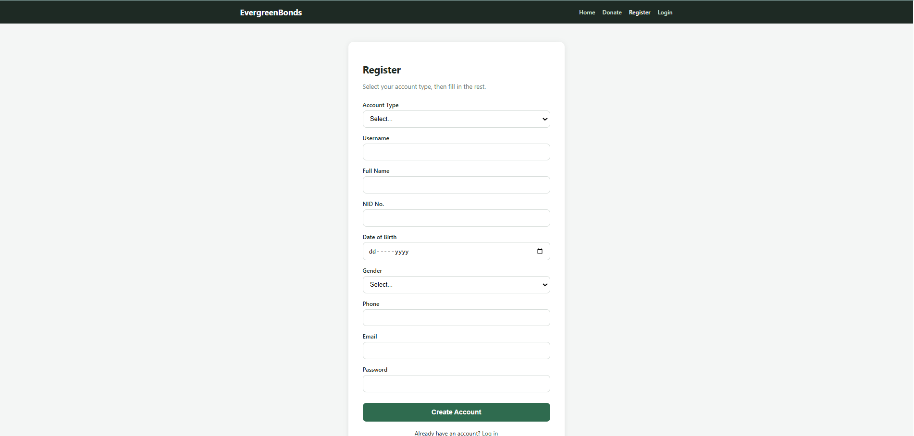

Apply to Adopt
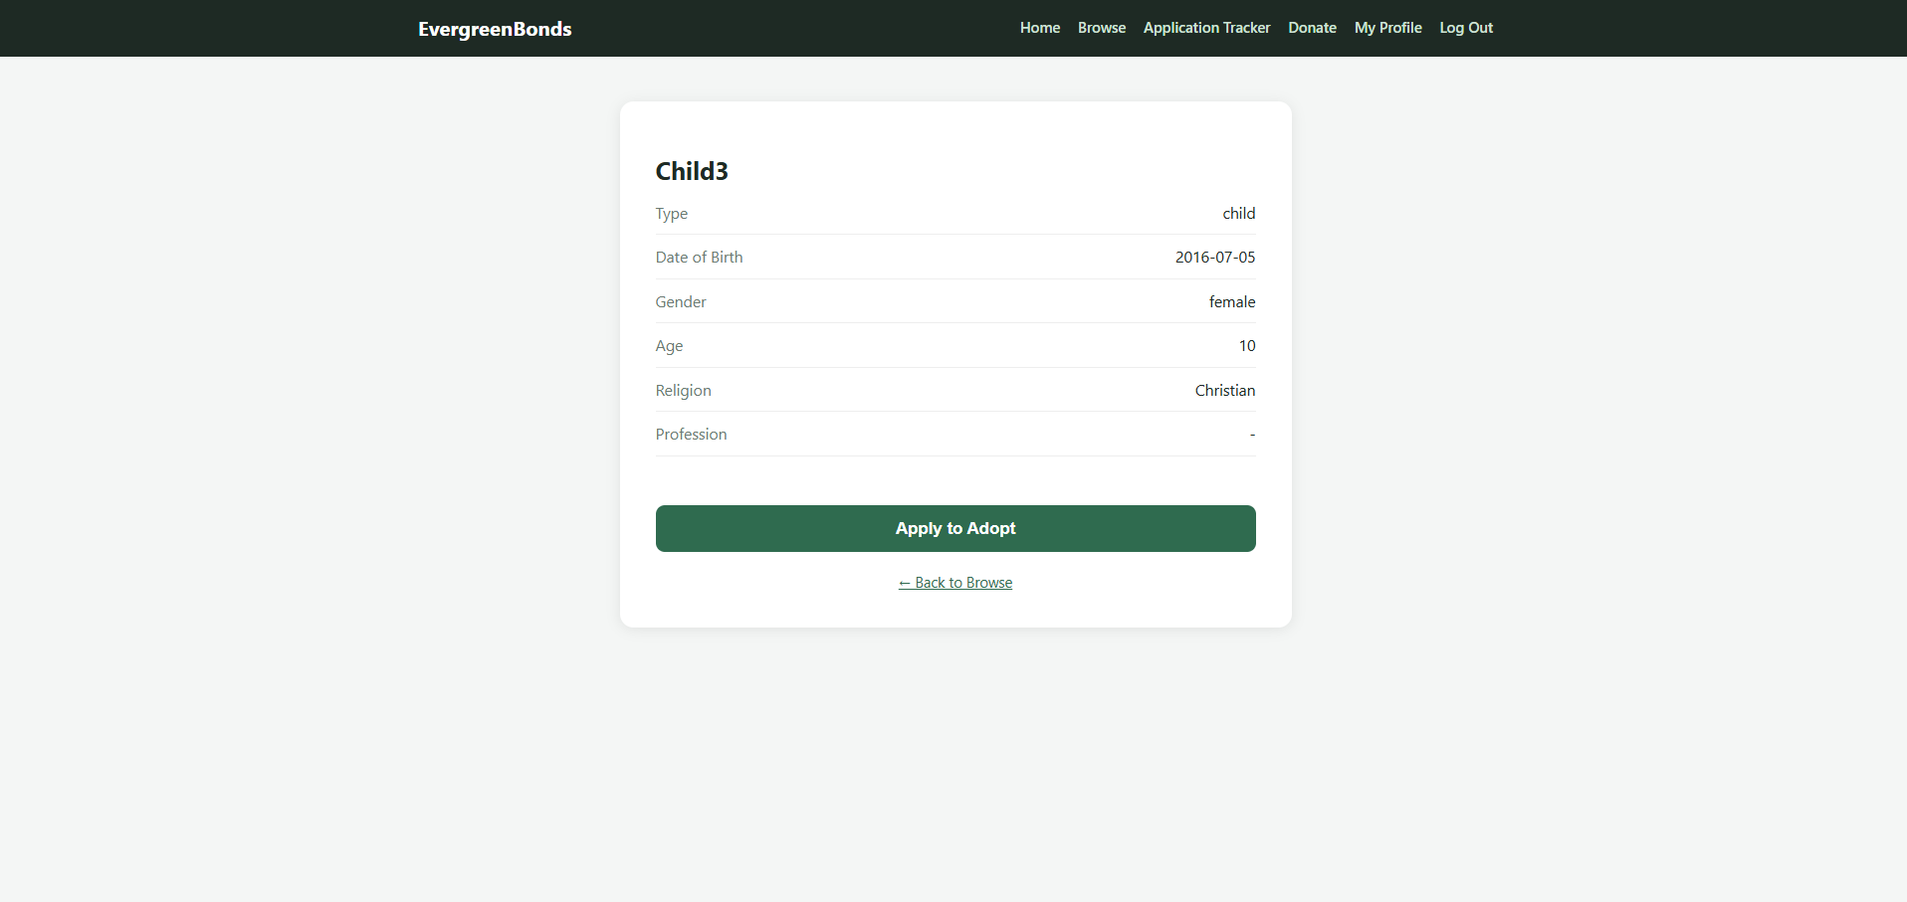

Donation & Sponsorship
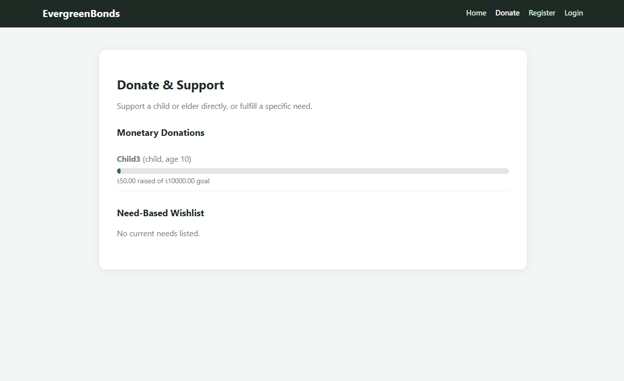

Contribution of ID : 24301369, Name : Ahnaf Abir Amjad

Browsing Children & Elderly Profiles
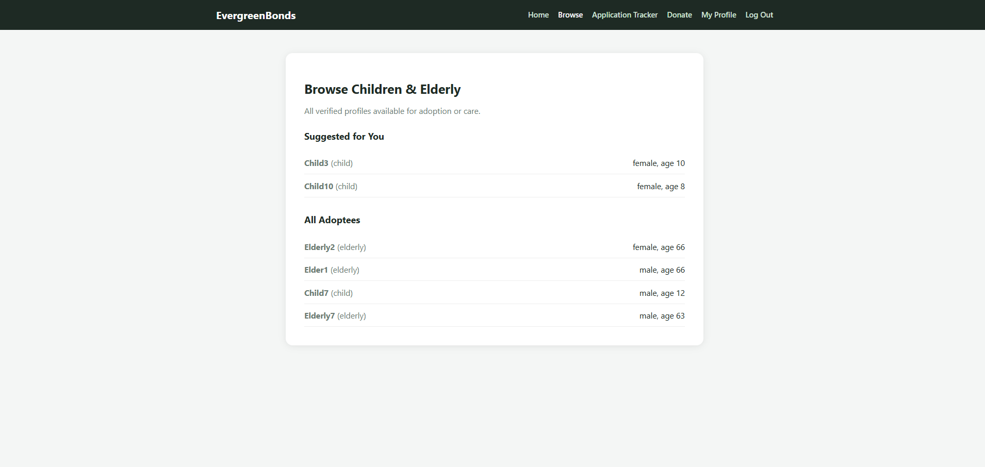

Application Progress Tracker
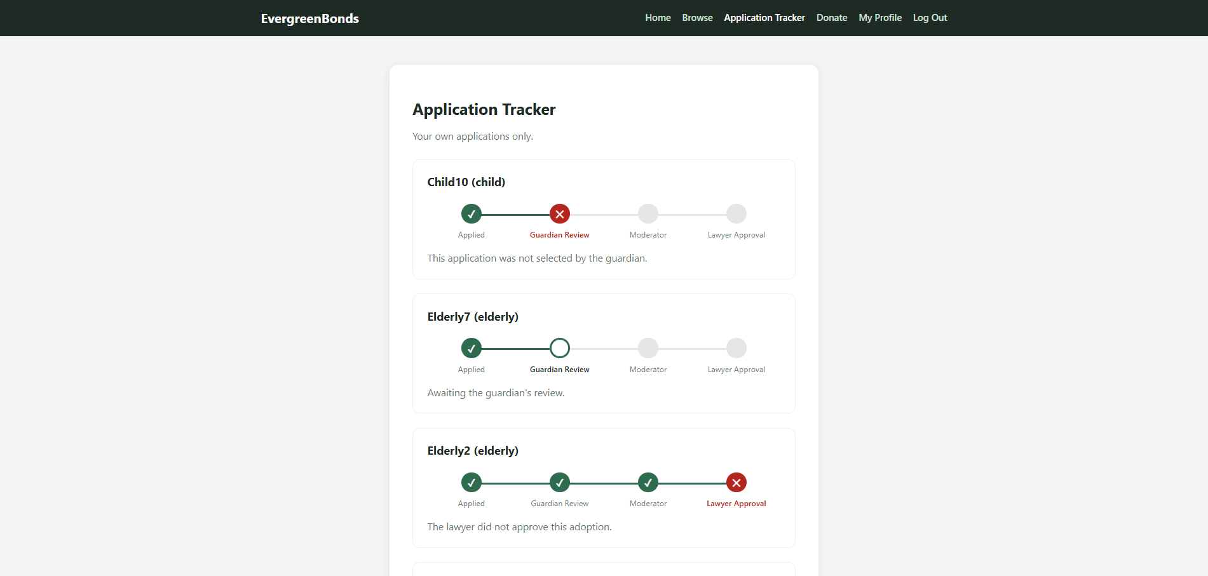

Smart Family Matchmaking System

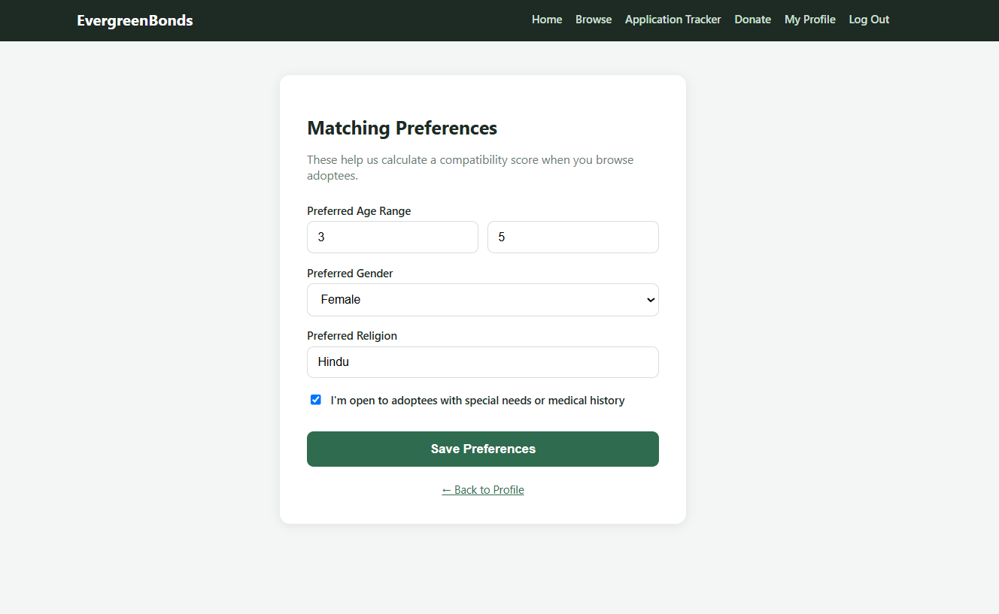

Backend Development

Contribution of ID : 24341028, Name : Md Ismail Mahmood

Feature 4 (reportModel.js)
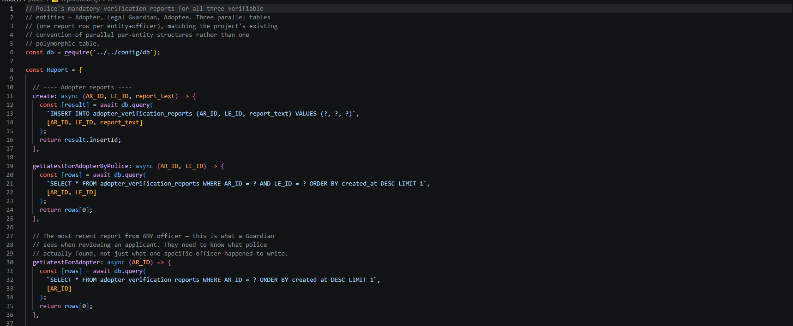

Feature 9 (Controllers/Lawyer/LawyerController.js)
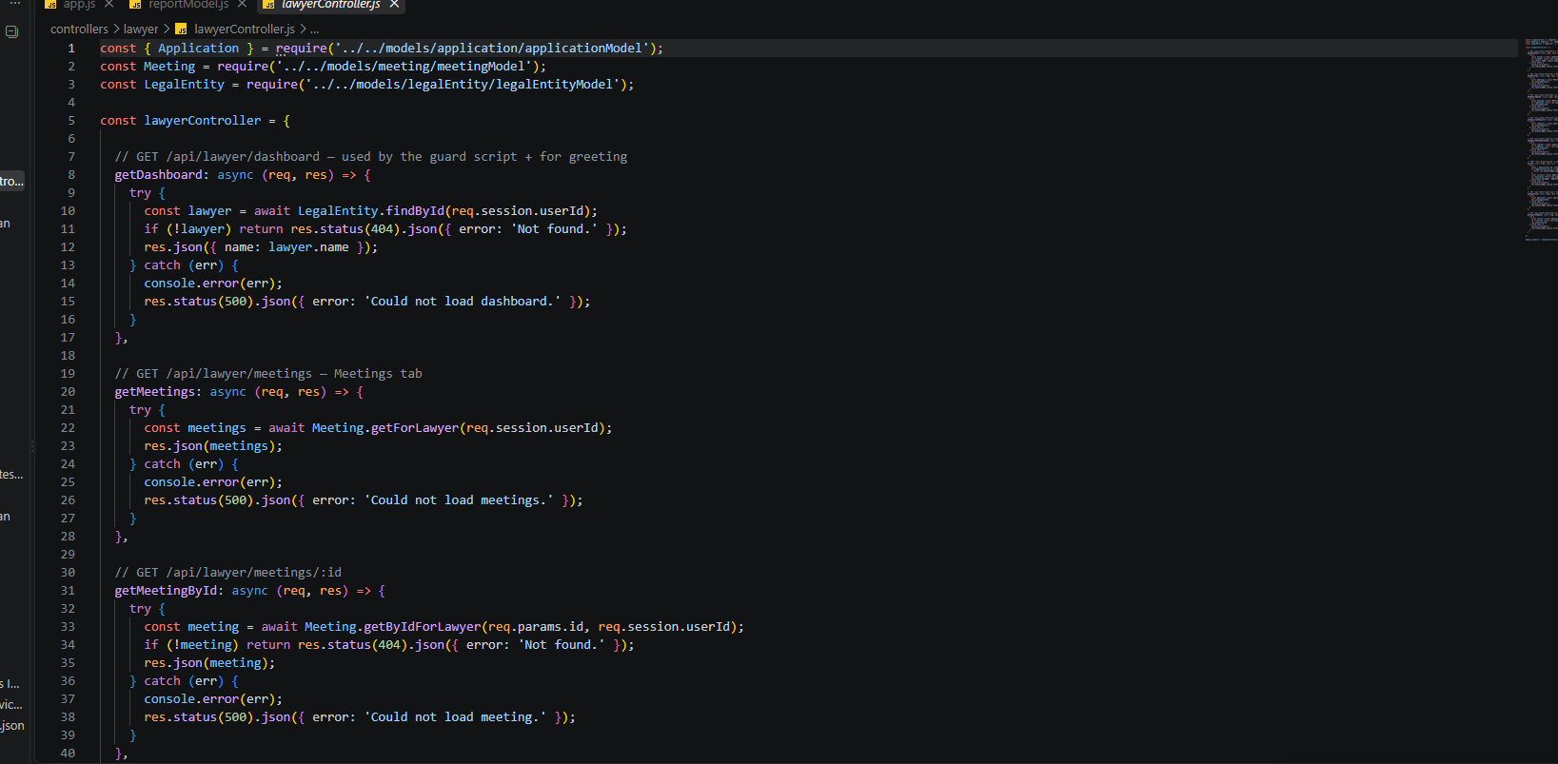

Feature 7 (Controller/Legal Guardian/DonationController.js)
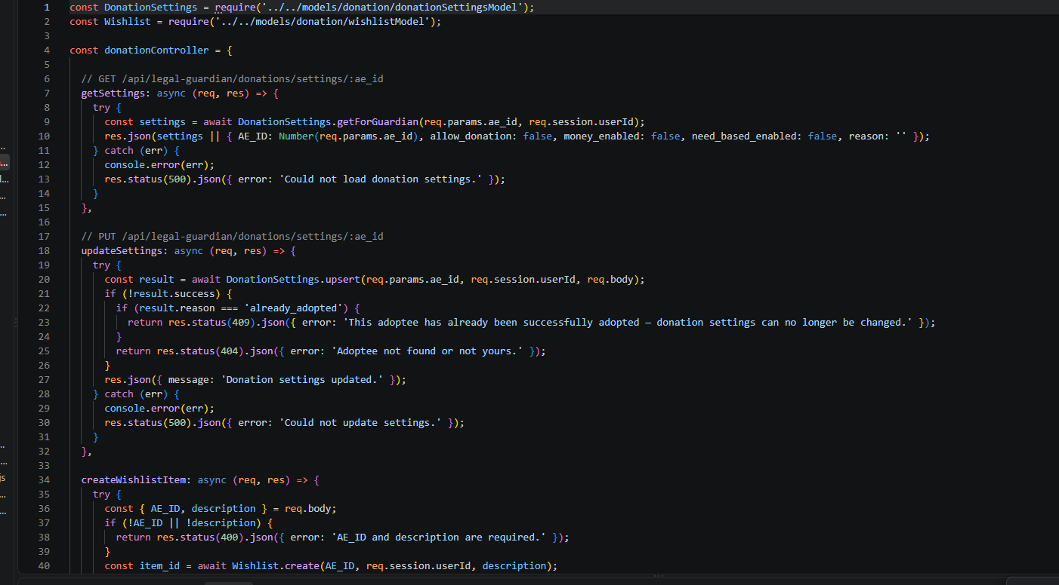

Contribution of ID : 24301244, Name : Quazi Naqibul Alam

Feature 1 (adopterModel.js)
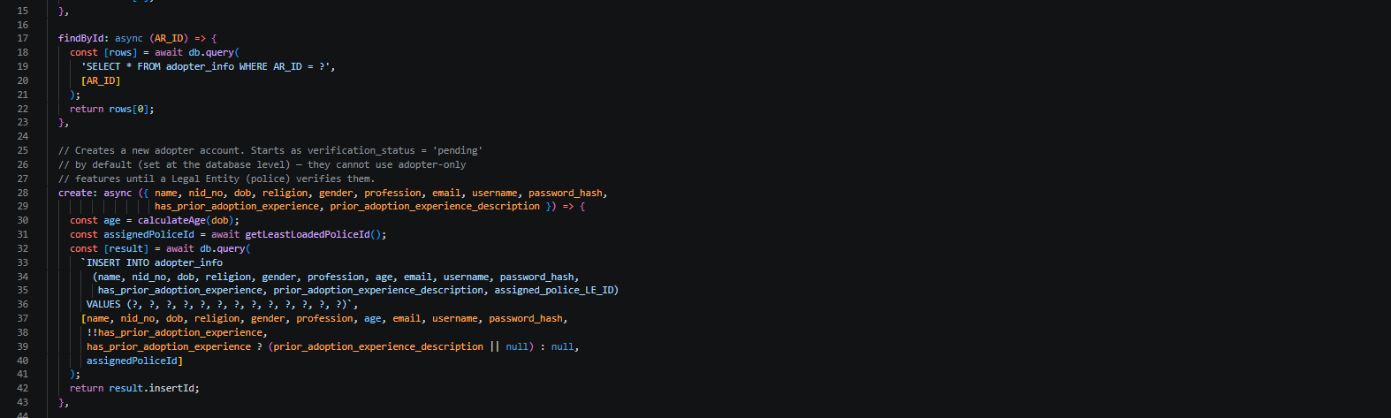
Feature 6 (DonationModel.js)
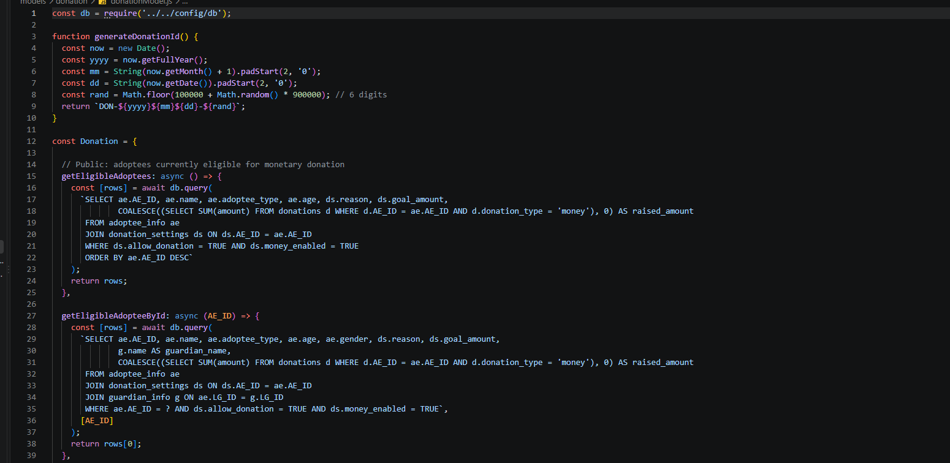
Feature 3 (controller/adopter/applicationcontroller.js)
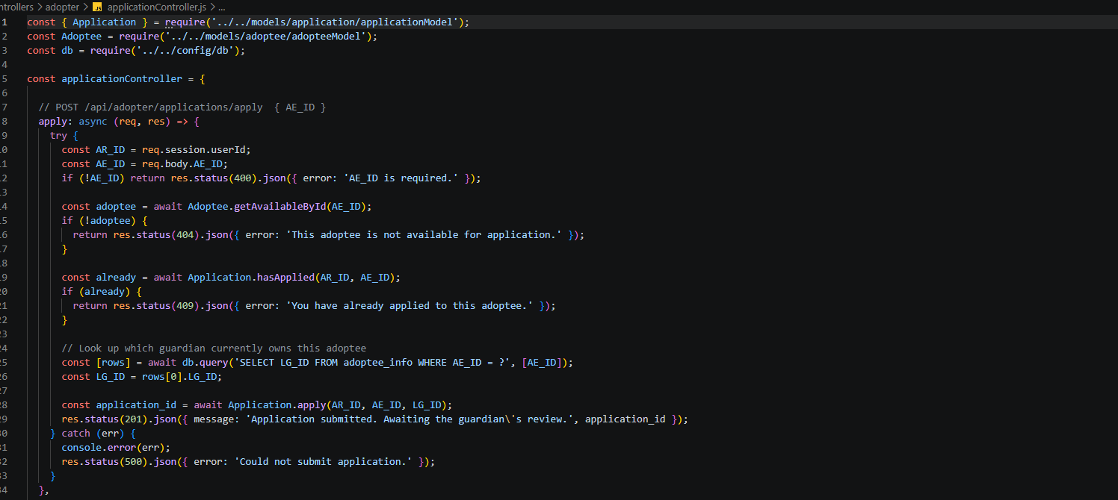

Contribution of ID : 24301369, Name : Ahnaf Abir Amjad

Feature 5 (preferenceModel.js)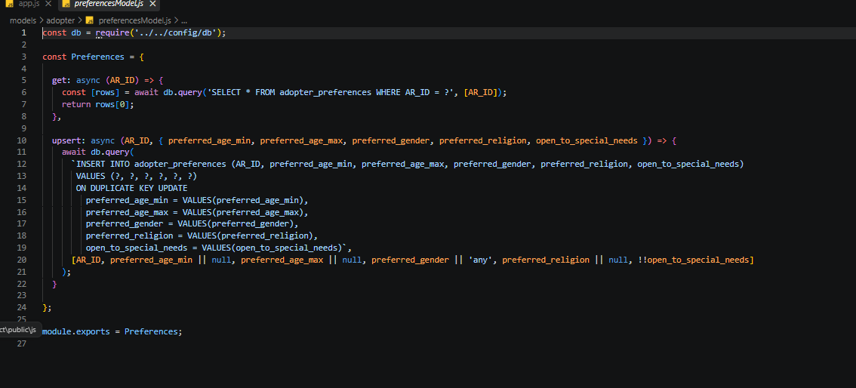

Feature 2 (browseController.js)
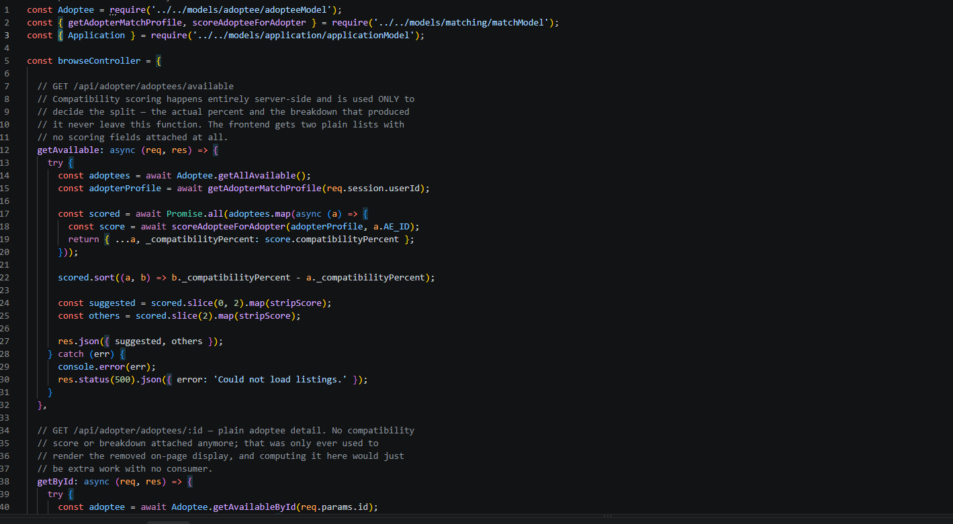

Feature 8 (model/application/applicationModel.js)
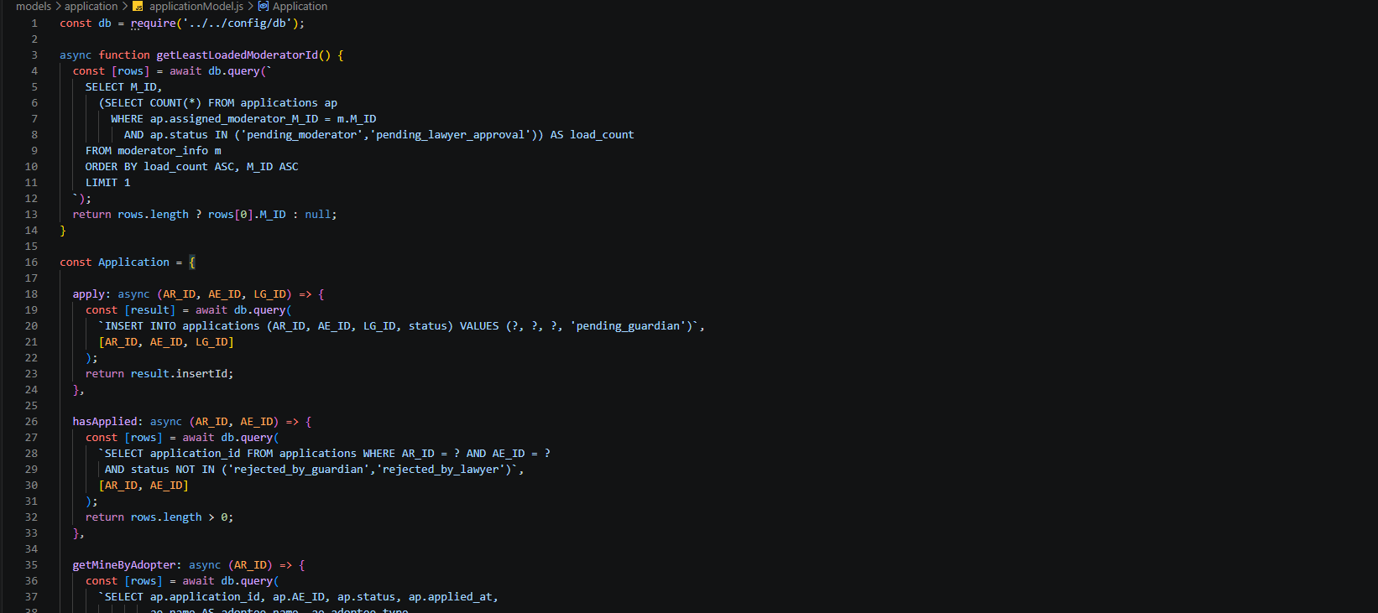

Source Code Repository

Google Drive Link:
https://drive.google.com/drive/folders/1RBmPV8TGswOwqZZb9qI-mqECSetRoIpu?usp=drive_link

Conclusion
Building our matchmaking platform was a technical challenge, but it was an even greater responsibility. Over the course of the project, we were able to successfully create a seamless solution which will help to organize a tremendously sensitive process i.e. connecting families with the children who are in need of homes, while managing extremely complex databases containing sensitive user information. By carefully implementing multiple user profiles from eagerly awaiting families and desperate guardians, to our administrative moderator system, we were able to create a simple and streamlined system designed to be smooth and efficient. But most importantly, this project has shown what it means to design software with a moral compass. We understood that we were managing far more than just data; we were managing futures. By deploying strict moderation protocols and legal review into the core of our architecture, we were able to create a platform where security, respect, and a commitment to the best possible future for the children was the number one priority. Ultimately, this project serves as a testament to how technology is capable of bringing families together with ease, safely.

References
Complete Coding by Prashant Sir. (n.d.). Complete NodeJS + ExpressJS + MongoDB course in Hindi | Notes | Certification [Playlist]. YouTube. https://www.youtube.com/playlist?list=PL78RhpUUKSwfeSOOwfE9x6l5jTjn5LbY3

