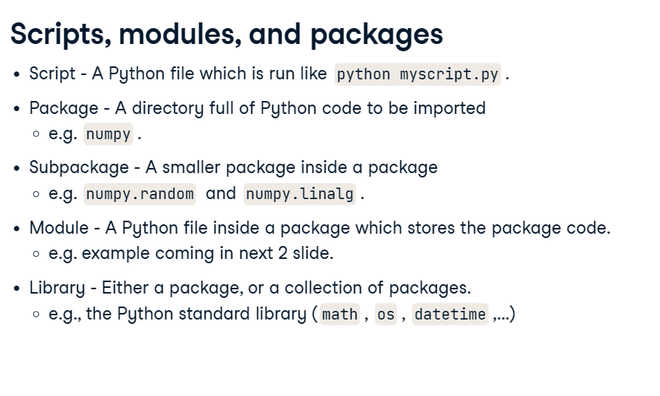

A really important part of developing packages is writing documentation.

You should write documentation for each function, each class, and each class method.

1. The first sentence of documentation is a summary, and should read like a command; like you are telling the function what to do. For simple functions this is all the documentation you will need. For more complex functions you can add additional information below.
2. After the summary, you'll have sections outlining the input parameters, and returned values.

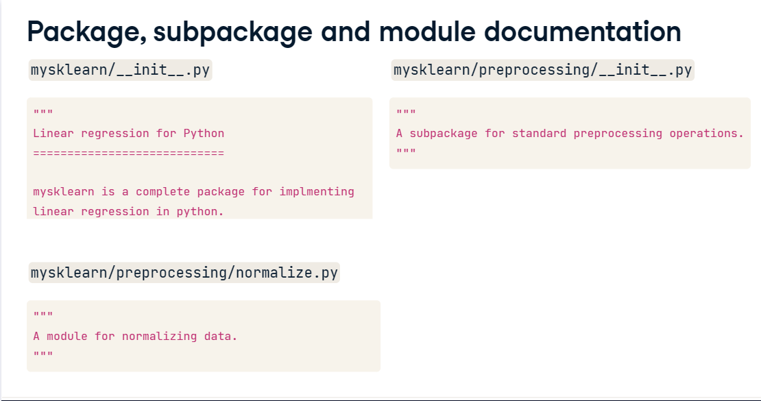

**when you import a parent package then it does not know about the**

**Child package/sub package then you import separately.**

**3. Without package imports**

00:23 - 00:30

To access the subpackages, you would need to import each of them separately, each time you use them.

**4. Without package imports**

00:30 - 00:35

The subpackages don't know about the modules they contain either.

You import them separately too.

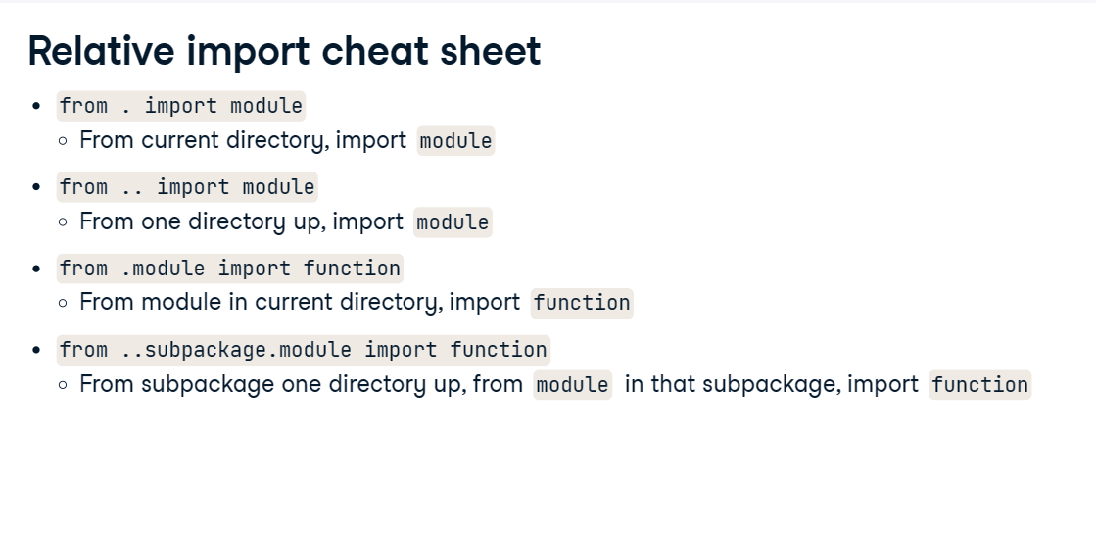

from storage.addition import add_numbers

res=add_numbers(2,3)

print(res)

# the python file/script in which you import the module from a package that file

# must be out from the package directory otherwise doesn't work.