**Methodology**

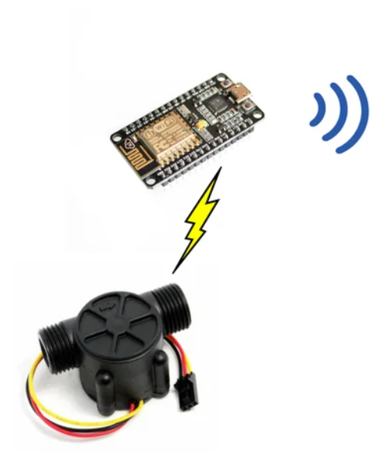 **NodeMCU ESP8266**







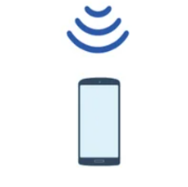

**SYSTEM**

**WATER FLOW SENSOR**

1. **The water flow**

The water flow rate can be calculated by counting the pulses from the output of the sensor. Each pulse is approximately **2.25 milliliters**. This Sensor is cheaper and best but not the accurate one as flow rate/volume varies a bit depending on the flow rate, fluid pressure, and sensor orientation.

1. **NodeMCU ESP 8266**

The whole system is based on sensors connected to NodeMCU ESP 8266 to monitor the water quantity. NodeMCU is a microcontroller that works as a central component of the system. It is used to control and process data captured by sensors.

**ESP8266 WiFi**

The ESP8266 WiFi Module is a self contained SOC with integrated TCP/IP protocol stack that can give any microcontroller access to your WiFi network. The ESP8266 is capable of either hosting an application or offloading all WiFi networking functions from another application processor. Each ESP8266 module comes pre-programmed with an AT command set firmware, meaning, you can simply hook this up to your Arduino device and get about as much WiFi-ability as a WiFi Shield offers (and that's just out of the box)! The ESP8266 module is an extremely cost effective board with a huge, and ever growing, community.

And Also **ESP8266** include the library “ESP8266WiFi.h”  which provides ESP8266 specific WiFi routines and we are calling it to connect to the network. Also include the library “ESP8266HTTPClient.h”, which provides methods to send HTTP requests with Api.

**CONCLUSION**

In this project, a prototype water monitoring system using IoT is presented. For this, some sensors are used. The data is sent to the cloud server via NodeMCU ESP8266. The collected data from all the sensors are used for analysis purposes for better solutions of water problems. So this application will be the best challenger in real-time monitoring & control system and use to solve all the water-related problems