 contact no: admin

**Booking Details** ${pickup} to ${return}

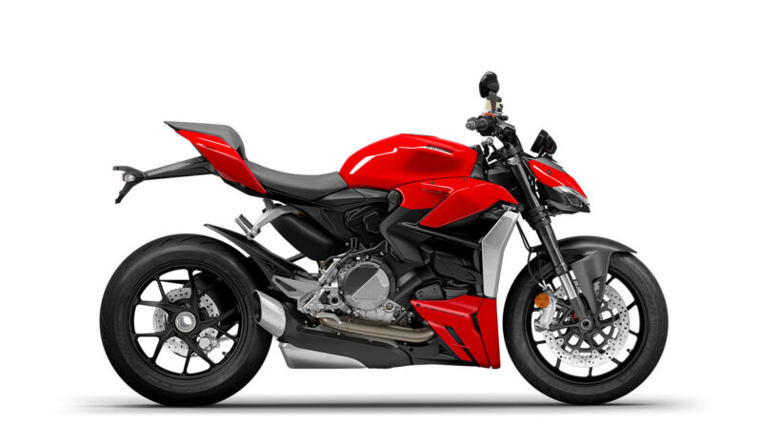

${brand#1} ${model#1}

${plate#1}