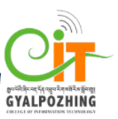

**First Review**

**For**

**Second Year Project**

**Bachelor of Science in Information Technology**

Quiz APP

**Submitted by**

**Nar Brd Kharka (12190065)**

**Gyalpozhing College of Information Technology**

**1. Introduction**

A. Purpose

The main aim of my project is to develop an application which will help the students to keep learning .besides students anyone can learn and explore python course where every individuals can be more active in programming knowledge.

OBJECTIVES:

1. To develop a platform For learning Language.

2. To improve in coding.

3. To help users to be more advanced in learning and it is like independent learning platform.

## System Scope

## Even today we depend too much on the traditional leaning and besides tutor teaching in the class student hardly get exposed. On other hand others who are learning Quiz in programming they are getting tried looking so many websites. Therefore, I felt that if I could provide a platform that could help every individuals.

## I am going to develop an android based application with the following features:

## 1. Login

## 2. Registration

## 3. User Profile

## 4. Lessons

## 5. Events

## Future Scope

## 6. Coding platform

## 7. Lesson for other language and different quiz for different Language

## 8. Example and solutions for the competitive programming

**User Scope**

The target of my project is the students as well who feels that there is need of programming. And this might serve good purpose like for the student of the middle school and higher school later in Bhutan.

**2. Requirements**

a. Functional Requirements: Describe each feature of your application

This are some of the features that will be included in my application:

## 1. Login: The user has to login in order to view all the other details and to learn as well as to do quiz.

## 2. Registration: The user has to first register in order to access all the features.

## 3. User Profile: The user can view all the details of the lesson learned and attempt quiz that are done according with the date.

## 4. Lesson: The user can learn the lessons thus is would be easy to attempt the quiz.

## 5. Events: User will get opportunities for the events that are going in and around.

b. Non-functional requirements

Some of the non-functional requirements of my application are:

1. Security

my application will be secure as the user will have to register first to use my application which means that if the user wants to use and view the details of their lesson learned they will have to login using their email and password.

1. Portability and compatibility

my application is portable as well as compatible as it can be supported in all the platforms of android versions.

1. Usability

my application is very easy to use as:

1. Learnability: The users will be able to use my application very easily since the direction and naming conventions will be properly written with icons. The important features are very less but effective like lessons, quiz and events. With this three features user will really enjoy the quiz.
2. Errors: The users will not make many mistakes as the features will be named specifically with icons.
3. Memorability: Since my application is not complex, the users will not face trouble when using my application after sometimes.
4. Capacity

Since I will be using Cloud firestore for my application, the capacity to

1. store data = 1GiB
2. read data = 50,000 per day
3. write data = 20,000 per day
4. delete data = 20,000 per day

c. Software Requirements: The technology used and version

The technology that is used for developing this application is

* Android studio (Version: 4.1.2 and Gradle Version: 6.5)

Android Studio is the official integrated development environment for Google’s Android operating system, built on JetBrain’s IntelleJ IDEA software and designed specifically for Android development.

* Java Development Kit

The Java Development Kit is an implementation of either one of the Java Platform, Enterprise Edition, or Java Platform, Mirco Edition platforms released by Oracle Corporation in the form of a binary product aimed at Java developers on Solaris, Linux, macOS or Windows.

**3. Hardware Requirements**

**- Users Requirement**

1. Android smart phone

2. Internet Connection

Hardware requirements for Windows OS:

1. A good laptop or desktop with 64 bits (windows, linux,mac)
2. 4 GB RAM minimum, 8 GB RAM recommended
3. 2 GB of available disk space minimum, 4 GB recommended (500 GB for IDE + 1.5 GB for android SDK and emulator system image)
4. 1280 * 800 minimum screen resolution
5. Android Phone (Emulator)

**4. System Design**

a. ERD (Entity Relationship Diagram)

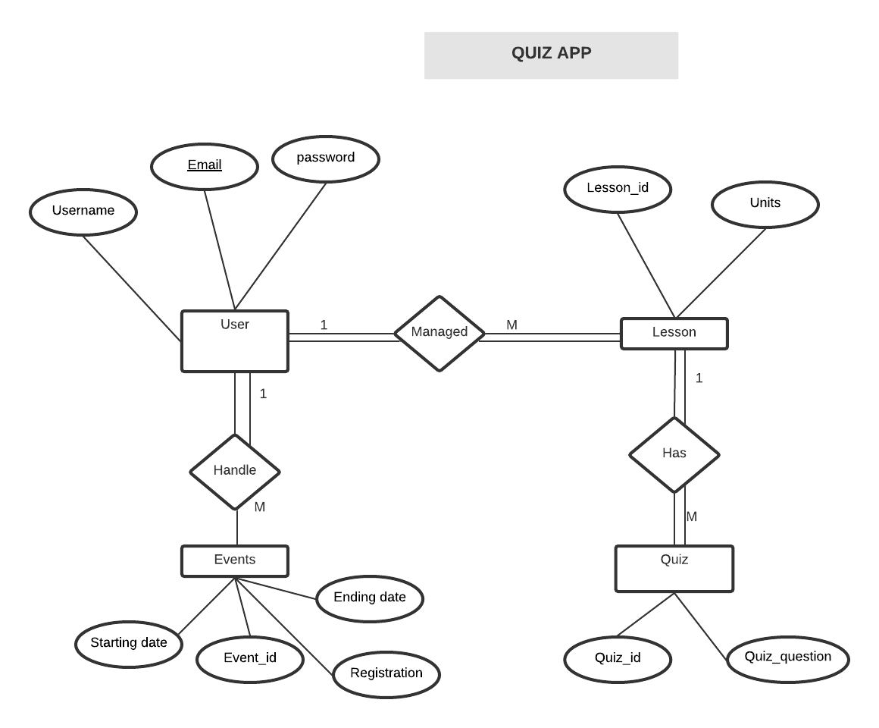

In my Entity Relationship Diagram, I have identified four entities and they are User, Lesson,Quiz and Events in which these entities are connected with relationship. There are 3 relationships and they are:

1. Has:
2. Manage:
3. handle:

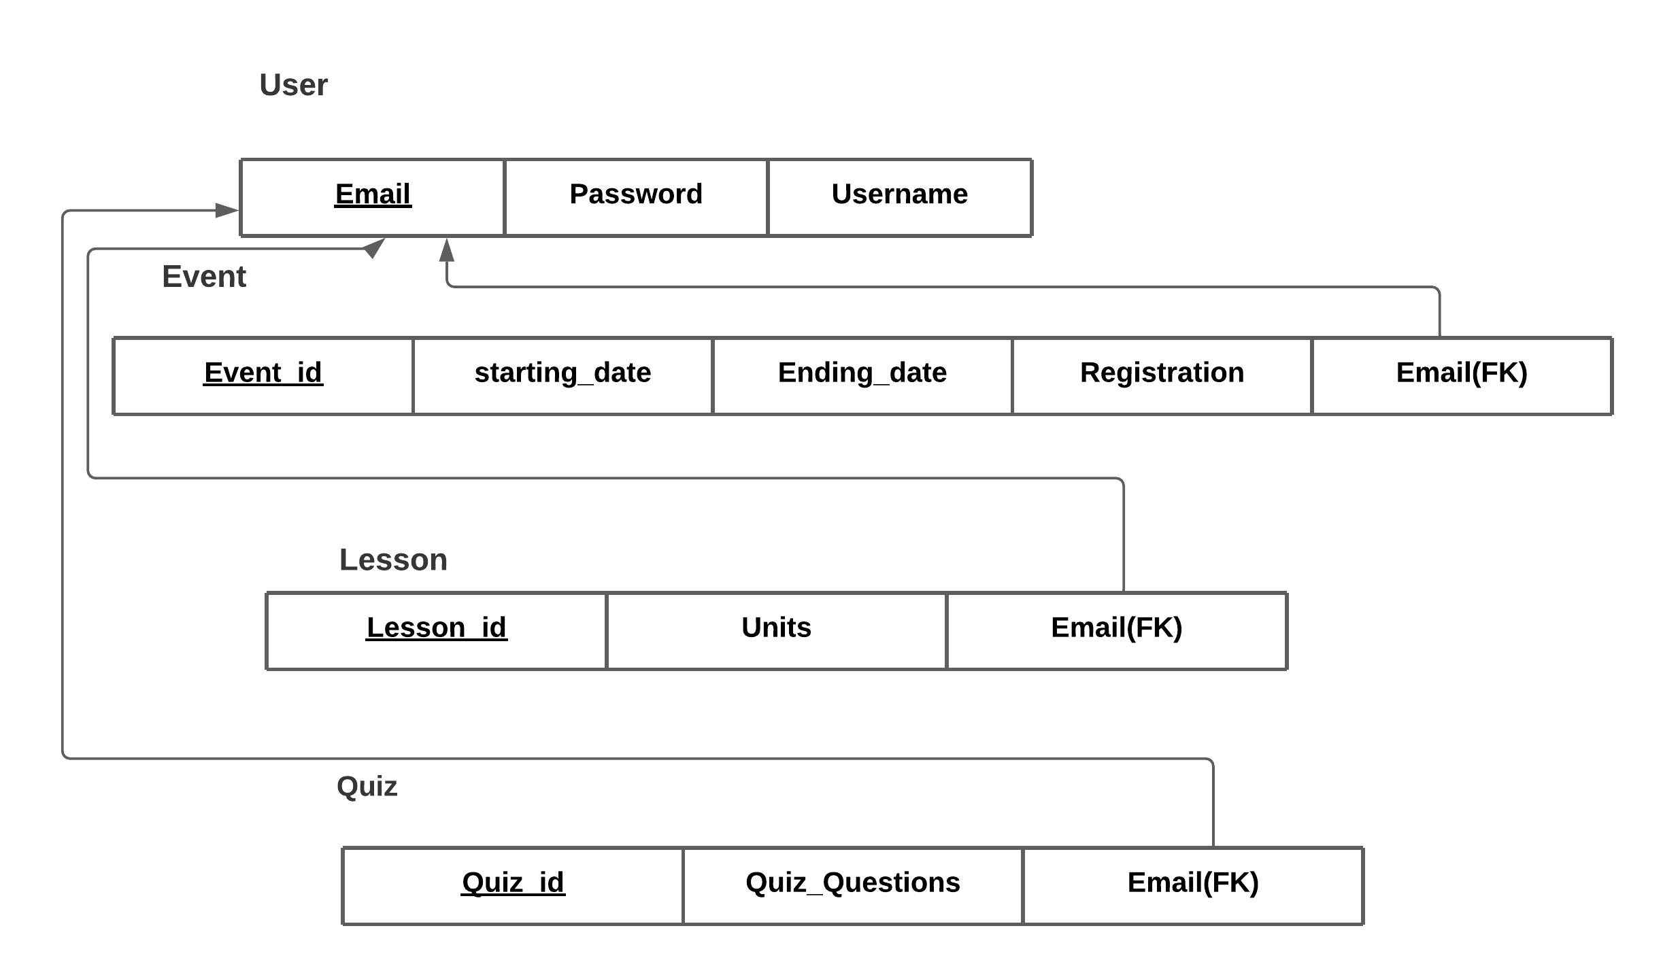b. Relational Schema

1. 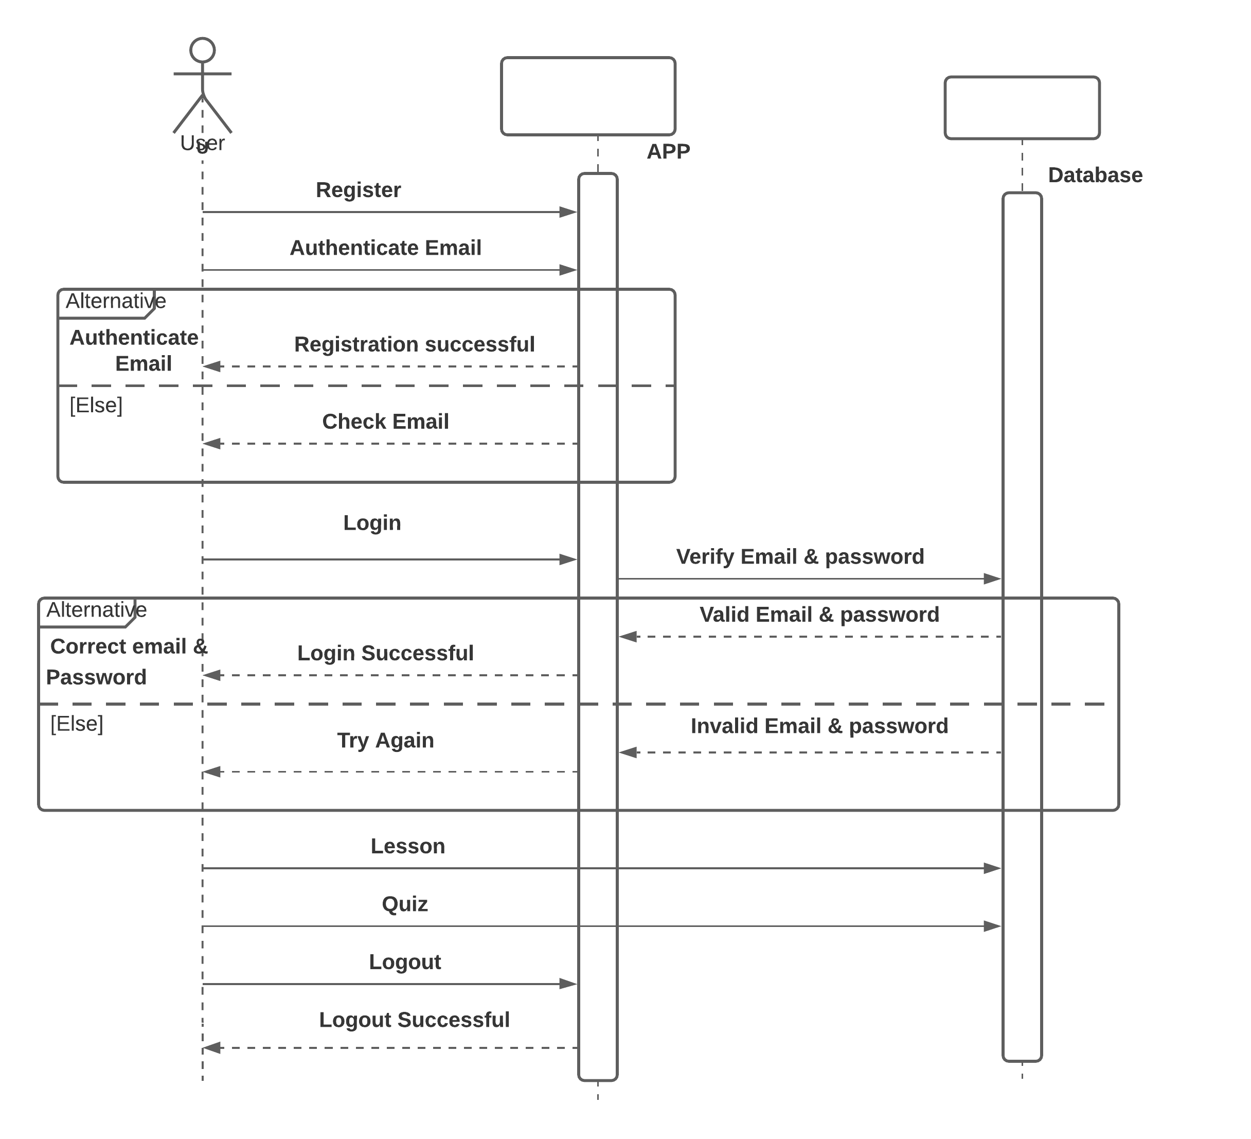Sequence Diagram

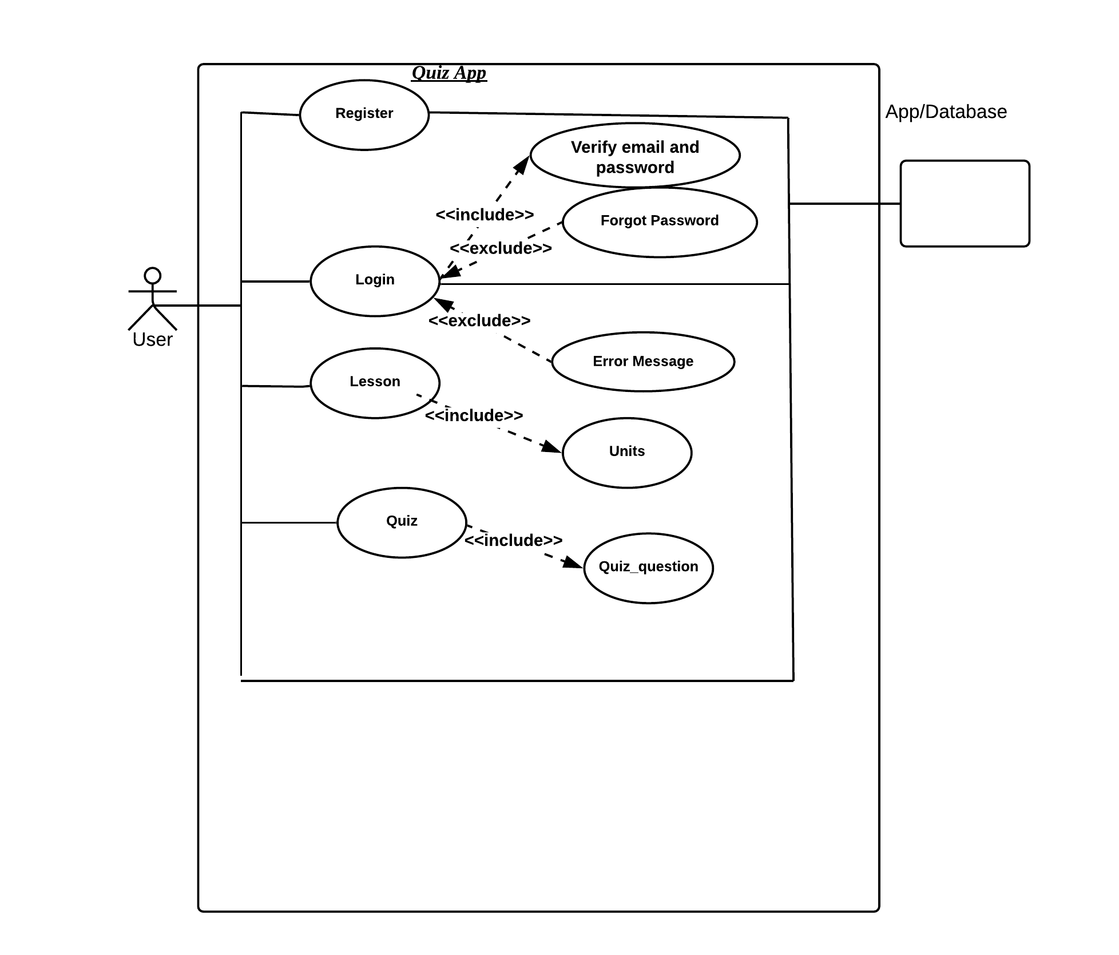d. Use case Diagram

Prototype Presentation