PROJECT MAINTENANCE HANDBOOK
QuietMel Project Maintenance and Technical Handover
Architecture, data contracts, metrics, operations, and troubleshooting
A code-backed operating baseline for future maintainers
Code baseline: main / 0ffe2b3
Baseline date: 10 August 2026 (Australia/Sydney)
Production project: Vercel / quietmel
Audience: developers, maintainers, model owners, and deployment owners

How to use this handbook
Executive summary
QuietMel is a map-first, low-stimulation travel application for Melbourne. Its differentiator is not simply finding the shortest route: it combines current City of Melbourne pedestrian readings, historical forecast profiles stored in Supabase, and Google walking alternatives to rank routes by practical quietness. The current product has no account system and does not persist user identity, location, journeys, or Google Place text.

This handbook treats the code on main at commit 0ffe2b3 as the source of truth. Where the README differs from the current implementation, the discrepancy is recorded under Known Gaps and Technical Debt.

Contents
- 1. Product purpose and current scope
- 2. Runtime architecture and data boundaries
- 3. Technology stack and repository map
- 4. Frontend application logic
- 5. Backend APIs and service behaviour
- 6. Data sources, database schema, and field definitions
- 7. Crowd, forecast, heatmap, and route metrics
- 8. Caching, concurrency, and fallbacks
- 9. Local development, migrations, imports, and deployment
- 10. Security, privacy, and third-party configuration
- 11. Release testing and troubleshooting
- 12. Known gaps and maintainer handover checklist

1. Product purpose and current scope
QuietMel helps people who can be affected by crowding, noise, and complex environments understand nearby conditions and choose lower-stimulation places and walking routes. The map remains the primary surface; controls appear only when needed.

1.1 Implemented capabilities
- Live pedestrian heatmap based on the latest available one-minute reading for each City of Melbourne sensor.
- Strict Heatmap, Sensors, and Combined map modes, including persistent sensor locations and live sensor detail cards.
- Automatic live refresh every 60 seconds and a manual no-cache refresh with visible loading feedback.
- A six-hour forecast rendered as 25 heatmap frames at 15-minute intervals, with play, pause, and timeline controls.
- Start and destination search using Google Autocomplete, with current-location or manually selected origins.
- Multiple Google walking alternatives ranked by a backend crowd-exposure score; selected routes are solid and alternatives are dashed.
- Nearby quiet-place discovery using semantic Google Place categories, distance ranking, and Google's fastest walking route.
- Eleven quick place categories for nearby discovery, with local browser preferences for visible categories.
- Location permission handling, current-position display, navigation-time position tracking, and blocking error feedback when permission is unavailable.
- Original and Dark themes, a language preference, a five-step first-run tour, and a backend-served PDF help centre.

1.2 Deliberate non-goals
- There is no current account, login, user profile, or server-side preference table. Earlier authentication and Turnstile code was removed.
- User location, searches, route paths, navigation progress, Google Place text, and minute-level live counts are not persisted.
- Navigation is not a full turn-by-turn engine: it displays the route and first instruction and updates the user marker, but has no off-route detection or voice guidance.
- Nearby quiet-place discovery uses place category and proximity as a proxy; it does not measure sound and currently does not filter candidate places by live crowd readings.

2. Runtime architecture and data boundaries
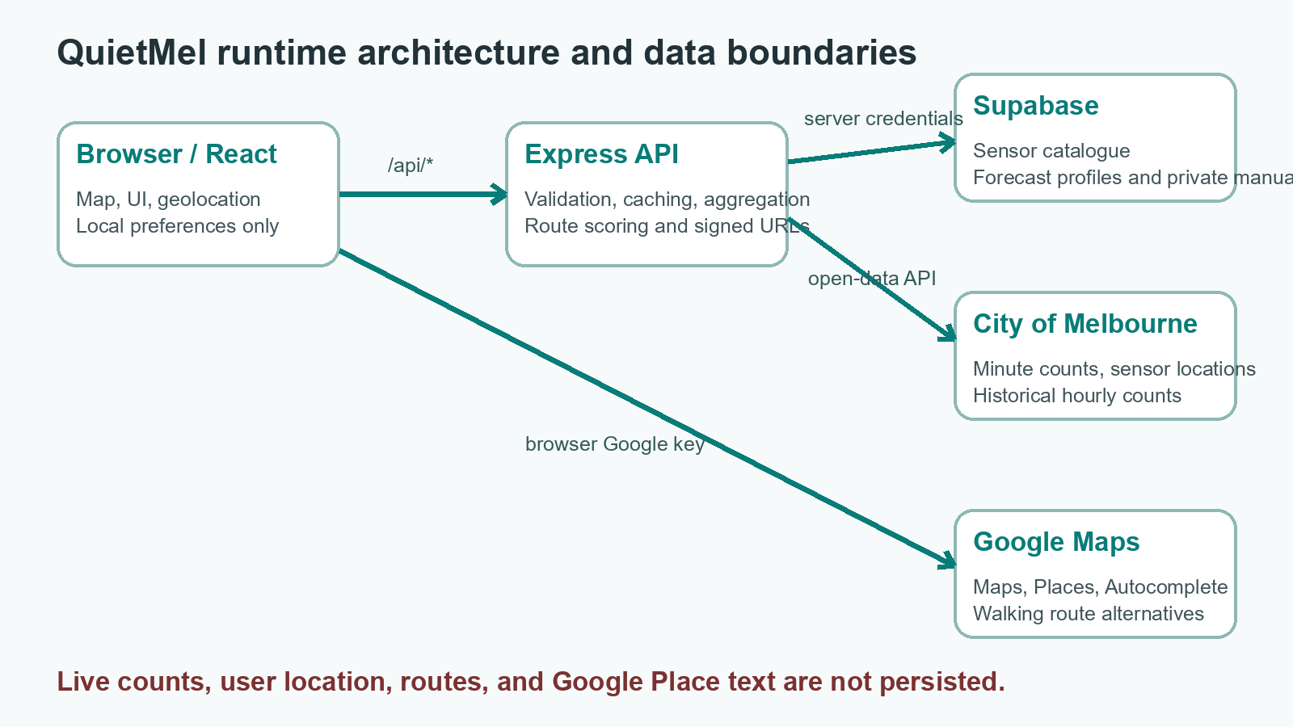

2.1 Request flow
- Browser to static app: React renders the map at / and HelpLibrary at /help.
- Browser to /api/*: Vercel rewrites the request to api/index.ts, which exports the shared Express app from server/app.ts.
- Express to City of Melbourne: the service requests live counts and active sensor locations with a 10-second source timeout.
- Express to Supabase: the server-only secret/service-role client reads and updates tables and creates private manual signed URLs.
- Browser to Google Maps Platform: Maps JavaScript, Places, Autocomplete, and Routes run directly in the browser with a referrer-restricted VITE key.

2.2 Persistence matrix
Data | Persisted? | Location / lifetime | Rule
Stable sensor locations | Yes | Supabase pedestrian_sensors | Used when the upstream location feed is unavailable
Minute live counts | No | City API plus 60-second Express memory cache | Avoids high-frequency database writes
Historical forecast profiles | Yes | Supabase crowd_hourly_profiles | Only runtime forecast source
Google Place text | No | Current page session | Only optional google_place_id may be stored
Help PDF files | Yes | Private Supabase Storage | Opened with one-hour signed URLs
Theme/language/tour/categories | Local only | localStorage | No cross-device sync without accounts
User position and routes | No | React state and browser geolocation | Privacy-preserving, session-only

3. Technology stack and repository map

3.1 Technology stack
Layer | Technology | Version / purpose
Frontend | React and React DOM | 19.2.8; UI and application state
Build | Vite | 8.2.0; local proxy and production bundle
Language | TypeScript | 6.0.3; strict frontend and backend checks
Maps | @vis.gl/react-google-maps | 1.9.0; Google map, marker, and InfoWindow wrappers
Backend | Express | 5.2.1; REST API and Vercel Function
Data platform | Supabase / PostgreSQL | Tables, RPC, RLS, and private Storage
Validation | Zod | 4.4.3; quiet-route request contract
Icons | lucide-react | 1.28.0; UI icon system
Model training | Python, pandas, numpy | Offline hourly-gradient-v1 profile generation
Hosting | Vercel | Vite frontend plus Express serverless entry

Dependency note
styled-components is installed in package.json, but the current interface is primarily styled with src/styles/*.css. Search for active imports before removing the package.

3.2 Repository responsibilities
Path | Responsibility | Maintenance note
src/App.tsx | Top-level state machine and mode transitions | Entry point for location, forecast, routes, settings, and tour
src/components/MapView.tsx | Google map and all overlays | Largest file; heatmap, places, routes, sensors, and location
src/components/RouteSearchPanel.tsx | Origin/destination input and autocomplete | Contains Safari blur/click workaround
src/components/RoutePlanner.tsx | Route alternatives and displayed metrics | Computes the displayed overall score
src/hooks | API request lifecycles | AbortController, duplicate suppression, and refresh timing
src/lib | Frontend contracts and API clients | crowd.ts and quietRoute.ts define key browser data shapes
server/routes | HTTP validation, headers, and error mapping | Keep business logic in services
server/services | Aggregation and domain logic | crowd, forecast, quietRoute, helpManuals
supabase/migrations | Database source of truth | Run in chronological order and version every schema change
model | Offline training and output artifacts | Excluded from Vercel and never read at runtime
scripts | Forecast import and manual upload | Loads server/.env, .env.local, then .env
api/index.ts | Vercel Express entry | Must remain consistent with vercel.json rewrites
docs | Team and maintenance documentation | Includes this handbook and history

4. Frontend application logic

4.1 Routing
src/main.tsx does not use React Router. It normalises window.location.pathname and renders HelpLibrary only for /help; every other path renders App. Vercel's SPA rewrite returns index.html for deep links. If the app gains more pages, adopt a proper router rather than adding many conditional branches.

4.2 Top-level application state
State | Default | Purpose and mode relationship
activeCategory | null | Non-null enters Google place discovery and hides crowd layers
crowdLayerMode | heatmap | heatmap / sensors / combined; mode changes clear sensor selection
forecasting | false | Exits place and route modes and forces heatmap
routePlanningActive | false | Displays scored route overlays and the route sheet
navigationActive | false | Shows only the selected route and starts watchPosition
userPosition | null | Memory-only browser coordinate
theme | original | Stored as quietmel:theme
language | en | Stored as quietmel:language
tourOpen | first visit | Controlled by quietmel:onboarding-complete

4.3 Layer separation and sensor details
- Heatmap mode renders only the canvas layer; no sensor marker exists to trigger a sensor InfoWindow.
- Sensors mode renders only AdvancedMarker elements and the selected InfoWindow. Stored locations remain visible without a current reading.
- Combined mode renders the heatmap first, then markers and InfoWindow. Route overlays use higher z-index values than the heat layer.
- The sensor card shows location name, pedestrians per minute, and reading time. Google detail text is cached per sensor for the current page session.
- If google_place_id exists, details are fetched by ID; otherwise a text query is biased to a 180-metre radius around the sensor.
- The card closes immediately from its button or 220 ms after pointer leave; pointer re-entry cancels the timer.

4.4 Place and route entry points
Entry | Search radius | Ranking / limit | Route behaviour
Quick place category | 2 km from current location | DISTANCE / 20 | Google's first walking route after place selection
Find quiet nearby | 4 km from current location | DISTANCE / 20 | First valid semantic place, then Google's fastest route
Origin/destination search | Australia with 50 km location bias | Autocomplete / 5 suggestions | Google alternatives, then Express crowd ranking

4.5 Location permission behaviour
- locateRequest starts at 1, so the map requests geolocation when Google Map becomes ready.
- Single-location requests use enableHighAccuracy=true and an 8-second timeout. Nearby quiet discovery also permits a 30-second cached position.
- Navigation uses watchPosition with maximumAge=5 seconds and timeout=10 seconds, and clears the watcher on cleanup.
- Quick place categories and nearby quiet discovery request permission if no current position exists and stop when permission is denied.
- The general route search intentionally still allows a manually selected origin when current location is unavailable.

4.6 localStorage contract
Key | Value | Effect when removed
quietmel:theme | original | dark | Returns to Original theme
quietmel:language | en | zh-CN | Returns to English
quietmel:onboarding-complete | true | Tour runs again on the next app load
quietmel.map-preferences | version 1 category preference object | Resets to parks, libraries, and cafes

5. Backend APIs and service behaviour

5.1 Endpoint catalogue
Method and path | Purpose | Caching / status | Primary failure
GET /api/health | Configuration check | 200 or 503 | Missing Supabase variables
GET /api/health/database | health_check RPC | No explicit cache | 503 / PGRST202
GET /api/crowd/live | Current crowd snapshot | 30s browser, 60s CDN, SWR 300s | 502 source unavailable
GET /api/crowd/live?refresh=1 | Forced live refresh | no-store | 502 / 500
GET /api/crowd/sensors | Stable sensor catalogue | 300s browser, 6h CDN, SWR 1d | 502 / 500
GET /api/crowd/forecast | Six-hour forecast | no-store | 503 model unavailable
POST /api/routes/quiet | Score route candidates | no-store | 400 invalid, 503 forecast, 502 other
GET /api/help/manuals | Published manual catalogue | 60s browser, 300s CDN | 503 database
GET /api/help/manuals/:id/access | Private PDF signed URL | private 300s | 404 / 503

5.2 Quiet-route request limits
- departureTime must be an ISO datetime.
- The request accepts one to four candidates. Candidate IDs are 1-40 characters.
- durationMinutes must be positive and at most 1,440; distanceMeters must be positive and at most 1,000,000.
- Each path contains 2-600 validated coordinates. The browser compacts route geometry to about 60 points before submission.
- Express limits JSON request bodies to 500 KB.

5.3 Response data contracts
Object | Important fields | Definition
LiveCrowdSnapshot | fetchedAt, newestReadingAt, stale, pointCount, points, source | One latest validated point per sensor
LiveCrowdPoint | sensorId, name, lat/lng, pedestriansPerMinute, crowdLevel, intensity, measuredAt | Current map point
PedestrianSensor | sensorId, description, lat/lng, status, googlePlaceId | Stable location even when no live count exists
CrowdForecastSnapshot | startsAt, endsAt, horizonHours, intervalMinutes, sensors, frames | 25 forecast frames for six hours
CrowdForecastValue | sensorId, PPM, level, intensity, qualityFlag, sampleCount | One sensor in one time frame
QuietRouteScore | average/maximum PPM, exposure, highCrowdPercent, coverage, combinedCost | Server-computed route metrics

5.4 CORS and generic errors
Production accepts origins listed in CLIENT_ORIGINS. Development also permits localhost:5173 and 127.0.0.1:5173. Requests without an Origin header are allowed. Unmatched routes return {error: 'not_found'} with 404; uncaught errors return {error: 'request_failed', message} with 500.

6. Data sources, database schema, and field definitions

6.1 External sources
Provider | Dataset / API | Use | Licence / storage
City of Melbourne | pedestrian-counting-system-past-hour-counts-per-minute | Current one-minute counts | CC BY 4.0; not stored
City of Melbourne | pedestrian-counting-system-sensor-locations | Name, coordinates, active status | CC BY 4.0; stable catalogue stored
City of Melbourne | pedestrian-counting-system-monthly-counts-per-hour | Two-year model training | CC BY 4.0; compact profiles stored
Google Maps Platform | Maps JavaScript, Places, Routes | Map, places, autocomplete, routes | Session-only Place text

6.2 pedestrian_sensors
Field | Type | Definition
location_id | bigint primary key | Stable City of Melbourne sensor identifier
sensor_name | nullable text | Upstream short name
sensor_description | text | Display name and descriptive fallback
latitude / longitude | double precision | Validated coordinates with a composite index
status | text | Defaults to A; current catalogue reads status A
google_place_id | nullable text | Optional persistable Google Place ID
source_name / source_url | text | Attribution and source endpoint
source_synced_at | timestamptz | Latest upstream synchronisation
created_at / updated_at | timestamptz | Record lifecycle timestamps

6.3 crowd_hourly_profiles
Field | Type / constraint | Business definition
location_id | bigint foreign key | Sensor identifier; profiles cascade on sensor deletion
day_of_week | 0-6 | 0=Sunday through 6=Saturday
season | four values | Australian meteorological season
hour_of_day | 0-23 | Australia/Melbourne local hour
baseline_ppm | >=0 | Median PPM for the group, or fallback statistic
trimmed_mean_ppm | >=0 | Mean after removing the lowest and highest 10 percent
p25_ppm / p75_ppm | >=0 | Linear-interpolated quartiles
gradient_ppm_per_hour | double | Next-hour baseline minus current baseline
sample_count | >=0 | Direct group sample count, not replaced by fallback support
quality_flag | ok / low_sample / fallback | >=10 / 5-9 / less than 5 direct samples
source_start_date / end_date | date | Actual training window
model_version | text | Currently hourly-gradient-v1
imported_at | timestamptz | Database import timestamp

Primary key: location_id + day_of_week + season + hour_of_day + model_version. Each sensor has 7 x 4 x 24 = 672 rows. The current 100-sensor model contains 67,200 rows.

6.4 help_manuals and private Storage
Field | Definition
id | Lowercase letters, numbers, and hyphens; stable API key
title_en / title_zh | Bilingual manual title
summary_en / summary_zh | Bilingual manual summary
storage_path | Unique object path inside the help-manuals bucket
page_count | Positive page count shown in the sidebar
sort_order | Catalogue order
is_published | Only true rows are exposed
updated_at | Metadata update timestamp

Row-level security
All three application tables enable RLS and revoke anon/authenticated access. Current reads and writes run through the server secret/service-role client. The help-manuals bucket is private, limited to 10 MB files and application/pdf MIME type.

7. Crowd, forecast, heatmap, and route metrics

7.1 Crowd level and intensity
crowdLevel(count):
count < 50 => low
count < 150 => medium
otherwise => high
intensity(count):
count <= 50 => round(count / 50 * 35)
count <= 150 => round(35 + (count - 50) / 100 * 40)
count > 150 => round(75 + min((count - 150) / 150, 1) * 25)

Intensity is bounded from 0 to 100 and saturates at 300 pedestrians per minute. The high-crowd route threshold uses the same 150 PPM boundary as crowdLevel=high.

7.2 Heatmap rendering metrics
- Points with pedestriansPerMinute <= 0 or intensity <= 0 are not drawn. Zero explicitly represents no pedestrians.
- radius = 36 + intensity * 0.3 + pulse * pulseStrength * 8.
- pulseStrength = max(0, (intensity - 75) / 25), so pulsing begins only above intensity 75.
- centreAlpha = 0.14 + intensity/100 * 0.13 + pulse * pulseStrength * 0.045.
- Colour is linearly interpolated across five configured colour stops. Device pixel ratio is capped at 2.
- Continuous animation is throttled to at least 32 ms between paints and stops when reduced motion is requested or the document is hidden.

7.3 Forecast training and runtime formula
Item | Current baseline
Training window | 7 Aug 2024 to 6 Aug 2026
Rows | 1,614,110 input and clean rows; no duplicate groups
Sensors | 103 source sensors; 28, 65, and 78 excluded; 100 trained
Profiles | 67,200 rows: 64,381 ok, 1,327 low_sample, 1,492 fallback
Validation | Latest 28-day temporal holdout; 99 sensors with test observations
Validation summary | Mean MAE 1.0402 PPM; median MAE 0.8285; median WAPE 17.0181%

prediction = round_to_1_decimal(max(0, baseline_ppm + gradient_ppm_per_hour * minute / 60))

The service resolves weekday, Australian season, hour, and minute in Australia/Melbourne time. It creates 25 frames from now through +6 hours at 15-minute intervals.

7.4 Low-sample fallback order
- Same sensor, weekday, and hour, ignoring season.
- Same sensor, weekday/weekend grouping, and hour, ignoring exact weekday and season.
- Same sensor and hour across all available dates.
- If no samples exist, numeric fields stay zero, quality_flag=fallback, and gradient is zero.

7.5 Quiet-route scoring
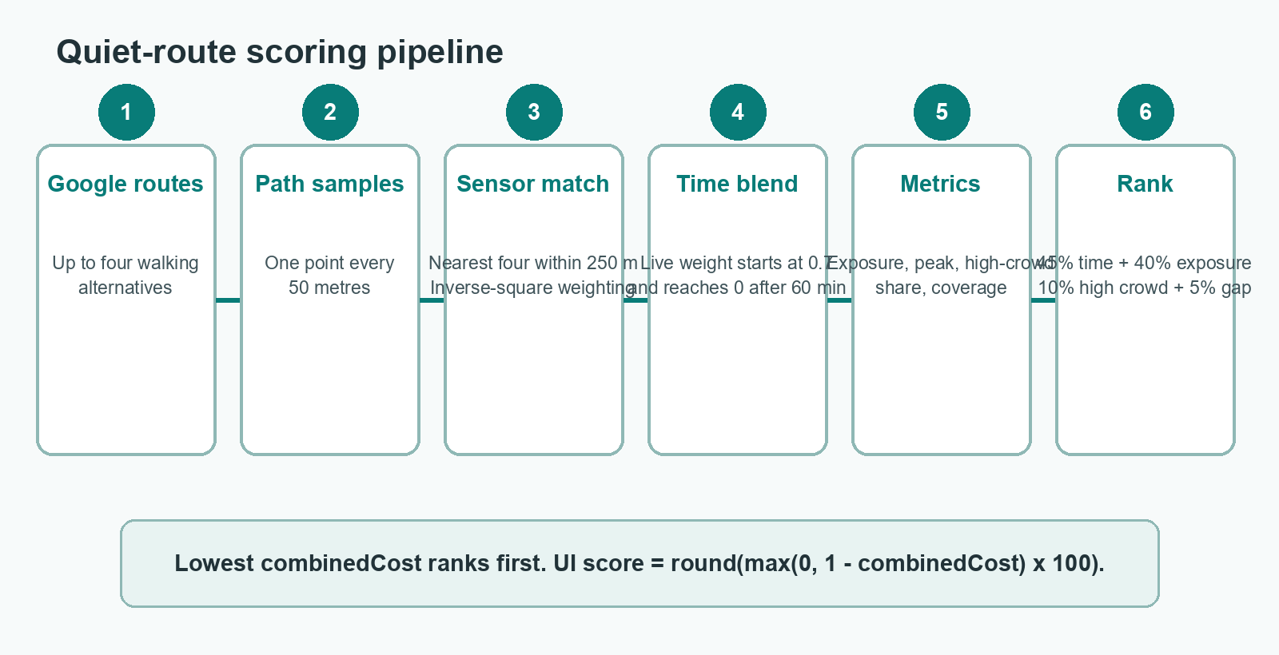
liveWeight = max(0, 0.7 * (1 - arrivalMinutes / 60))
blended = live * liveWeight + forecast * (1 - liveWeight)
sensorWeight = 1 / max(40, distanceMetres)^2
routeCrowd = sum(blended * sensorWeight) / sum(sensorWeight)
exposure = sum(routeCrowd * minutesPerSample)
coverageConfidence = coveredSamples / totalSamples

A sample is covered when at least one forecast sensor is within 250 metres. Up to four nearest sensors are used. If none are nearby, crowd falls back to the frame-wide forecast average, but that sample does not increase coverageConfidence. The forecast frame is selected by rounding arrivalMinutes / 15 and clamping the result.
combinedCost =
normalize(durationMinutes) * 0.45
+ normalize(crowdExposure) * 0.40
+ min(1, highCrowdPercent / 100) * 0.10
+ (1 - coverageConfidence) * 0.05
UI overall score = round(max(0, 1 - combinedCost) * 100)

Displayed metric | Definition
averageCrowdPpm | crowdExposure / durationMinutes
maximumCrowdPpm | Maximum estimated PPM across route samples
highCrowdPercent | Share of route minutes estimated at 150 PPM or above
extraMinutesComparedWithFastest | Candidate duration minus fastest candidate duration
crowdReductionPercent | Non-negative exposure reduction relative to the fastest candidate
crowdLevel | Average PPM below 50=low, below 150=medium, otherwise high
priority | Ascending combinedCost; priority 1 is recommended

8. Caching, concurrency, and fallbacks
Layer / resource | Lifetime | Concurrency control | Fallback
Browser live hook | 60-second interval | Single requestRef; abort on cleanup | Retains last successful snapshot and exposes error
Express liveCache | 60 seconds | Shared liveRequest Promise | Returns stale=true when an older cache exists
Express sensorCache | 6 hours | Parallel pagination | Reads pedestrian_sensors when source fails
HTTP live | 30s / 60s / SWR 300s | CDN | Manual refresh is no-store
HTTP sensors | 300s / 6h / SWR 1 day | CDN | Stable Supabase catalogue
Forecast | no-store | Parallel queries for unique time keys | No local CSV fallback; missing data returns 503
Google sensor details | Page session | Map<sensorId, Promise> | Failed requests are removed so they can retry
Manual signed URL | 1 hour | Cached per manual ID | Refreshes when less than 60 seconds remain

Why long sessions do not grow without bound
The live hook permits one active request, Express stores only one current snapshot and one sensor map, the canvas clears before each paint, and forecast state is reset on exit. Refreshes do not append an unlimited browser history of snapshots.

9. Local development, migrations, imports, and deployment

9.1 Environment variables
Variable | Location | Required | Purpose
VITE_GOOGLE_MAPS_API_KEY | .env.local / Vercel | Yes | Browser-visible key; restrict by referrer and API
VITE_GOOGLE_MAPS_MAP_ID | .env.local / Vercel | Recommended | DEMO_MAP_ID locally; production Map ID recommended
SUPABASE_URL | server/.env / Vercel | Yes | Supabase project URL
SUPABASE_PUBLISHABLE_KEY | server/.env / Vercel | Required by health check | SUPABASE_ANON_KEY is accepted as legacy fallback
SUPABASE_SECRET_KEY | server/.env / Vercel | Yes | Server only; SERVICE_ROLE_KEY accepted as fallback
CLIENT_ORIGINS | server/.env / Vercel | Recommended in production | Comma-separated CORS allowlist
PORT | server/.env | No | Defaults to 3000 locally

9.2 Local commands
npm install
npm run dev # Vite 5173 + Express 3000
npm run lint
npm run check:server
npm run build
npm run preview

9.3 Supabase migration order
- 20260805000100_health_check.sql
- 20260805000200_pedestrian_sensors.sql
- 20260808000100_crowd_hourly_profiles.sql
- 20260810000100_help_manuals.sql
Run the SQL files in order through Supabase SQL Editor or an already configured Supabase CLI workflow. Then verify GET /api/health/database.

9.4 Data import commands
npm run forecast:import -- --dry-run
npm run forecast:import
npm run help:upload -- --dry-run
npm run help:upload

The forecast import enforces exactly 100 sensors, 672 rows per sensor, 67,200 total rows, one model version, finite numeric values, and the absence of sensors 28, 65, and 78. It deletes the previous rows for that model version before inserting batches of 500.

9.5 Vercel deployment
- The repository is linked to the existing Vercel project quietmel. The production URL is https://quietmel.vercel.app.
- A push to GitHub main can trigger production deployment; a linked workspace may also use vercel deploy . --prod.
- vercel.json must match /api/:path* -> /api before the catch-all /:path* -> /index.html rewrite.
- .vercelignore excludes model/ and output/. Runtime forecasts and manuals come from Supabase.
- After deployment, test /api/health, /api/health/database, /api/crowd/live, /api/crowd/forecast, and /api/help/manuals.

10. Security, privacy, and third-party configuration
- Never expose SUPABASE_SECRET_KEY or SERVICE_ROLE_KEY through a VITE_ variable. They belong only in server/.env or Vercel server environment variables.
- Restrict the Google browser key to approved HTTP referrers and to Maps JavaScript API, Places API, Places API (New), and Routes API.
- Express disables x-powered-by, limits JSON to 500 KB, and validates route candidates with Zod.
- The product has no account or profile data. Location and routes remain in browser memory and are not sent to Supabase.
- Help files are private. The browser receives a short-lived signed URL, never a storage admin credential.
- Preserve City of Melbourne attribution and the CC BY 4.0 licence link in the interface and documentation.

11. Release testing and troubleshooting

11.1 Minimum release checklist
- npm run lint and npm run build succeed.
- Both allow and deny geolocation paths are tested; denied permission must stop location-dependent features.
- Heatmap, Sensors, and Combined modes are separated and the InfoWindow stays above the heat layer.
- Manual refresh sends refresh=1 and automatic refresh never creates parallel live requests.
- Forecast returns 25 frames, supports Now/+3hr/+6hr, and does not draw zero readings.
- Autocomplete selection works in Safari; route alternatives switch between solid and dashed styling.
- The help page calls /api/help endpoints and makes no /help/*.pdf static requests.
- Original/Dark theme, language selection, and the first-run tour are tested on desktop and mobile.

11.2 Troubleshooting matrix
Symptom | Likely cause | Action
/api/* returns 404 | Vercel rewrite or api/index.ts | Check rewrite order and Function build logs
Database returns 503/PGRST202 | Migration or schema cache | Run health_check migration and refresh schema
Live data returns 502 | City API timeout or changed fields | Inspect crowd service error and stale-cache fallback
Forecast returns 503 | Profiles absent, version mismatch, or no sensor join | Verify hourly-gradient-v1 rows and sensor IDs
Route scoring fails | Forecast unavailable or invalid request | Test forecast first, then interpret 400/503/502
Google map is blank | Key, billing, API, or referrer restriction | Verify all four APIs and production domain
Safari suggestions cannot be selected | Input blur removes list before click | Keep onPointerDown preventDefault on suggestion buttons
Manual PDF does not open | Signed URL, Storage MIME, or browser PDF support | Test access endpoint and a Range request returning 206
Denied location feature still continues | Error shown without an early return | Ensure permission failure stops subsequent search or routing

12. Known gaps and maintainer handover checklist

12.1 Code and documentation discrepancies
README route constraint mismatch
README says routes more than 25% or ten minutes slower than the fastest route are rejected. The current server/services/quietRoute.ts does not implement that filter; it scores every Google candidate returned. Add code and tests if the product still requires this constraint.

Nearby quiet-place naming mismatch
findNearbyQuietPlace selects the nearest semantically quiet category and Google's fastest route. It does not query sound levels, test current crowd readings, or select a low-activity sensor area. Some RoutePlanner wording is therefore stronger than the implemented logic.

- Chinese mode is not a full-site localisation. Settings, help, and some buttons are bilingual, but many map and route strings remain hard-coded in English.
- MapView.tsx and App.tsx are large and should be separated into heatmap, place, location, and route modules with focused tests.
- The repository has no automated test suite or CI workflow. Current gates are TypeScript, ESLint, and manual browser testing.
- Health configuration requires a publishable key even though core runtime services use the admin client; reassess whether this should remain mandatory.
- NavigationDemo, demoRoutes, and other prototype assets remain. Confirm imports before deleting them.
- vite.config.ts still mentions MapLibre in a comment, although the actual map engine is Google Maps.
- Keep all source files UTF-8 and verify the Chinese option in the browser after any text edit.

12.2 First-day handover checklist
- Pull main, compare HEAD with the 0ffe2b3 baseline, and read all newer commits.
- Configure personal Google and Supabase credentials without copying or committing production secrets.
- Run lint/build, start both services, and test health, live, sensors, forecast, routes, and help APIs.
- Confirm the three application tables, health_check RPC, private help-manuals bucket, and RLS rules in Supabase.
- Confirm Vercel root, build, output, rewrite, and environment-variable settings.
- Complete location, autocomplete, multi-route, and help-PDF flows in both Chromium and Safari.
- Resolve the documented product mismatches before extending route or quiet-place logic.

Appendix A: source-file index
Concern | Primary files
Top-level modes | src/App.tsx
Map, heatmap, sensors, places | src/components/MapView.tsx
Live data | server/services/crowd.ts; src/hooks/useLiveCrowd.ts
Forecast | model/train_crowd_profiles.py; server/services/forecast.ts
Route scoring | server/services/quietRoute.ts; src/lib/quietRoute.ts
Search and autocomplete | src/components/RouteSearchPanel.tsx
Help centre | server/services/helpManuals.ts; src/components/HelpLibrary.tsx
Database | supabase/migrations/*.sql
Production routing | api/index.ts; vercel.json; .vercelignore

Update this handbook whenever a data contract, metric, scoring weight, migration, or production routing rule changes.

