**Flexible Fast Charging System (Flexpole)**

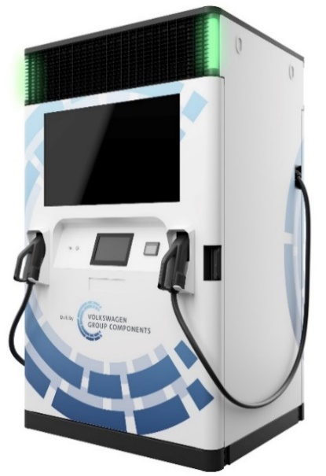

|  |  |
| --- | --- |
| Technical Specifications | |
| Certification[1] | CE (CE) |
| Protection | IP 54 System  IP 67 Battery |
| Mechanical Protection | IK 08 |
| Max system DC output power[2] | 250kW |
| Dimension (H x W x D) | 2260mm x 1340mm x 1100mm |
| Weight | 2650 kg |
| Operating Temperature | -20°C to 50°C |
| Operating Temperature without DC Output Power Derating | -20°C to 35°C |
| Humidity | 5% to 90% |
| Network Connections1 | GSM/3G/LTE (CE) |
| EMC emission1 | IEC 61000-6-2, IEC 61000-6-4, EN 61851-21-2:2018 (CE) |
| Noise emission (at 5m distance) | ≤ 60 dB |
| Output DC charging point #1 | |
| DC output power2 | Max. 150 kW (DPD) |
| DC output current[3] | Max. 350 A @430V  Max. 188 A @800V |
| DC output voltage | 200 – 920VDC |
| DC output interface | CCS Type 2 Combo |
| DC Metering conform to MessEG | Yes (only German variant) |
| DC Metering conform to MID | Yes (EU - non German variants) |
| Vehicle PLC communication | ISO 15118, DIN 70121 |
| Output DC charging point #2 |  |
| DC output power2 | Max. 150 kW (DPD) |
| DC output current[4] | Max. 350 A @430V  Max. 188 A @800V |
| DC output voltage | 200 – 920VDC |
| DC output interface | CCS Type 2 Combo |
| DC Metering conform to MessEG | Yes (only German variant) |
| DC Metering conform to MID | Yes (EU - non German variants) |
| Vehicle PLC communication | ISO 15118, DIN 70121 |
| Input | |
| Grid connection | 400 V, 50 Hz  TN-C-S; 3P + N + PE  16 / 32 / 63A  2 low voltage safety lines (Impact) |
| Electrical protection | Overvoltage category IV (DIN 60664-1) |
| RCD protection | Yes |
| Power factor | > 0.95 |
| Efficiency | > 75% (varies through mission profile and temperature range)  > 80% @ 20°C ambient temperature |
| Battery | |
| Internal battery rated capacity | 193.5kWh (net capacity in validation) |
| Maximum usable capacity[5] | Currently: 140 kWh  From SW 4.9.0 on: 160 kWh |
| Max. recharge power2 | 2x20kW to battery  1x40kW (DPD) to vehicle |
| User Interface | |
| HMI | 10” Touch Screen  43” Advertising Screen  Status LEDs  Charge Stop button |
| Authorization / Payment | RFID Mifare (IEC 14443 A/B)  Compliant to PCI-PTS 3.x, PCI-PTS 5.x  NFC / Credit Card (IEC 18092)  Supported payment acquirers:  PayOne |
| Operator Interface | |
| OCPP | OCPP 1.6-J  Improved security for OCPP 1.6-J, edition 2 |

Dimensions:

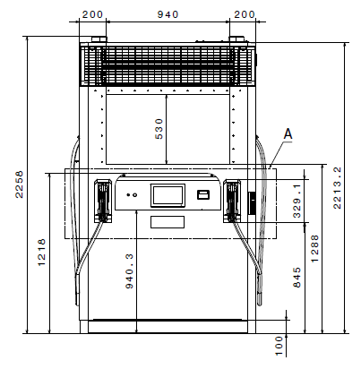

Figure: front view

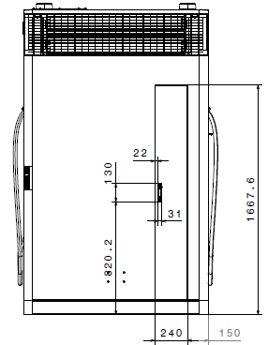

Figure: rear view

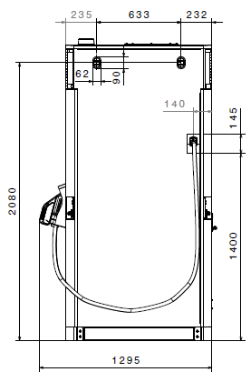 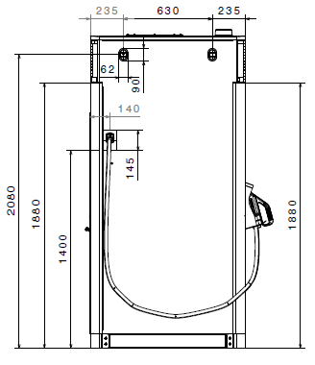

Figure: right view Figure: left view

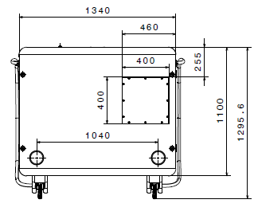 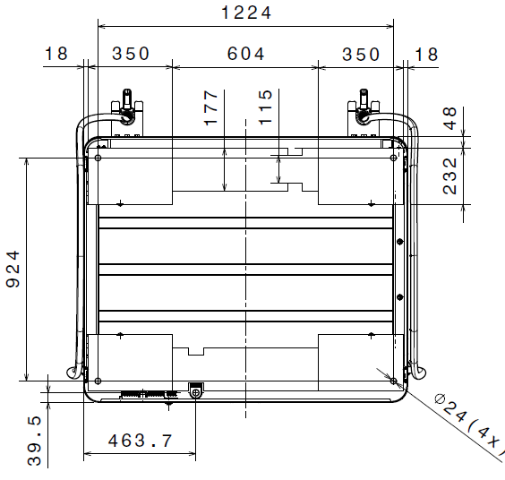

Figure: top view Figure: bottom view

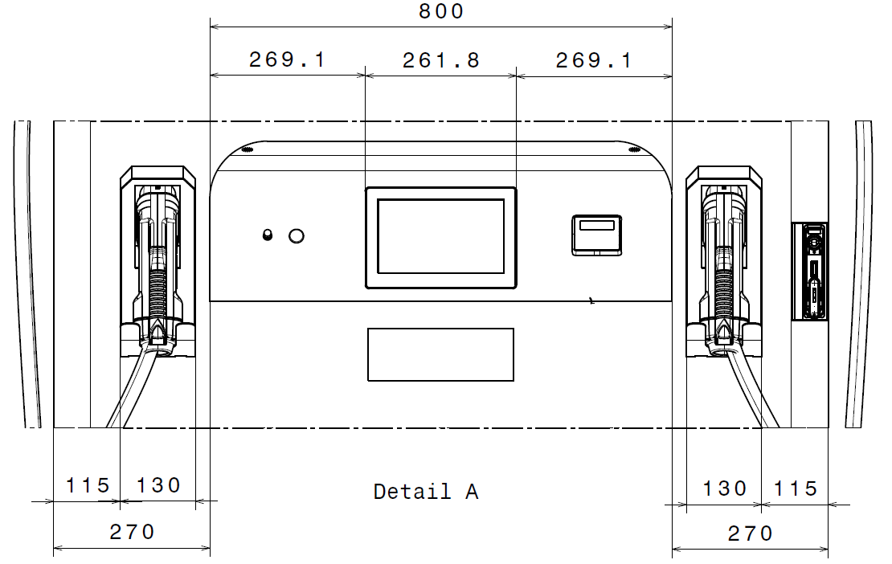

Figure: front detail view

1. See CE declaration of conformity document
2. When connected to grid with 400V/63A
3. With temperature-controlled 400A rated high power CCS cable
4. With temperature-controlled 400A rated high power CCS cable
5. See warranty agreement

   PRINT “HAHA”