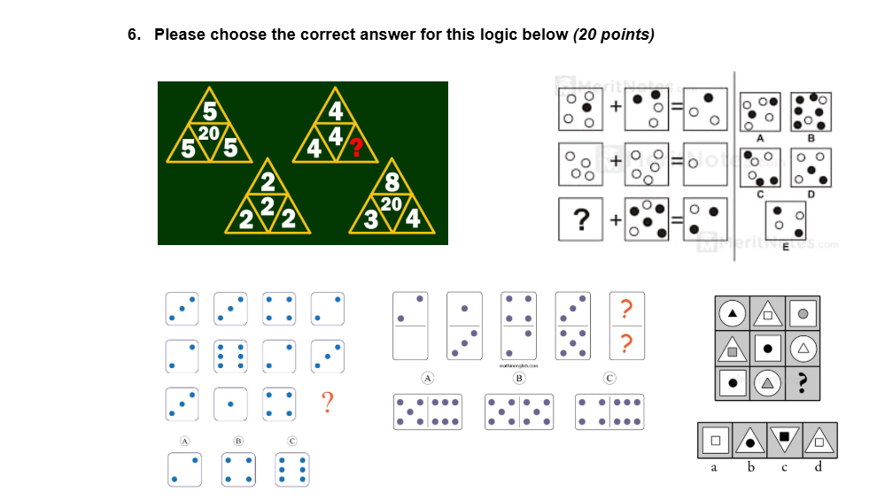
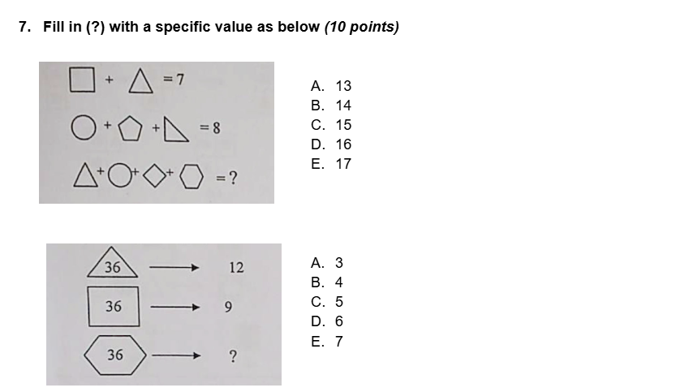
Answer : d
Answer : D
Answer :12
Answer: D. 6
Answer : A. 13

