The Phantom Bicycles

Guandong Liu and Katherine McDonough

Table of Contents

Assignment Four Documentation

The Story of the Phantom Bicycles……………………………………………………3

User Manual……………………………………………………………………….......4

Models…………………………………………………………………………………6

Assignment Analysis…………………………………………………………………..7

Assignment Three Documentation

Scene Description……………………………………………………………………...8

Bicycle Description……………………………………………………………………9

Animation Description…………………………………………………………….…10

The Story of the Phantom Bicycles

There exists a park where two mysterious bicycles appear. No one appears to be riding these bicycles, but rather they appear to be self-peddling bicycles giving them the name phantom bicycles. The bicycles always ride in the same two circles; one going in a small clockwise circle and the second moving in a larger counterclockwise circle. Never has anyone seen the bicycles come or go. The locals are very curious about these phantom bicycles, so they sent a helicopter to patrol the area. However, the bicycles were already there when the helicopter arrived, so it is now slowly orbiting above the bicycles waiting to see them leave.

User Manual

View the phantom bicycles in the park with the helicopter hovering above. In this global view click and drag the scene to rotate the entire park to see it from an angle that you desire. Whenever you would like to return to the default view press the “G” key.

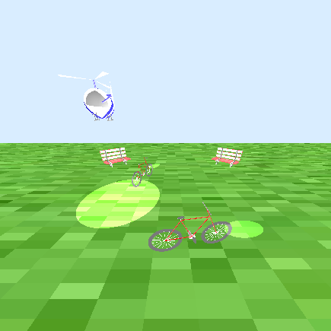

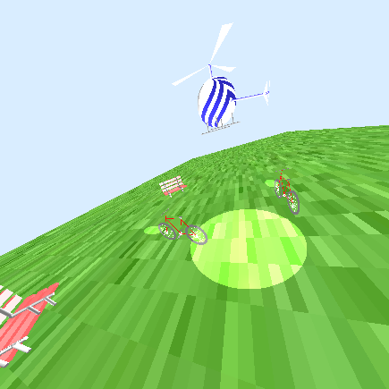

You also have the ability to change your view to place yourself into the park itself.

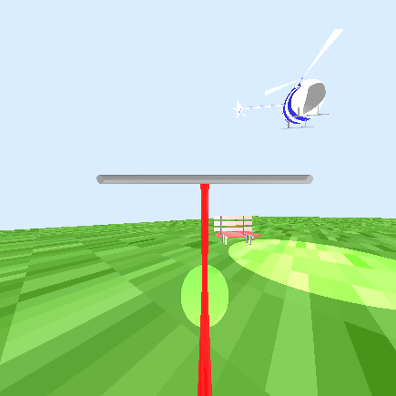Become a phantom bike rider yourself. Press either the “O” key to view the world as if you were the rider of the bicycle going around in the small circle. Press the “F” key to view the world as if you were the rider of the bicycle going around in the large circle. 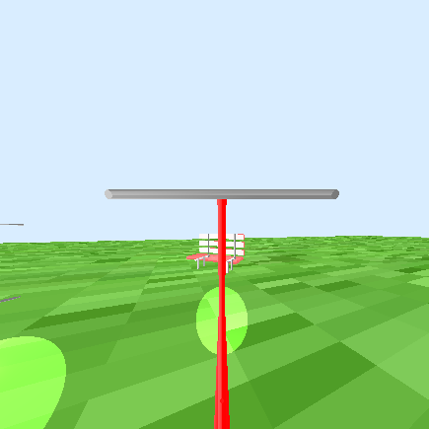

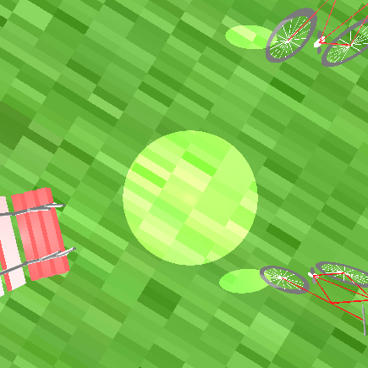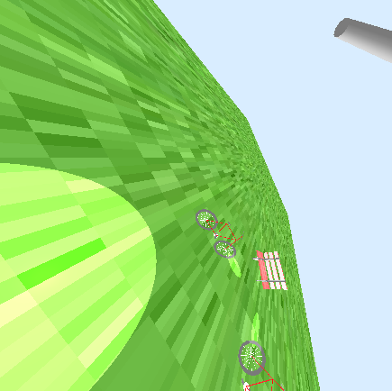View the bicycles from the helicopter. Pressing the “H” key will allow you to view the bicycles as if you were looking out the bottom of the helicopter cockpit. While in this view, use the arrow keys to change the angle from which you view the bicycles.

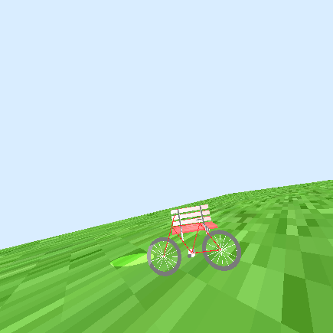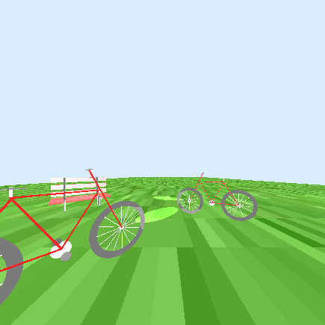View the screen from any view that you desire. Pressing the “I” key puts you into the interactive camera mode. Move forward in the direction you are facing by hitting the up arrow and moving backwards in the direction opposite the direction you are facing with the down arrow. Change the way you are facing by turning in the clockwise direction with the right arrow and the counterclockwise direction with the left arrow. Pressing the “W” key will move the camera up and the “Z” key will move the camera down. Pressing the “S” key will tilt the camera to the right and “A” will tilt the camera to the left.

Models

Bicycle

In order to view the phantom bicycles, we created the model of a single bicycle. This different components of the bicycle were divided into three categories: propulsion, frame and human interaction (even though no humans interact with these bicycles). Propulsion includes the front and rear wheels, the gear mechanism, and the pedals. Each wheel itself is composed of a hollowed cylinder for the tire and sixteen cylinders for the spokes. The gear mechanism is one flat cylinder to represent the gear, a small cylinder to protrude from each side of the gear to read the pedals, and a small cylinder on each side o connect the pedals to the gear. The pedals are then made of one flat cylinder each. The bicycle frame consists of four cylinders to compose the main portion of the bicycle. Finally, the human interaction includes the seat, seat adjustment, handlebar, and handlebar connector. Excepting for the hollowed cylinder for the wheel, all of the parts are cylinders that were manipulated into different sizes appropriate for their purpose. Each cylinder was then colored appropriately.

Helicopter

When creating the helicopter, four categories were used instead of three: cockpit, main rotor, tail, and landing gear. To complete the helicopter, we incorporated more shapes, as can be seen with the cockpit which is comprised of a gigantic sphere. To incorporate all of the different colors on the cockpit, we used an image to wrap around the sphere. The main rotor consists of three blades made from triangles and a cylindrical shaft to connect the blades to the cockpit. The tail has its body and a tail rotor. The tail body is a long but thin cylinder while the tail rotor is similar to the main rotor but only has two blades instead. The landing gear is a pair, left and right. Both of them consist of a long skid and two supports. Skid is a longer cylinder parallel to the horizon while supports are shorter and vertical to the ground, standing on the skid and supporting the helicopter’s body. Everything except the cockpit is assigned a single color.

Bench

The bench is created with the three different categories, boards, supports, and legs, and two different objects, boxes and cylinders. The boards are six different long boxes. The supports are four long cylinders and the legs are four short cylinders.

Assignment Analysis

Division of Labor

To complete the project, Guandong created the YMCA xml files and helicopter model and added all lighting features, including the basics, spotlight, and needed additions to the XML file. Katherine created the bicycle and bench models, updated the animation function, included texture mapping capabilities and the different camera capabilities.

Difficulty Level

The time to complete all the features in assignment 4 is about 20 – 25 hours. We thought both the time required and the difficult level were manageable given the amount of time to work on the assignment.

Scene Description

On the ground, two bicycles move recursively. The orbits of the bicycles are circles in different radius centered at the origin. The bicycle moving on the smaller circle goes clockwise while the bicycle moving on the bigger circle goes counterclockwise. As the bicycles move in the circles, both the front and the rear wheels of both bicycles rotate around the center of the wheels. The gear mechanism (including the pedals and all connectors) for the pedals rotates. These two combined animations give the appearance of an invisible person riding the bicycle.

In a future iteration of the scene, a helicopter will hover above the ground and also move in a circle orbit. In order to capture the movement of the bicycles, the helicopter has a different spend from the two bicycles. The main rotor and the tail rotor of the helicopter will rotate about their respective center axis.

Currently, there is one stationary camera set in yz-plane with positive y-coordinate and positive z-coordinate that allows the user to view both bicycles during their entire rotation. In the future iteration, there will be a second camera on the bottom of the helicopter. This camera will look down at the ground and the bicycles. Through this camera, we can see the orbits of the bicycle more clearly. We can also control this camera to decide where it is looking. However, the camera cannot look higher than parallel with the ground. Moreover, we will be able to toggle between these two cameras.

Bicycle Description

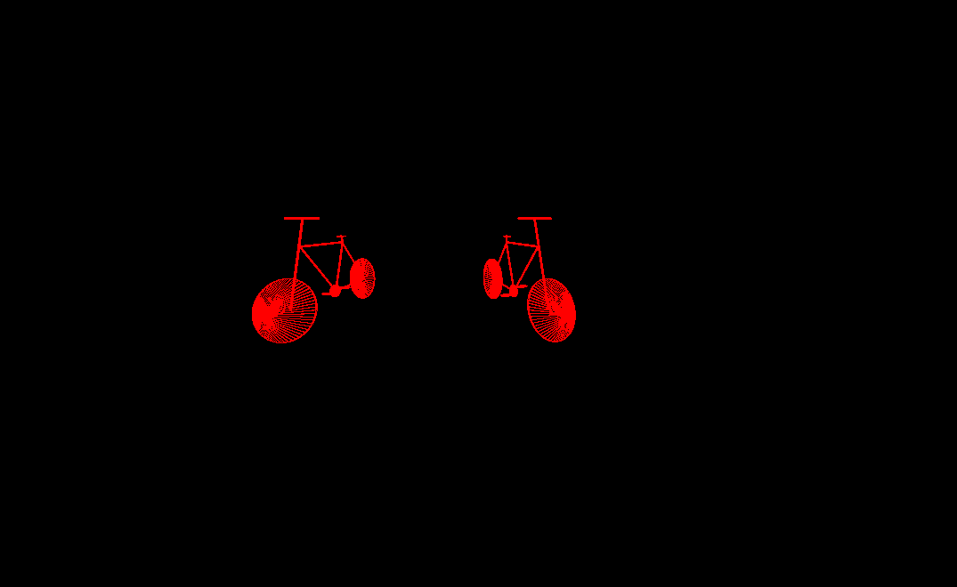

Two bicycles are orbit around the origin at different radii. The bicycle closer to the origin rotates in a clockwise manner while the bicycle farther away rotates in the counterclockwise manner. Both wheels on both bikes rotate in a clockwise fashion around their respective centers when viewing the side of the bicycle and the bicycle faces the right. The gear mechanism that incorporates the pedal gear the pedal connectors and the pedals all rotate around the center of the gear to given the appearance of an invisible person riding a bicycle.

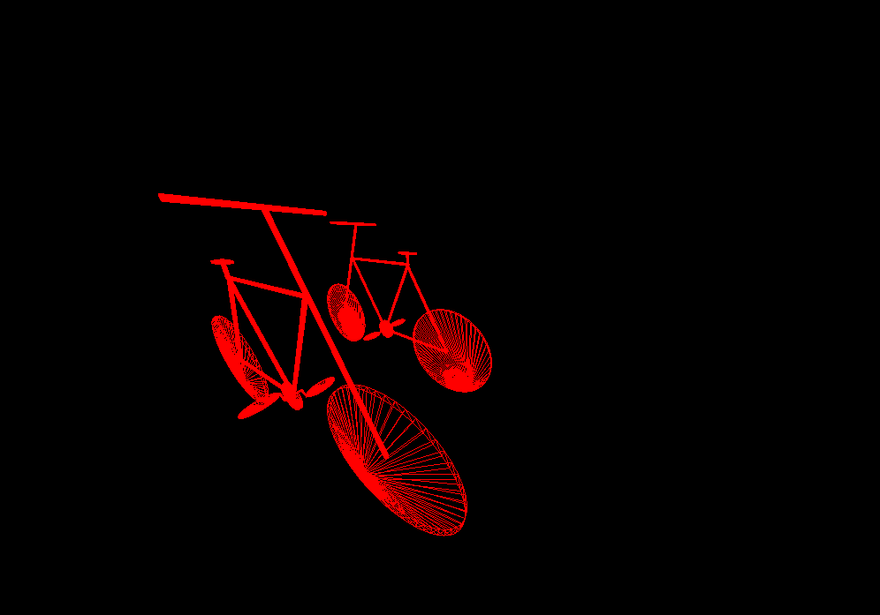

Animation Description

In the view file, we keep track of the number frame that we are currently drawing. This frame count variable is increased by one every time the draw function is called. The animate function will then use this frame count to determine how much to rotate the different elements.

To animate the bicycles rotating around the origin, we add a animation transformation matrix to two transformation nodes in the two-bicycles.html files. These nodes, name counterclockwise and clockwise, can be found on lines three and eleven of the XML file. The following code will compute and add these matrices. This code can be found in the Scenegraph.java file on lines 112 – 118:

*// Animate the rotations of the entire bicycle in the large circle*Matrix4f farTransform = **new** Matrix4f().rotate((**float**) Math.*toRadians*(time), 0, 1, 0);  
**nodes**.get(**"counterclockwise"**).setAnimationTransform(farTransform);  
  
*// Animate the rotations of the entire bicycle in the small circle*Matrix4f nearTransform = **new** Matrix4f().rotate((**float**) Math.*toRadians*(-2*time), 0, 1, 0);  
**nodes**.get(**"clockwise"**).setAnimationTransform(nearTransform);

To animate the wheels rotating, we add an animation transformation matrix to the rear wheel and front wheel node (named rwheel and fwheel respectively) in the bicycle.xml file, seen on lines sixty-eight and eighty-four respectively. The matrix had to be added twice to each node for each bicycle. The code for this is included below and can be seen in the Scenegraph.java file on lines 124 - 134.

*// Animate the propulsion*Matrix4f propTransform = **new** Matrix4f().rotate((**float**) Math.*toRadians*(-2*time), 0, 0, 1);  
Matrix4f negpropTransform = **new** Matrix4f().rotate((**float**) Math.*toRadians*(2*time), 0, 0, 1);  
  
*// Rear wheel of near bike***nodes**.get(**"near-rwheel"**).setAnimationTransform(propTransform);  
  
*// Front wheel of near bike***nodes**.get(**"near-fwheel"**).setAnimationTransform(propTransform);  
  
*// Rear wheel of far bike***nodes**.get(**"far-rwheel"**).setAnimationTransform(propTransform);  
  
*// Front wheel of far bike***nodes**.get(**"far-fwheel"**).setAnimationTransform(propTransform);

The gear and pedal animation is done by adding animation transformation matrices to the gear node (line ninety-seven) named mechanism that rotates around the center of the gear and then to each pedal (rpedal – line 150 and lpedal 165) that will ensure the pedals always stay parallel to the ground. The code for this can be found in the Scenegraph.java file on lines 136 – 144 and below. The matricies were built above before the wheel rotation and can be seen above.

*// Animate the pedal mechanisms of the near bike***nodes**.get(**"near-mechanism"**).setAnimationTransform(propTransform);  
**nodes**.get(**"near-lpedal"**).setAnimationTransform(negpropTransform);  
**nodes**.get(**"near-rpedal"**).setAnimationTransform(negpropTransform);  
  
*// Animate the pedal mechanisms of the far bike***nodes**.get(**"far-mechanism"**).setAnimationTransform(propTransform);  
**nodes**.get(**"far-lpedal"**).setAnimationTransform(negpropTransform);  
**nodes**.get(**"far-rpedal"**).setAnimationTransform(negpropTransform);