*QT Framework Explanation*



*What’s QT?*

**Qt** is an application development framework based on C++. Traditionally, C++ is the major programming language used to develop with Qt. Since the introduction of Qt Quick (Qt UI Creation Kit) in the beginning of 2011, Qt has been supporting script-based declarative programming with QML.

**Qt** is used for developing [graphical user interfaces](https://en.wikipedia.org/wiki/Graphical_user_interface) (GUIs) and multi-platform [applications](https://en.wikipedia.org/wiki/Application_software) that run on all major [desktop](https://en.wikipedia.org/wiki/Desktop_computer) platforms and most mobile or embedded platforms. Most GUI programs created with Qt have a native-looking interface, in which case Qt is classified as a [widget toolkit](https://en.wikipedia.org/wiki/Widget_toolkit). Non-GUI programs can also be developed, such as [command-line](https://en.wikipedia.org/wiki/Command-line_interface) tools and consoles for servers.

*Why I chose QT*

**Qt** supports various compilers, including the [GCC](https://en.wikipedia.org/wiki/GNU_Compiler_Collection) C++ compiler, the [Visual Studio](https://en.wikipedia.org/wiki/Microsoft_Visual_Studio) suite, [PHP](https://en.wikipedia.org/wiki/PHP) via an extension for PHP5, and has extensive [internationalization](https://en.wikipedia.org/wiki/Internationalization_and_localization) support. Qt also provides [Qt Quick](https://en.wikipedia.org/wiki/Qt_Quick), that includes a [declarative](https://en.wikipedia.org/wiki/Declarative_programming) [scripting language](https://en.wikipedia.org/wiki/Scripting_language) called [QML](https://en.wikipedia.org/wiki/QML) that allows using [JavaScript](https://en.wikipedia.org/wiki/JavaScript) to provide the logic.

**Qt** is one of, if not, the most intuitive and easy-to-learn frameworks out of all ten provided. It also has a sizable user base, making both learning and developing apps from the framework convenient and enjoyable.

*Installing QT*

1. Go to qt.io
2. Click on “Download. Try.”

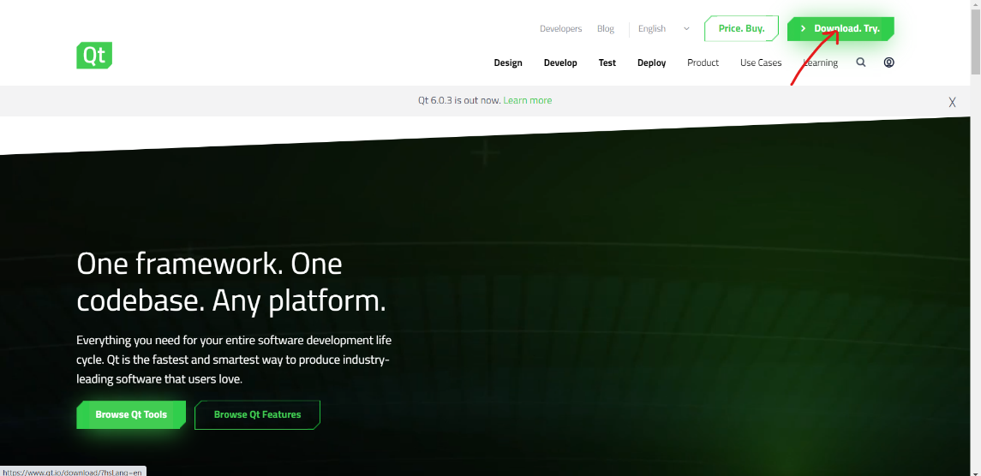

1. 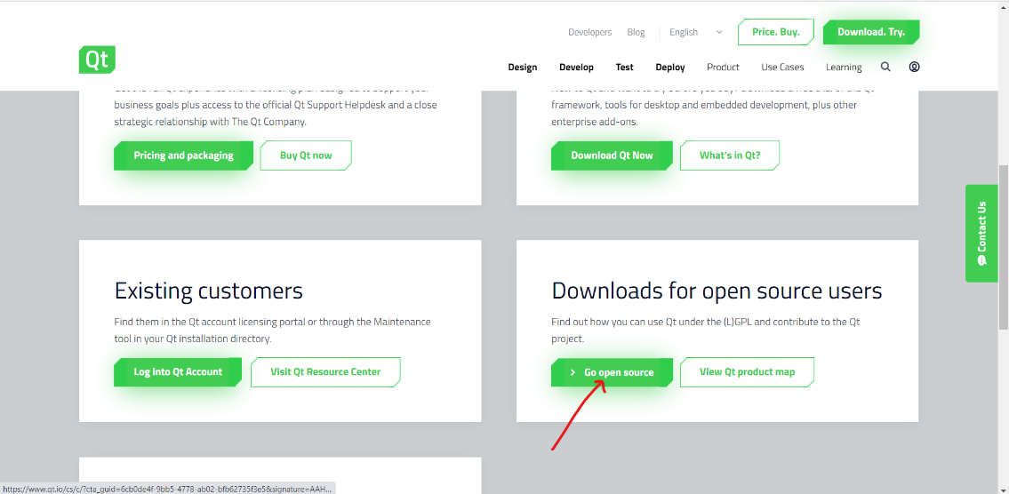Scroll down and click “Go open source”.
2. Scroll down again, click the green button, then the “Download” button. At this point, you should have an executable file on your way.

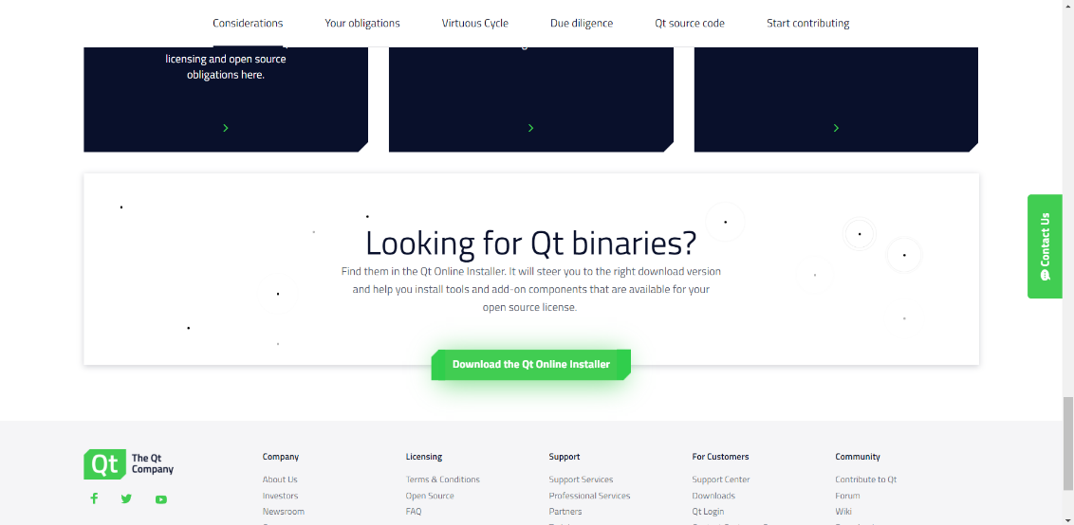

1. Open the executable, log in (or register in case you do not have a QT account).

Read and agree to their open-source policy.

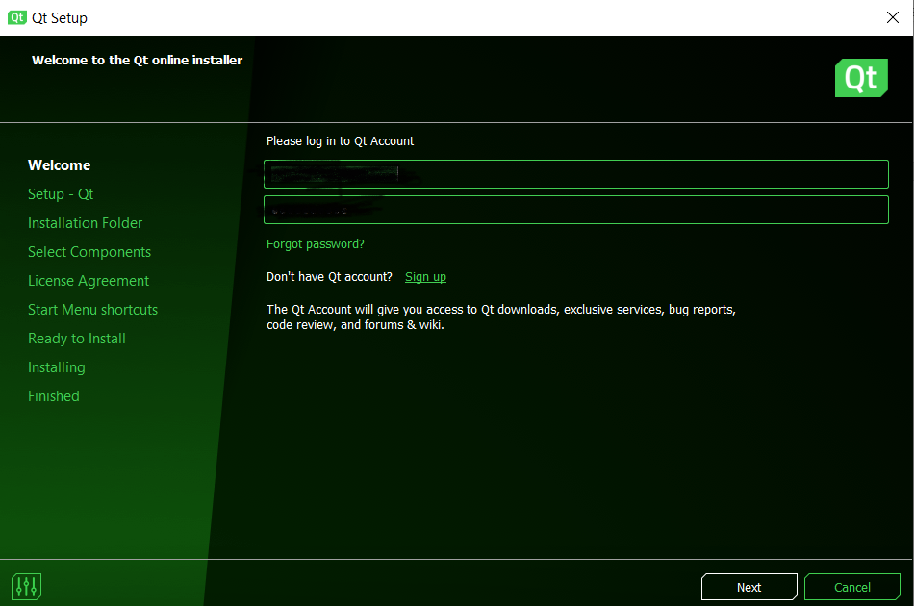

1. Select your installation path. I recommend going with the Default 5.15 package.

Agree to their license agreement, install and you should have QT ready on your system!

