***Project Overview – Class Generator***

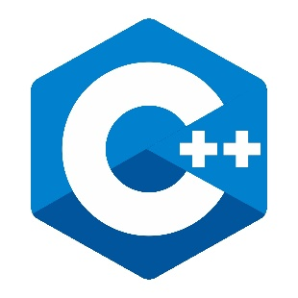

*A brief on Object-Oriented Programming*

**Object-Oriented Programming** consists of several important activities, which are compiled and attached together to create a software that has impeccable qualities, features, and functionality. It is these components of the software that decide its scalability, performance, reliability, security, and more, as well as ensures that the software or application is developed as per the requirements of the client.

*Project Inspiration*

The point of this project is to facilitate our coding process. As classes are ubiquitously used throughout the lab, an application that conveniently generates them for the user can be very beneficial and timesaving.

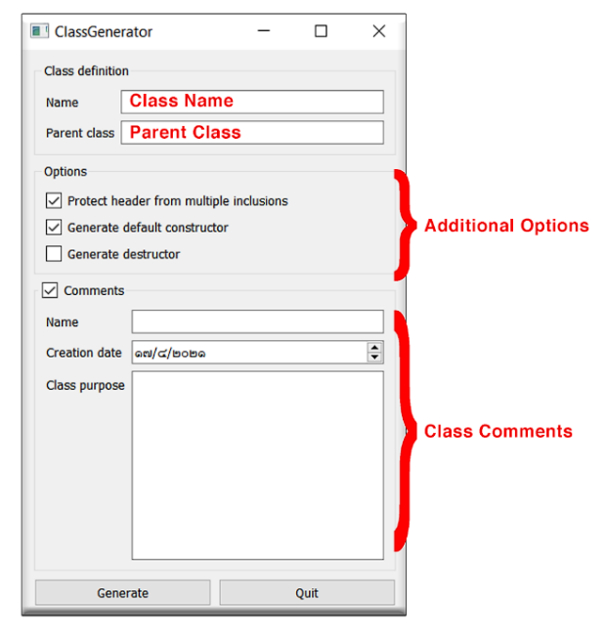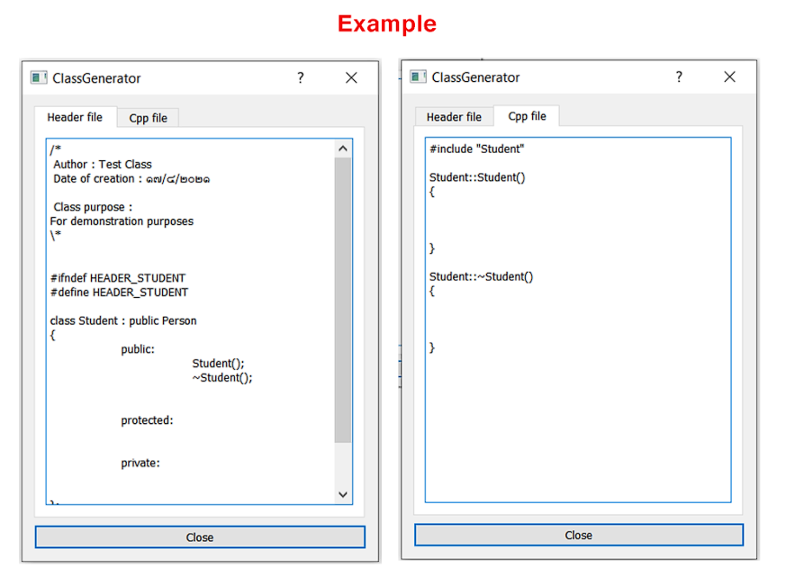This application itself is very intuitive and straightforward. On startup, there are several boxes prompting input; These inputs are then generated into a class.

