



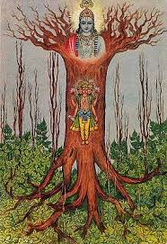

(The picture of an Ashvattha Tree)

1.1. Traditional Knowledge System (TKS) 2

1.2. Knowledge Representation 2

1.3. Knowledge Management 3

1.4. Knowledge Meta Model 3

1.5. Digital Library 3

1.6. Road Map 3

### Traditional Knowledge System (TKS)

India's Traditional Knowledge Systems are considered to have transcendental, noble goals. They are sophisticated and pedagogically well-formed. They take all possible knowledge in their grasp and represent them visually as an inverted tree.

There is a Detailed and sophisticated Ontology in the Vedas. The Tree is hierarchical and has parent and child braches. For example, The Vedas are children of the औं sound, considered the primordial origin of everything. The Vedas are 4 in number (Rk, Yajur, Sāma and AtharvaNa).

Then there are the 6 Vedangas, 108 Upanishads, Samhitas, Brahmanas etc.

The Vedangas are Shiksha (phonetics), Kalpa (etymology), VyakaraNa (grammar), Nirukta (syntax analysis), Chandas (metre), and Jyotisha (astrology/astronomy).

There are the Upanishads (10 Major and 98 minor) , the

six Darshanas (Sankhya, Yoga, Vaisheshika, 2 Mimamsas, Vedanta).

There are Samhitas like Charaka Samhita and Sushrutha Samhita, and BrahmaNas like Shatapatha BrahmaNa.

There are systems which teach the 14 Vidyas and 64 Kalas.

### Knowledge Representation

This knowledge can be represented in many ways. It is pedagogically important to know what connects to what, how one can study these branches of knowledge, and why the subjects are connected in particular ways.

Are the 4 Vedas (Rk, Yajur, Sāma and AtharvaNa) to be represented under the "Veda" node in a parent-child relationship ? Are the Vedangas to be considered parts of the whole ? Where are the Darshānas to be placed ?

We propose to build the representation as an Inverted Tree. The tree will have nodes and links. The nodes will be subjects listed above, and the links will be the relation between the subjects. These relations will be labeled in a systematic manner. The subjects will be described by means of certain attributes.

There are many variations of the Knowledge Tree possible. Our purpose is to facilitate pedagogical programs, knowledge navigation and mapping of concepts from one subject to another for research, education, learning and content development.

Knowledge is considered as a triangle with the corners denoting PramaNa (Known Object) , Pramata (Knower of Object) and PramEya (Knowledge). This applies to any subject of study.

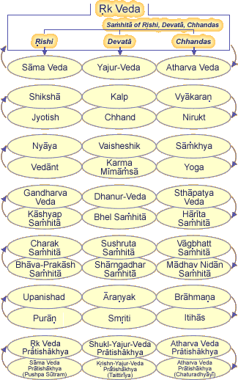

An example is the part of the Vedic tree according to Shree Mahesh Yogi, as depicted above. (This is a static, drawn picture from their website).

### Knowledge Management

Using the tree representation structure, we can build connections at various nodes of the tree. The subjects themselves can be populated with content, images, graphics, readings, commentaries, quizzes and so on. The technical manner of using hyperlinks is widely prevalent. Everything could be just a set of web pages on a site. But the reason for the placement of these links in some place, the labeling of the links and so on are not canonically validated by competent authorities. These are arbitrary and depend on the content developers and web site designers. The content should be consciously structured as a gigantic tree. The nodes and links of this tree should undergo formal development, review and publishing. Further, content development should be divided among competent scholars, editors and reviewers. There has to be a system of work allocation and follow up. We plan to build a database backend with Structured Knowledge Management Processes that can be designed to manage the entire effort and provide metrics, dashboards, roles, permissions and best practices.

Content is available in various works like Shri Madvacharya's ब्रह्मसूत्रभाष्यम् (Brahmasutra Bhashya), भगवद्गीताभाष्यम् (Bhagavadgītābhashyam), अनुव्याख्यानम् (Anu Vyakhyana) and so on. These works address a variety of subjects. The relation between subjects and works is thus a "many-to-many" relationship. Further, a work has authorship. Authors and Works are also in a many-to-many These entities have to be modeled properly in our database . Then the Tree will aid a learner, researcher or reviewer in navigating well, in a standard manner. Collaborations among the various people building content, using content and doing quality control over the content will be well-administered.

### Knowledge Meta Model

Such a meta-structure enables the tree to be adapted to any school of Indian Philosophy - The Vedas, the Nastika systems, opponents of the Vedas, Bauddha, Jaina and so on. "Sub trees" can be derived out of existing trees. One can start at a particular node and move "above" to ancestors or "below" to descendants.

A subject content may have topics, chapters, paragraphs, sentences etc. These texts can be parsed to find connecting concepts in other parts of the tree, neighborhoods, word clusters etc. Thus they can be tagged and marked with attributes. New connections can be discovered and thus inter-disciplinary work facilitated. By creating word-to-concept maps, one can discover new paths of navigation. Again, a Thesaurus approach (like Amarakosha with its Dhātu system) to analyzing sentences, word divisions, unions etc can be envisaged. Paninian VyakaraNa rules can be embedded into these analysis and parsing tools.

### Digital Library

The Knowledge Tree will have a Digital Library component. This component will be like a physical library online. Works will be catalogued, itemized and searchable by various "filters" like type of work, keywords, authors, institutional source of work, geographical origin, school of philosophy etc. The library will have work-flows for scholarly content development, review and publication. Indian languages and scripts will be supported and search-enabled. Scholarly work can be translations, summaries, commentaries and reviews. All such activities will be collaboratively managed and maintained. Work allocation and supervision are facilitated. Work-flow processes are a core feature of this system.

### Road Map

The System will be built in phases. In phase 1, a basic Tree Structure with collapsible and expandable nodes will be built. The connections will be labelled links, and the labels will be standardized. The tree will be populated by manual data entry. In phase 1, the interface will be a non-graphical database version for web browsers

In phase 2, a graphical interactive tree version will be built, similar to mind maps, but supported by a relational or graph database backend. This backend will store millions of nodes and links, and scale to service tens of thousands of users.

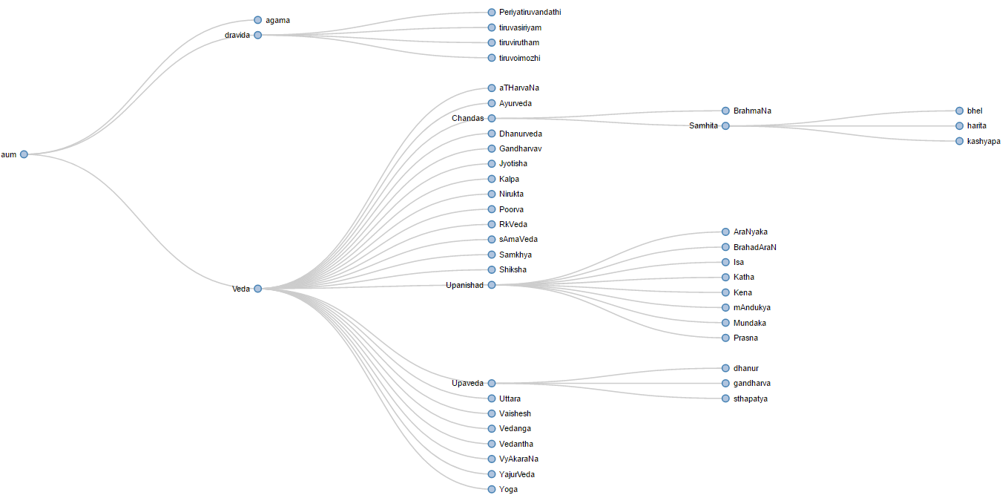

The idea is to develop [a dynamic, interactive tree](knowledgeTree.avi) that can be respond to user actions. One can add nodes, edit their properties and remove nodes. Clicking on a subject to enable display of details as a text, audio or video description.

In phase 3, mining of content from existing open digital libraries on the web via web-crawling and web-scraping tools will be developed. Also possible will be extraction from PDF files. This phase is actually more skill-demanding than it appears. It requires text analysis and relevance measurement, filtering of required vs. extraneous content and fitting of content according to the structure of the Knowledge Tree.