Mini Project Report
SRM INSTITUTE OF SCIENCE AND TECHNOLOGY
College of Engineering and Technology
Department of Electronics and Communication Engineering
21ECC211L / Devices and Digital IC Lab
III Semester, 2026- 27 (Odd Semester)

Subject code & Title : 21ECC211L / Devices and Digital IC Lab

Year & Semester : II Year / III Semester (2026–27, Odd Semester)

Project Title : Class D Audio Amplifier

Lab In-charge : Dr. Lakshmi Thara / Dr. Haroon Haider

Team Members Registration No & Name: 1. Narashimmaa R K [RA2511004010597]
2. Anesh [RA2511004010598]
3. S Sujan [RA2511004010599]

Reg. No & Name | Narashimmaa R K  [RA2511004010597] | Anesh  [RA2511004010598] | S Sujan  [RA2511004010599]
Mark split up | Narashimmaa R K  [RA2511004010597] | Anesh  [RA2511004010598] | S Sujan  [RA2511004010599]
Novelty of the project
(10 marks)
Level of understanding of the Project (5 marks)
Contribution of the Project Work (5 Marks)
Project Report
(10 Mark)
Total ( 30 Marks)

REPORT VERIFICATION

Date: Signature of Lab In- charge

Mini Project Title | CLASS D AUDIO AMPLIFIER USING PWM AND A MOSFET HALF-BRIDGE

OBJECTIVE
The objective of this mini project is to design and build a Class D audio amplifier that plays music from a phone through a 4 Ω speaker, using only analog ICs and discrete components and no microcontroller. We also wanted to understand how a PWM modulator, a MOSFET half-bridge and an LC filter work together, and to check each stage by calculation and simulation and then test it on the breadboard.
ABSTRACT
A Class D amplifier uses its output transistors as switches instead of linear amplifiers, which is why very little power is lost as heat. In this project the audio from a phone is mixed, set by a volume pot and boosted by a TL074 preamplifier. A comparator (KA393, equivalent to LM393) compares it with a 55 kHz triangle wave made by two more TL074 sections, which gives a PWM signal. An IR2104 gate driver with a bootstrap circuit switches two IRLZ44N MOSFETs from a 12 V adapter, and a 47 µH and 1 µF filter returns the audio to a 4 Ω speaker. The report gives the complete circuit, the design equations, simulated waveforms, the filter response and a stage-by-stage test table.
INTRODUCTION
Audio amplifiers are grouped into classes by the way their output transistors conduct. In Class A the transistor conducts all the time, in Class B two transistors share the wave and each conducts for half of it, and Class AB overlaps the two to remove crossover distortion. In all of them the transistors work in their linear region, so they carry current while they also have voltage across them. That product turns into heat, which is why linear amplifiers need large heatsinks and waste much of the power at low volume [1], [2].
A Class D amplifier avoids this by using the output transistors only as switches, fully on or fully off. The audio is first converted into pulse width modulation (PWM), where the width of each pulse follows the instantaneous audio level. These pulses switch a half-bridge of two MOSFETs, and an LC low-pass filter removes the fast switching component so that only the audio reaches the speaker [3], [4]. A switch that is on has almost no voltage across it and one that is off carries no current, so the efficiency can be far higher than in linear amplifiers. The letter D simply follows C in the alphabet; it does not stand for digital.
Commercial Class D amplifiers are usually single chips and many use digital modulators. Our lab rule asks for a purely analog circuit, so the modulator here is made from op-amps and a comparator, and the high-side MOSFET is driven through a bootstrap circuit [6]. This keeps every stage visible, so that each one can be calculated, simulated and measured separately on a breadboard.
HARDWARE REQUIREMENT/DESCRIPTION
The components are listed in Table 1 with the reference designators used on the circuit diagram.
Table 1. Components used
Ref. | Component | Value / part | Qty
J1 | DC adapter with barrel jack | 12 V, 1 A | 1
D1 | Schottky diode (reverse protection) | 1N5819 | 1
C1 | Electrolytic capacitor | 470 µF, 25 V | 1
R1–R6, R8, R9 | Resistors | 10 kΩ, ¼ W | 8
R7 | Resistor | 22 kΩ, ¼ W | 1
R10, R11 | Resistors (gate) | 10 Ω, ¼ W | 2
VR1 | Potentiometer, log (audio taper) | 10 kΩ | 1
VR2 | Trimmer | 100 kΩ | 1
C2 | Electrolytic capacitor | 10 µF, 25 V | 1
C3, C5 | Capacitors | 1 µF | 2
C4 | Film or NP0 capacitor | 1 nF | 1
C6 | Polyester film capacitor | 1 µF, 63 V | 1
C7 | Electrolytic capacitor | 1000 µF, 25 V | 1
C8–C11 | Ceramic capacitors (decoupling) | 0.1 µF | 4
U1 | Quad op-amp | TL074 | 1
U2 | Dual comparator | KA393 (LM393) | 1
U3 | Half-bridge gate driver | IR2104 | 1
D2 | Fast diode (bootstrap) | UF4007 | 1
Q1, Q2 | N-channel logic-level MOSFET | IRLZ44N | 2
L1 | Power inductor | 47 µH, 3 A | 1
J2 | 3.5 mm stereo jack with Type-C to 3.5 mm adapter | – | 1
LS1 | Speaker | 4 Ω, 5 W | 1
– | Breadboard and jumper wires | 830 points | 1 set

CIRCUIT DIAGRAM AND DESCRIPTION
Figure 1 shows the block diagram of the amplifier and Figure 2 shows the complete circuit diagram with every pin number, the supply connections and the decoupling capacitors. Nets with the same name (MID, TRI, AUDIO, PWM, SW, +12V and GND) are connected together. The signal flows from the phone through the preamplifier into the comparator, which turns it into PWM; the driver and the two MOSFETs then switch the supply, and the filter recovers the audio.
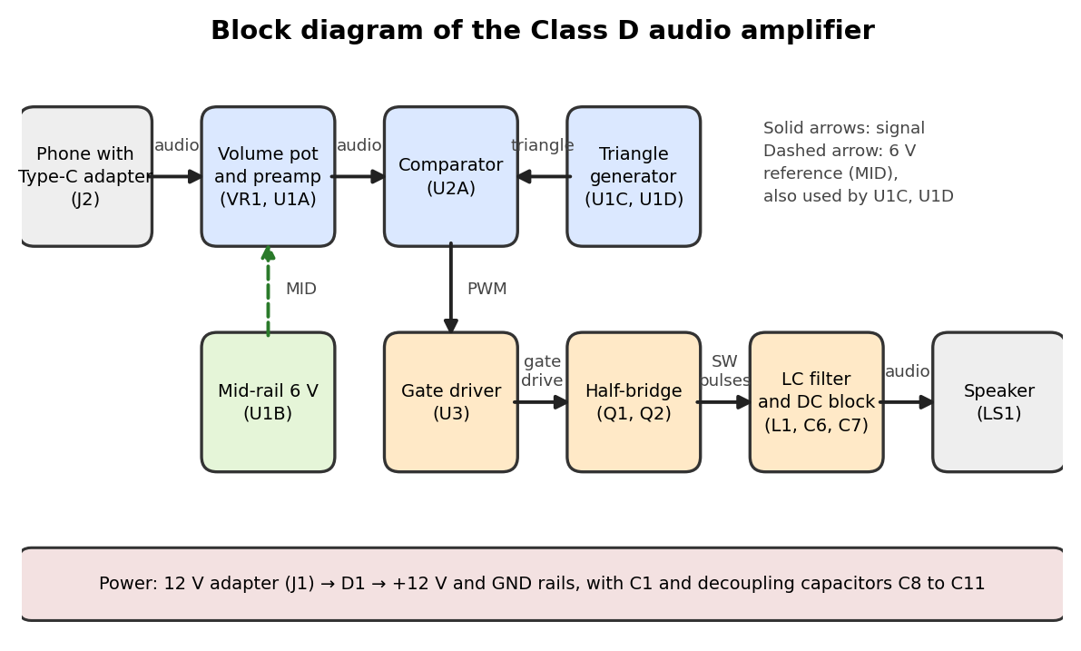
Figure 1. Block diagram of the Class D audio amplifier

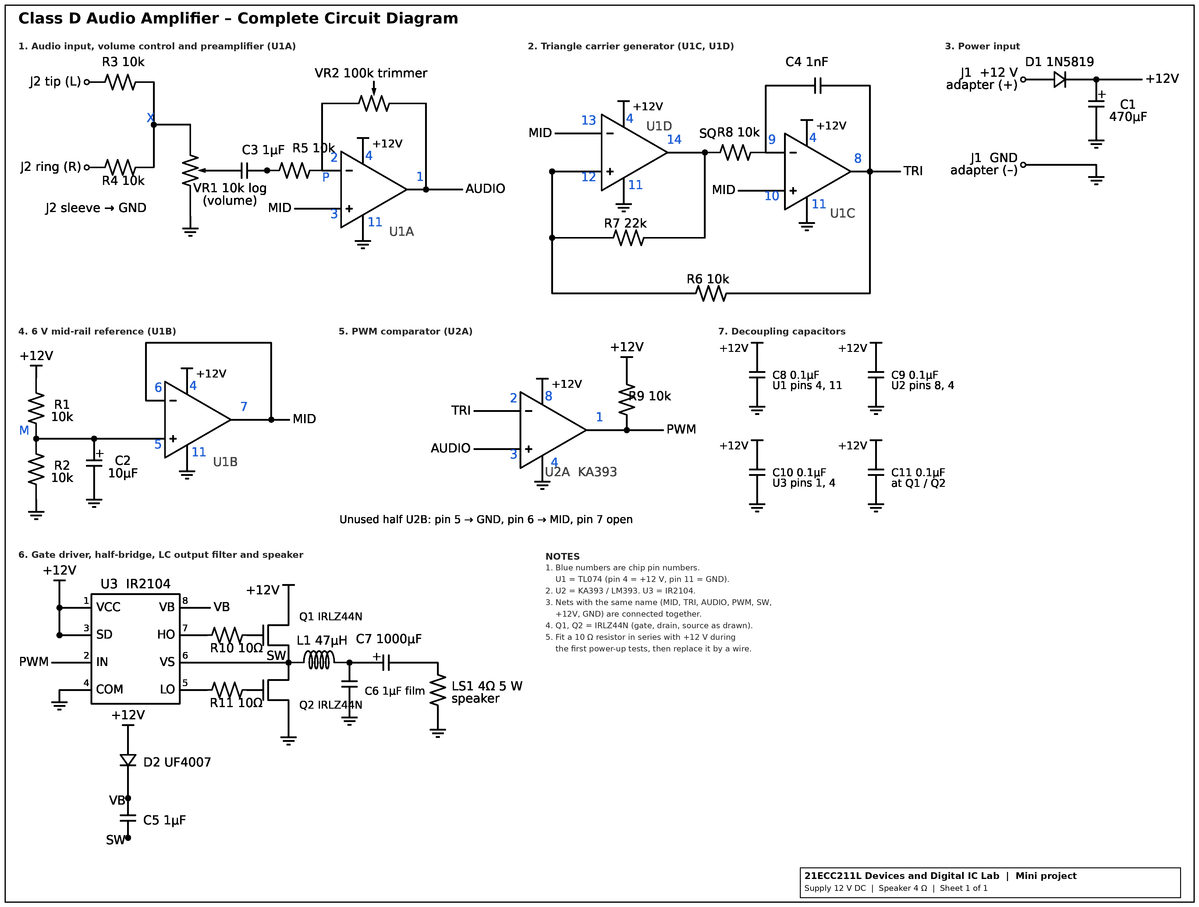
Figure 2. Complete circuit diagram of the Class D audio amplifier

Power supply. The 12 V adapter feeds the +12 V rail through D1, which protects the circuit if the adapter is connected the wrong way round. C1 supplies the short current pulses drawn when the MOSFETs switch, and the 0.1 µF capacitors C8 to C11 sit across the supply pins of each IC and across the MOSFET supply.
Mid-rail. The op-amps run from a single 12 V supply, so the audio is placed on a 6 V level called MID. R1 and R2 divide the supply, V_MID = 12 × R2/(R1 + R2) = 6 V, C2 filters it, and U1B (a voltage follower) buffers it so that it can feed several points without sagging.
Input and preamplifier. The left and right channels of J2 are added through R3 and R4 and go to the volume pot VR1. C3 passes the music and blocks DC (corner 1/(2π·R5·C3) ≈ 16 Hz). U1A is an inverting amplifier with gain −VR2/R5, adjustable from 0 to −10 with the trimmer. Its output AUDIO sits at 6 V when there is no sound.
Triangle generator. U1D is a Schmitt trigger (positive feedback through R7) and U1C is an integrator (R8 and C4). The trigger output SQ is a square wave, the integrator turns it into a straight ramp, and R6 feeds the ramp back so that the trigger flips each time the ramp reaches a threshold. The output TRI is a triangle wave with f = R7/(4·R6·R8·C4) = 55 kHz and a peak of about ΔV·R6/R7 ≈ 2 V, where ΔV ≈ 4.5 V is the TL074 output swing about MID [9].
Comparator. U2A compares AUDIO (+ input) with TRI (− input). Its output is high when the audio is above the triangle and low otherwise, so the duty cycle is D = ½ + v/(2·V_tri,pk). The output is open-collector, so R9 pulls it up to 12 V. The unused second half of the KA393 has its inputs tied to GND and MID [10].
Gate driver. The IR2104 (U3) turns the PWM into two gate signals: HO follows the input and LO is its inverse. It adds a dead time of about 0.5 µs so that Q1 and Q2 are never on together, and its SD pin is held high to keep it enabled [7]. Because Q1 is on the high side, its gate has to go above 12 V. D2 charges C5 from the supply while SW is low, and C5 then works as a floating supply between VB and VS (bootstrap) [6]. R10 and R11 limit the gate current and damp ringing.
Half-bridge and output filter. Q1 and Q2 (logic-level, 22 mΩ) connect the switch node SW to +12 V or to GND [8], so SW is a 0 to 12 V pulse train whose average follows the audio. L1 and C6 form a second-order low-pass filter [5] with f_c = 1/(2π√(L1·C6)) = 23.2 kHz and Q = R_L·√(C6/L1) = 0.58. C7 blocks the 6 V average at SW; with the 4 Ω speaker its corner is 1/(2π·R_L·C7) = 40 Hz.
Table 2. Design equations and values
Parameter | Equation | Value
Mid-rail | V_MID = 12·R2/(R1 + R2) | 6 V
Preamp gain | A = −VR2/R5 | 0 to −10
Input corner | f = 1/(2π·R5·C3) | 16 Hz
Carrier frequency | f = R7/(4·R6·R8·C4) | 55 kHz (SPICE 52.2 kHz)
Triangle peak | V = ΔV·R6/R7, ΔV ≈ 4.5 V | about 2.0 V (4.1 V p-p)
Duty cycle | D = ½ + v/(2·V_tri,pk) | 0 to 1 for |v| ≤ 2 V
Gain of the PWM stage | A = V_s/(2·V_tri,pk) | 2.9
Bootstrap capacitor, minimum [6] | C ≥ 2(2Q_g + I_QBS/f + Q_LS)/(V_CC − V_f − V_LS − V_min) | about 0.1 µF with assumed Q_g = 60 nC, I_QBS = 100 µA, Q_LS = 5 nC, V_min = 8.7 V; 1 µF used
Inductor ripple current | ΔI = V_s·D(1 − D)/(L1·f) | 1.2 A peak-to-peak at D = 0.5
Filter cut-off | f_c = 1/(2π√(L1·C6)) | 23.2 kHz
Filter Q | Q = R_L·√(C6/L1) | 0.58
Gain at 20 kHz and 55 kHz | |H(jω)| of the output network | −3.6 dB and −15.9 dB (SPICE)
DC-blocking corner | f = 1/(2π·R_L·C7) | 40 Hz
Maximum output power | P = V_p²/(2R_L), V_p ≤ 6 V | 4.5 W ideal (6 V peak)

RESULTS AND DISCUSSION
Figures 3 to 5 are results of circuit simulations in ngspice [11] on the circuit of Figure 2. The op-amp, comparator and gate-driver blocks are behavioural models (output swing 1.5 V to 10.5 V, dead time about 0.5 µs), the MOSFETs include their on-resistance and body diodes, and the bootstrap supply is treated as an ideal 11.3 V source. They show what the design should do and are not measurements. In Figure 3 the oscillator settles at 52.2 kHz, a little below the 55 kHz calculated because the op-amp delay is not zero, with a 4.2 V peak-to-peak triangle centred on 6 V, and the preamplifier gives a gain of 5 with the trimmer at 50 kΩ. Figure 4 shows SW switching between 0 V and 12 V; during the dead time both gates are low and the body diode carries the inductor current. The output network in Figure 5(a) is 0.2 dB down at 1 kHz, 3.6 dB down at 20 kHz and 15.9 dB down at the carrier, and Figure 5(b) shows that the carrier still sits about 9 dB below the 1 kHz tone because it is only 2.4 times the cut-off frequency. In the simulation the dead time also lowers the gain and adds distortion once the load current is larger than the inductor ripple current.
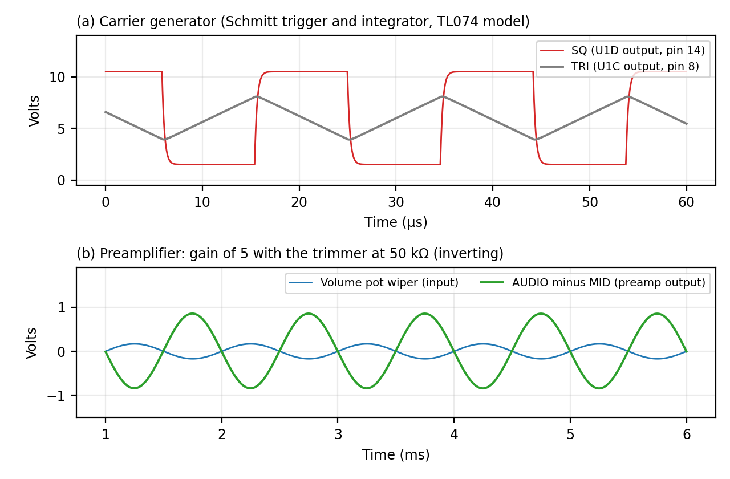
Figure 3. SPICE simulation of the modulator: (a) carrier generator, (b) preamplifier
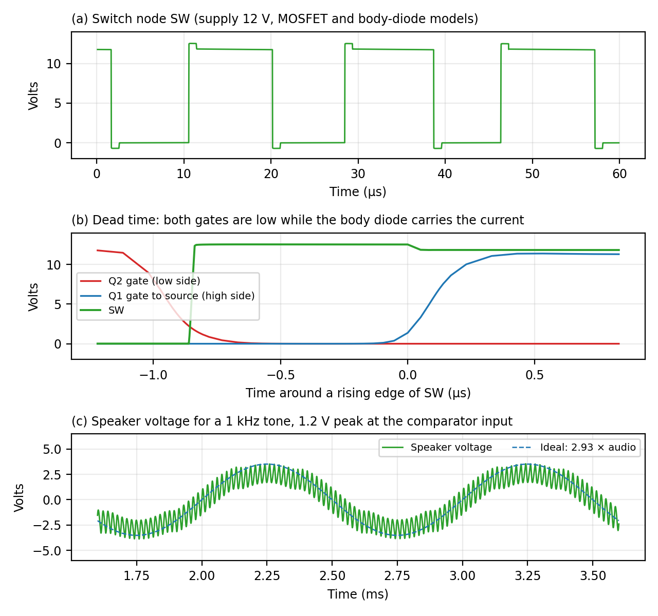
Figure 4. SPICE results for the power stage: (a) switch node, (b) dead time around one edge, (c) speaker voltage
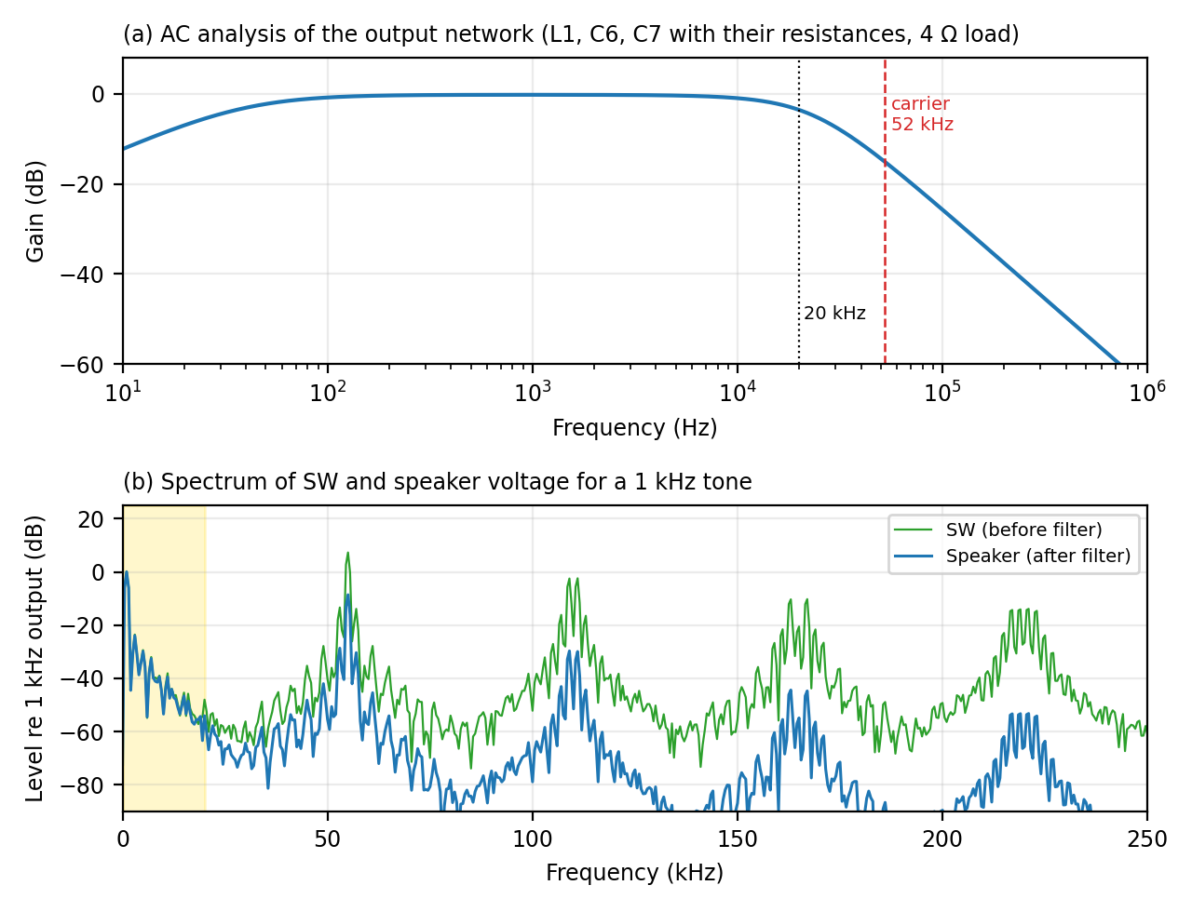
Figure 5. SPICE results for the output network: (a) frequency response, (b) spectrum for a 1 kHz tone
The circuit is tested stage by stage on the breadboard. Table 3 lists the expected value at each test point; the measured column is filled in from the multimeter and oscilloscope readings.
Table 3. Test points (expected and measured values)
No. | Test point | Expected | Measured
1 | +12 V rail after D1 | about 11.5 V (adapter minus diode drop)
2 | MID rail, U1 pin 7 | 6 V
3 | AUDIO, U1 pin 1, silent | 6 V
4 | TRI, U1 pin 8 | triangle, 4.2 V p-p, about 52 to 55 kHz, centred on 6 V
5 | SQ, U1 pin 14 | square wave, about 1.5 V to 10.5 V
6 | PWM, U2 pin 1 | 0 to 12 V pulses, about 50 % duty when silent
7 | U3 pin 5 (LO) and pin 7 (HO) | complementary gate pulses
8 | SW node | 0 to 12 V pulses, mean about 6 V
9 | Speaker terminal | audio only, DC about 0 V

The main limits of this design come from the choices made. A second-order filter with the carrier so close to the cut-off leaves visible ripple and costs 3.6 dB at 20 kHz, and a higher carrier frequency or a fourth-order filter would improve both. The dead time of about 0.5 µs is about 5 % of the carrier period and is the main source of distortion in the simulation; a faster driver, a lower carrier frequency or feedback from the output would reduce it. There is no feedback in this circuit, so ripple on the supply also reaches the speaker. The simulation leaves out wiring and speaker inductance and supply noise, so the real circuit will differ. Add the measured values from Table 3 and your oscilloscope photographs here after testing.
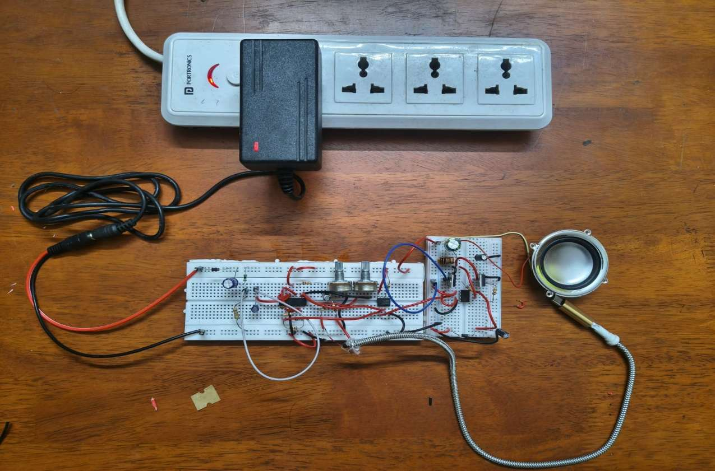
Figure 6. Breadboard model of the Class D audio amplifier
CONCLUSION
A Class D audio amplifier was designed around a triangle-wave modulator, an IR2104 driver, two logic-level MOSFETs and an LC filter, with no microcontroller. Calculation and SPICE simulation give a carrier of about 52 kHz and an output filter with a 23 kHz cut-off, and they show that dead time is the main source of distortion. The circuit was built in separate stages so that each one can be tested on the breadboard. Add one sentence with your measured result.
REFERENCES
- A. S. Sedra and K. C. Smith, Microelectronic Circuits, 7th ed. New York, NY, USA: Oxford University Press, 2015.
- P. Horowitz and W. Hill, The Art of Electronics, 3rd ed. Cambridge, U.K.: Cambridge University Press, 2015.
- Texas Instruments, “Design Considerations for Class-D Audio Power Amplifiers,” Application Report SLOA031, Aug. 1999.
- Texas Instruments, “Filter-Free Class-D Audio Amplifiers,” Application Report SLOA145, Feb. 2010.
- Texas Instruments, “LC Filter Design,” Application Report SLAA701.
- International Rectifier (now Infineon Technologies), “HV Floating MOS-Gate Driver ICs,” Application Note AN-978.
- International Rectifier (now Infineon Technologies), “IR2104(S) & (PbF) Half-Bridge Driver,” datasheet.
- International Rectifier (now Infineon Technologies), “IRLZ44N HEXFET Power MOSFET,” datasheet.
- Texas Instruments, “TL07x Low-Noise FET-Input Operational Amplifiers,” datasheet.
- Texas Instruments, “LM393 Dual Differential Comparator,” datasheet (the KA393 is a pin-compatible equivalent).
- ngspice, the open source SPICE circuit simulator, version 42, ngspice.sourceforge.io.

