SEATSENSE:
“An App-Based Solution for Live Seat Tracking and Booking on Campus”

By
Narashimmaa R K (RA2511004010597)
S Sujan (RA2511004010599)
Hariharan J (RA2511004010600)
Alban Josh (RA2511004010604)
E Sujeeth (RA2511004010641)

Under the guidance of

Dr. Praveen Kumar S
Assistant Professor, Department of ECE

In partial fulfilment for the Course

of

21DCS201P – DESIGN THINKING AND METHODOLOGY



DEPARTMENT OF ELECTRONICS AND COMMUNICATION ENGINEERING
SRM INSTITUTE OF SCIENCE AND TECHNOLOGY
COLLEGE OF ENGINEERING AND TECHNOLOGY
KATTANKULATHUR
NOVEMBER 2026

SRM INSTITUTE OF SCIENCE AND TECHNOLOGY

(Under Section 3 of UGC Act, 1956)

BONAFIDE CERTIFICATE

Certified that this activity report for the course 21DCS201P DESIGN THINKING AND METHODOLOGY is the Bonafide work of Narashimmaa R K (RA2511004010597), S Sujan (RA2511004010599), Hariharan J (RA2511004010600), Alban Josh (RA2511004010604) and E Sujeeth (RA2511004010641) who carried out the work under my supervision.

SIGNATURE SIGNATURE

Dr. Praveen Kumar S Academic Co- Ordinator
Assistant Professor
Department of ECE
SRMIST
Kattankulathur

TABLE OF CONTENTS

S. No | CONTENTS
1. | VISUALIZATION
2. | 30 CIRCLE CHALLENGE
3. | EMPATHY MAPPING
4. | BRAINSTORMING
5. | PROBLEM SIZING
6. | JOURNEY MAPPING
7. | CONVERGENCE AND DIVERGENCE
8. | BUSINESS MODEL CANVAS
9. | REVERSE PRESENTATION
10. | REFLECTIONS

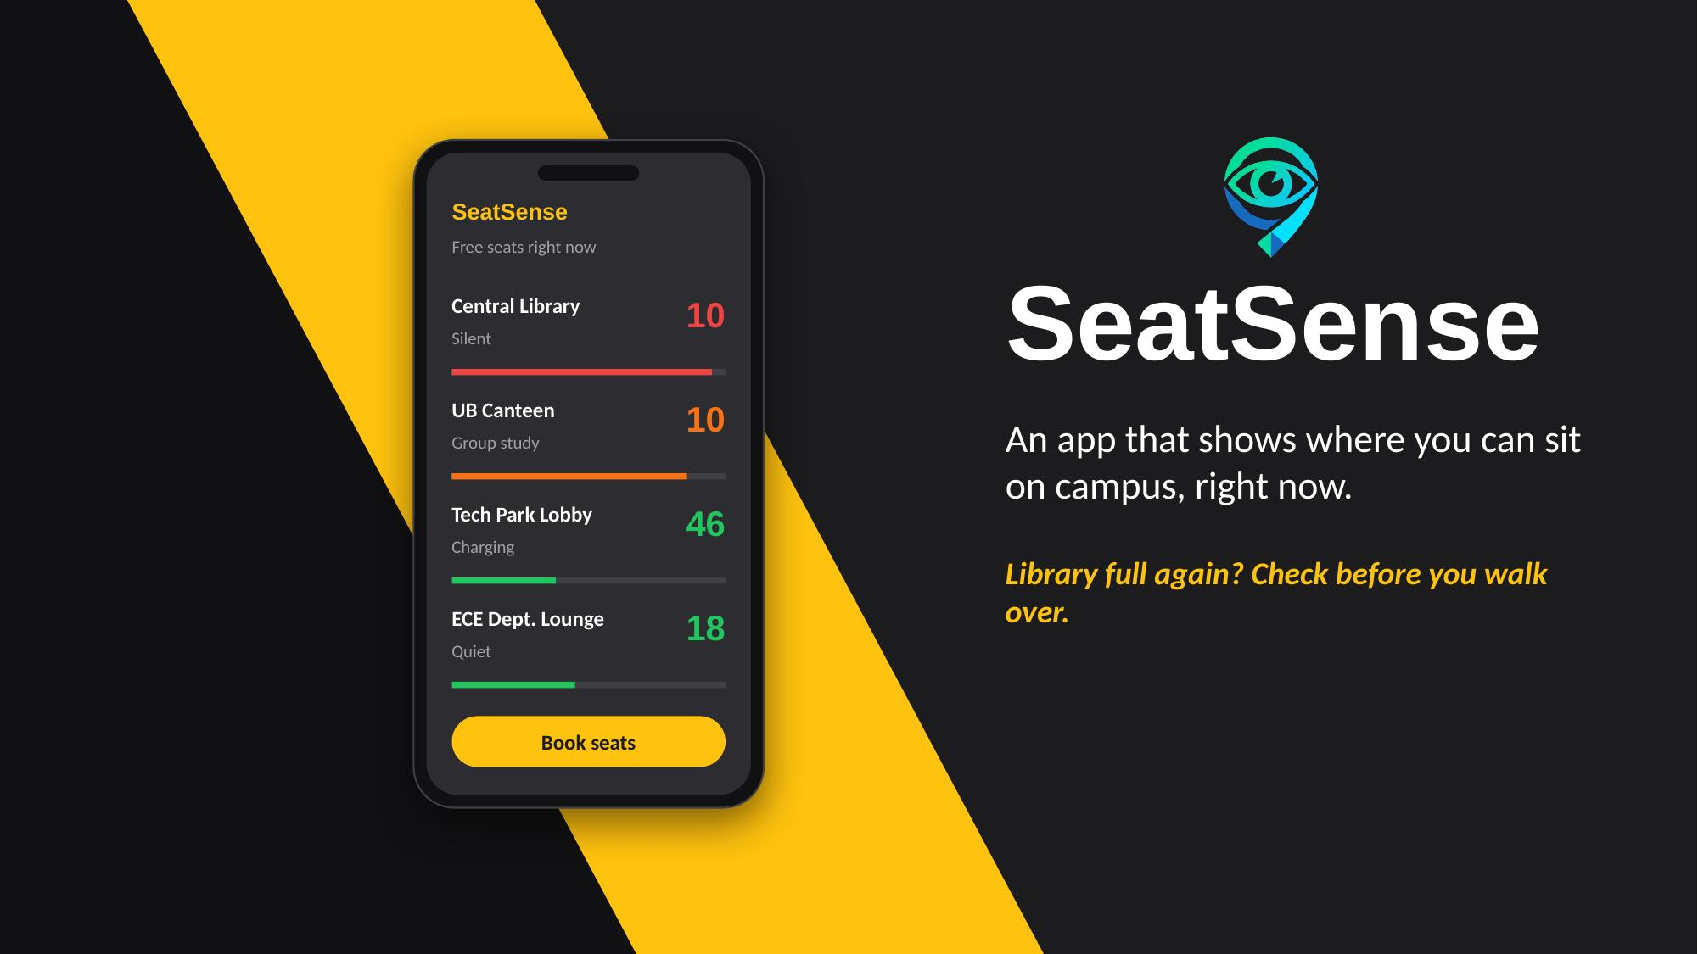  Slide 1 | 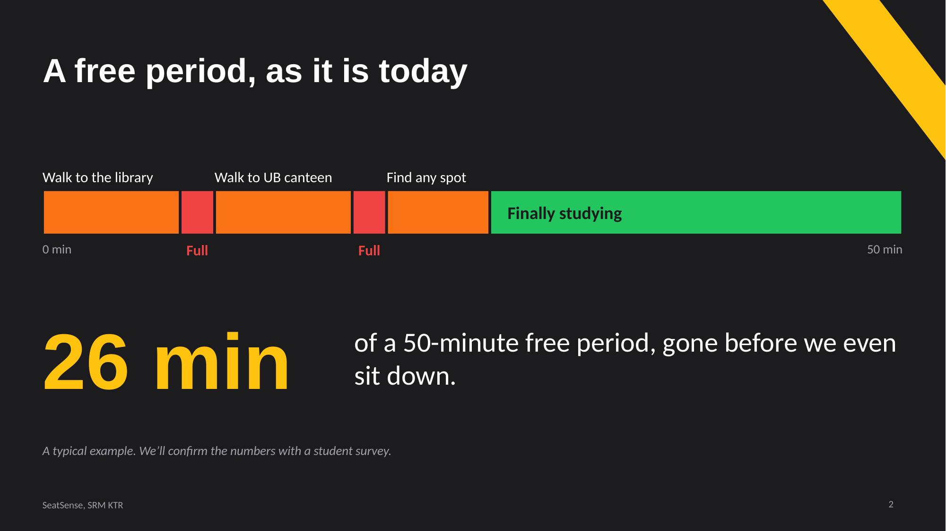  Slide 2
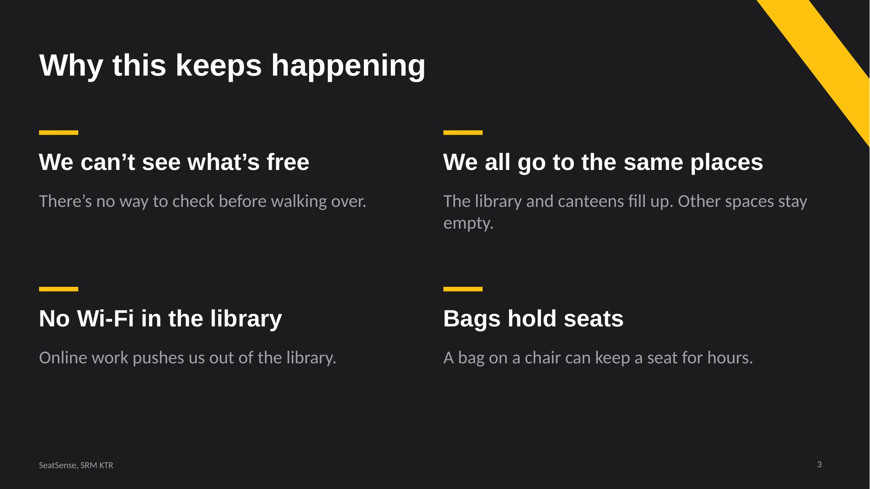  Slide 3 | 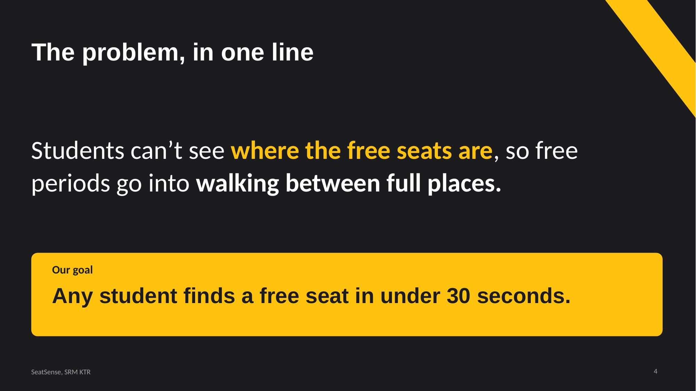  Slide 4

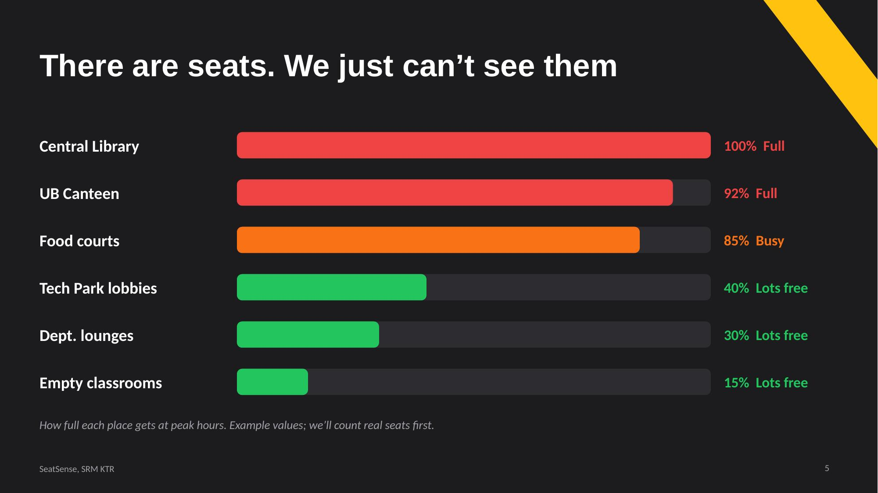  Slide 5 | 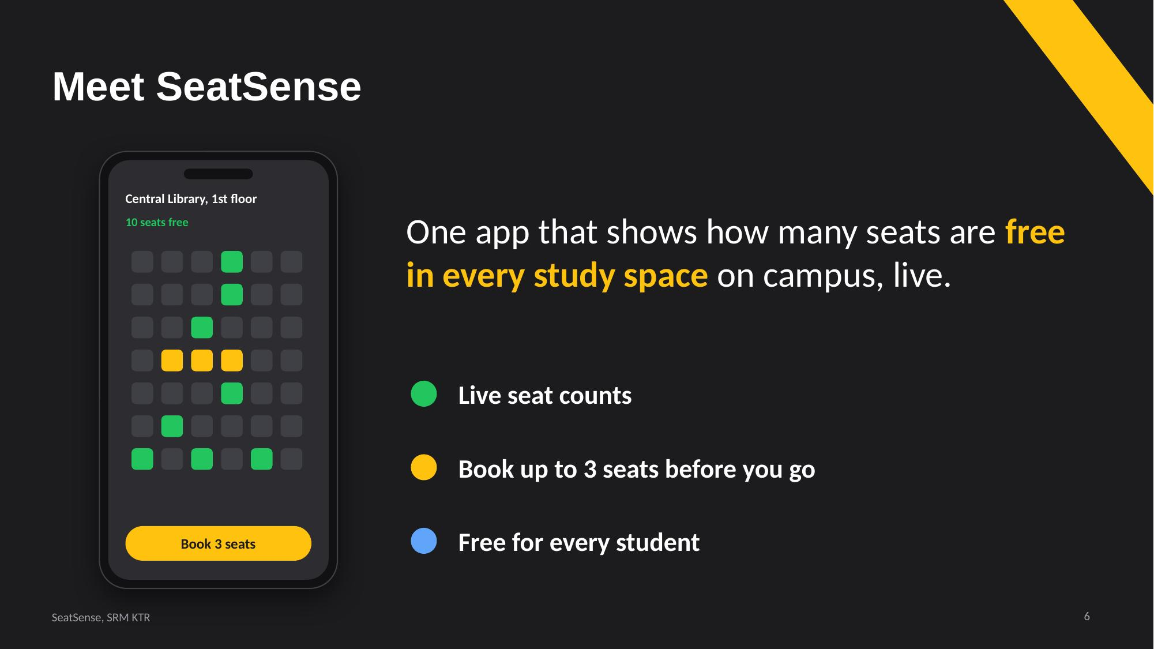  Slide 6
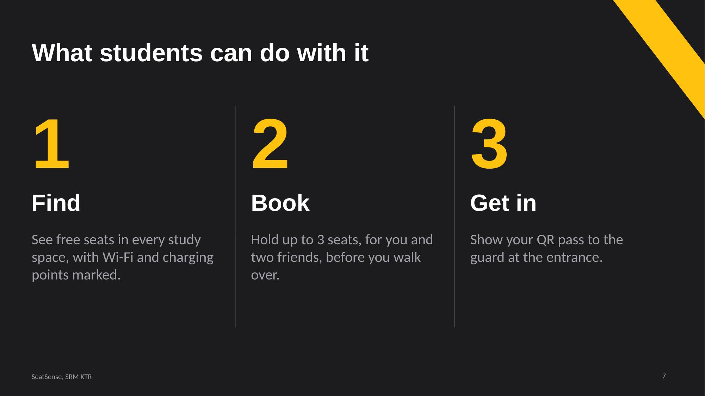  Slide 7 | 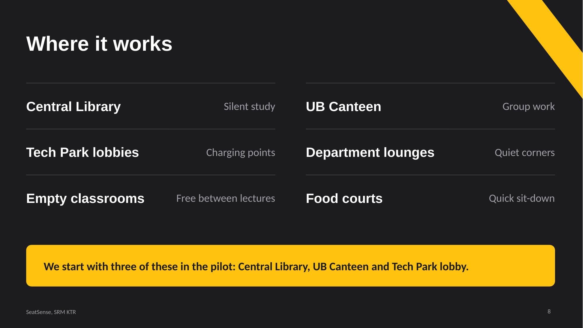  Slide 8

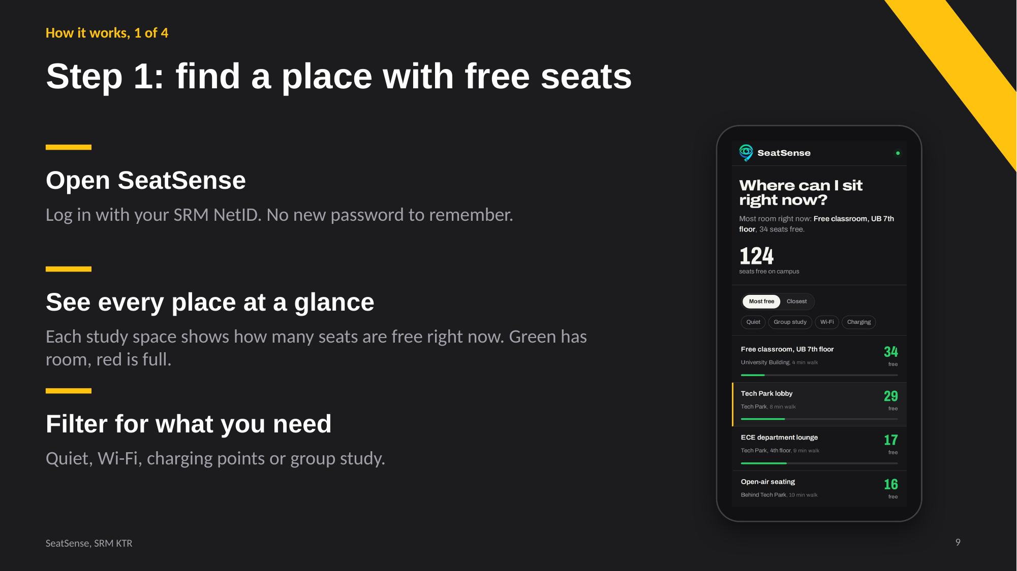  Slide 9 | 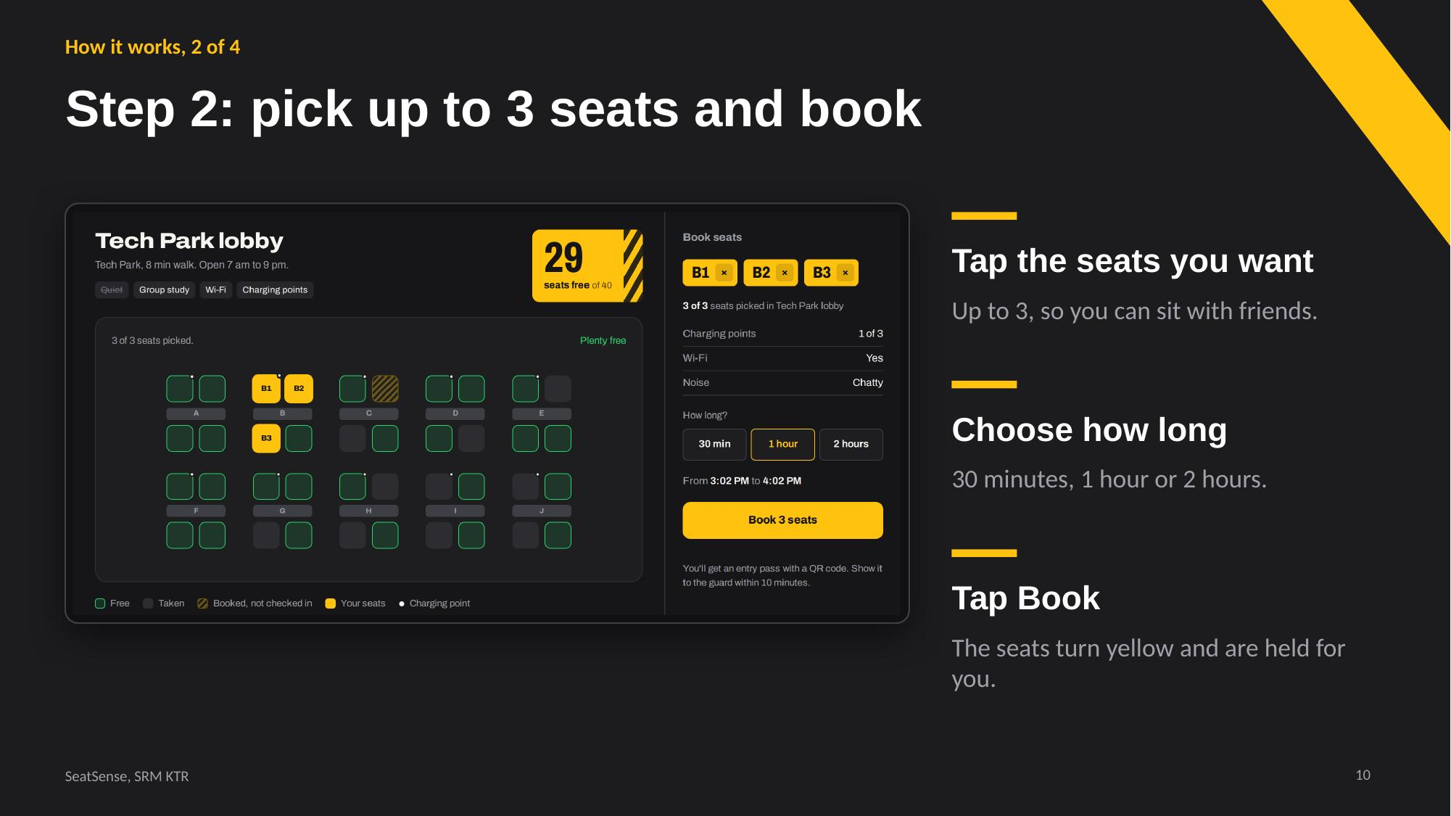  Slide 10
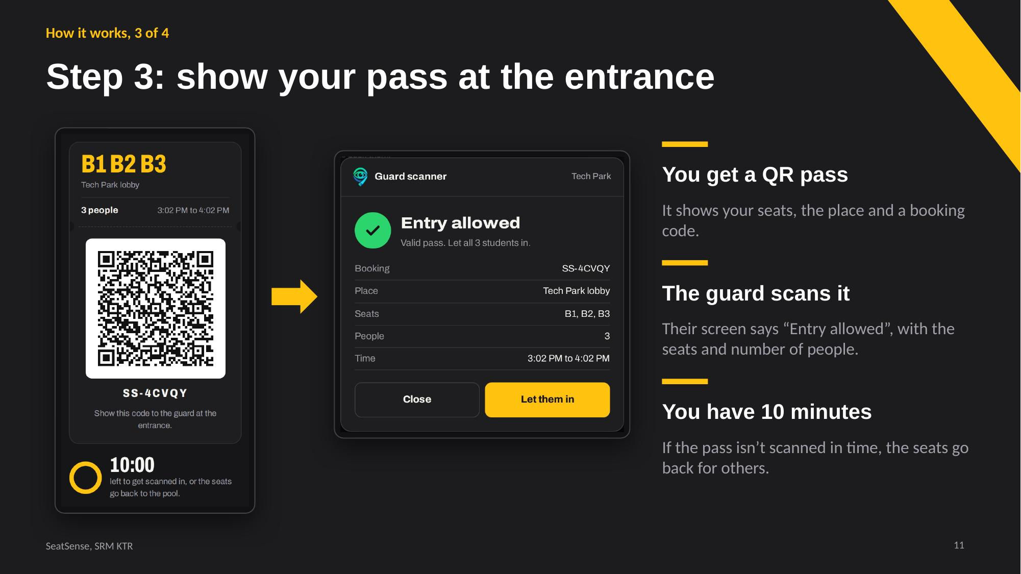  Slide 11 | 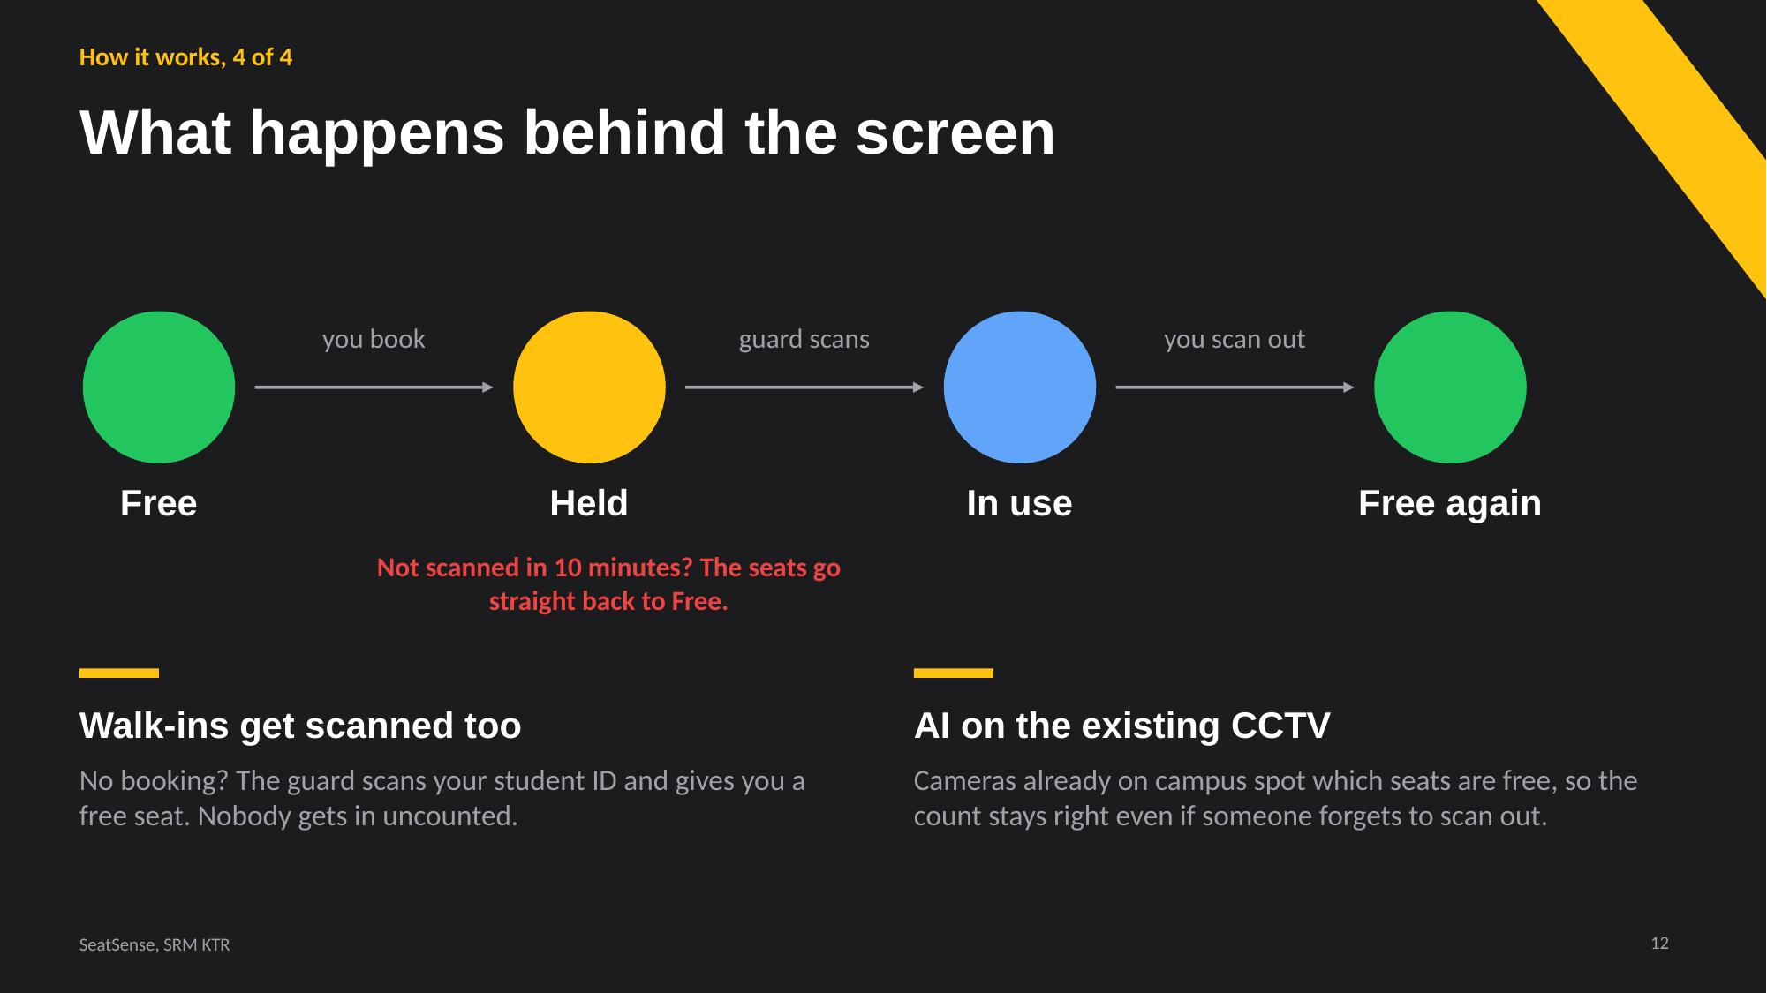  Slide 12

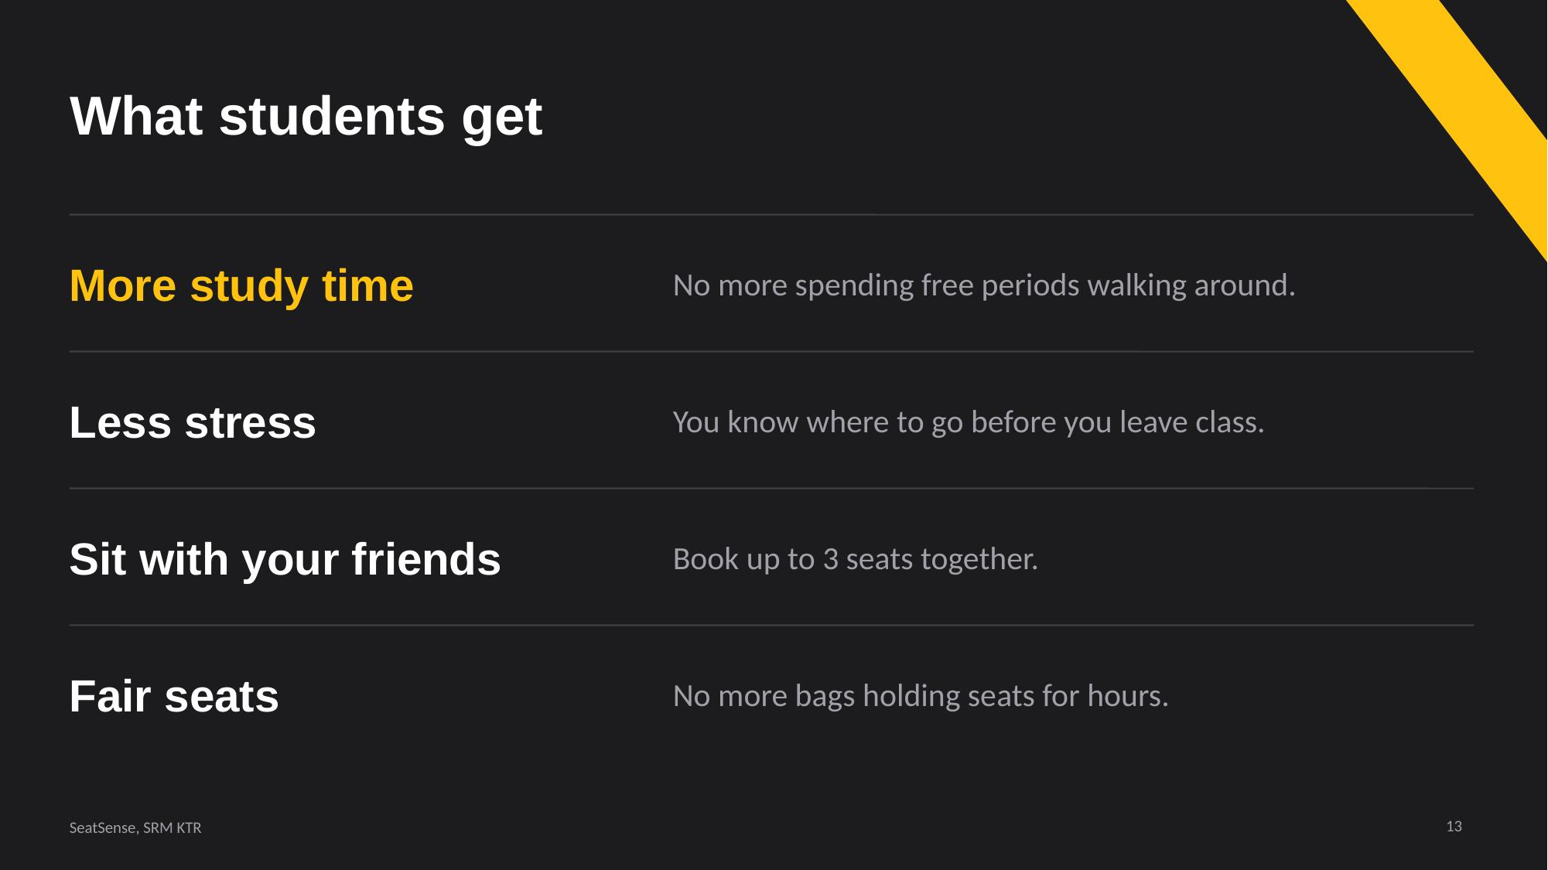  Slide 13 | 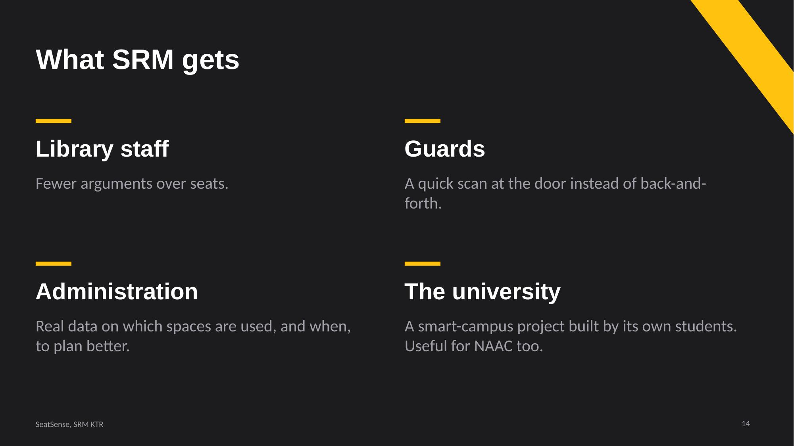  Slide 14
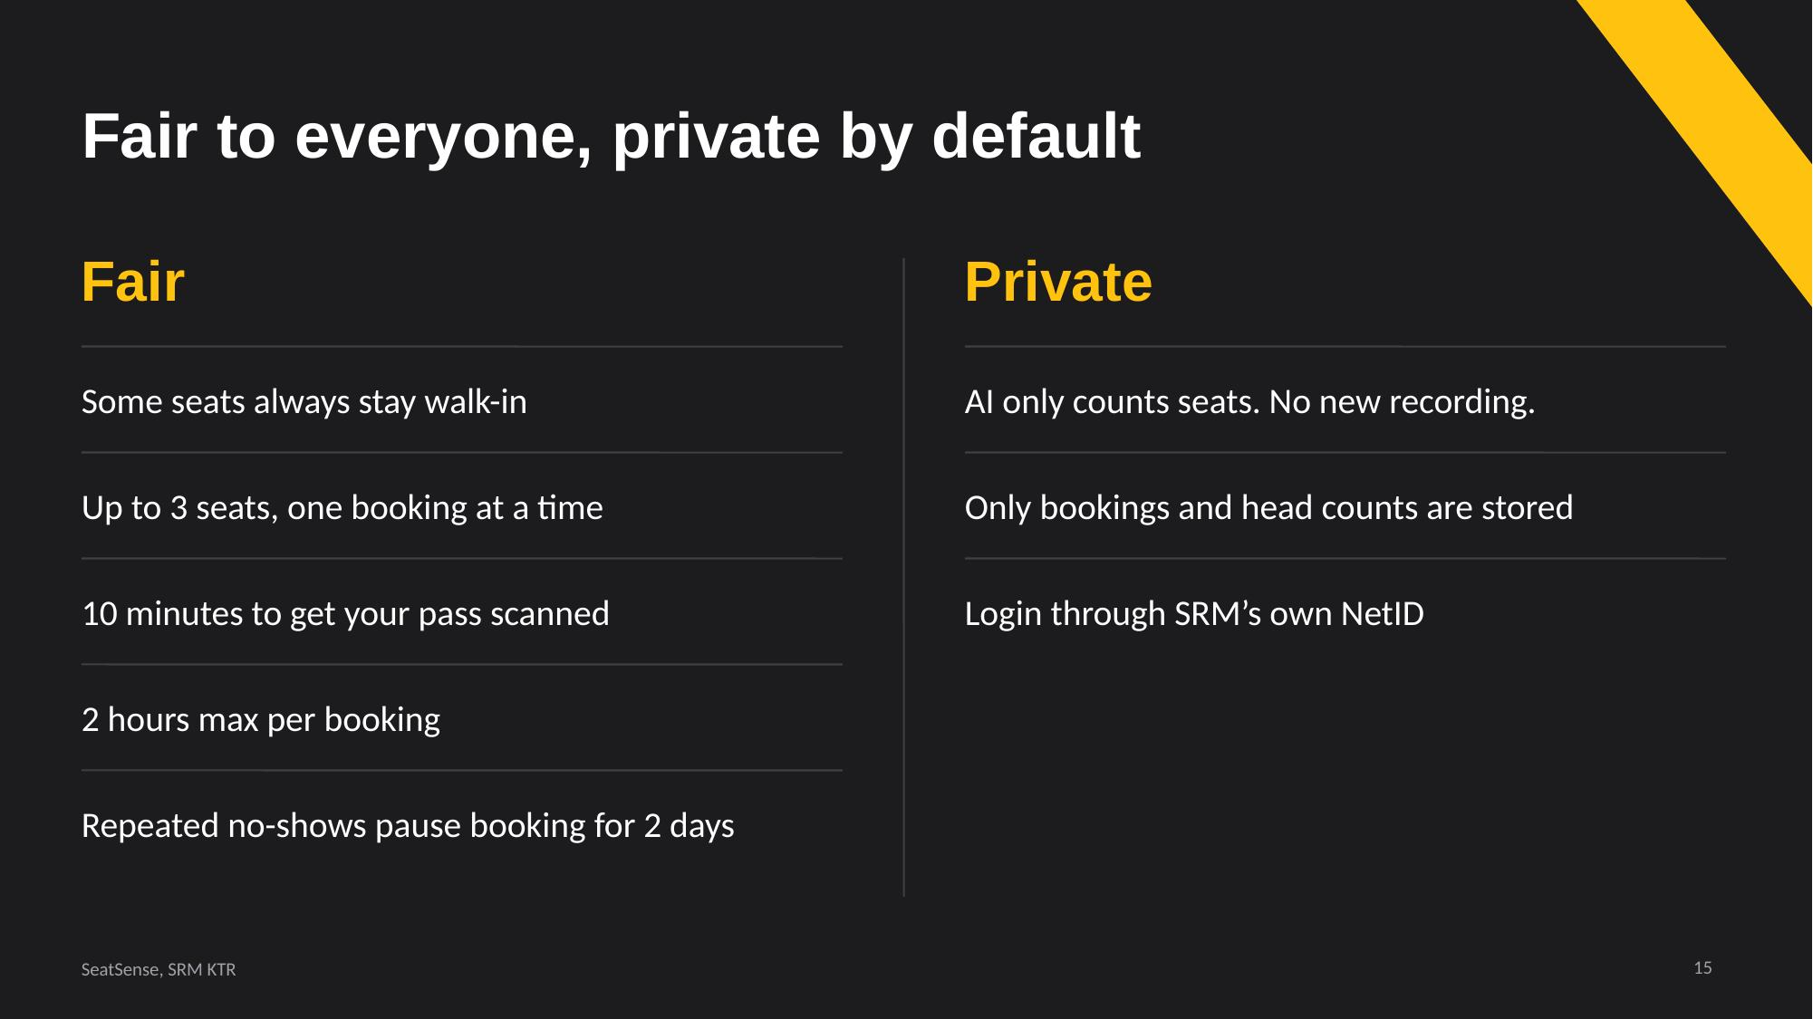  Slide 15 | 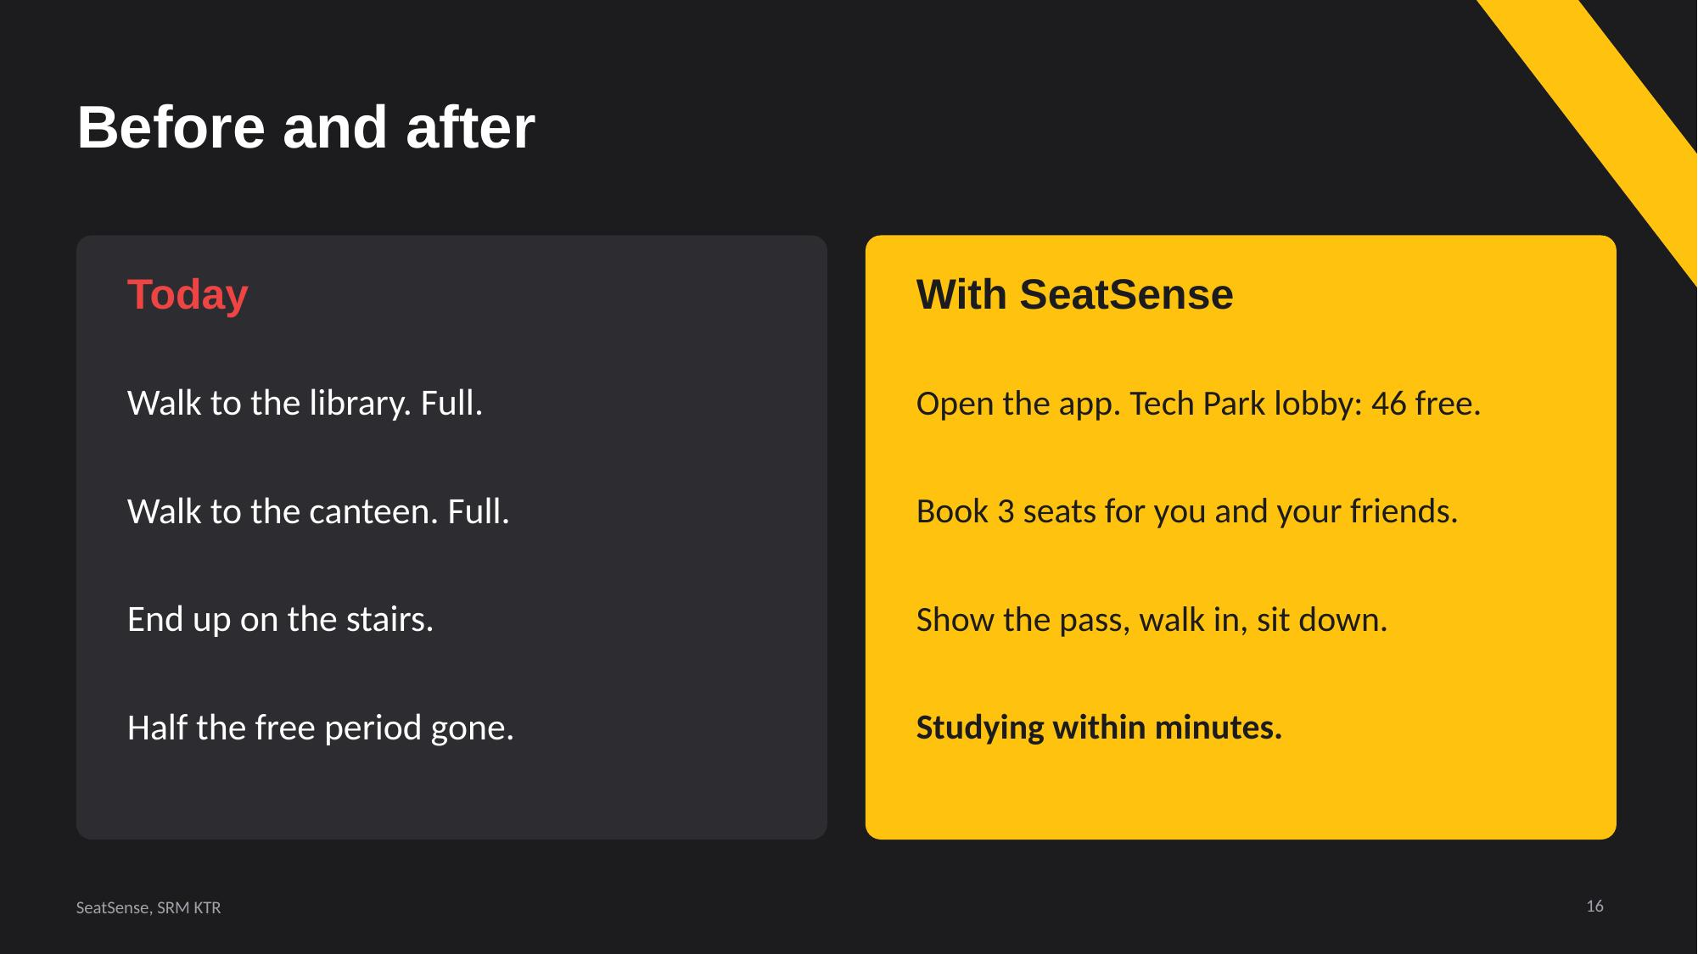  Slide 16

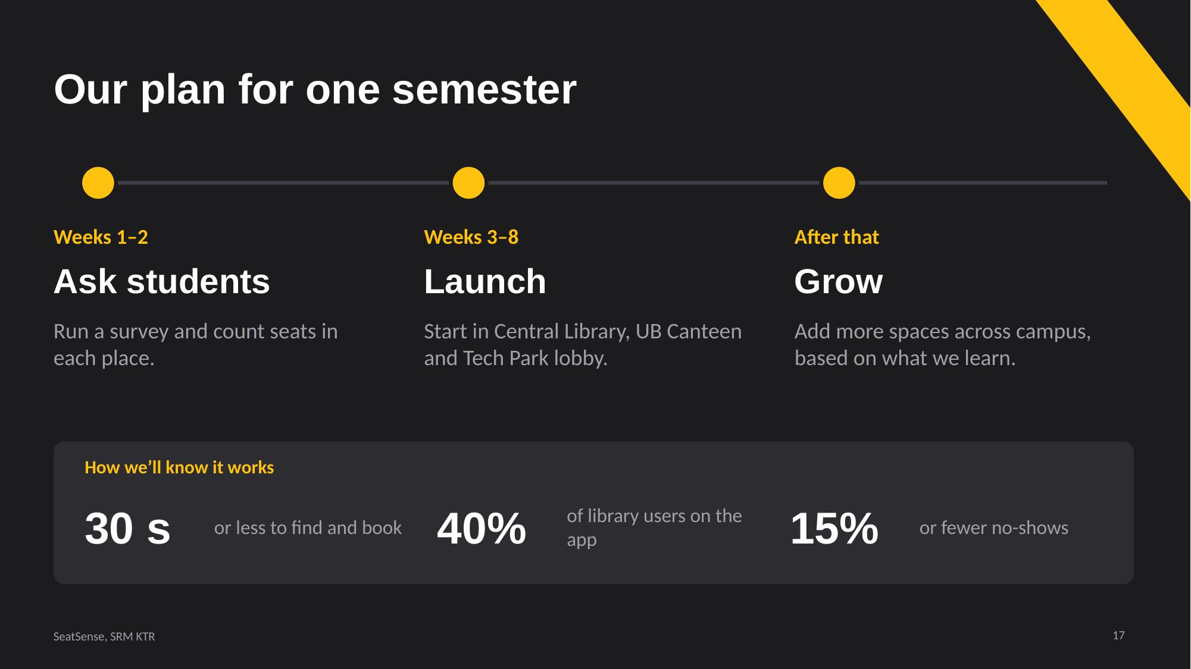  Slide 17 | 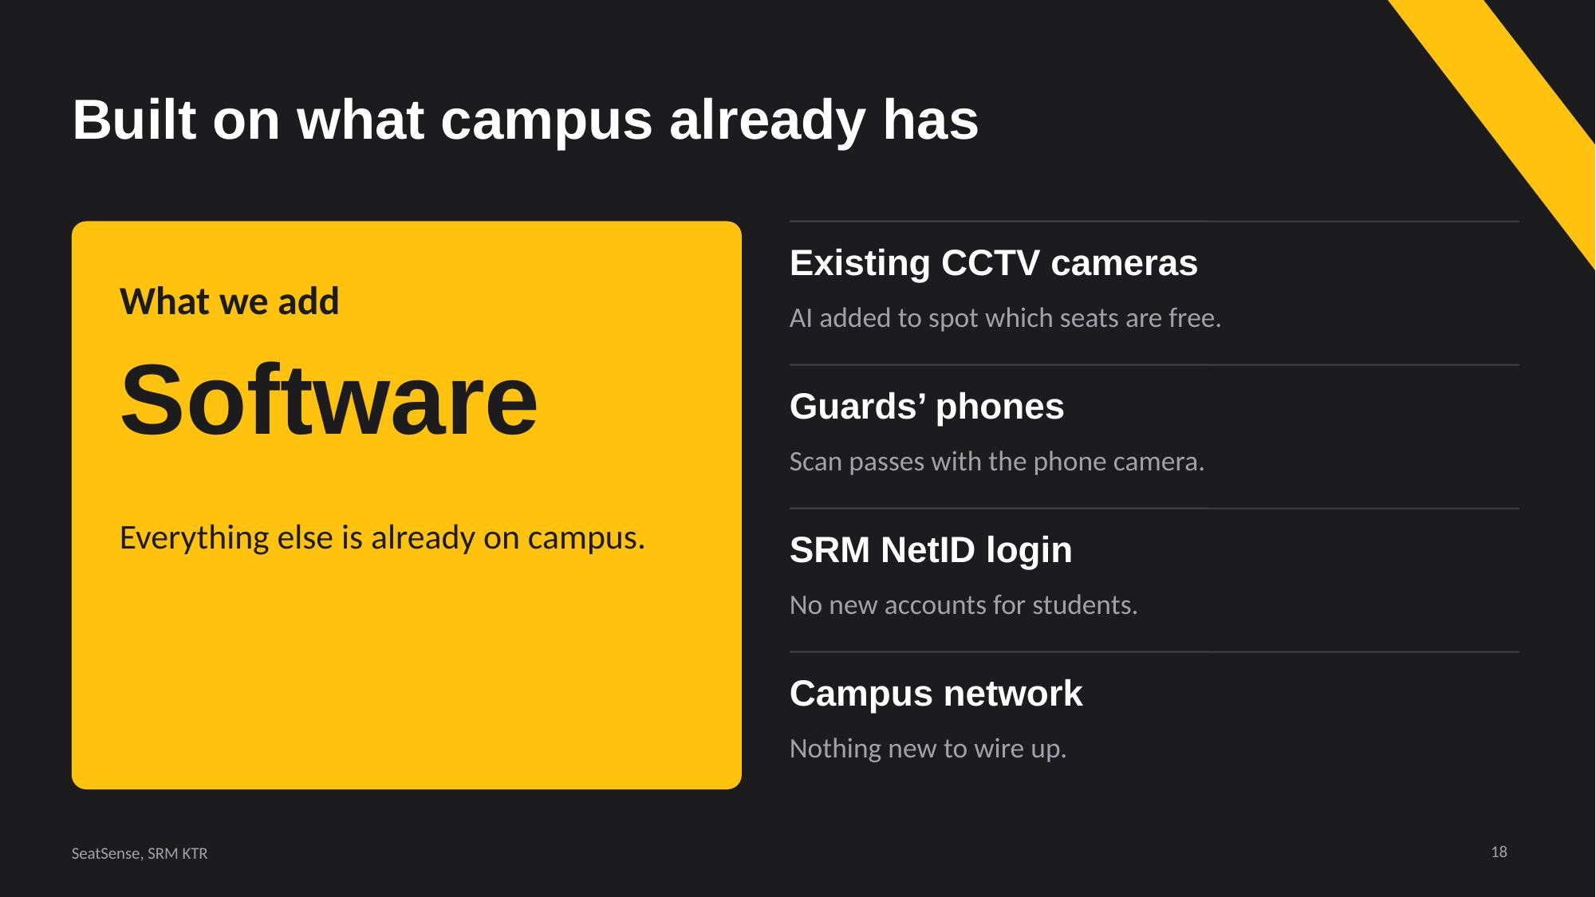  Slide 18
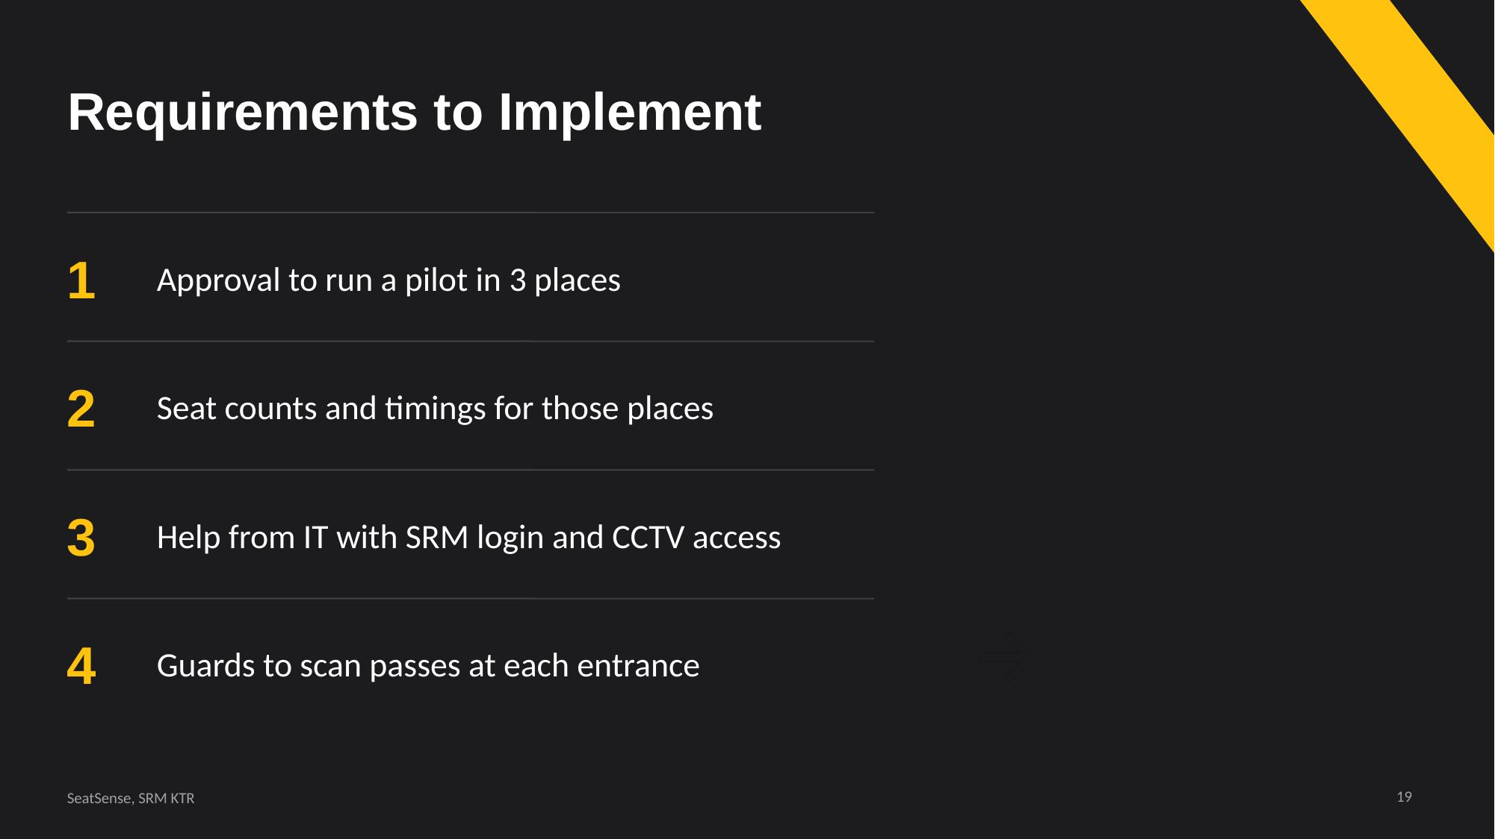  Slide 19 |   Slide 20

