**DETECTION OF DISTRIBUTED DENIAL OF SERVICE ATTACKS IN SDN USING MACHINE LEARNING TECHNIQUES**

**ABSTRACT:**

Software-defined network (SDN) is a network architecture that used to build, design the hardware components virtually. We can dynamically change the settings of network connections. In the traditional network, it's not possible to change dynamically, because it's a fixed connection. SDN is a good approach but still is vulnerable to DDoS attacks. The DDoS attack is menacing to the internet. To prevent the DDoS attack, the machine learning algorithm can be used. The DDoS attack is the multiple collaborated systems that are used to target the particular server at the same time. In SDN control layer is in the center that link with the application and infrastructure layer, where the devices in the infrastructure layer controlled by the software. In this paper, we propose a machine learning technique namely Decision Tree to detect malicious traffic. Our test outcome shows that the Decision Tree detects whether the attack is safe or not.

**KEYWORDS**: SDN, attacks, DDoS, Decision Tree.

**Existing Method:**

The increasing growth of machine learning, computer techniques divided into traditional methods and machine learning methods. This section describes the related works of DDoS attacks and how machine learning methods are better than traditional methods. The existing method in this project have a certain flow and also few techniques are used for model development. But it requires large memory and result is not accurate.

**Disadvantages:**

* Low Accuracy
* High complexity.
* Highly inefficient.
* Requires skilled persons

**Proposed System:**

We propose this application that can be considered a useful system since it helps to reduce the limitations obtained from traditional and other existing methods. The objective of this study to develop fast and reliable method which detects the DDoS effects accurately. To design this system is we used a powerful algorithm in a based Python environment.

**Block Diagram:**

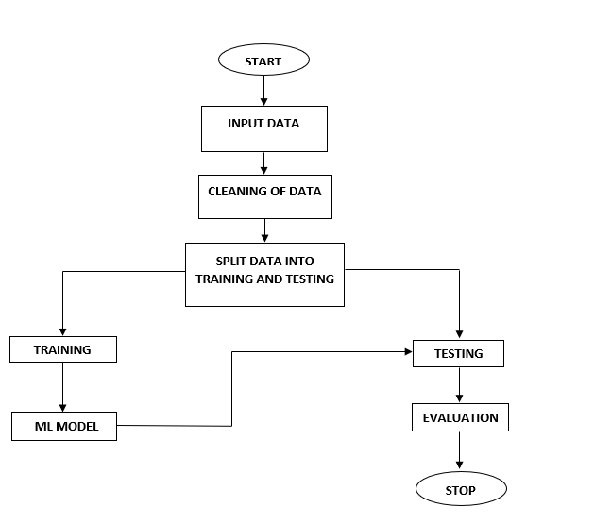

**Advantages**:

* Accuracy is good.
* Low complexity.
* Highly efficient.
* No need of skilled persons.

**Submitted by: Under the Guidance of**

19191A0564 N. Narasimha Reddy K. Bala Chandra Reddy

19191A0513 N. Sreekanth Assistant Professor (Adhoc)

19191A0509 A. Saravana Department of CSE