**WEEK 1 : DATA STRUCTURES AND ALGORITHMS**

**Exercise 2: E-commerce Platform Search Function**

**CODE :**

**Product.java**

public class Product {

    int productId;

    String productName;

    String Category;

    public Product(int productId, String productName, String category) {

        this.productId = productId;

        this.productName = productName;

        Category = category;

    }

    @Override

    public String toString() {

        return "Product{" +

                "productId=" + productId +

                ", productName='" + productName + '\'' +

                ", Category='" + Category + '\'' +

                '}';

    }

}

**LinearSearch.java**

public class LinearSearch {

    public static Product linearSearch(Product[] products,String key){

        for(Product p: products){

            if(p.productName.equalsIgnoreCase(key)){

                return p;

            }

        }

        return null;

    }

}

**BinarySearch.java**

import java.util.Arrays;

import java.util.Comparator;

public class BinarySearch {

    public static Product binarySearch(Product[] products, String targetName){

        Arrays.sort(products, new Comparator<Product>() {

            public int compare(Product p1, Product p2) {

                return p1.productName.compareToIgnoreCase(p2.productName);

            }

        });

        Product key = new Product(0, targetName, "");

        int index = Arrays.binarySearch(products, key, new Comparator<Product>() {

            public int compare(Product p1, Product p2) {

                return p1.productName.compareToIgnoreCase(p2.productName);

            }

        });

        return (index >= 0) ? products[index] : null;

    }

}

**Test.java**

public class Test {

    public static void main(String[] args){

        Product[] catalog = {

                new Product(101, "Laptop", "Electronics"),

                new Product(102, "Shoes", "Fashion"),

                new Product(103, "Mobile", "Electronics"),

                new Product(104, "Watch", "Accessories")

        };

        Product res1 = LinearSearch.linearSearch(catalog,"Watch");

        System.out.println("Linaer Search Result : "+res1);

        Product res2 = BinarySearch.binarySearch(catalog, "Mobile");

        System.out.println("Binary Search Result: " + res2);

    }

}

**OUTPUT :**

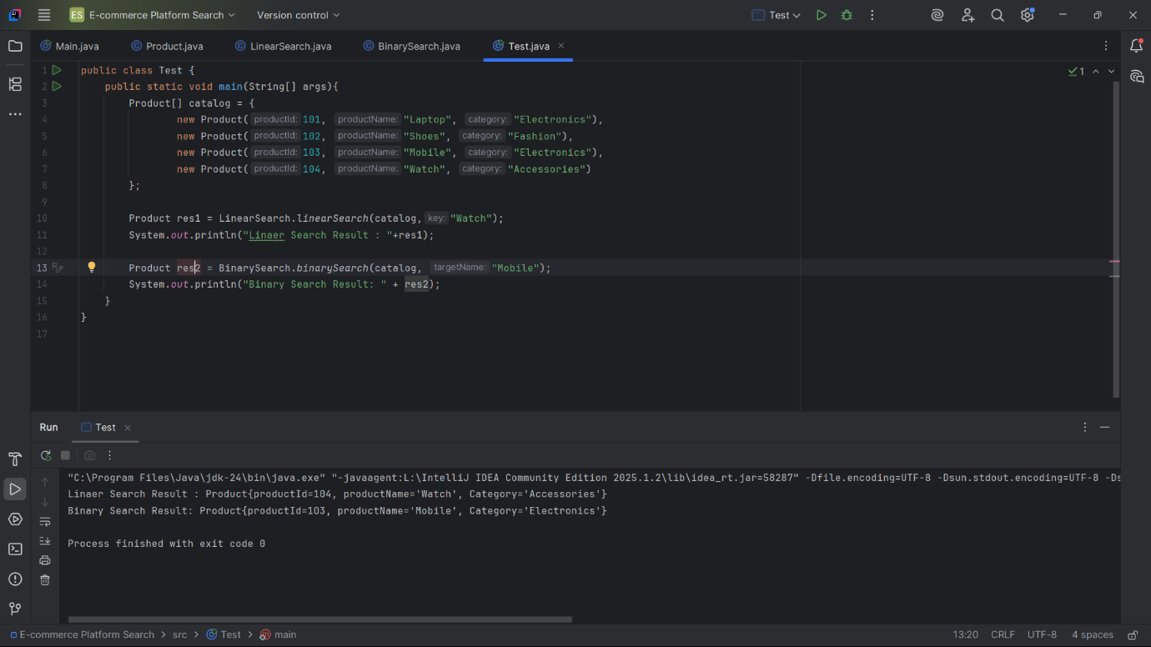

**Exercise 7: Financial Forecasting**

**CODE :**

**FinancialForecast.java**

public class FinancialForecast {

    public static double futureValue(double amount, double rate, int years) {

        if (years == 0) return amount;

        return (1 + rate) * futureValue(amount, rate, years - 1);

    }

    public static void main(String[] args) {

        double amount = 1000;

        double rate = 0.05;

        int years = 5;

        double result = futureValue(amount, rate, years);

        System.out.printf("Future Value after %d years: %.2f\n", years, result);

    }

}

**OUTPUT :**

