**WEEK 1 : DESIGN PATTERNS AND PRINCIPLES**

**Exercise 1: Implementing the Singleton Pattern:**

**CODE:**

**Logger.java**

public class Logger {

    private static Logger logger = new Logger();

    private Logger(){

        System.out.println("Logger Class");

    }

    public static Logger getInstance(){

        return logger;

    }

}

class Test{

    public static void main(String[] args){

        Logger obj1 = Logger.getInstance();

        Logger obj2 = Logger.getInstance();

        if(obj1==obj2){

            System.out.println("Single Instance");

        }

        else{

            System.out.println("Multiple Instance");

        }

    }

}

**OUTPUT:**

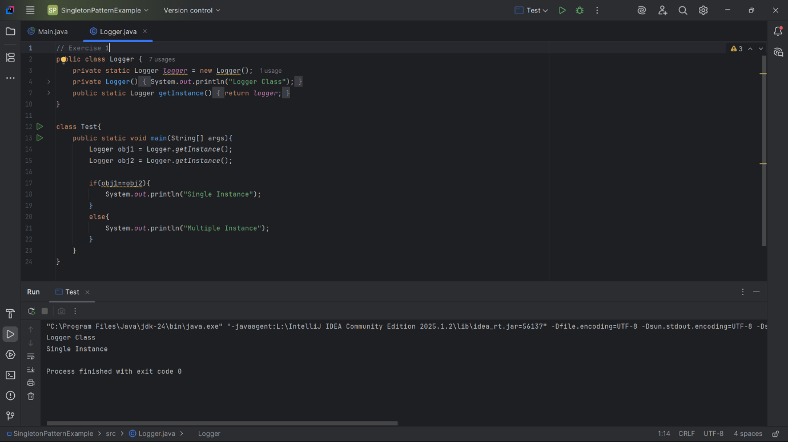

**Exercise 2: Implementing the Factory Method Pattern**

**CODE:**

**Dcocument.java**

package factory;

public interface Document {

    void open();

}

**WordDocument.java**

package factory;

public class WordDocument implements Document{

    @Override

    public void open() {

        System.out.println("Opening Word Document");

    }

}

**PdfDocument.java**

package factory;

public class PdfDocument implements Document{

    @Override

    public void open() {

        System.out.println("Opening PdfDocument");

    }

}

**ExcelDocument.java**

package factory;

public class ExcelDocument implements Document{

    @Override

    public void open() {

        System.out.println("Opening Excel Document");

    }

}

**DocumentFactory.java**

package factory;

public class DocumentFactory {

    public Document createDocument(String type){

        if (type == null) return null;

        if (type.equalsIgnoreCase("word")) {

            return new WordDocument();

        } else if (type.equalsIgnoreCase("pdf")) {

            return new PdfDocument();

        } else if (type.equalsIgnoreCase("excel")) {

            return new ExcelDocument();

        }

        System.out.println("Unknown document type.");

        return null;

    }

}

**Test.java**

package factory;

public class Test {

    public static void main(String[] args){

        DocumentFactory obj = new DocumentFactory();

        Document d1 = obj.createDocument("pdf");

        Document d2 = obj.createDocument("pdf");

        Document d3 = obj.createDocument("excel");

        Document d4 = obj.createDocument("ppt");

        if (d1 != null) d1.open();

        if (d2 != null) d2.open();

        if (d3 != null) d3.open();

        if (d4 != null) d4.open();

    }

}

**OUTPUT:**

