**Week2: JUnit Basic Testing Exercises**

**Exercise 1: Setting Up Junit**

**CODE :**

**pom.xml**

<dependencies>  
 <dependency>  
 <groupId>org.junit.jupiter</groupId>  
 <artifactId>junit-jupiter</artifactId>  
 <version>5.10.2</version>  
 <scope>test</scope>  
 </dependency>  
</dependencies>

**Exercise 2: Writing Basic JUnit Tests**

**CODE :**

**Calculator.java**

public class Calculator {  
 public int add(int a,int b){  
 return a + b;  
 }  
}

**CalculatorTest.java**

import org.junit.jupiter.api.Test;  
  
import static org.junit.jupiter.api.Assertions.*;  
  
class CalculatorTest {  
 @Test  
 public void testAdd1(){  
 var calc = new Calculator();  
 *assertEquals*(7,calc.add(3,4));  
 }  
  
 @Test  
 public void testAdd2(){  
 var calc = new Calculator();  
 *assertTrue*(7==calc.add(3,4));  
 }  
  
  
}

**Output :**

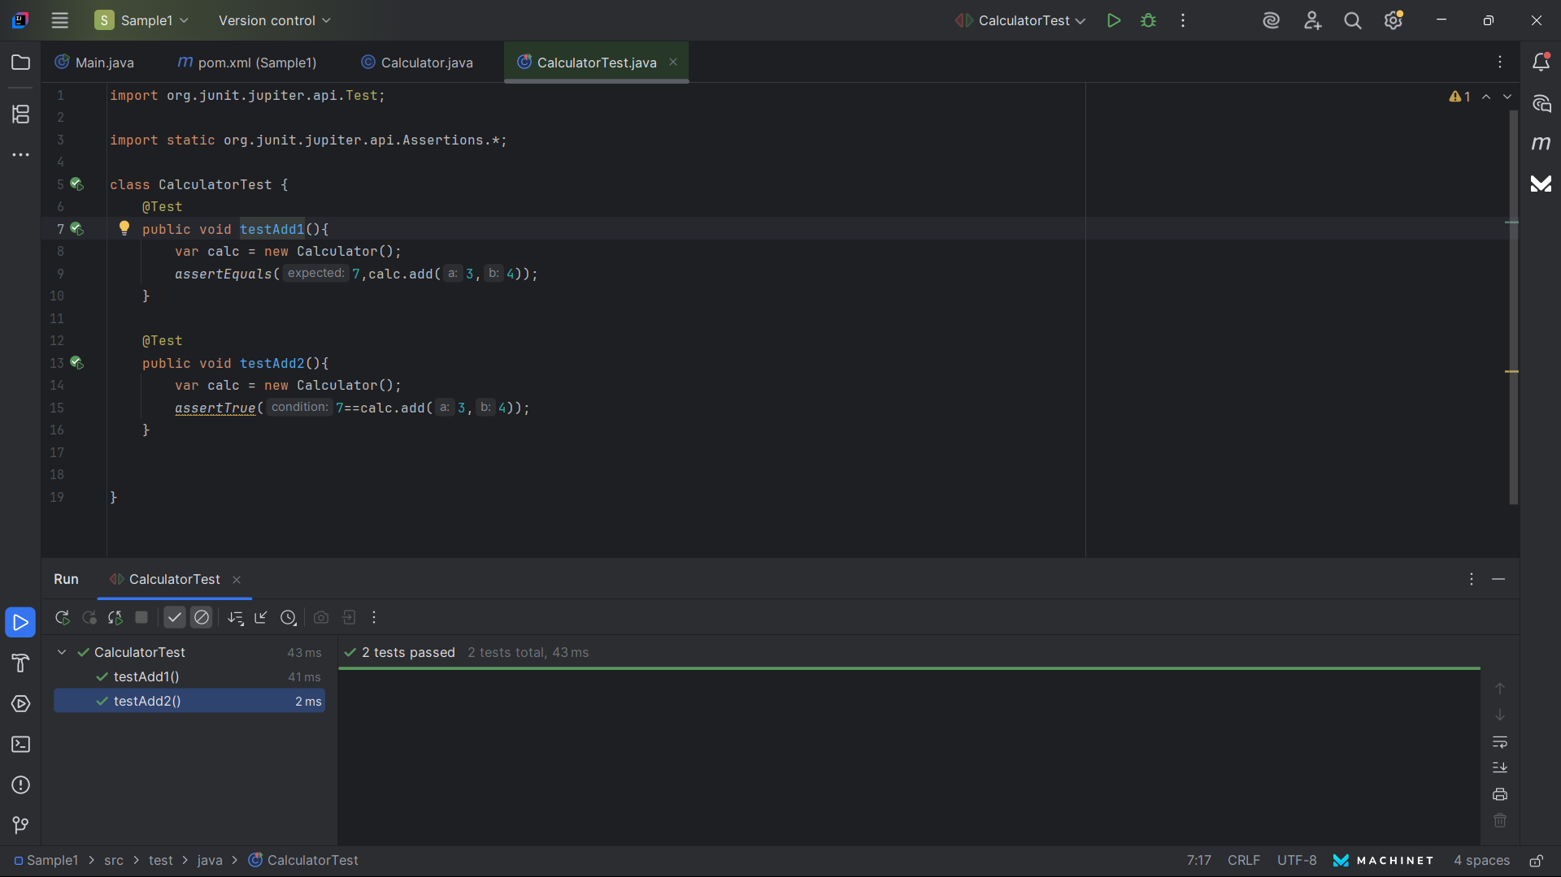

**Exercise 3: Assertions in Junit**

**CODE :**

**AssertionsTest.java**

import org.junit.jupiter.api.Test;  
  
import static org.junit.jupiter.api.Assertions.*;  
public class AssertionTest {  
  
 @org.junit.jupiter.api.Test  
 public void testAssertions() {  
 *assertEquals*(5, 2 + 3); // Equal  
 *assertTrue*(5 > 3); // True  
 *assertFalse*(5 < 3); // False  
 *assertNull*(null); // Null check  
 *assertNotNull*(new Object()); // Not null  
 }  
}

**Output :**

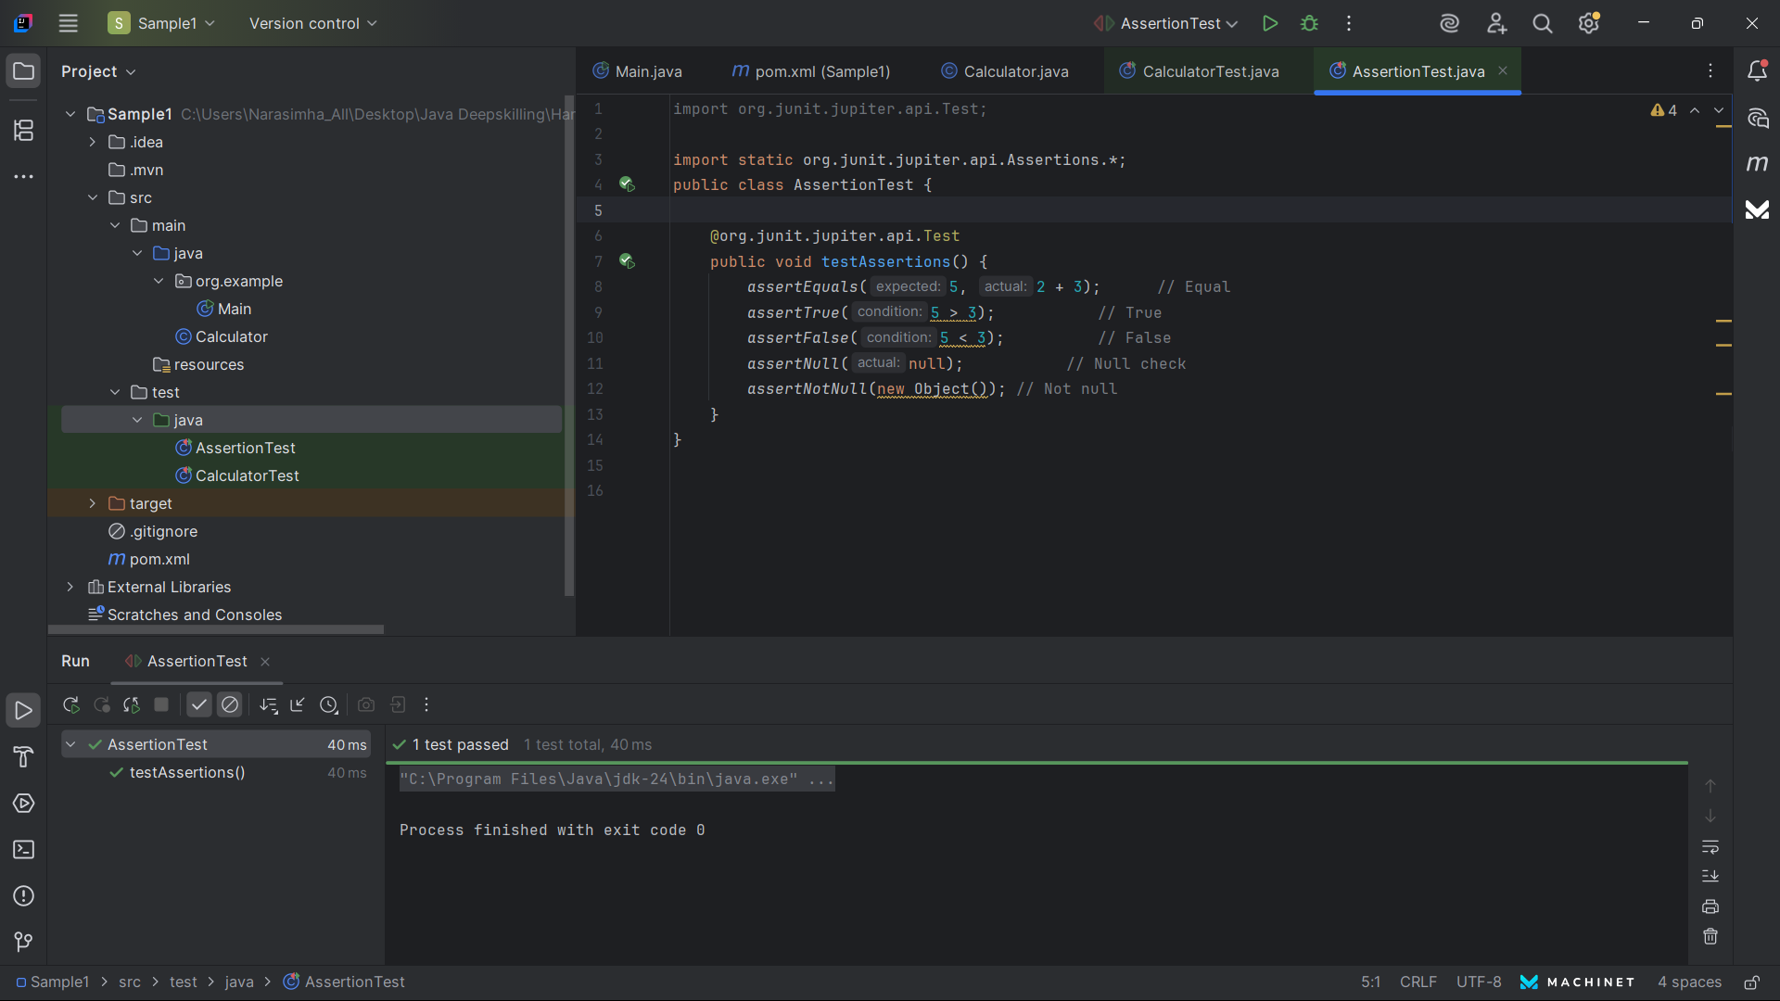

**Exercise 4: Arrange-Act-Assert (AAA) Pattern, Test Fixtures, Setup and Teardown Methods in JUnit**

**CODE :**

**CalculatorTest.java**

import org.junit.jupiter.api.*;

import static org.junit.jupiter.api.Assertions.*;

public class CalculatorTest {

Calculator calc;

@BeforeEach

void setUp() {

calc = new Calculator(); // Setup test fixture

System.out.println("Setting up");

}

@AfterEach

void tearDown() {

System.out.println("Cleaning up"); // Optional teardown

}

@Test

void testAdd() {

int result = calc.add(2, 3); // Act

assertEquals(5, result); // Assert

}

@Test

void testSubtract() {

int result = calc.subtract(5, 2);

assertEquals(3, result);

}

}

**Output :**

