**Week 2 : SLF4J Logging Exercises**

**Exercise 1: Logging Error Messages and Warning Levels**

**CODE :**

**pom.xml**

<dependency>

<groupId>org.slf4j</groupId>

<artifactId>slf4j-api</artifactId>

<version>1.7.30</version>

</dependency>

<dependency>

<groupId>ch.qos.logback</groupId>

<artifactId>logback-classic</artifactId>

<version>1.2.3</version>

</dependency>

**LoggingExample.java**

import org.slf4j.Logger;

import org.slf4j.LoggerFactory;

public class LoggingExample {

private static final Logger logger = LoggerFactory.getLogger(LoggingExample.class);

public static void main(String[] args) {

logger.error("This is an error message");

logger.warn("This is a warning message");

}

}

**Output :**

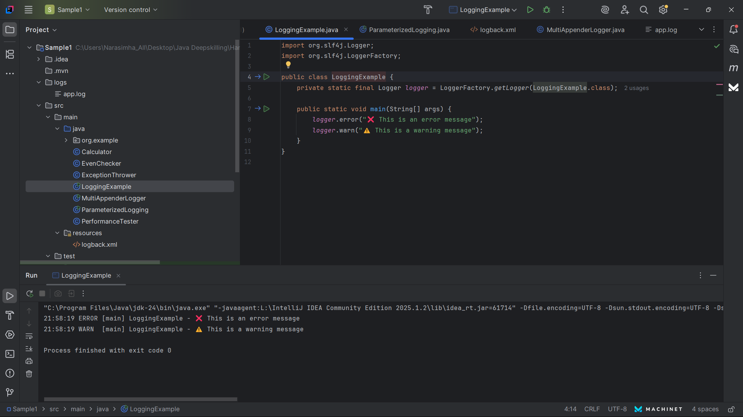

**Exercise 2: Parameterized Logging**

**CODE :**

**pom.xml :**

<dependency>

<groupId>org.slf4j</groupId>

<artifactId>slf4j-api</artifactId>

<version>1.7.30</version>

</dependency>

<dependency>

<groupId>ch.qos.logback</groupId>

<artifactId>logback-classic</artifactId>

<version>1.2.3</version>

</dependency>

**ParamaterizedLogging.java**

import org.slf4j.Logger;  
import org.slf4j.LoggerFactory;  
  
public class ParameterizedLogging {  
 private static final Logger *logger* = LoggerFactory.*getLogger*(ParameterizedLogging.class);  
  
 public static void main(String[] args) {  
 String username = "Stephen";  
 int balance = 4500;  
  
 *logger*.info("User {} has a balance of ₹{}", username, balance);  
 *logger*.warn("User {} has reached login limit", username);  
 *logger*.error("User {} has transaction failure for ₹{}", username, 2000);  
 }  
}

**Output :**

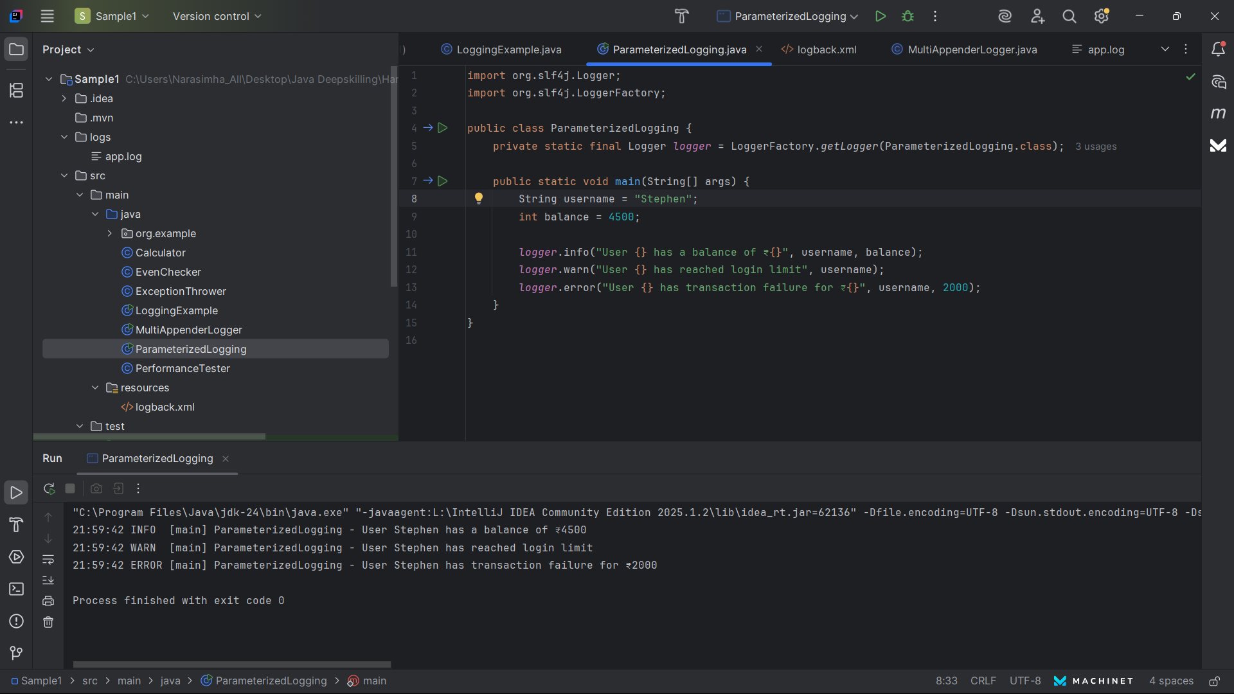

**Exercise 3: Using Different Appenders**

**CODE :**

**pom.xml** :

<dependency>

<groupId>org.slf4j</groupId>

<artifactId>slf4j-api</artifactId>

<version>1.7.30</version>

</dependency>

<dependency>

<groupId>ch.qos.logback</groupId>

<artifactId>logback-classic</artifactId>

<version>1.2.3</version>

</dependency>

**Logback.xml**

<configuration>

<appender name="console" class="ch.qos.logback.core.ConsoleAppender">

<encoder>

<pattern>%d{HH:mm:ss.SSS} [%thread] %-5level %logger{36} - %msg%n</pattern>

</encoder>

</appender>

<appender name="file" class="ch.qos.logback.core.FileAppender">

<file>app.log</file>

<encoder>

<pattern>%d{HH:mm:ss.SSS} [%thread] %-5level %logger{36} - %msg%n</pattern>

</encoder>

</appender>

<root level="debug">

<appender-ref ref="console" />

<appender-ref ref="file" />

</root>

</configuration>

**MultiApppender.java:**

import org.slf4j.Logger;  
import org.slf4j.LoggerFactory;  
  
public class MultiAppenderLogger {  
 private static final Logger *logger* = LoggerFactory.*getLogger*(MultiAppenderLogger.class);  
  
 public static void main(String[] args) {  
 *logger*.debug("Debug: App initialized");  
 *logger*.info("Info: User accessed dashboard");  
 *logger*.warn("Warning: Disk usage at 90%");  
 *logger*.error("Error: Payment service failed");  
 }  
}

**Output:**

